Ken Arney, Reviewing Officer
Regional Forester
USDA Forest Service, Southern Region

James Melonas, Responsible Official
Forest Supervisor
National Forests in North Carolina

Attn: Objection Coordinator
Nantahala and Pisgah National Forests
160 Zillicoa St., Suite A
Asheville, NC 28801

Submitted electronically via CARA Online Portal:
https://cara.ecosystem-management.org/Public/CommentInput?Project=43545

Notice of Objection to the Final Land Management Plan
for the Nantahala and Pisgah National Forests

OBJECTOR CONTACT INFORMATION
Pursuant to 36 C.F.R. § 219.54 (c)(3) Ben Prater, Director of Southeast Program is designated as
the lead objector.

Defenders of Wildlife
Ben Prater, Lead Objector
Defenders of Wildlife
1 Rankin Ave. Second Floor
Asheville, NC 28801
bprater@defenders.org
828-412-0980

I am filing this objection to the Final Land Management Plan for the Nantahala and Pisgah National Forests, the Final Environmental Impact Statement, and Draft Record of Decision on behalf of Defenders of Wildlife and our 1.8 million members and supporters. James Melonas is the Responsible Official for Land and Resource Management Plan and Ken Arney is Responsible Official for Species of Conservation Concern. My address, telephone number, and email address are included above. As the Southeast Program Director, I designated myself as the lead objector on behalf of Defenders of Wildlife.
For the entire life of the forest plan revision process I have been directly involved as a representative of Defenders of Wildlife and advocated for the protection of biodiversity. I have participated as a collaborator in the Stakeholder Forum and as a member of the Nantahala Pisgah Forests Partnership. In addition to participating in these collaborative groups I have personally provided comments at each stage of the planning process in coordination with several partner organizations.
Despite this participation there are still several aspects of the Revised Forest Plan that do not adequately address our concerns regarding the protection and management of rare and unique habitats, old growth forests, species of conservation concern and federally listed species. Therefore, we are choosing to object in the hopes of securing a better future for wildlife conservation on the Nantahala and Pisgah National Forests.
As my statement of reasons for objecting, suggested remedies, and demonstration of the link between my prior substantive comments and the content of my objection, I am incorporating the objection filed today by the Southern Environmental Law Center on behalf of The Wilderness Society, MountainTrue, Defenders of Wildlife, and Sierra Club. In the past when groups have joined in a single objection, the Forest Service has only allowed one member of the group to participate in objection resolution meetings. Because I have been working directly on the Forest Plan Revision for nearly a decade it is only fair that I be included as an official objector. I am filing this additional objection to preserve my ability to participate in the objection resolution meeting.
Sincerely,
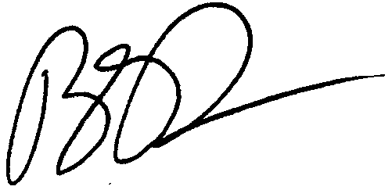
Ben Prater
Southeast Program Director
Defenders of Wildlife

