May 08, 2019

Regional Forester
USDA Forest Service
Attn: Stanislaus National Forest Over-snow Vehicle Use Designation Project
1323 Club Drive
Vallejo, CA 94592

Objection Response to the Record of Decision Alternative 5 Modified Plan:
I am a cabin owner on the 5N01 Eagle Meadow Road between Haypress Lake and Relief Reservoir. My family and I had submitted comments during the open public commentary period between late August and October 9, 2018. My comments are outlined in the attached letter dated October 8th, 2018. Our family has respected the environment and the surrounding area and has enjoyed both the summer and winter seasons at our cabin. Many cabin owners as well as our family who own private lots of land in this area that is approximately two miles long by one half mile wide, a very small and modest space, on National Forest land and Private Property next to the vast Emigrant Wilderness and the adjacent Yosemite National Park, have been snowmobiling in the area between Red Rock Meadow, Haypress Lake, Relief Reservoir, Silver Mine Creek, and the northern boundary of Emigrant Wilderness each winter for over 40 years since the 1970’s. We wish to continue to ride the area that our family has enjoyed for decades and want our future generations to enjoy as well.
My concerns that were outlined in the attached comment letter dated October 8th and are listed in this paragraph, state that under the original Stanislaus Forest Preferred Alternative Option 5 Plan released in late August, 2018, all of the property owners who own cabins on private property in the area between Haypress and Relief Reservoir on the 5N01 Eagle Meadow road would be cut off and restricted from winter access to our cabins and private properties on a public road where many of us have been riding snowmobiles for over 40 years. In fact, the penalty for doing something that our family has done together for decades by accessing our property by public road via snowmobile is a $5,000 fine and/or six months jail time if this area is treated as Wilderness or a Forest Closure Order is issued. It seems unreasonable that cabin owners in the Eagle Valley and Long Valley would be granted OSV access to their cabins, but we cabin owners further along the 5NO1 Eagle Meadow road would not be granted OSV access to our private property, even on a maintained road that we pay our property taxes and green sticker money toward. The Eagle Valley and Long Valley cabin owners would also be granted designated areas of National Forest adjacent to their cabins in which to ride, where we would lose all of our traditional riding areas, even a mile radius around our property which we are accustomed to. Our two-mile long by one half mile wide riding area should not be restricted and we should also continue to have access to ride Forest Road 20EV77 to Relief Reservoir and Forest Road 20EV79 to East Flange Rock at the edge of Emigrant Wilderness.

Stanislaus Forest Record of Decision Alternative 5 Modified Map released 03/22/19 – purple is rideable, non-purple is restricted - NOT ACCEPTABLE – this map needs to include the circled area as OSV rideable for many riders for many years of historical use (not Wilderness) includes private property:
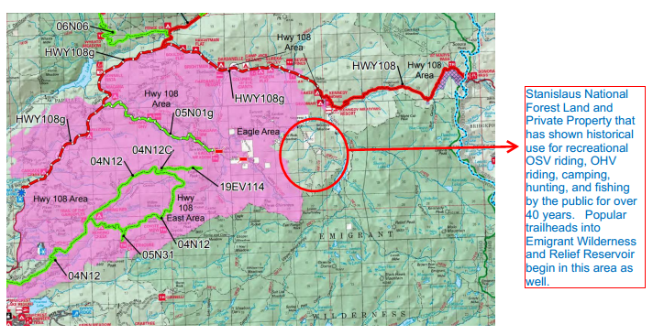
In reviewing the Record of Decision Alternative 5 Modified Plan released on March 22th, 2019, we were pleased that most of our traditional OSV riding areas shaded in purple on the decision map above will continue to remain open to OSV use. However, much to our dismay, a very popular historical OSV riding area of National Forest Land and many private property lots, our family’s lot included, is scheduled to be closed to public OSV use and is circled in the diagram above. My concern is that not only does this close an area that has demonstrated recreational OSV use for five decades, but if this area is closed to the public for OSV riding during the winter months, the same grounds could also be used to close it to the public during the summer months for motorized vehicle access on the 5N01 Road, Forest Roads 20EV77 and 20EV79, as well as OHV riding, camping, fishing, hunting, and hiking by the public. This area is important to maintain public access due to the fact that Road 5N01 and Forest Road 20EV77 to Relief Reservoir are accessed from time to time by large construction vehicles that are contracted by PG&E to repair and monitor the dam. This is the only access road to the reservoir dam and is critical for infrastructure and resource management. Even though Forest Road 20EV77 may be designated private easement, the public should have access to all of Road 5N01 and Forest Road 20EV79 to the wilderness boundary.
I am very appreciative of the time that Forest Supervisor Jason Kuiken spent speaking with me on March 26, 2019, where we discussed his review of the area in question. The two issues that he had discussed with me regarding keeping the area open to public OSV use were as follows:
1) The information that he referenced states that Eagle Meadow Road 5N01 is designated public easement between Highway 108 and Haypress Lake, and at that point, the 5N01 road easement changes to private owners easement between Haypress Lake and where Road 5N01 ends and the popular Forest Roads/Jeep Trails/OHV Trails 20EV77 and 20EV79 begin, and therefore the Forest was unable to release to the public the official Forest map that designates the area as public access to Road 5N01 past Haypress Lake if the road was designated private easement.
2) He stated that his intention was to grant some of the snowmobile groups’ request that a clear ridge boundary determines the OSV boundary, and that it was difficult to do so if the 5N01 Road was designated private easement, and the eastern boundary at Long Valley was an obvious ridge, making it difficult to provide an obvious ridge boundary for the area in question.
Forest Supervisor Jason Kuiken also mentioned that private property cabin owners in the area would be able to access their properties via OSV as long as they stay on the 5N01 Road and their properties since Forest Service does not have jurisdiction over private property and private easement. He also mentioned that if the easement on the 5N01 Road were to be changed from private easement to public easement, he would be open to discussing further the issue of leaving the area open to OSV use.
After the discussion with Forest Supervisor Jason Kuiken, the following weekend on March 30th, my brother Casey and I rode snowmobiles to our private property cabin, where the two-story building was nearly buried under 12 feet of snow. We rode to all of the other cabins in the area in order to discuss the 5N01 Road easement issue with the other cabin owners and how to keep the area open to the public in both summer and winter. While we were at our cabin, Mary Krupka and a group from the Sonora Snowmobile Club and the annual Sierra snowmobile convention rode up on snowmobiles and we discussed the OSV decision. I mentioned that it did not seem right that under the new Forest Record Of Decision Alternative 5 Modified Plan, she, the other cabin owners in Long Valley and Eagle Valley, and other OSV riders would no longer be able to come over to our side of the hill to visit the cabin owners in our area but that we cabin owners between Haypress Lake and Relief Reservoir would be able to ride over to the other side of the hill to visit all of the other cabin owners in Long Valley and Eagle Valley. She said “Well, how am I going to visit all of my friends?!”. This is a very good point. I explained that there are often deep snow drifts on the 5N01 Road below our cabin that make it difficult to travel with small children, and that it was much easier to ride across the open terrain past Red Rock Meadow to our property. We would like to continue to ride the hills around our cabin the same as the Eagle/Long Valley cabin owners are able to do since this is some of the most spectacular OSV riding in the Sierra.
There has never been a gate or a sign located at Road 5N01 at Haypress Lake stating that beyond that point on the 5N01 Road was designated private property easement only. We are very interested in researching this issue with Tuolumne County and discover the road easement assessment as stakeholder property owners. In fact, if this is the case, we property owners are certainly not doing a very good job of keeping out the traffic and number of people who have been using the 5N01 Road to travel to Relief Reservoir and to the northern boundary Emigrant Wilderness for camping, hunting, riding OSV's, riding OHV's, jeeps, hiking, and fishing. Every time that we drive to Relief Reservoir to park and hike around the reservoir and into the Emigrant Wilderness on any given summer weekend, there are at least three or four groups camping at the reservoir. There must continue to be public access to the roads in this area in both summer and winter in order to honor historical use and to allow these groups of people to continue to use the area as they have enjoyed for decades.
Proposal: Since the objection period closes only 45 days from the date of the Record of Decision, and we did not have the time to discuss the 5N01 road easement issue with all of the other cabin owners and research the issue at the Tuolumne County Assessor's office, my proposal is to move the eastern boundary of the ROD OSV area to include as OSV rideable the area as follows: from Red Rock Meadow and Haypress Lake in the north, up to but not necessarily include the 5N01 Road in the east down to the northern boundary of Emigrant Wilderness, to the west to include the ridge that is adjacent to Long Valley. Snowmobilers already know where these boundaries are located because there is an obvious cliff to the east of the 5N01 road that falls to the valley where Kennedy Meadows is located, and there is an obvious ridge along the northern boundary of Emigrant Wilderness that falls down to Emigrant Meadows where the wilderness maker is located and the snowmobile tracks end. I have highlighted the area that needs to be included in yellow in the map below to the current OSV map. This proposal will allow property owners and historical use snowmobilers to use the National Forest and Private Property land as OSV as in many past decades.
My other proposal would be to research and discuss with the other property owners a possible designation change of the road easement of the 5N01 Road between Haypress Lake and the end of the 5N01 Road from private to public to continue to allow the public to use the roads and to honor historical use.
Per my proposal, please add the highlighted yellow area in the diagram below to the purple OSV area.
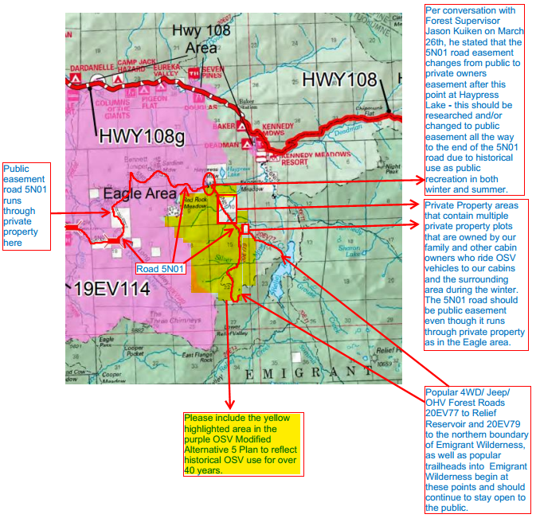

Attached is my comment letter originally submitted in October, 2018 with photos of our family’s snowmobile trips between the 1970’s and 1990’s in the National Forest areas listed above with landmarks such as the Three Chimneys, East Flange Rock, and Sonora Pass in the background. None of these photos were taken in Emigrant Wilderness or Carson-Iceberg Wilderness areas.
Our public lands do belong to the public, but we property owners and snowmobilers ARE the public, and we are the ones who love the area, know and respect the area, and use the area. Our views and right of access to private property should be respected as well!

Annie Clarke
1888 El Rancho Dr.
Santa Cruz, CA 95060
(831) 332-9563
annie.clarke681@gmail.com

