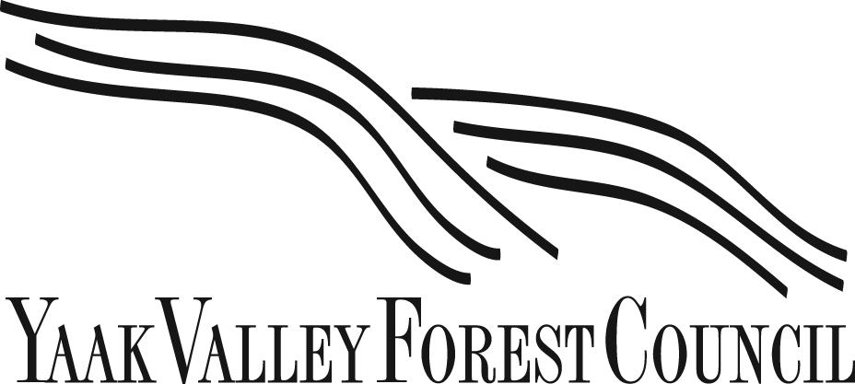

May 8, 2023
Chris Bachman
Conservation Director
Yaak Valley Forest Council
11896 Yaak River Road
Troy, MT 59935
(406) 295-9736
cbachman@yaakvalley.org
Lolo National Forest Supervisor’s Office
c/o Amanda Milburn, Plan Revision
24 Fort Missoula Rd.
Missoula, MT 59804
RE: Lolo National Forest Land Management Plan Revision

I am writing on behalf of the Yaak Valley Forest Council to give formal comments on the Lolo National Forest Land Management Plan Revision. 2023.
The Yaak Valley Forest Council (YVFC), created in 1997, is a Montana based 501(c)3 nonprofit that implements conservation and restoration programs focused on protecting and preserving critical wildlife habitat for the sensitive, threatened, and endangered species inhabiting the wild Yaak Valley. Our Mission is to protect the last roadless areas in the Yaak Valley, the Kootenai National Forest and surrounding public lands; maintain and restore the ecological integrity of our geographical zone by conserving and improving habitat for native and sensitive species.
The Lolo National Forest provides a critical wildlife habitat connectivity corridor. The Lolo National Forest has lands in three different Grizzly Bear Recovery Areas and is critically located between the Northern Continental Divide, Greater Bitterroot and Cabinet-Yaak Ecosystems. It is critical that forest management practices prioritize habitat connectivity for TES species including the grizzly bear and the carbon sequestering, atmospheric carbon stabilizing properties of mature and old growth forests.

We request the following be incorporated into the Lolo National Forest Land Management Plan Revision:

For the Wilderness Inventory
- Apply connectivity as an Outstandingly Remarkable Value.
- Include all roadless areas, including those under 5000 acres. These are vital as secure habitat for grizzly bears and other wildlife and for connectivity.
- Include areas with past disturbance that is now considered "substantially unnoticeable." These areas are critical to connectivity and will become totally unnoticeable over the life of the forest plan process when they remain undisturbed.
- Include Mature and Old Growth Forest as an Outstandingly Remarkable Value.
- Include all areas recommended for Wilderness classification by the Citizen Alternative.

For the Wild & Scenic River Inventory
- Apply the Climate Shield data as an Outstandingly Remarkable Value.
- Include all rivers recommended for Wild & Scenic in the Citizen alternative.
- Apply bull trout and cutthroat trout presence and designated Bull Trout Critical Habitat as Outstandingly Remarkable Resource Values.
- Include all rivers found to be suitable for Wild & Scenic classification in the 1991 Lolo National Forest Plan Amendment 12 assessment.

We appreciate the opportunity to comment and support maintaining forest health to support thriving forests and thriving populations of wildlife.

Respectfully Submitted,
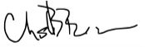
Chris Bachman
Conservation Director
Yaak Valley Forest Council

