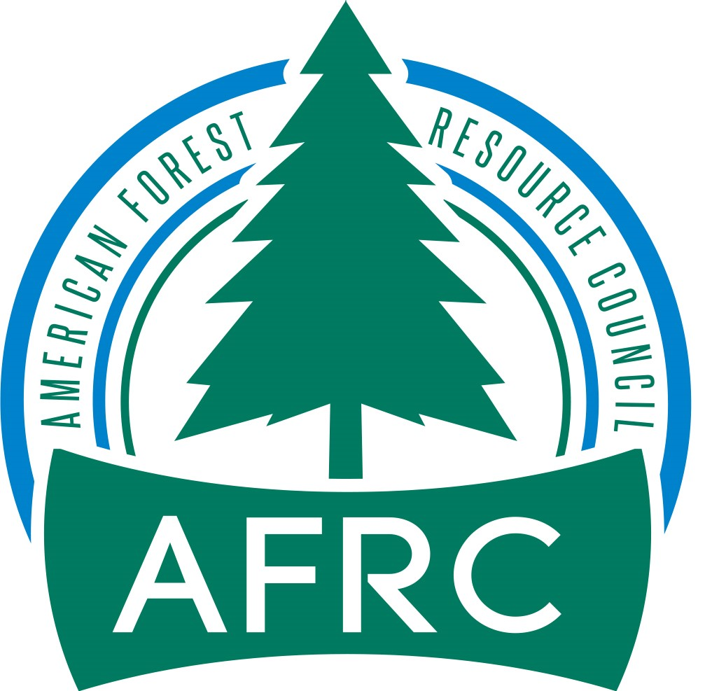

August 13, 2020

Jason Kuiken
Forest Supervisor
USDA - Stanislaus National Forest
19777 Greenley Road
Sonora CA, 95370

Re: Federal Register Notice Volume 85, No. 137 published July 16, 2020 Pages 43205- 43206 Titled “Stanislaus National Forest; California; Social and Ecological Resilience Across the Landscape EIS”

Action: Notice of intent to prepare an environmental impact statement.

As provided for in your Scoping Letter, Calforests is submitting Comments electronically to: https://cara.ecosystem-management.org/Public/commentInput?Project=56500.

Dear Mr. Kuiken,

Thank you for the opportunity to comment on the SERAL project scoping document. Calforests commends the Stanislaus National Forest in taking this step to move toward landscape-scale projects. We further commend you for utilizing the Yosemite/Stanislaus Solutions collaborative group. Interaction with the Collaborative helps to ensure that a diverse range of viewpoints and expertise has been taken into consideration as the forest moves towards a decision.

Calforests has a membership consisting of most of California’s large industrial forest landowners, many non-industrial forest landowners, most of the 28 remaining medium and large sawmills and veneer mills, several biomass powerplants and one shavings mill. Our mission is to create a favorable operating environment for the forest products industry, ensure a reliable wood supply from public and private lands, and promote sustainable management of forest lands.

Calforests concurs with the Project Purpose as stated in the Federal Register Notice (pg. 43205):

“The purpose of the SERAL EIS is to prepare the landscape for the safe reintroduction of fire as a key ecological process, increase the landscape’s resilience and adaptive capacity to natural disturbances such as fire, drought, insects and disease, reduce the risk of fire spreading into communities or damaging critical infrastructure, and to manage the forest in a cost-effective manner, including making wood products available to local industries and businesses. The actions proposed in the SERAL project are needed to minimize the potential for large-, high severity fire and habitat loss; shift the landscape vegetation structure and composition towards conditions that are more in alignment with its historic NRV, abate hazard trees; control occurrences of invasive, non-native plants; and assist wildfire management operations., conserve and/or restore terrestrial and aquatic ecosystems and protect these systems.”

Calforests also concurs with the Project “Need” as stated in the Federal Register Notice (pg. 43205):

“The actions proposed are needed to minimize the potential for large, high-severity fire and habitat loss; shift the landscape vegetation structure and composition towards conditions that are more in alignment with its historic Natural Range of Variability, abate hazard trees; control occurrences of invasive, non-native plants; and assist wildfire management operations., conserve and/or restore terrestrial and aquatic ecosystems and protect these systems.”

The Stanislaus National Forest has been a significant contributor to the wood supply in Tuolumne County for its wood processing infrastructure. Tuolumne County enjoys the most diverse set of wood processing facilities of any county in the state with a state-of the art sawmill and co-generation powerplant, stand-alone biomass power plant, fence mill, and a shavings mill. As shown by a Forest Service Washington Office timber program review of the Stanislaus National Forest in 2005, the Forest needs to be providing economic timber sale and stewardship projects that generate 40 million board feet (mmbf) per year to maintain the viability of the infrastructure. On average the Forest has sold 36.7 mmbf/year since 2006.

Calforests commends the Stanislaus National Forest for taking the positive step through the SERAL project of addressing the overly dense vegetative condition at a landscape scale. From the Westcore Data Tables using 2005 Forest Inventory and Analysis (FIA) permanent plot data, on average on productive forest land not reserved, the Stanislaus National Forest was carrying 278 trees/acre on a landscape that likely has a carrying capacity of about 20-150 trees/acre depending on elevation, slope, slope position and aspect.

The 2010 FIA data on the national forests in California showed tree density increased from 2005 by 12 percent. The Forest Service, unfortunately, did not rerun the Westcore Data Tables using the 2010 FIA data. So though there’s not data specific for the Stanislaus National Forest, the trend is obvious. Tree density is increasing because the Forest Service has not been able to do fuels reduction on enough acres to move the Forest toward the desired condition.

The Region, including the Stanislaus National Forest, had a significant increase in fuels reduction acres accomplished in 2019 to 216, 000 acres. The Stanislaus Natl. Forest accomplished 23,255 acres of its 487,982 acres of productive forest land not reserved (4.8 percent). The Stanislaus Natl. Forest in 2019 was aligned exactly with the Regional Forester’s March 2011 Leadership Intent white paper calling for 500,000 acres/year on 9 million acres of productive forest land not reserved on a 20-year time horizon (about 5 percent/year).

The point of the above information is that the landscape scale SERAL project is exactly the right thing to do to further increase the annual fuels reduction accomplishments on the Forest.

Following are specific comments to the proposed action shown in the Scoping Notice.

Mechanical Thinning Treatments

D.1 Variable Density Thinning (p.9) – Specialized equipment for removal of harvested material on slopes greater than 35% should include “winch-assist harvesters and forwarders”. Further, there is substantial empirical evidence that winch-assist harvesters and forwarders can operate with no ground disturbance on slopes of 80 percent or greater. The harvester’s technique of cutting, limbing and topping trees as the harvester moves down the slope provides the opportunity to place the limbs and tops in front of the harvester. This creates the opportunity to have a mat of vegetation for the machine to “walk” on. When this technique is used, there is no soil disturbance and no measurable compaction. Further, the vegetative “carpet” reduces rain drop impact and has shown to lead to no discernable runoff.

Table 3 (p.10). Desired structure within forested stands based on NRV

The lower Tree Basal Area for both forest types are appropriate. However, the upper Tree Basal Area for both Forest Types are too high. Recent research by Malcolm North on “Carrying Capacity” in the Sierra Nevada indicates that at full carrying capacity, stands remain vulnerable to Natural Disturbance Agents (Wildfire, Insects and Disease and Drought). Dr. North recommends a target of perhaps 2/3 of the carrying capacity would be appropriate. That would indicate the upper range of “desired condition” for each type shown in the Table should be reduced by about 30 percent.

Table 4 (p. 11): Diameter at breast height limitations, exemptions and other constraints pertaining to variable density thinning treatments.

Calforests does not believe diameter limits are appropriate to achieve the desired objective. We would suggest directing that the largest on-site trees that contribute to the objective should be retained.

Calforests believes reducing overall tree density in the Protected Activity Centers (PACs) should be an objective. Page 5 of the scoping document states that “between 2014 and 2017 . . . 55 percent of the Owl PACs on the Stanislaus, Sierra and Sequoia National Forests have seen on average 20 trees/acre, mostly of larger diameter, killed due to tree mortality.” Calforests suspects most of this mortality is because of vegetative density exceeding the carrying capacity of the site.

- Fuelbreaks, Prepared Strategic Roadsides, and Defensible Space
P. 14

Calforests commends the Stanislaus Natl. Forest for incorporating Strategic and Roadside Fuelbreaks and fuelbreaks for defensible space. However, we caution that a 30” diameter limit could lead to not being able to reduce the basal area sufficiently to create a functional fuelbreak. We encourage that the direction simply be to retain the largest trees up to the desired basal area to achieve the objective of a functional fuelbreak.

Calforests believes an objective of a desired basal area would be useful for all fuelbreaks. We find that a 50 square foot basal area for pine type and 70 square feet for mixed conifer approximates the desired condition.

A.1 Inner Core (P. 16)

“. . .vegetation will be retained along roadsides to discourage unauthorized vehicle use off designated routes.”

This direction would not be compatible with creating a functional roadside fuelbreak that would provide safe public ingress/egress on an evacuation route and safe direct attack ground suppression. Further, retaining vegetation next to a road creates an increased risk of a human-caused fire starts. According to CalFire, about 95% of all fire starts in CA are human-caused and most are in close proximity of a road.

Standard & Guide 75 (p. 26) – “0.25-mile buffer around active nest during the breeding season (March 1-August 15) should limit or prohibit mechanical harvest activities that may disturb breeding owls.” This sentence should be changed to also limit or prohibit “hand thinning” (noise from chainsaws) March 1-August 15.

CalForest greatly appreciated the opportunity to comment and hope our comments will provide additional strengthening of a proposed action that will move the landscape toward a desired condition.

Sincerely,

STEVEN A. BRINK Eric Carleson

Vice-President – Public Resources Executive Director
California Forestry Association Associated California Loggers
916-208-2425
steveb@calforests.org

Andy Geissler
Federal Timber Program Director
American Forest Resource Council

Enclosure:

- Stanislaus Natl. Forest Westcore Data Table Information for Productive Forest land Not Reserved (Data Source is permanent plots on the Stanislaus Natl. Forest of the Forest Inventory & Analysis Program (FIA) from 2005.
Net Growth, Annual Mortality, & 2006-2019 Avg. Sold Volume for Stanislaus Natl. Forest
(Data Source: www.fs.fed.us/r5/rsl/publications/westcore/ & 2006-2019 Cut & Sold Reports)
(Data from growing stock on available, productive forestland Westcore Data Tables
by Steve Brink, 8/24/2012
Total Acres | 896,993
Acres Forested | 745,607
Acres Not Forested | 151,386
Acres of Productive Forestland | 620,547
Acres of Non-Productive Forestland | 125,060
Acres of Productive Reserved | 132,565
Acres Productive Not Reserved | 487,982
Tentatively Suitable | 385,691
Softwood volume in growing stock (>5" dbh)
on productive forestland | 10,878.78
Avg. Above Ground Biomass (> 1" dbh (live and standing dead)
on productive forestland | 30,355,889
Average # of Trees/acre on productive not reserved forestland | 278
Annual net growth = 0.37 mbf/acre on productive not reserved
(1.7 tons/acre/year of new growth)
On Productive Forest Land Not Reserved:
Gross Growth = 222.5 mmbf/year
Annual Mortality = 41.2 mmbf/year
Net Growth = 181.4 mmbf/year
Average Sold Volume 2006-2019 = 36.7 mmbf

