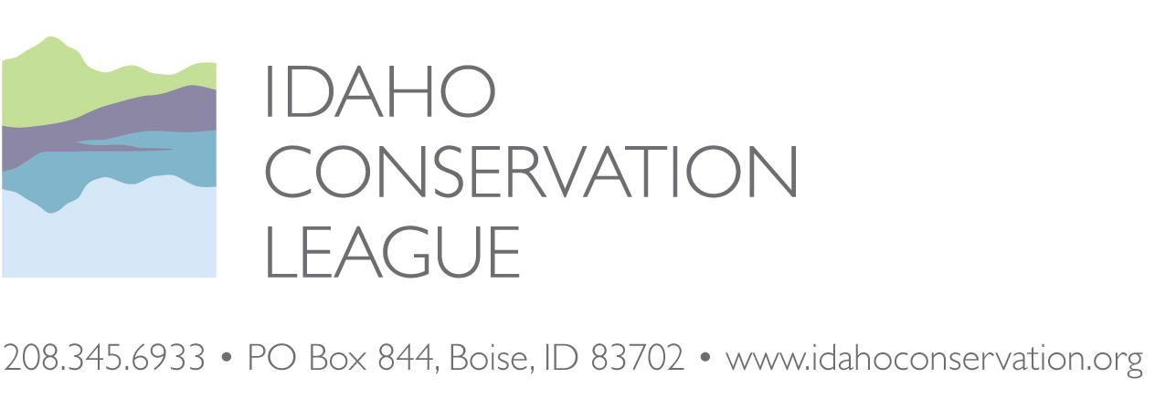

David Hogan
District Ranger
500 N Mission St.
McCall ID
83638
david.hogen@usda.gov

Josh Simpson
Recreation Program Manager
500 N Mission St.
McCall ID
83638
joshua.simpson@usda.gov

Submitted to the project webpage

November 18, 2021

RE: East Fork South Fork Salmon River Restoration and Access Management Plan Environmental Assessment (“EFSF RAMP”)

Dear David and Josh,

Thank you for considering our scoping comments on the East Fork South Fork Salmon River Restoration and Access Management Plan (RAMP) project. Since 1973, the Idaho Conservation League has been Idaho’s voice for clean water, clean air and wilderness—values that are the foundation for Idaho’s extraordinary quality of life. The Idaho Conservation League works to protect these values through public education, outreach, advocacy, and policy development. As Idaho's largest state-based conservation organization, we represent over 30,000 members and supporters who support responsible travel management and the protection and restoration of natural resources.

Since it’s initiation, the Idaho Conservation League has been a voting member of the Big Creek – Yellow Pine – South Fork collaborative. The group reached consensus on a series of restoration and access management recommendations and submitted them to the Forest Service for consideration in the development of this project.

Several members of the public had successfully challenged the Forest Service’s 2012 Travel Management Planning decisions and Motor Vehicle Use Map. The Court did not enter final judgment but invited the parties to see if they could reach an equitable resolution using a collaborative process. The collaborative includes diverse representation from stakeholders representing restoration, recreation, private property owners and other interests.

The Settlement Agreement states that the Payette National Forest will undertake motorized travel management planning consistent with 36 C.F.R. Part 212, Subpart B and consistent with the requirement for public involvement pursuant to NEPA. As part of this process, the Forest Service needs to identify the minimum road system within the project area that meets resource and other management objectives, meets applicable statutory and regulatory requirements, reflects long-term funding expectations, and minimizes adverse environmental impacts. There is a need in the East Fork South Fork Salmon River area to improve soil and riparian productivity for Endangered Species Act listed fish species and sensitive species and to improve recreational opportunities.

The Forest Service proposes accomplishing these needs by rehabilitating damaged watersheds, managing varied recreational facilities responsibly, and improving motorized and non-motorized recreation opportunities where appropriate.

The Payette National Forest Forest-wide Travel Analysis Report and maps are an important component in this decision-making process. It is important to note that the Travel Analysis Report is not a decision document and that the Forest Service can make different determinations provided that the agency can justify these decisions. Consensus recommendations from the collaborative that factor in improvements in watershed conditions may be one way to justify any departures:

The TAP is a “living” document and therefore will be updated regularly. Line officers and Interdisciplinary Teams will continue to consult the TAP as they are planning future projects. Since the TAP presents opportunities for change and makes no decisions about the transportation system, future projects will continue to receive public input that pertains to the Forest transportation system and may recommend decisions which are not consistent with the TAP. Modifications to the TAP’s recommendations as a result of final decision will be incorporated, after the appropriate National Environmental Policy Act procedures have been completed. -Payette National Forest.

The group successfully collaborated on both the Big Creek and South Fork Restoration and Access Management Plans which resulted in both restoration and recreation improvements now being implemented. A key element to our group’s success was active participation among diverse interests and agreement to develop a process that worked for the group. Collaborative participants agreed on a charter, formalized a decision-making process, and communicated with Forest Service staff.

Collaborative partners came with impressive, site-specific, on-the-ground knowledge of recreational trails as well as expertise in natural resource issues. To address the Forest Service’s restoration requirements for this area, our group’s proposals had to provide a net benefit for watersheds which allowed the Forest Service to use these “restoration offsets” to officially add recreational routes to the travel plan. GRAIP data has been an important tool in determining which road sections are most in need of maintenance or improvements and which ones are stable and low-risk.

While we appreciate the Forest Service including the collaborative’s recommendations in a larger suite of proposed actions, it is difficult for both members of the collaborative and the public to see which specific proposals earned the consensus support of the collaborative, which were discussed but collaborative participants could not reach consensus on, and which are entirely new. As the Forest Service proceeds, we recommend that the collaborative’s consensus recommendations serve as the preferred alternative. If specific components of the collaborative’s recommendations were not considered, it would be helpful to know why.

We support the determination of the Minimal Road System throughout the project area and the inclusion of the Thunder Mountain area as part of this proposal. We hope that the Forest Service uses a similar approach in the Thunder Mountain area to meet restoration goals while addressing access and recreational issues to the extent practicable.

Here are the collaborative’s consensus recommendations which ICL fully supports:

November 15, 2021
David Hogan
District Ranger
500 N Mission St
McCall, ID
83638
david.hogen@usda.gov
Josh Simpson
Recreation Program Manager
500 N Mission St
McCall, ID
83638
linda.l.jackson@usda.gov
Dear Mr. Hogan and Mr. Simpson,
Thank you for the opportunity to comment on the Payette National Forest’s (“Forest”) proposed East Fork South Fork Restoration and Access Management Project (“Project”). As you are aware, the Big Creek/Yellow Pine/South Fork Salmon River Collaborative (“Collaborative”) met and discussed this Project for over two years. The goals identified for the Project were to:
1. Look for 50” motorized recreational opportunities;
2. Look for restoration opportunities; and
3. Provide for outstanding legal rights such as Tribal, mineral, and private property access.
On December 12, 2018, the Collaborative submitted a Draft consensus proposal to the Forest for consideration. We were disheartened to see the efforts of our two-years of work were not the starting point for this scoping document. The Collaborative understands that the Forest added components from the Thunder Mountain Area that were outside of our Collaborative efforts, but we would expect that the proposed actions for the EFSFSR would more closely mirror our recommendations submitted to the Forest. The Collaborative would ask that our recommendations (attached below) would be the preferred alternative for actions in the EFSFSR as this moves forward in the NEPA process.
Sincerely,
Kyle Fend, Rounded
Wes Keller, Resource
Sandra Mitchell, Recreation

EAST FORK SOUTH FORK SALMON RIVER

RESTORATION AND ACCESS MANAGEMENT PROPOSED ACTION
Background
This document represents consensus recommendations from the Big Creek/Yellow Pine/South Fork Salmon River Collaborative (“the Collaborative”) to the Payette National Forest regarding proposed actions in the East Fork of the South Fork Salmon River (“EFSFSR”). The project area is located on the Payette National Forest in Management Areas 12 and 13. The Collaborative was formed through the efforts of Senator Mike Crapo and represents interested and affected stakeholders from a broad range of interests, including the environmental community, mining industry, motorized and non-motorized recreation groups, Nez Perce Tribe Watershed Division, regulatory agencies, community residents, and state and county governments. The Collaborative was facilitated by the University of Idaho Extension office in Cascade, ID. The Payette National Forest attended and provided relevant background information.
THE COLLABORATIVE AGREED WITH CONSENSUS
TO THE FOLLOWING PROJECTS:
Projects benefiting motorized recreation:
∙ Redesign switchbacks on Sheep Creek Trail (# 071) for pack saddle/motorcycle use ∙ Construct a new ATV loop along unauthorized mining roads on Red Mountain ∙ Maintain Quartz Creek Road/Trail (# 067) as an ATV trail past the Quartz Creek bridge up to the proposed Red Mountain ATV loop
∙ Designate Wilson Mine Road as ATV trail
∙ Designate short segment of Horse Heaven Road for Trail Open to all Vehicle (“TOV”) use
Projects benefiting non-motorized recreation:
∙ Designate and sign the non-motorized trail to Fish Lake
∙ Place Salt Creek Trail back on U.S. Forest Service system as a designated non-motorized trail
Projects benefiting natural resources:
∙ Address sediment delivery issues on the Yellow Pine Bar Road (leading to camping) through graveling/resurfacing
∙ Reroute the McCall-Yellow Pine Road around the Eiguren Ranch & recontour the “Bowling Alley” slide area
∙ Maintain Missouri Creek Trail (# 031) non-motorized trail status and conduct trail improvements for sediment reduction
∙ Conduct Storm Damage Risk Reduction (“SDRR”) work around sediment delivery points & fix trail issues on Quartz Creek Road/Trail (# 067)
∙ Fix culvert issues on East Fork South Fork Salmon River Road hanging culvert and Spring Creek culvert (on Profile Summit Road)
∙ Decommission Mule Hill Road for resource benefits
∙ Decommission Sugar Creek Spurs for resource benefits
No Action Decision:
∙ Sugar Creek Road: next time the road is opened would be the time to evaluate opening this road to the public or decommissioning through road recontour
DETAILED RECOMMENDATIONS AND MAP LINKS FOR INDIVIDUAL PROJECTS FROM THE PROPOSED ACTION:
Projects benefiting motorized recreation:
An integral goal of the Collaborative charter was to find motorized recreation opportunities to preserve or enhance effective public access within Management Areas 12 and 13. The Collaborative believes the following projects help achieve this goal:
Sheep Creek Trail: This 2-wheel motorcycle trail has two switchback sections that are continual steeped and too tight for stock and motorcycle access. The trail needs to be rerouted to have fewer and wider switchbacks that will accommodate a broader variety of visitors and be more sustainable that existing alignment. Redesign switchbacks and reroute as necessary for safer use by pack stock and motorcyclists (~1.1 miles). Decommission the old trail that will no longer be used. Map: https://arcg.is/0u0H1b
Quartz Creek Road/Trail (# 067): After leaving Yellow Pine and starting at the junction of the Abstein Road and Quartz Creek Road (after crossing the bridge over the EFSFSR), the road designation for the public for FS # 067 will remain TOV up to the location of the old Tungsten Mine, providing a wide area for a vehicle turnaround. From the old Tungsten Mine, the designation will become ATV (<50 inch) for the rest of the Quartz Creek trail up to the newly proposed Red Mountain ATV trail (~0.73 miles) with the expressed intention that the existing road footprint not be narrowed to <50 inch and be kept at existing width. Map: https://arcg.is/yn5nn
Red Mountain ATV loop: A new ATV trail (~2.96 miles) will be designated on existing, unauthorized road prisms on Red Mountain. This ATV loop will continue from the portion of the Quartz Creek Road/Trail re-designated for ATV use as part of this Proposed Action. There are numerous short spur roads off the newly designated ATV loop trail that should be closed by rocks or gates (if mineral access is needed) or scarification to encourage staying on the main trail. Again, it is noted that the existing road footprint not be narrowed to <50 inch and be kept at existing width. Map: https://arcg.is/DTSrW
Wilson Mine Road: There is an existing road prism currently being used as an unauthorized route, to the north and west of the Wilson Mine private property boundary. The Collaborative recommends designating this existing use trail as an authorized ATV trail (~0.9 miles). Close off side roads using rocks or gates (if mineral access is needed) so that unauthorized motorized use does not occur on private property. Create turnaround at an appropriately wide location and place rocks around turnaround so no new trail development occurs. Map: https://arcg.is/1TLTyP
Horse Heaven Road: Designate short segment of the Horse Heaven Road for TOV use, all the way to top of the ridge (~0.8 miles). Add boulders or other appropriate controls to facilitate a turn around and overlook area. Map: https://arcg.is/1jST9G
Projects benefiting non-motorized recreation:
In an effort to preserve or enhance effective non-motorized recreation public access within Management Areas 12 and 13, the following opportunities have been identified:
Fish Lake Trail: Designate the Fish Lake Trail as a non-motorized trail (~1.8 miles). Construct a pull out on the Profile Road for parking and install an informative and pack in / pack out sign at the trailhead. Conduct minor trail improvements as necessary. Map: https://arcg.is/14Sibn
Salt Creek Trail: There is currently a trail prism that starts at the confluence of Salt Creek and the EFSFSR. This proposal would designate the Salt Creek Trail as a non-motorized trail (~4 miles). Conduct minor trail improvements as necessary. Map: https://arcg.is/0b4OO0
Projects benefiting natural resources:
An important aspect of this Collaborative recommendation is to maintain and improve conditions for Endangered Species Act-listed fish and wildlife. When the word decommissioning is used in this document, it is referring to full recontour of the road prism to match the surrounding hill slope.

Yellow Pine Bar Road: Gravel the Yellow Pine Bar Road that leads to campsites along the EFSFSR (~0.9 miles). This could be done the next time the county gravels the EFSFSR road. Map: https://arcg.is/0bWe1C
McCall-Stibnite Road: Reroute a section of the EFSFSR road to improve conditions for fish habitat and human safety. Decommission the existing road through the “Bowling Alley” slide area by full recontour (~0.8 miles) in an effort to reduce sediment delivery to streams. Construct a new road on Forest Service land, farther from the EFSFSR, to bypass the “Bowling Alley” and improve safety conditions. Please refer to the letter previously sent by the Collaborative (on _____) to the Forest Service and Valley County concerning the recommendations for this road. Map: https://arcg.is/0CD4b9
Missouri Creek Trail: After the Missouri Creek fire, fire crews conducted some trail work on the Missouri Creek Trail. Additional trail maintenance that keeps water off the trail (e.g., water bars) would reduce the amount of fine sediment entering Missouri Creek. Conduct trail improvements, addressing water drainage issues (~3.4 miles). Map: https://arcg.is/H5bG
Quartz Creek Sediment Reduction: Quartz Creek has been identified as having the highest sediment delivery to streams of all roads in the EFSFSR drainage. Significant sediment reduction can be obtained by road/trail gravel lifts, water bar construction and maintenance, in-sloping, and general SDRR work at sediment delivery points identified through Geomorphic Road Analysis and Inventory Package (GRAIP) surveys (~1.4 miles). Map: https://arcg.is/1vimKi
Culvert Fixes: Two culverts on National Forest System roads need repair in the project area. 1) One problem culvert exists on the old EFSFSR Road, above the current EFSFSR Road (approximately mile marker 3.1) (https://arcg.is/1XmaDS). During spring flows, water passing through this culvert has the potential to cause road damage and sediment delivery to the stream. The Collaborative recommends removing this culvert and creating a small section of stream channel. 2) Another problem culvert exists on the Profile Creek Road, along Spring Creek. This culvert is undersized and needs to be modified for increased capacity or replaced with an appropriately sized culvert. Map: https://arcg.is/jSP8a
Mule Hill Road: Decommission the Mule Hill Road through full recontour and restore stream crossings during the decommissioning process (~2.1 miles). Map: https://arcg.is/08mqz8
Sugar Creek Spur Roads: Decommission Sugar Creek Spur roads through full recontour (~3.9 miles). Map: https://arcg.is/10qLXy
No Action Decision:
Sugar Creek Road: The Collaborative reached consensus to defer any decision on the Sugar Creek Road until the next time the road is opened through significant road modifications using a Special Use Permit. At that point, the Sugar Creek Road should be evaluated for opening to the public or decommissioning through road recontour.

Discussion points regarding Cinnabar Mine access outside of the Collaborative recommendations and process:
Although outside the charter of the Collaborative, individual members of the Collaborative have been working with private property owners and the State of Idaho to establish an alternative public motorized access to Cinnabar that is primarily on private property. This effort currently has support from Midas Gold and the Oberbillig Family Trust but will require some minimal assistance from the Payette National Forest because the route crosses a few very short sections of National Forest Service land in-between large blocks of private land (See Figure 1 below). Efforts to secure this access route will take place outside of the Collaborative and do not represent the Collaborative. Some members of the collaborative reached consensus regarding the Sugar Creek recommendations based on their expectation that this proposal will be implemented.
Additional information:
The Collaborative requests that if previously undetermined or unauthorized roads are identified, in reality, as maintenance level one (ML1) system roads that the following be considered: ∙ We request the FS evaluate newly discovered ML1 roads and unauthorized roads for resource impacts and implement appropriate decommissioning or obliteration so that the full range of recreation and restoration opportunities can be implemented as presented in the proposal. We would ask that the FS evaluate these roads as part of initial scoping so that the Collaborative is aware of any significant departures from this proposal. ∙ The Collaborative recommends that those ML1 roads that do not represent a resource impact be retained as ML1 roads within the Forest Service and more specifically the Krassel Ranger District minimum road system.

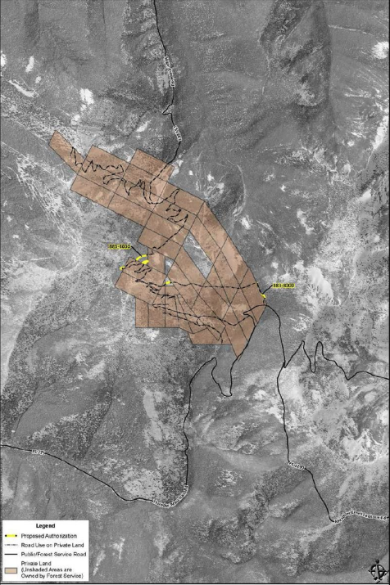

Figure 1

ICL does not support the expansion of additional recreation opportunities beyond those recommended by the collaborative at this time. We would be willing to consider additional recreational trail expansions if the Environmental Analysis demonstrates these can be offset by additional watershed and terrestrial restoration opportunities included in this proposal.
The maps provided in the scoping document do not provide sufficient information about project location or the overall direction provided in the Forest Plan. We recommend including more detailed maps in the Environmental Assessment and the Forest Plan direction for the area (passive restoration, etc). Private properties to which the Forest Service is seeking to provide reasonable access with this project should also be identified.

For the Rapid River trail project on the New Meadows District, the Forest Service created a useful Story Map which made it easier to identify the current situation and changes on the ground from different alternatives. The scoping notice also listed trail numbers on the maps. https://www.fs.usda.gov/nfs/11558/www/nepa/80448_FSPLT3_5331052.pdf

Regarding decommissioning of any unauthorized or non-system roads and trails, the Forest Service should make it clear in the Environmental Assessment if these routes are currently available for public motorized use. There was a lot of misunderstanding in the South Fork RAMP that the decommissioning of abandoned logging roads that were not available for public motorized use would result in reduced public motorized access, which was not the case. We believe the Forest Service can do a better job of disclosing what the changes will actually be with the EFSF RAMP.

As with the Big Creek and South Fork RAMPs, outreach and education are critical components if this project is going to be successful. We recommend that the Forest Service work with local recreation clubs, the McCall community, Valley County, the Idaho Department of Parks and Recreation, the community of Yellow Pine and others on education, signage and mapping. We also recommend sending these monitoring reports to members of the collaborative and inviting collaborative members on a post-implementation field trip. We appreciate the implementation report for the Big Creek RAMP and recommend continuing to provide updates on that project as well as the SF RAMP and EFSF RAMP. A field trip in the summer of 2022 could be helpful to understand more about implementation and effectiveness of these projects and any adaptive management needs.

Thank you again for considering our comments. We look forward to working with the Forest Service, our collaborative partners and other members of the public on the review of the Environmental Assessment, final planning and implementation of this project.

Sincerely,

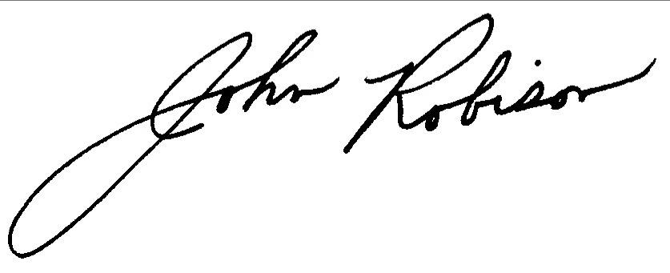
John Robison
Public Lands Director
jrobison@idahoconservation.org
(208) 345-6933 x 13

