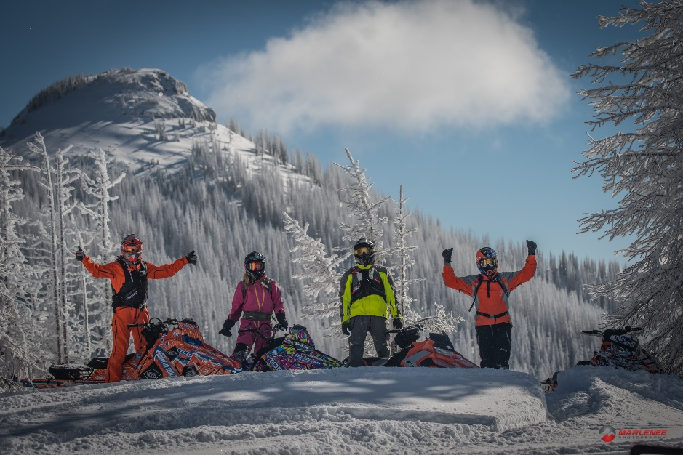
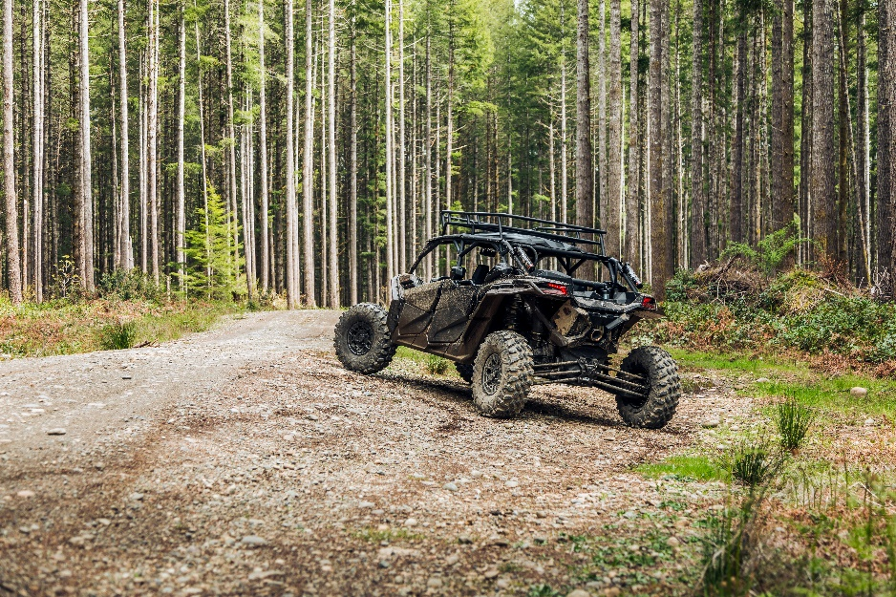
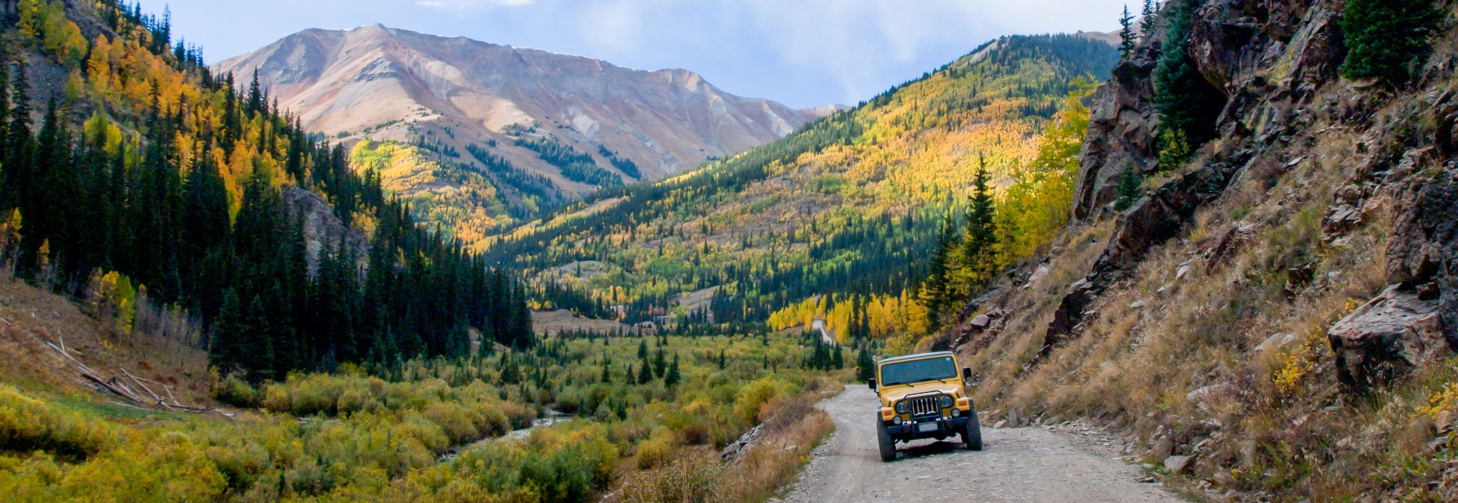
February 2024
Submitted by:
Abt Global, LLC
Tabor Center
1200 17th Street, 10th Floor
Denver, CO 80202

Economic Contribution of Off-Highway Vehicle

Recreation in Colorado
Fiscal Year 2022–2023 Season
Submitted to:
Scott Jones
Colorado Off Highway Vehicle Coalition
PO Box 741353
Arvada, CO 80006
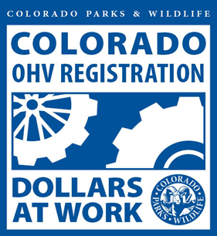

CONTENTS
Executive Summary ES-1
Households that Participate in Motorized Recreation ES-1
Expenditures Associated with Motorized Recreation ES-2
Total Economic Contribution Associated with Motorized Recreation in Colorado ES-2
Regional Economic Contribution of Off-Highway Vehicle Recreation ES-3
State Park Case Study ES-5
Conclusions ES-6
1. Introduction 1
2. State Economic Contribution Approach 2
2.1 Approach to Estimate Economic Contribution 2
2.1.1 Estimate the Households that Participate in Off-Highway Vehicle Recreation 3
2.1.2 Trip and Annual Maintenance Expenditures 6
2.2 IMPLAN Approach 8
3. Economic Contribution of Off-Highway Vehicle Recreation in Colorado 11
3.1 Direct Expenditures in Colorado 11
3.2 Multiplier Effects in Colorado 11
3.3 Total Economic Contribution in Colorado 12
4. Regional Economic Contribution of Off-Highway Vehicle Recreation 14
5. Study Limitations 19
Appendix A: Summary Data 20
Number of Households Participating in Motorized Recreation 20
Itemized Trip Expenditures for Trips Associated with Motorized Recreation in Colorado During the 2022–2023 Season 20
Annual Expenditures on Maintenance, Storage, and Miscellaneous Items Associated with Motorized Recreation in Colorado 22
New Vehicle Sales 22
Appendix B: State Park Case Study 24
Introduction 24
Description 24
Use and Economic Benefits of a Hypothetical OHV State Park 24
Summary of Survey Responses 24
Number of Households and Trips to Visit a Hypothetical OHV State Park 26
Estimated Economic Contribution of a Hypothetical OHV State Park in Eastern Colorado 27
State Revenues from Park Entrance Fees 28

List of Figures
Figure ES-1. Regional Study Areas 3

Figure ‎2-1. Recreational OHV Registrations and Permits in Colorado (2013–2023) 4
Figure ‎2-2. Recreational Snowmobile Registrations and Permits in Colorado (2013–2023) 4
Figure ‎2-3. Trips Taken by Resident and Non-Resident Households in Colorado during the 2022–2023 Season 7
Figure ‎4-1. Regional Study Areas 14

List of Tables
Table ES- 1. Number of Resident and Non-Resident Households Participating in Motorized Recreation in Colorado during the 2022–2023 Season 1
Table ES- 2. Total Economic Contribution of OHV Recreation in Colorado during the 2022–2023 Season (Direct, Indirect, and Induced), Residents and Non-Residents (millions of 2022$) 2
Table ES- 3. Estimated Economic Contribution of Motorized Recreation by Region in Colorado for the 2022–2023 Season, Resident and Non-Resident, Year-Round (millions of 2022$) 4
Table ES- 4. Estimated Annual Trips to Hypothetical OHV State Park 5
Table ES- 5. Total Economic Contribution of OHV Recreation in Hypothetical State Park in Weld County, Colorado, Residents and Non-Residents 6

Table ‎2-1. Number of Resident and Non-Resident Households Participating in Motorized Recreation in Colorado during the 2022–2023 Season 6
Table ‎2-2. Number of Trips for Resident and Non-Resident Households 7
Table ‎2-3. Total Trip Expenditures during the 2022–2023 Season (millions of 2022$) 7
Table ‎2-4. Annual Estimated Colorado Residents’ Expenditures during the 2022–2023 Season (millions of 2022$) 8
Table ‎2-5. Expenditures Categories Mapped to IMPLAN Sectors 9
Table ‎3-1. Direct Economic Contributions of Off-Highway Vehicle Recreation in Colorado during the 2022–2023 Season (millions of 2022$) 11
Table ‎3-2. Multiplier Economic Activity Associated with Off-Highway Vehicle Recreation in Colorado during the 2022–2023 Season (millions of 2022$) 12
Table ‎3-3. Total Economic Contribution of OHV Recreation in Colorado during the 2022–2023 Season (Direct, Indirect, and Induced), Residents and Non-Residents (millions of 2022$) 12
Table ‎4-1. Regional Study Areas 15
Table ‎4-2. Percent of Trips by Region for Residents 15
Table ‎4-3. Percent of Trip by Region for Non-Residents 15
Table ‎4-4. Estimated Economic Contribution of Motorized Recreation by Region in Colorado for the 2022–2023 Season, Resident and Non-Resident, Year-Round (millions of 2022$) 16
Table ‎4-5. Estimated Economic Contribution of Motorized Recreation by Region in Colorado for the 2022–2023 Season, Resident and Non-Resident, Winter (millions of 2022$) 17
Table ‎4-6. Estimated Economic Contribution of Motorized Recreation by Region in Colorado for the 2022–2023 Season, Resident and Non-Resident, Summer (millions of 2022$) 18

Table A-1. Percentage of Respondents that Participate in Motorized Recreation 20
Table A-2. Number of Households Participating in Motorized Recreation during the 2022–2023 Season 20
Table A-3. Median Number of Trips Taken per Household during the 2022–2023 Season 20
Table A-4. Average Itemized Expenditures for Latest Trip for Residential Households for the 2022–2023 Season (2022$) 20
Table A-5. Average Itemized Expenditures for Latest Trip for Non-Resident Households for the 2022–2023 Season (2022$) 21
Table A-6. Average Itemized Expenditures for Latest Day Trip for Residential Households for the 2022–2023 Season (2022$) 21
Table A-7. Average Itemized Expenditures for Latest Overnight Trip for Residential Households for the 2022–2023 Season (2022$) 22
Table A-8. Average Estimated Itemized Expenditures by Resident Households for the 2022–2023 Season (2022$) 22
Table A-9. Estimated Motorized Recreation Vehicle Sales by Resident Households (millions of 2022$) 23

Table B-1. Survey Response: Location 24
Table B-2. Survey Response: Distance Willing to Travel 25
Table B-3. Survey Response: Length of Stay 25
Table B-4. Survey Response: Annual Number of Trips 25
Table B-5. Estimated Number of Trips Taken by Households 26
Table B-6. Estimated Annual Trips to Hypothetical State Park 27
Table B-7. Total Economic Contribution of OHV Recreation in Hypothetical State Park in Weld County, Colorado, Residents and Non-Residents - High Estimate 27
Table B-8. Total Economic Contribution of OHV Recreation in Hypothetical State Park in Weld County, Colorado, Residents and Non-Residents - Low Estimate 27
Table B-9. Survey Response: Willingness to Pay for Park Access 28
Table B-10. Estimated State Revenue for Park Access Above and Beyond State Park Entrance Fees (Rounded to the Nearest $10,000) 28

Executive Summary
Colorado offers unique opportunities for motorized recreation throughout much of the state. As such, the sport and industry of motorized recreation has increased in popularity in Colorado, both for residents and non-residents. Abt Global, LLC (Abt) evaluated the economic contribution of motorized recreation throughout Colorado for the 2022–2023 season (July 1, 2022 through June 30, 2023). This study is an update based on a previously conducted study, completed in December 2016, that estimated the economic contribution for the 2014–2015 season, referred to as the “2016 study” in this report.

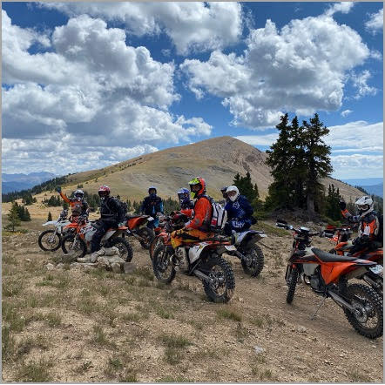
Households that Participate in Motorized Recreation
Colorado Parks and Wildlife (CPW) reported that over 290,000 off-highway vehicle (OHV) registrations and use permits were issued in Colorado during the 2022–2023 season for both Colorado resident and non-resident households. The registration and use permit data was used to estimate the number of Colorado resident and non-resident households participating in motorized recreation in 2022–2023. For the purposes of this study, motorized recreation was categorized into three vehicle types: OHVs; four-wheel drive vehicles (4WDs); and snowmobiles. OHVs include all-terrain vehicles (ATVs), utility task vehicles (UTVs), dirt bikes, side-by-sides, and other multi-wheeled vehicles. The 4WD category consists of trucks, pickups, jeeps, and sport-utility vehicles (SUVs). An estimated 11.2 percent of residential households in Colorado, approximately 253,000 households, participated in motorized recreation in Colorado for the 2022–2023 season. Roughly 41,000 non-resident households participate in motorized recreation in Colorado (Table ES-1).
Between 2013 and 2023, OHV registrations for residents increased by 60 percent while OHV permits for non-residents increased by over 40 percent. OHV registrations and permits peaked in 2021 with over 225,000 resident registrations and over 59,000 non-resident permits sold. Resident snowmobile permits have been constant over the past decade, with 29,076 permits issued for the 2022–2023 season. Snowmobile permits for non-residents increased consistently from 2013 to 2023 to peak in 2023 at over 6,800 permits.
Table ES-1. Number of Resident and Non-Resident Households Participating in Motorized Recreation in Colorado during the 2022–2023 Season
Households | OHVs | Snowmobiles | 4WDs | Total
Colorado resident households | 159,833 | 13,148 | 79,617 | 252,598
Non-resident households | 31,076 | 6,889 | 3,500 | 41,465
Combined households | 190,910 | 20,037 | 83,117 | 294,064

Expenditures Associated with Motorized Recreation
During the 2022–2023 season, motorized recreational enthusiasts spent an estimated $2.4 billion while taking trips using motorized vehicles for recreational purposes. More than 92 percent of these expenditures occurred during the summer recreational season. In addition to spending money on trips, households that participate in motorized recreation also spend money on maintenance, repairs, accessories, vehicle storage, and miscellaneous items associated with their vehicles. Motorized recreational enthusiasts spent an additional $1 billion annually on various items to support and enhance their experiences in Colorado, as well as an additional $203 million in new motorized vehicle sales. In total, motorized recreational enthusiasts were responsible for $1.4 billion in direct sales captured within Colorado during the 2022–2023 season.

Total Economic Contribution Associated with Motorized Recreation in Colorado
OHV enthusiasts were estimated to support $1.4 billion in direct sales, an additional $1.4 billion in indirect and induced sales, for a total of $2.9 billion in total sales during the 2022–2023 season. Motorized recreation in Colorado directly or indirectly supports almost 18,700 jobs and $1 billion in labor income. Of the total economic contribution of motorized recreation in Colorado, OHV participants contribute 66.7 percent of economic contribution while snowmobiles and 4WDs contribute 6.9 percent and 26.4 percent, respectively.
Table ES-2. Total Economic Contribution of OHV Recreation in Colorado during the 2022–2023 Season (Direct, Indirect, and Induced), Residents and Non-Residents (millions of 2022$)
Economic Contribution Category | OHVs | Snowmobiles | 4WDs | Total Economic Contribution¹
Total Gross Sales | $1,923 | $199 | $762 | $2,885
Jobs² | 12,800 | 1,400 | 4,500 | 18,700
Labor Income | $694 | $73 | $266 | $1,032
Value added or gross regional product (GRP) | $1,115 | $117 | $428 | $1,661
State and local business taxes | $129 | $17 | $58 | $204
Federal business taxes | $131 | $13 | $48 | $192
Notes:
1. These include new motorized vehicle sales and multiplier effects.
2. Jobs are not in millions.
3. Gross regional product, also known as value added, is the market value of a product or gross sales less the value or costs of intermediate products and services.

Regional Economic Contribution of Off-Highway Vehicle Recreation
This study also evaluated the regional economic contribution of motorized recreation within Colorado. The approach used the results of an online survey conducted in 2015 to collect data on regions where enthusiasts participate in motorized recreation. The IMPLAN analysis used six regional study areas, mapped and described in Figure ES-1.
Figure ES-1. Regional Study Areas
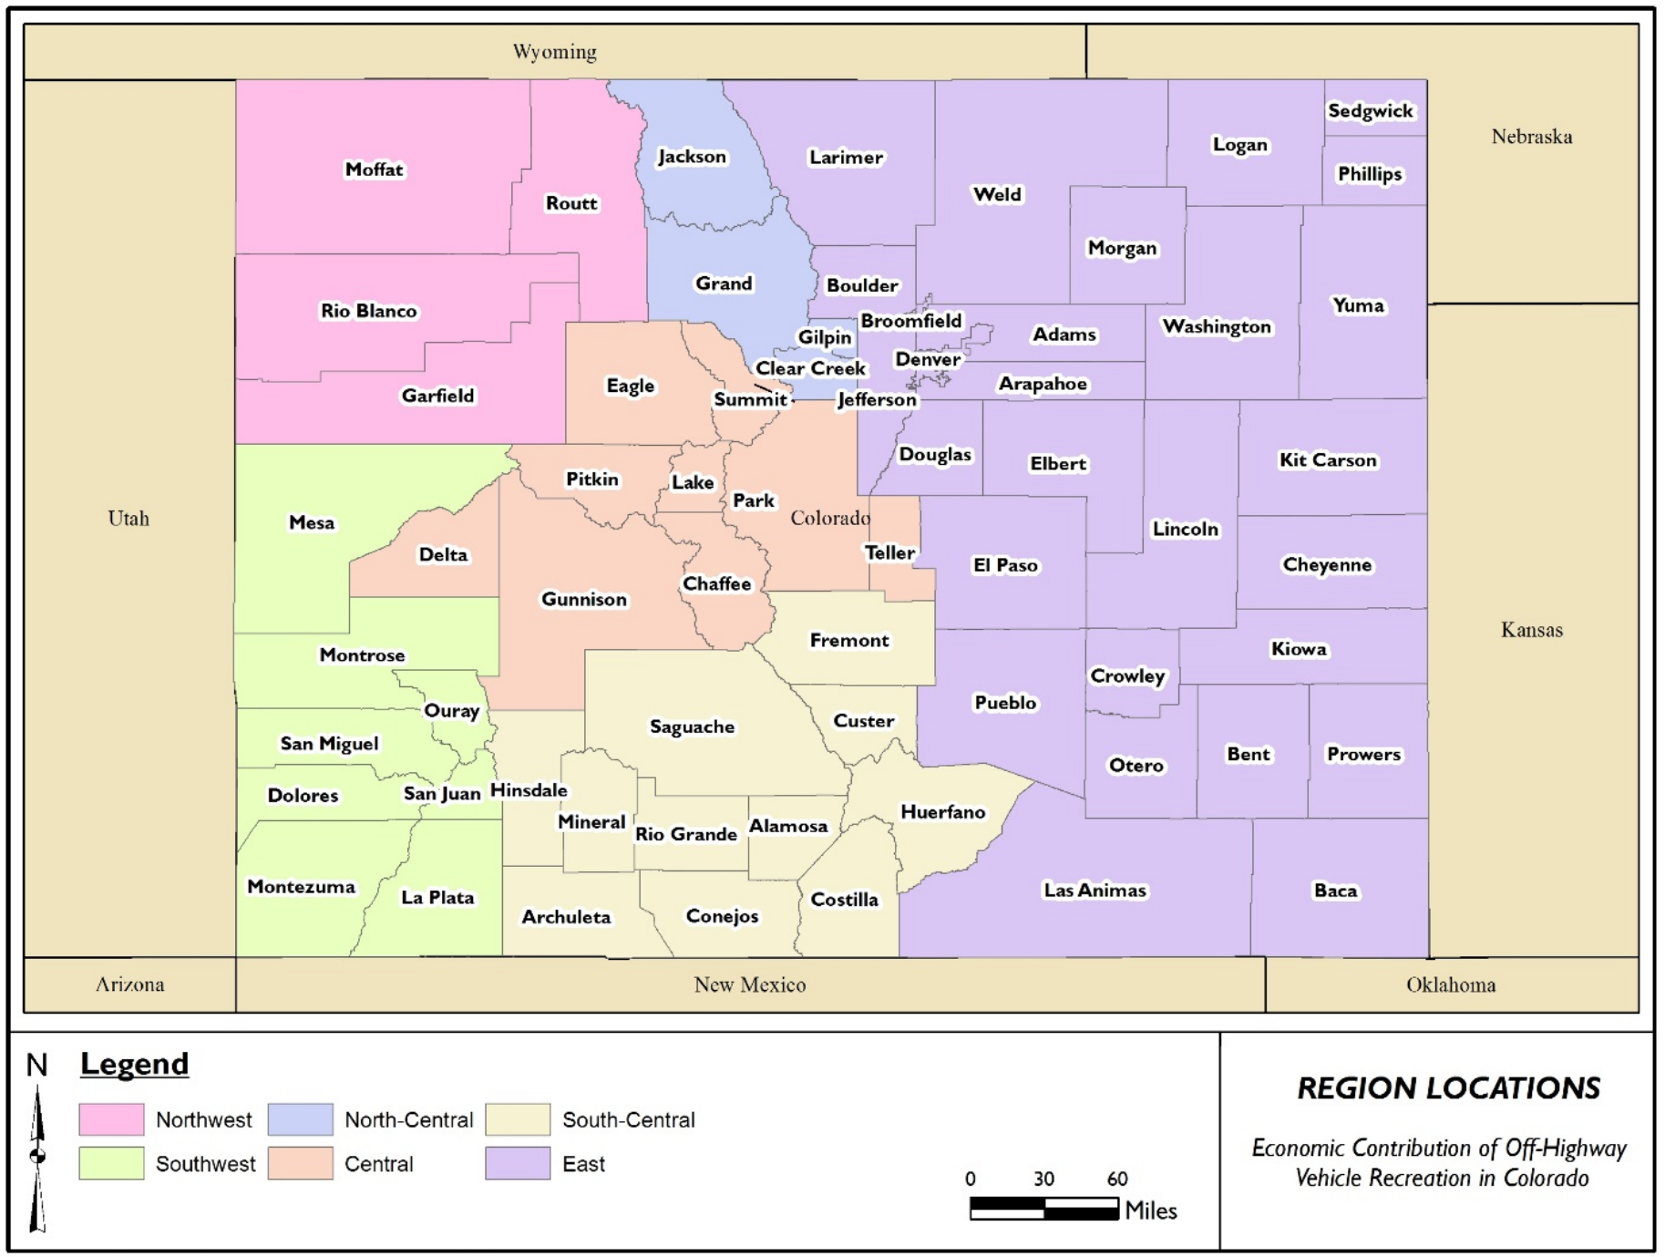
Source: Pinyon (2016).

The regional analysis focused on trip expenditures and did not include annual maintenance and repair expenditures, which are discussed under the state contribution analysis. The average number of trips taken by resident and non-resident households was applied to average trip expenditures to estimate the total expenditures per region. The IMPLAN study area models were then used to estimate the direct, indirect, and induced regional economic contribution. The regional economic contribution of motorized recreation is summarized in Table ES-3. The region that received the greatest economic contribution from motorized recreation during the 2022–2023 season was southwest Colorado, with motorized recreation supporting total sales of $462 million. The central and east regions in Colorado also attracted considerable motorized recreation, supporting $461 million and $250 million in total sales, respectively.

Table ES-3. Estimated Economic Contribution of Motorized Recreation by Region in Colorado for the 2022–2023 Season, Resident and Non-Resident, Year-Round (millions of 2022$)
Contribution | Region |  |  |  |  |  | Total²
Direct Impact | NW CO | SW CO | SC CO | CTRL CO | NC CO | EAST CO
Direct sales | $47 | $305 | $122 | $318 | $94 | $126 | $1,012
Number of jobs¹ | 487 | 3,197 | 1,356 | 3,102 | 992 | 1,245 | 10,378
Labor income | $17 | $108 | $41 | $123 | $35 | $48 | $372
Value added or GRP | $28 | $175 | $69 | $197 | $57 | $77 | $602
State and local taxes | $4 | $26 | $12 | $26 | $8 | $12 | $88
Federal taxes | $3 | $18 | $7 | $22 | $6 | $8 | $65
Other Economic Activity
Indirect and induced sales | $23 | $157 | $55 | $144 | $28 | $124 | $530
Number of jobs | 108 | 763 | 299 | 667 | 126 | 546 | 2,508
Labor income | $7 | $52 | $13 | $43 | $7 | $42 | $163
Value added or GRP | $12 | $84 | $23 | $75 | $13 | $69 | $276
State and local taxes | $1 | $7 | $3 | $8 | $1 | $6 | $26
Federal taxes | $1 | $10 | $2 | $7 | $1 | $8 | $30
Total Economic Activity
Total sales | $70 | $462 | $176 | $461 | $123 | $250 | $1,542
Number of jobs | 595 | 3,959 | 1,655 | 3,769 | 1,117 | 1,791 | 12,886
Labor income | $24 | $159 | $54 | $166 | $42 | $91 | $535
Value added or GRP | $39 | $259 | $92 | $272 | $69 | $147 | $878
State and local taxes | $5 | $33 | $15 | $35 | $9 | $17 | $114
Federal taxes | $4 | $28 | $10 | $29 | $7 | $17 | $94
Notes:
1. Jobs are not in millions.
2. Numbers may not sum due to rounding.
3. Gross regional product, also known as value added, is the market value of a product or gross sales less the value or costs of intermediate products and services.

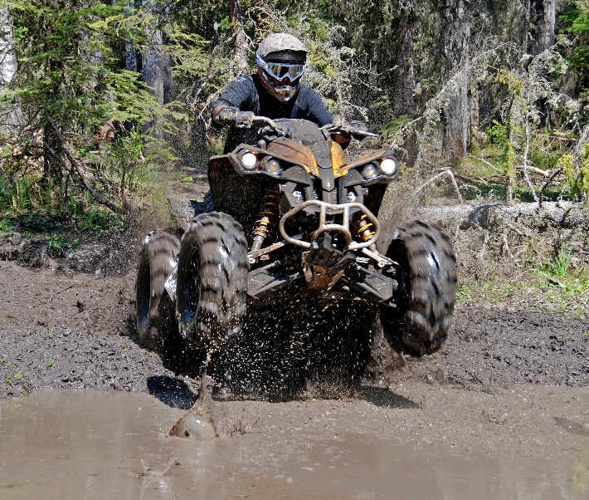
State Park Case Study
Since the 2016 study was completed, there has been expanded focus on the use and expansion of state parks by the Governor’s Office, which has driven the designation of Fishers Peak State Park in 2019 and Sweetwater Lake State Park in 2021, although they have limited to no OHV opportunities. In response to these highly visible designations, there has been significant interest from OHV interests and local communities in new or expanded OHV opportunities on state parks and the associated economic benefits for adjacent communities. Additional support was voiced around the use of a new state park near population centers to reduce recreational pressure on existing resources. Many OHV users would like to have an OHV-focused state park with opportunities, such as rock crawl and trail areas, that do not often align with multiple uses on federal lands. As a result of the increased interest and request for more information on an OHV-focused state park, additional survey research was conducted and is described in this section.
Colorado Off Highway Vehicle Coalition (COHVCO) recently surveyed its members to gauge interest in a hypothetical OHV state park. An advertisement was provided on the COHVCO Facebook page along with a link to the survey, noting the possibility of creating Colorado’s first OHV state park. The survey received 2,181 resident respondents, roughly 1 percent of state OHV registrations; and 74 non-resident respondents, an estimated 0.2 percent of non-resident permits; and 24 respondents that did not disclose their residence location. Approximately 40 percent of the COHVCO Facebook members participated in the survey.
The case study considers a hypothetical OHV state park in Weld County, in the east region of Colorado. This analysis can be used to help CPW better understand the economic benefits of such parks in the State of Colorado.
Applying the survey sample trips estimate to the broader population of all households participating in OHV recreation in the east region yields an estimated 123,946 trips by Colorado households and 3,156 trips by non-residents households to the hypothetical OHV state park. This is considered a high estimate of visitation, assuming all households visiting the east region would visit the OHV state park, based on the 2023 online survey results (an average of 4 trips to the OHV state park per year). To provide a range of estimated trips to the hypothetical state park, a proposed lower estimate is half of the estimated trips: 61,973 trips by resident households and 1,578 trips by non-resident households. Table ES-4 summarizes the range of annual trips to the hypothetical OHV state park in Weld County.
Table ES-4. Estimated Annual Trips to Hypothetical OHV State Park
Type of Estimate | Non-Resident Trips | Resident Trips
High | 3,156 | 123,946
Low | 1,578 | 61,973
Table ES-5 presents the economic benefits under the high and low estimates of annual trips to the hypothetical OHV state park in Weld County. Jobs and labor income would be generated and experienced within Weld County, while sales and gross regional product would be generated from within Weld County, although these benefits may leak out of the county.
Table ES-5. Total Economic Contribution of OHV Recreation in Hypothetical State Park in Weld County, Colorado, Residents and Non-Residents
Economic Contribution Category | Economic Benefit – High Estimate | Economic Benefit – Low Estimate
Total Gross Sales | $44,750,000 | $22,380,000
Jobs | 413 | 207
Labor Income | $15,510,000 | $7,760,000
Value added or GRP | $25,080,000 | $12,540,000
State and local business taxes | $3,360,000 | $1,690,000
Federal business taxes | $2,550,000 | $1,270,000
State parks charge an entry fee to help keep them clean and build new trails and facilities, as well as produce educational programs in local communities. In addition to purchasing an annual state park pass, 62 percent of respondents indicated that they would be willing to spend additional money to access an OHV park. If we assume that the hypothetical OHV state park would charge a usage fee in addition to the annual vehicle pass fee, ranging from an additional $10 to $40 per visit or trip, depending on the level of visitation, the revenue to the state would range from $640,000 (low visitation with $10/trip) to $5.1 million (high visitation with $40/trip).

Conclusions
This and previous studies have estimated the economic contribution of motorized recreation and show the sport continues to be an important economic driver for the state of Colorado. During the 2022–2023 season, motorized recreation enthusiasts generated $2.4 billion in total sales which supported either directly or indirectly almost 18,700 jobs and $1 billion in labor income. These activities have historically been an important economic driver to many communities and the state, and it is anticipated that OHV recreation will continue to be important in the future.

Introduction
Colorado offers unique opportunities for motorized recreation throughout much of the state. As such, the sport and industry of motorized recreation have increased in popularity in Colorado, both for Colorado residents and residents of other states. Abt Global, LLC (Abt) evaluated the economic contribution of motorized recreation throughout Colorado for the 2022–2023 season. This report is a summary of the results.
Over the past 25 years, Colorado Off Highway Vehicle Coalition (COHVCO) and partners in the motorized community, such as Trail Preservation Alliance, have funded and obtained grants from the Colorado Parks and Wildlife (CPW) off-highway vehicle (OHV) grant program for funding three studies to evaluate the economic contribution of OHV recreation in Colorado. The third study, completed in December 2016, estimated the economic contribution for the 2014–2015 season, referred to as the “2016 study” in this report. The 2016 study estimated that motorized recreational enthusiasts directly spent $1.6 billion at 2015 dollars ($2.0 billion in 2022 dollars) on motorized vehicle recreation during the 2014–2015 season. This spending supported an estimated $2.2 billion in sales (2022$), $828 million in labor income (2022$), and almost 17,000 jobs. The results of these studies demonstrate the importance of this OHV recreation to the economy of Colorado, especially in rural areas that heavily depend on outdoor recreation activities.
The 2016 study used an online survey of motorized recreationists in Colorado to estimate average expenditures during recreational trips or outings, average number of trips per year, as well as other annual expenditures needed to maintain equipment and vehicles. Using the approach described in the 2016 study, Abt adjusted the average expenditures from the 2015–2016 study for inflation and used these expenditures in combination with the updated number of OHV and snowmobile permits to estimate the number of households engaged in motorized recreation, the number of trips taken in Colorado, and the total annual expenditures on motorized recreation trips and maintenance. Abt obtained updated IMPLAN data with associated economic multipliers and used the total expenditures to estimate the economic contribution to Colorado in terms of sales, gross regional product, employment, labor income, and taxes. For the purposes of this analysis, motorized recreation can include the use of a variety of vehicles including all-terrain vehicles (ATVs), dirt bikes, snowmobiles, four-wheel drive vehicles (4WDs), side-by-sides, and other vehicles designed for off-highway recreation. These types of motorized recreation are grouped into three general categories: OHVs; 4WDs; and snowmobiles. OHVs include ATVs, dirt bikes, side-by-sides, utility task vehicles (UTVs), and others.
This report is organized into the following sections. Section 2 explains the approach used by Abt to estimate the economic contribution of OHV recreation in Colorado. Section 3 summarizes the total economic contribution of motorized recreation in Colorado during the 2022–2023 season, and Section 4 provides a regional analysis for Colorado based on survey information on where the trip expenditures are spent within the state.

State Economic Contribution Approach
In general, this study used the approach described in the 2016 study; however, several updates were made as described below.
- Abt updated the number of OHV and snowmobile permit data for residents and non-residents with data obtained from Colorado Parks and Wildlife (CPW).
- Abt obtained updated data from the Colorado Department of Revenue (CDOR) on the number of 4WD vehicles in the state and used information from automobile industry to estimate the proportion of 4WD vehicles used for motorized recreation.
- Average annual trip and non-trip expenditures, related to motorized recreation, obtained from the 2016 on-line survey, were updated to 2022 dollars.
- Motorized vehicle sales from the 2016 study were updated to 2022 dollars.
- The project team obtained the most recent IMPLAN® (IMPact Analysis for PLANning) model and data, and input-output (I-O) model for the year 2022 to estimate economic multipliers for Colorado.
- Similar to the 2016 study, an excel model was used to estimate total expenditures, which were used with IMPLAN to estimate employment, income, sales, and taxes generated by the economic activity tied to motorized recreation in Colorado.
The following sections provide a summary of the overall approach for this study.

Approach to Estimate Economic Contribution
The 2016 study used an online survey to collect information on the behaviors of individuals engaged in motorized recreation in Colorado. The project team used the following steps to estimate the economic contribution of motorized recreation using the results of the survey.
Step 1: Estimate the number of households that participate in motorized recreation in Colorado.
Step 2: Estimate the trip expenditures while participating in motorized recreation in Colorado.
Step 3: Estimate annual expenditures related to maintenance and support of motorized vehicles and activities.
Step 4: Estimate the new sales of OHVs in Colorado.
Step 5: Estimate the economic contribution to Colorado with total expenditures and purchases made by motorized recreation enthusiasts.
These steps are further described in this section.

Estimate the Households that Participate in Off-Highway Vehicle Recreation
To determine the number of households that participate in motorized recreation in Colorado, the project team obtained data from CPW on OHV and snowmobile registrations and use permits. The CPW administers Colorado’s statutorily created OHV Program, which requires OHV registration for all motor vehicles that are not licensed for public road access but are used on designated OHV trails and routes in Colorado. In addition, motorized vehicles that are street-legal or owned by out-of-state residents must have an OHV use permit if these vehicles are operated on designated trails or routes in Colorado. CPW tracks motorized recreation use by fiscal year (July 1 to June 30). For example, 2022–2023 would be July 1, 2022 to June 30, 2023, thus snowmobile registrations and permits capture a full year’s use, but an OHV season is likely split over two fiscal years.
CPW reported that over 290,000 OHV registrations and use permits were issued in Colorado during the 2022–2023 season. Between 2013 and 2023, OHV registrations for residents increased by 60 percent while OHV permits for non-residents increased by over 40 percent (Figure ‎2-1). OHV registrations and permits peaked in 2021 with over 225,000 resident registrations and over 59,000 non-resident permits sold. Snowmobile registrations for residents have remained fairly constant between 2013 and 2023, with 29,076 permits issued for the 2022–2023 season, although snowmobile permits for non-residents have increased by approximately 109 percent, peaking at over 6,800 permits in 2023 (Figure ‎2-2).
Figure ‎2-1. Recreational OHV Registrations and Permits in Colorado (2013–2023)

Figure ‎2-2. Recreational Snowmobile Registrations and Permits in Colorado (2013–2023)

The project team further analyzed the data on OHV registrations and use permits to estimate the number of households that participate in OHV recreation. For the 2001 study, Hazen and Sawyer obtained the full registration database from Colorado State Parks. The database included names and addresses for each permit issued by the OHV program. Hazen and Sawyer sorted the database to include only unique residential addresses, partially by eliminating any commercial operations and multiple vehicles registered to one household. The 2001 study estimated that 79 percent of the total number of OHVs registrations in Colorado were registered to a unique residential household that potentially used their vehicle for recreation.
Data provided by CPW for the current study includes the total number of registrations and use permits for OHVs and snowmobiles. Therefore, the analysis completed for the 2001 study to determine the unique number of households cannot be replicated. Accordingly, the project team assumed that the same proportion of unique households own and use motorized vehicles for recreation in the 2022–2023 season as in 2000. Thus, the same proportion (79 percent) was applied to the 2023 vehicle registrations to estimate the number of households participating in OHV motorized recreation for 2022–2023 season (e.g., ATVs, UTVs, and dirt bikes). In addition, the project team accounted for the number of households that actually used their motorized vehicles for recreation during the 2022–2023 season based on survey responses: 98 percent for residents and 81 percent for non-residents. The number of households that use OHVs for motorized recreation was estimated to be 159,833 for residents and 31,076 for non-residents.
CPW provided the total number of snowmobile registrations for 2023. The number of Colorado registrations was 29,076, and the number of non-resident registrations was 6,889. In the 2001 study, 48 percent of all snowmobile registrations in Colorado were registered to a unique residential household that likely used their vehicle for recreation. This same proportion was applied to the total number of snowmobiles registered in Colorado during the 2022–2023 season. The project team further assumed that 94 percent of Colorado resident survey respondents participated in snowmobile recreation during the 2022–2023 season. For this study, all non-resident permits were assigned to unique households. This results in an estimated 13,148 and 6,889 resident and non-resident households, respectively, that potentially participate in snowmobile recreation.
It is widely understood that 4WDs are not only used for recreation but are often used for business, commuting, and other work-related or personal reasons. This is particularly the case for 4WDs such as pickup trucks and SUVs. This study is focused on evaluating the number of households that use 4WDs for motorized recreation. The number of households using 4WDs for motorized recreation was estimated using information provided from the Colorado Department of Revenue (CDOR) as well as from an automobile industry trade company.
CDOR does not identify the number of 4WD vehicles but publishes the number of passenger vehicles (3.68 million) and light trucks (1.23 million). SUVs are included in the passenger vehicle category, and the light truck vehicle category includes pick-up trucks and cargo vans. According to an automobile industry research study, in 2019, 29.2 percent of all vehicles in Colorado are 4WD, which excludes all-wheel drive cars. Applying 29.2 percent to the estimate of passenger vehicles and light trucks yields an estimated 3.2 million vehicles with 4WD in Colorado. Two assumptions were used from the 2001 study: an average of 2.5 vehicles per household (from the 2000 survey) and an estimated 14.2 percent of households use a vehicle for motorized recreation. Applying these assumptions results in an estimated 81,357 households who use 4WDs for motorized recreation., Data was not available to estimate the number of non-resident households who use their 4WDs for motorized recreation in Colorado. The estimated non-resident participants provided in Table ‎2-1 was obtained from the 2001 study, an estimate of 3,500 non-resident households participate in motorized recreation using 4WD vehicles.
The resident and non-resident households participating in motorized recreation during the 2022–2023 season are summarized in Table ‎2-1. Approximately 11.2 percent of residential households in Colorado were estimated to participate in motorized recreation in Colorado during the 2022–2023 season. Roughly 30,000 non-resident households came from out-of-state to participate in motorized recreation.
Table ‎2-1. Number of Resident and Non-Resident Households Participating in Motorized Recreation in Colorado during the 2022–2023 Season
Households | OHVs | Snowmobiles | 4WDs | Total
Colorado resident households | 159,833 | 13,148 | 79,617 | 252,598
Non-resident households | 31,076 | 6,889 | 3,500 | 41,465
Combined households | 190,910 | 20,037 | 83,117 | 294,064

Trip and Annual Maintenance Expenditures
Motorized recreation contributes to the economy when motorized recreational enthusiasts purchase retail items, hotel and motel accommodations, or they spend money to operate and maintain their vehicles. For this study, expenditures are separated into two types:
- Trip expenditures—expenditures made by motorized recreational enthusiasts while using their vehicles on trips.
- Annual expenditures—expenditures on maintenance, repairs, and other accessories that support motorized recreation.
Methods used to estimate these types of expenditures are discussed below.

Trip Expenditures
The first step in estimating total trip expenditures required the project team to estimate the number trips taken by resident and non-resident households for motorized recreational activities during the 2022–2023 season. The project team estimated the number of trips, using data obtained from the 2015 surveys and described in the 2016 study, for each of the three categories of motorized recreation (Figure 2-3).
Figure ‎2-3. Trips Taken by Resident and Non-Resident Households in Colorado during the 2022–2023 Season
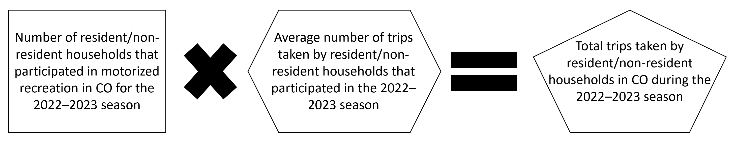
The total number of trips taken by resident and non-resident households for motorized recreation in Colorado during the 2022–2023 season for each of the three categories is summarized in Table ‎2-2.
Table ‎2-2. Number of Trips for Resident and Non-Resident Households
Households | OHVs | Snowmobiles | 4WDs | Total
Colorado resident households | 2,237,665 | 157,776 | 955,404 | 3,350,846
Non-resident households | 124,305 | 72,335 | 14,000 | 210,640

Total trip expenditures were estimated by multiplying the number of trips taken by resident and non-resident households during the 2022–2023 season by the average trip expenditures. Average trip expenditures were obtained from the 2015 online survey of motorized recreation users, described in the 2016 study. Average trip expenditures were adjusted for inflation to 2022 dollars using the Consumer Price Index (CPI). A summary of the average itemized expenditures is provided in Appendix A.
Total trip expenditures for resident and non-resident households are summarized in Table ‎2-3. Trip expenditures are specified as summer and winter use. Summer use includes OHVs and 4WDs, while winter use includes snowmobile activities. During the 2022–2023 season, motorized recreational enthusiasts spent an estimated $2.38 billion when taking trips to use their motorized vehicles for recreational purposes. More than 92 percent of these expenditures occurred during the summer recreational season.
Table ‎2-3. Total Trip Expenditures during the 2022–2023 Season (millions of 2022$)
Expenditure Category | Summer | Winter | Total
 | OHVs & 4WDs | Snowmobiles
Gasoline/oil for motorized recreational vehicles | $438 | $39 | $477
Gasoline/oil for tow vehicles | $506 | $42 | $548
Restaurant/lounge purchases | $332 | $30 | $362
Food and beverage purchased at grocery, convenience stores | $306 | $18 | $324
Overnight accommodations | $377 | $37 | $414
Guides and tour packages | $16 | $5 | $21
User fees and donations | $92 | $2 | $94
Souvenirs, gifts, and entertainment | $61 | $6 | $67
Other trip related expenses | $65 | $6 | $71
Total | $2,193 | $185 | $2,378

Annual Expenditures
In addition to spending money on recreational trips, households participating in motorized recreation spend money on maintenance, repairs, accessories, storage, and miscellaneous items associated with their vehicles. These annual expenditures made in Colorado were estimated for this study for resident households.
Average annual expenditures were obtained from the 2015 online survey responses and updated with the CPI to 2022 prices. The average itemized expenditures for resident households used for this analysis are shown in Appendix A. Colorado motorized recreational enthusiasts are estimated to have spent more than $1 billion annually on various items to support and enhance their experiences in Colorado. Annual expenditures by the three categories of motorized recreation for the 2022–2023 season are summarized in Table ‎2-4.
Table ‎2-4. Annual Estimated Colorado Residents’ Expenditures during the 2022–2023 Season (millions of 2022$)
Expenditure Category | OHVs | Snowmobiles | 4WD | Total All Vehicles
Repairs and parts | $202 | $19 | $192 | $412
Vehicle storage | $18 | $2 | $9 | $29
Motorized recreational accessories | $105 | $8 | $126 | $239
Clothing | $73 | $1 | $0 | $74
Safety equipment | $64 | $7 | $34 | $104
Annual insurance payment | $44 | $4 | $54 | $101
Registration or permit fee | $20 | $1 | $14 | $35
Club memberships | $10 | $1 | $4 | $15
Magazine subscriptions | $3 | $0 | $1 | $5
GPS, maps, software | $0 | $2 | $1 | $2
Other items | $9 | $1 | $18 | $28
Total | $548 | $43 | $451 | $1,043

The project team used the estimates of the number of new motorized vehicles sold and total sales of new motorized vehicles from the 2016 study and updated the price level to 2022 dollars. There were an estimated $203 million in new sales of motorized vehicles in the 2002–2023 season.

IMPLAN Approach
The Colorado state IMPLAN for 2022 (version 7), an I-O model, was used to estimate the economic contribution to the state of Colorado. Trip and annual expenditures were mapped to sectors in IMPLAN as summarized in Table ‎2-5. The IMPLAN® model was used to estimate jobs, labor income, value added, and sales associated with the motorized expenditures using industry ratios and multipliers derived from the I-O modeling methods.
Table ‎2-5. Expenditures Categories Mapped to IMPLAN Sectors
Expenditure Category | IMPLAN Code | IMPLAN Description
Magazine subscriptions | 152 | Printing
GPS, maps, software | 302 | Broadcast and wireless communications equipment manufacturing
New vehicle sales / tow trailer, flatbed; safety equipment (helmets, tools, first aid, etc.); repairs and parts; tow trailer/flatbed; motorized recreational accessories (covers, saddle or tank bags, ski skins, studs, carbides, mirrors, etc.); clothing (suits, pants, gloves, etc.); other trip related expenses | 402 | Retail: motor vehicles and parts dealers
Gasoline/oil for motorized recreational vehicles and tow vehicles | 408 | Retail gasoline stations
Souvenirs, gifts, and entertainment | 412 | Miscellaneous store retailer
Vehicle storage | 422 | Warehousing and storage
Annual insurance payment | 445 | Insurance carriers
Guides and tour packages | 504 | Other amusement and recreation industries
Food and beverage purchased at grocery, convenience stores | 506 | Retail food and beverage stores
Overnight accommodations (motel, cabin, etc.) | 507 | Hotels and motels
Restaurant/lounge purchases | 509 | Food services and drinking places
Club memberships | 524 | Labor and civic organizations
Registration or permit fee; user fees and donations | 534 | Other local government enterprises
Source: IMPLAN (2023)

The project team estimated the total economic contribution of motorized recreation in Colorado by applying the expenditures estimated and discussed in the previous sections to the multipliers derived from the IMPLAN I-O model. I-O modeling is a systematic method to describe the flow of money between production and consumption sectors within a particular economy through a series of linkages among industries, institutions, and households. IMPLAN is an I-O dataset and model that is widely used by industry and governments. It provides I-O multipliers used to calculate the total direct, indirect, and induced sales, gross regional product, income, employment, and business taxes resulting from the expenditures made by OHV enthusiasts.
Direct, indirect, and induced contributions are defined as follows.
- Direct—represents the response (e.g., employment) in the economy to the industry affected by the purchase of a good or service.
- Indirect—represents responses of industries in providing goods and services to the directly affected industries.
- Induced—represents the response of increased household income (spending) resulting from direct and indirect contributions.
Economic contributions generated from motorized recreation include labor income, employee compensation, proprietor income, value added or gross regional product (GRP), and business taxes. Definitions for each type of contribution estimated during this study are described below.
- Labor Income—employee compensation and proprietor’s income, as defined below.
- Employee Compensation—the total wages and salaries of workers who are paid by employers, as well as the value of benefits such as health care and life insurance, retirement payments, and non-cash compensation.
- Proprietor’s Income—payments received by self-employed individuals as income.
- Gross Regional Product (GRP or Value Added)—the market value of a product or gross sales less the value or costs of intermediate products and services.
- Business Taxes—excise taxes, property taxes, fees, licensing, and sales taxes paid by businesses.
Employment estimated in this study includes the number of part and full-time jobs generated by activities associated with motorized recreation.

Economic Contribution of Off-Highway Vehicle Recreation in Colorado
This section describes the results of the economic contribution analysis for Colorado.

Direct Expenditures in Colorado
Motorized recreation enthusiasts are residents and non-residents that contribute to Colorado’s economy by purchasing goods or services related to motorized recreation. These purchases include new motorized vehicles, expenditures related to recreational trips (hotels, food, fuel, etc.), maintenance/operating costs for vehicles, and other accessories related to motorized recreation (clothes, tools, safety equipment, etc.). Results from this study indicate that motorized recreation enthusiasts contributed $1.4 billion in direct sales related to this activity in Colorado during the 2022–2023 season (Table ‎3-1). This is the spending by motorized recreation enthusiasts that is captured within Colorado. This spending supported approximately 11,500 direct jobs and $556 million in direct labor income during the 2022–2023 season in Colorado. Additionally, these activities contributed $871 million in Gross Regional Product (GRP), $139 million in state and local business taxes, and $96 million in federal taxes. These results are summarized in Table ‎3-1.
Table ‎3-1. Direct Economic Contributions of Off-Highway Vehicle Recreation in Colorado during the 2022–2023 Season (millions of 2022$)
Total Direct Gross Sales | $1,438²
Gross sales components¹
Jobs³ | 11,500
Labor income | $556
Value added (GRP) | $871
State and local business taxes | $139
Federal business taxes | $96
Notes:
1. Figures for labor income, other property type income, and indirect business taxes are components of gross sales and thus cannot be added together. Adding all dollar figures in this table would constitute double counting of economic contribution.
2. This includes new motorized vehicle sales.
3. Jobs are not in millions.

Multiplier Effects in Colorado
The direct expenditures or spending made by motorized recreation enthusiasts generate additional economic activity through indirect and induced effects (downstream), also known as economic multiplier effects. These multiplier effects are the result of downstream businesses benefitting from the purchases of the directly affected industry and workers spending their income in the regional economy. For example, when motorized recreation participants spend their income to purchase services from an automotive garage (direct effect), the garage would in turn purchase materials or equipment from distributers or manufacturers (indirectly affected businesses) and the workers of both the direct and indirectly affected business spend their salaries in the local economy. The multiplier effects of motorized recreation result in an additional $1.4 billion in sales, 7,200 jobs, and $476 million in labor income during the 2022–2023 season (Table ‎3-2).
Table ‎3-2. Multiplier Economic Activity Associated with Off-Highway Vehicle Recreation in Colorado during the 2022–2023 Season (millions of 2022$)
Indirect and Induced (Downstream) Contributions | $1,447²
Gross Sales Components¹
Jobs³ | 7,200
Labor Income | $476
Value Added (GRP) | $790
State and Local Business Taxes | $65
Federal Business Taxes | $96
Notes:
1. Figures for labor income, other property type income, and indirect business taxes are components of gross sales and thus cannot be added together. Adding all dollar figures in this table would constitute double counting of economic contribution.
2. These include new motorized vehicle sales multiplier effects.
3. Jobs are not in millions.

Total Economic Contribution in Colorado
Motorized recreational enthusiasts spent an estimated $1.4 billion related to motorized activity during the 2022–2023 season. These direct sales also contributed to an additional $1.4 billion in indirect and induced sales for a total of almost $2.9 billion in total sales supported by motorized recreation in Colorado. Motorized recreation in Colorado is directly or indirectly responsible for almost 18,700 jobs and $1 billion in labor income. The economic contribution in Table ‎3-3 is distributed by OHVs (ATVs, UTVs, and dual sport/dirt bikes), snowmobiles and 4WDs. Based on gross sales, OHVs contribute 66.7 percent of total motorized recreation economic contribution while snowmobiles and 4WDs contribute 6.9 percent and 26.4 percent, respectively. In 2015, motorized recreation in Colorado was estimated to support $2.2 billion in sales (2022$); this study estimates that sales were $2.9 billion for the 2022-2023 season, an increase of approximately 30 percent.

Table ‎3-3. Total Economic Contribution of OHV Recreation in Colorado during the 2022–2023 Season (Direct, Indirect, and Induced), Residents and Non-Residents (millions of 2022$)
Economic Contribution Category | OHVs | Snowmobiles | 4WDs | Total Economic Contribution¹
Total Gross Sales | $1,923 | $199 | $762 | $2,885
Jobs² | 12,800 | 1,400 | 4,500 | 18,700
Labor Income | $694 | $73 | $266 | $1,032
Value added or GRP | $1,115 | $117 | $428 | $1,661
State and local business taxes | $129 | $17 | $58 | $204
Federal business taxes | $131 | $13 | $48 | $192
Notes:
1. These include new motorized vehicle sales and multiplier effects.
2. Jobs are not in millions.

To ground truth these values, other studies have estimated outdoor recreation’s contribution to state Gross Domestic Product (GDP) in Colorado. In 2022, Colorado’s GDP reached $491.3 billion; and motorized recreation economic activity estimated for this study (GRP of $1.7 billion) accounts for an estimated 0.3 percent of Colorado’s GDP. In 2022, the Bureau of Economic Analysis estimated that the state’s outdoor recreation industry sales accounted for 2.8 percent of Colorado’s GDP or $13.9 billion (not including indirect and induced effects). In 2017, Southwick Associates estimated that outdoor recreation in Colorado supported $35 billion (2017$) of the state’s GDP (including direct and indirect effects), or roughly 7 percent. In 2022, 7 percent of Colorado's $491.3 billion GDP would indicate that outdoor recreation accounts for approximately $43 billion in 2022 prices. Motorized recreation, accounting for $1.7 billion in GRP as estimated in this study, accounts for approximately 4 percent of Colorado’s outdoor recreation economy.

Regional Economic Contribution of Off-Highway Vehicle Recreation
This study also evaluated the regional economic contribution of motorized recreation within Colorado, which is described in this section. The approach used the 2015 online survey to collect data on regions where enthusiasts participate in motorized recreation. The IMPLAN analysis used six regional study areas, mapped and described in Figure ‎4-1 and Table ‎4-1.
Figure ‎4-1. Regional Study Areas
Source: Pinyon (2016).

Table ‎4-1. Regional Study Areas
Region | Counties
Northwest | Garfield, Moffat, Rio Blanco, and Routt
Southwest | Mesa, Montezuma, Montrose, La Plata, Ouray, San Juan, Dolores, and San Miguel
North-Central | Gilpin, Clear Creek, Grand, and Jackson
Central | Eagle, Summit, Park, Gunnison, Lake, Pitkin, Chaffee, Delta, and Teller
South-Central | Hinsdale, Saguache, Custer, Fremont, Huerfano, Costilla, Mineral, Alamosa, Conejos, Rio Grande, and Archuleta
East | Adams, Arapahoe, Baca, Bent, Boulder, Broomfield, Cheyenne, Crowley, Denver, Douglas, El Paso, Elbert, Jefferson, Kiowa, Kit Carson, Larimer, Las Animas, Lincoln, Logan, Morgan, Otero, Phillips, Prowers, Pueblo, Sedgwick, Washington, Weld, and Yuma

The regional analysis focused on trip expenditures and did not include annual maintenance and repair expenditures that are discussed under the state contribution analysis. Table ‎4-2 and Table ‎4-3 provide the percentages of trips by region for resident and non-resident participants obtained from the survey. The percentages were then applied to the total number of trips within the state (estimated from 2015 survey data) to estimate the total number of trips to each region. The trips for resident and non-resident households were then applied to average trip expenditures to estimate the total expenditures per region. The IMPLAN study area models were then used to estimate the direct, indirect, and induced regional economic contribution.
Table ‎4-2. Percent of Trips by Region for Residents
Region | Snowmobiles | OHVs | 4WDs
Northwest | 19% | 4% | 7%
Southwest | 12% | 23% | 22%
North Central | 18% | 14% | 8%
Central | 39% | 34% | 35%
South Central | 11% | 6% | 15%
East | 2% | 19% | 13%

Table ‎4-3. Percent of Trip by Region for Non-Residents
Region | Snowmobiles | OHVs | 4WDs
Northwest | 9% | 2% | 1%
Southwest | 27% | 53% | 36%
North Central | 4% | 2% | 1%
Central | 16% | 26% | 30%
South Central | 44% | 15% | 27%
East | 0% | 3% | 4%

The regional economic contribution of motorized recreation is summarized in Table ‎4-4, Table ‎4-5, and Table ‎4-6. The regions that received the greatest economic contribution from motorized recreation during the 2022–2023 season were southwest and central Colorado, with motorized recreation supporting total sales of $462 million and $461 million, respectively.

Table ‎4-4. Estimated Economic Contribution of Motorized Recreation by Region in Colorado for the 2022–2023 Season, Resident and Non-Resident, Year-Round (millions of 2022$)
Contribution | Region |  |  |  |  |  | Total²
Direct Impact | NW CO | SW CO | SC CO | CTRL CO | NC CO | EAST CO
Direct sales | $47 | $305 | $122 | $318 | $94 | $126 | $1,012
Number of jobs¹ | 487 | 3,197 | 1,356 | 3,102 | 992 | 1,245 | 10,378
Labor income | $17 | $108 | $41 | $123 | $35 | $48 | $372
Value added or GRP | $28 | $175 | $69 | $197 | $57 | $77 | $602
State and local taxes | $4 | $26 | $12 | $26 | $8 | $12 | $88
Federal taxes | $3 | $18 | $7 | $22 | $6 | $8 | $65
Other Economic Activity
Indirect and induced sales | $23 | $157 | $55 | $144 | $28 | $124 | $530
Number of jobs | 108 | 763 | 299 | 667 | 126 | 546 | 2,508
Labor income | $7 | $52 | $13 | $43 | $7 | $42 | $163
Value added or GRP | $12 | $84 | $23 | $75 | $13 | $69 | $276
State and local taxes | $1 | $7 | $3 | $8 | $1 | $6 | $26
Federal taxes | $1 | $10 | $2 | $7 | $1 | $8 | $30
Total Economic Activity
Total sales | $70 | $462 | $176 | $461 | $123 | $250 | $1,542
Number of jobs | 595 | 3,959 | 1,655 | 3,769 | 1,117 | 1,791 | 12,886
Labor income | $24 | $159 | $54 | $166 | $42 | $91 | $535
Value added or GRP | $39 | $259 | $92 | $272 | $69 | $147 | $878
State and local taxes | $5 | $33 | $15 | $35 | $9 | $17 | $114
Federal taxes | $4 | $28 | $10 | $29 | $7 | $17 | $94
Notes:
1. Jobs are not in millions.
2. Numbers may not sum due to rounding.

Table ‎4-5. Estimated Economic Contribution of Motorized Recreation by Region in Colorado for the 2022–2023 Season, Resident and Non-Resident, Winter (millions of 2022$)
Contribution | Region |  |  |  |  |  | Total²
Direct Impact | NW CO | SW CO | SC CO | CTRL CO | NC CO | EAST CO
Direct sales | $9.7 | $17 | $26 | $19 | $7.2 | $0.41 | $79
Number of jobs¹ | 94 | 176 | 284 | 173 | 72 | 4 | 802
Labor income | $3.6 | $6.1 | $8.9 | $7.3 | $2.7 | $0.16 | $29
Value added or GRP | $5.9 | $10 | $15 | $12 | $4.4 | $0.26 | $48
State and local taxes | $1.1 | $2.1 | $3.4 | $2.1 | $0.76 | $0.05 | $9.6
Federal taxes | $0.56 | $0.87 | $1.5 | $1.1 | $0.44 | $0.03 | $4.5
Other Economic Activity
Indirect and induced sales | $4.5 | $8.5 | $12 | $8.2 | $2.1 | $0.41 | $35
Number of jobs | 31 | 51 | 82 | 57 | 17 | 2 | 241
Labor income | $1.3 | $2.8 | $2.7 | $2.4 | $0.49 | $0.14 | $9.9
Value added or GRP | $2.3 | $4.5 | $4.9 | $4.3 | $0.96 | $0.23 | $17
State and local taxes | $0.23 | $0.39 | $0.62 | $0.42 | $0.09 | $0.02 | $1.8
Federal taxes | $0.23 | $0.52 | $0.52 | $0.44 | $0.09 | $0.02 | $1.8
Total Economic Activity
Total sales | $14 | $26 | $38 | $27 | $9.2 | $0.82 | $115
Number of jobs | 125 | 227 | 365 | 230 | 89 | 6 | 1,043
Labor income | $4.9 | $8.9 | $12 | $9.8 | $3.2 | $0.30 | $39
Value added or GRP | $8.2 | $15 | $20 | $16 | $5.4 | $0.49 | $65
State and local taxes | $1.3 | $2.5 | $4.1 | $2.5 | $0.85 | $0.07 | $11
Federal taxes | $0.79 | $1.4 | $2.0 | $1.6 | $0.53 | $0.05 | $6.3
Notes:
1. Jobs are not in millions.
2. Numbers may not sum due to rounding.

Table ‎4-6. Estimated Economic Contribution of Motorized Recreation by Region in Colorado for the 2022–2023 Season, Resident and Non-Resident, Summer (millions of 2022$)
Contribution | Region |  |  |  |  |  | Total²
Direct Impact | NW CO | SW CO | SC CO | CTRL CO | NC CO | EAST CO
Direct sales | $37 | $288 | $95 | $299 | $87 | $126 | $932
Number of jobs¹ | 393 | 3,021 | 1,072 | 2,929 | 920 | 1,241 | 9,576
Labor income | $14 | $101 | $32 | $116 | $32 | $48 | $343
Value added or GRP | $22 | $165 | $54 | $185 | $52 | $77 | $554
State and local taxes | $3 | $23 | $9 | $24 | $7 | $12 | $78
Federal taxes | $2 | $17 | $6 | $21 | $6 | $8 | $60
Other Economic Activity
Indirect and induced sales | $18 | $148 | $43 | $136 | $26 | $123 | $495
Number of jobs | 77 | 711 | 217 | 610 | 109 | 543 | 2,268
Labor income | $5 | $49 | $10 | $40 | $6 | $42 | $153
Other property type income | $9 | $79 | $18 | $71 | $12 | $69 | $259
State and local taxes | $1 | $7 | $2 | $8 | $1 | $6 | $24
Federal taxes | $1 | $9 | $2 | $6 | $1 | $8 | $28
Total Economic Activity
Total sales | $56 | $436 | $139 | $435 | $113 | $249 | $1,427
Number of jobs | 470 | 3,732 | 1,290 | 3,539 | 1,028 | 1,784 | 11,844
Labor income | $19 | $151 | $42 | $156 | $38 | $90 | $496
Other property type income | $31 | $244 | $72 | $256 | $64 | $146 | $813
State and local taxes | $4 | $30 | $11 | $32 | $8 | $17 | $103
Federal taxes | $3 | $26 | $8 | $27 | $7 | $17 | $88
Notes:
1. Jobs are not in millions.
2. Numbers may not sum due to rounding.

Study Limitations
Certain activities and events have been excluded from the analysis because adequate data was not available to estimate the economic contribution of such activities. In addition, the preparers of this analysis utilized several assumptions within the analysis, and additional information regarding these assumptions would help to improve the accuracy of the results, described below.
- Data needed to estimate non-residential households that travel to Colorado to participate in motorized recreation is limited. While non-residents are required to obtain a use permit to use motorized vehicles on public lands in Colorado, there is evidence that the rate of compliance is low. Thus, the number of non-residential households included in the study may be low.
- Both this study and previous studies have experienced difficulties estimating the number of households that use 4WD vehicles specifically for motorized recreation. These types of vehicles are very popular in Colorado and only a percentage of these households use these vehicles for off-highway recreational purposes. Although this study does use updated assumptions with new sources, additional sources of information should seek to verify these estimates.
- There are several organized motorized recreational events and rallies that have economic impacts important to local communities and the state. The full extent of these activities and events has not been inventoried or evaluated in this study.
- The direct economic contribution of the use of commercial guides and rentals has not been estimated for this study, although the study may indirectly capture this impact in trip spending estimates. These operations are popular in many parts of the state and add to the economic contribution of motorized recreation.
- Data needed to estimate the number of new OHVs sold in Colorado is limited. While the number of dirt bikes and ATVs purchased was obtained from the Motorcycle Industry Council, data on the new purchases of UTVs is not available from industry organizations. In 2016, Pinyon made inquiries to dealerships regarding the prevalence of UTV sales, although future surveys should seek to obtain additional information on UTV sales.

Appendix A: Summary Data

Number of Households Participating in Motorized Recreation
The tables in this appendix summarize the estimated percentage of households that participated in motorized recreation as well as the average number of trips during the 2022–2023 season. Table A-1 summarizes the percentages of respondents that participated in motorized recreation during the 2022–2023 season, based on data collected from 2015 online surveys, as described in the 2016 study.
Table A-1. Percentage of Respondents that Participate in Motorized Recreation
Households | OHVs | Snowmobiles | 4WDs
Colorado resident households | 98% | 94% | 98%
Non-resident households | 81% | 85% | 100%

Table A-2 provides the total number of households that participated in motorized recreation during the 2022–2023 season.
Table A-2. Number of Households Participating in Motorized Recreation during the 2022–2023 Season
Households | OHVs | Snowmobiles | 4WDs
Colorado resident households | 159,833 | 13,148 | 79,617
Non-resident households | 31,076 | 6,889 | 3,500

Table A-3 displays the median number of trips taken by residents and non-resident households in Colorado during the 2022–2023 season, which is based on the 2015 online survey responses, as described in the 2016 study.
Table A-3. Median Number of Trips Taken per Household during the 2022–2023 Season
Households | OHVs | Snowmobiles | 4WDs
Colorado resident households | 14 | 12 | 12
Non-resident households | 4 | 11 | 4

Itemized Trip Expenditures for Trips Associated with Motorized Recreation in Colorado During the 2022–2023 Season
The following tables summarize the average trip expenditures used to estimate total trip expenditures by motorized recreational enthusiasts during the 2022–2023 season. The itemized expenditures are specified for both resident and non-resident households (Table A-4 and Table A-5). Adjustments were made to these expenditures to eliminate outliers and unrelated items based on survey responses, as described in the 2016 study. The average expenditures from the 2016 study were inflated to 2022 prices.

Table A-4. Average Itemized Expenditures for Latest Trip for Residential Households for the 2022–2023 Season (2022$)
Expenditure Category | OHVs | Snowmobiles | 4WDs
Gasoline/oil for motorized recreational vehicles | $98 | $135 | $195
Gasoline/oil for tow vehicles | $169 | $162 | $48
Restaurant/lounge purchases | $91 | $106 | $62
Food and beverage purchased at grocery, convenience stores | $96 | $62 | $47
Overnight accommodations | $94 | $108 | $73
Guides and tour packages | $3 | $3 | $2
User fees and donations | $26 | $5 | $9
Souvenirs, gifts, and entertainment | $13 | $15 | $16
Other trip related expenses | $16 | $11 | $13
Total | $607 | $607 | $465

Table A-5. Average Itemized Expenditures for Latest Trip for Non-Resident Households for the 2022–2023 Season (2022$)
Expenditure Category | OHVs | Snowmobiles | 4WDs
Gasoline/oil for motorized recreational vehicles | $235 | $239 | $199
Gasoline/oil for tow vehicles | $646 | $221 | $99
Restaurant/lounge purchases | $551 | $178 | $119
Food and beverage purchased at grocery, convenience stores | $356 | $115 | $80
Overnight accommodations | $749 | $274 | $258
Guides and tour packages | $56 | $56 | $2
User fees and donations | $199 | $19 | $10
Souvenirs, gifts, and entertainment | $126 | $44 | $46
Other trip related expenses | $129 | $62 | $17
Total | $3,047 | $1,208 | $830

Trip expenditures can vary considerably depending on whether the trip is for only one day or is an overnight trip, as described in the 2016 study. Table A-6 and Table A-7 summarize the average itemized expenditures for day and overnight trips, respectively. Consistent with the 2016 study, it was assumed that 4WD day and overnight trip expenditures would remain the same, with the exception of including costs for overnight accommodations for the overnight trips. It was assumed that all non-resident trips would be overnights trips.
Table A-6. Average Itemized Expenditures for Latest Day Trip for Residential Households for the 2022–2023 Season (2022$)
Expenditure Category | OHVs | Snowmobiles | 4WDs
Gasoline/oil for motorized recreational vehicles | $68 | $87 | $195
Gasoline/oil for tow vehicles | $118 | $104 | $48
Restaurant/lounge purchases | $63 | $68 | $62
Food and beverage purchased at grocery, convenience stores | $67 | $39 | $47
Overnight accommodations | $0 | $0 | $0
Guides and tour packages | $2 | $2 | $2
User fees and donations | $18 | $3 | $9
Souvenirs, gifts, and entertainment | $9 | $10 | $16
Other trip related expenses | $11 | $7 | $13
Total | $358 | $320 | $392

Table A-7. Average Itemized Expenditures for Latest Overnight Trip for Residential Households for the 2022–2023 Season (2022$)
Expenditure Category | OHVs | Snowmobiles | 4WDs
Gasoline/oil for motorized recreational vehicles | $98 | $135 | $195
Gasoline/oil for tow vehicles | $169 | $162 | $48
Restaurant/lounge purchases | $91 | $106 | $62
Food and beverage purchased at grocery, convenience stores | $96 | $62 | $47
Overnight accommodations | $94 | $108 | $73
Guides and tour packages | $3 | $3 | $2
User fees and donations | $26 | $5 | $9
Souvenirs, gifts, and entertainment | $13 | $15 | $16
Other trip related expenses | $16 | $11 | $13
Total | $607 | $607 | $465

Annual Expenditures on Maintenance, Storage, and Miscellaneous Items Associated with Motorized Recreation in Colorado
The annual expenditures by resident households for vehicle maintenance, repairs, storage, and miscellaneous items during the 2022–2023 season were obtained from the 2015 online survey results and inflated to 2022 prices. Table A-8 summarize the average itemized annual expenditures for resident households in Colorado.
Table A-8. Average Estimated Itemized Expenditures by Resident Households for the 2022–2023 Season (2022$)
Expenditure Category | OHVs | Snowmobiles | 4WDs | Total Average for all Vehicles
Repairs and parts | $1,298 | $1,459 | $2,483 | $1,747
Vehicle storage | $132 | $150 | $127 | $137
Tow trailer/flat bed | $0 | $0 | $0 | $0
Motorized recreational accessories (covers, saddle or tank bags, ski skins, studs, carbides, mirrors, etc.) | $674 | $620 | $1,620 | $971
Clothing (suits, pants, gloves, etc.) | $374 | $33 | $3 | $137
Safety equipment (helmets, tools, first aid, etc.) | $397 | $497 | $423 | $439
Annual insurance payment | $292 | $289 | $724 | $435
Registration or permit fees | $120 | $82 | $163 | $122
Club memberships | $61 | $51 | $42 | $51
Magazine subscriptions | $19 | $14 | $15 | $16
GPS, maps, software | $1 | $126 | $8 | $45
Other items | $59 | $45 | $222 | $109
Total | $3,427 | $3,365 | $5,832 | $4,208

New Vehicle Sales
Data on the number of new motorized vehicles purchased during the 2022–2023 season uses information from the 2016 study. The prices for new motorized vehicles were obtained from the 2016 study and adjusted for inflation to 2022 dollars (Table A-9). The value of new sales for all vehicles are estimated to range from $30.3 million for 4WDs to $58.5 million for UTVs. Total vehicle sales for all motorized vehicles are estimated to be approximately $203 million.
Table A-9. Estimated Motorized Recreation Vehicle Sales by Resident Households (millions of 2022$)
 | ATVs | Dirt or Dual-Purpose Bikes | UTVs | Snowmobiles | 4WDs | Total
Number of new motorized vehicles sold | 5,140 | 4,440 | 3,300 | 2,216 | 796 | 15,892
Average price of new motorized vehicles purchased | $9,939 | $8,597 | $17,723 | $11,815 | $38,065 | $86,139
Estimated value of new motorized vehicles sold in Colorado* | $51 | $38 | $58 | $26 | $30 | $203
* Rounded to the nearest million dollars

Appendix B: State Park Case Study

Introduction
Since the 2016 study was completed, there has been expanded focus on the use and expansion of state parks by the Governor’s Office, which has driven the designation of Fishers Peak State Park in 2019 and Sweetwater Lake State Park in 2021, although they have limited to no OHV opportunities. In response to these highly visible designations, there has been significant interest from OHV interests and local communities in new or expanded OHV opportunities at state parks and the associated economic benefits for adjacent communities. Additional support was voiced around the use of a new state park near population centers to reduce recreational pressure on existing resources. Many OHV users would like to have an OHV-focused state park with opportunities, such as rock crawl and trail areas, that do not often align with multiple uses on federal lands. As a result of the increased interest and request for more information on an OHV-focused state park, additional survey research was conducted and is described in this section.
Colorado Off Highway Vehicle Coalition (COHVCO) recently surveyed its members to gauge interest in a hypothetical off-highway vehicle (OHV) state park. An advertisement was provided on the COHVCO Facebook page along with a link to the online survey in fall of 2023, noting the possibility of Colorado’s first OHV state park. The survey received 2,279 total respondents: 2,181 resident respondents, roughly 1 percent of state OHV registrations; 74 non-resident respondents, an estimated 0.2 percent of non-resident permits; and 24 respondents that did not disclose their residence location. Approximately 40 percent of the COHVCO Facebook members participated in the survey.

Description
The case study considers a hypothetical OHV state park in Weld County, in the east region of Colorado. This case study uses information from the hypothetical OHV state park survey and from the current study to estimate the economic benefits and state revenues that would be supported by the establishment of an OHV state park. This analysis can be used to help Colorado Parks and Wildlife (CPW) better understand the economic benefits such parks might have in the State of Colorado. Additional description is provided in the sections below.

Use and Economic Benefits of a Hypothetical OHV State Park

Summary of Survey Responses
The survey asked approximately 20 questions about future interest in a hypothetical OHV state park. Responses to four relevant questions are summarized below. Tables B-1 – B-4 display the distribution of responses to four select questions.
The question, “Where are you generally located?” yielded the following:
Table B-1. Survey Response: Location
Locations | Count | Percent
I-25 Corridor | 1,634 | 72%
Elsewhere in Colorado | 547 | 24%
Out of State | 74 | 3%
No response | 24 | 1%
Total | 2,279 | 100%
The question, “On average, how far would you travel to access a destination riding opportunity like an OHV park?” yielded the following:
Table B-2. Survey Response: Distance Willing to Travel
Distance | Non-Resident | Non-Resident Percent | Resident | Resident Percent
No response | 1 | 1% | 5 | 0%
Less than 25 miles | 3 | 4% | 105 | 5%
26–60 miles | 6 | 8% | 719 | 33%
61–100 miles | 8 | 11% | 834 | 38%
Over 100 miles | 56 | 76% | 518 | 24%
Total | 74 | 100% | 2,181 | 100%
The question, “On average, how many days would you stay at a destination riding area?” yielded the following:
Table B-3. Survey Response: Length of Stay
Number of Days per Trip | Non-Resident | Non-Resident Percent | Resident | Resident Percent
No response | 1 | 1% | 12 | 1%
1 day | 3 | 4% | 380 | 17%
2 days | 13 | 18% | 859 | 39%
3 days | 29 | 39% | 606 | 28%
4 days or more | 28 | 38% | 324 | 15%
Total | 74 | 100% | 2,181 | 100%
The question, “On average, how many times a year would you visit an OHV destination such as a park?” yielded the following:
Table B-4. Survey Response: Annual Number of Trips
Number of Trips per Year | Non-Resident | Non-Resident Percent | Resident | Resident Percent
No response | 2 | 3% | 11 | 1%
1 | 14 | 19% | 100 | 5%
2 | 18 | 24% | 325 | 15%
3 | 11 | 15% | 399 | 18%
4 or more | 29 | 39% | 1,346 | 62%
Total | 74 | 100% | 2,181 | 100%

The case study estimated the economic impact of a hypothetical OHV park using the information obtained from the online survey administered on the COHVCO Facebook page. The survey targeted COHVCO members, the most likely visitors to an OHV state park. Approximately 2,279 COHVCO members responded to the online survey, about 1.2 percent of the estimated number of households participating in OHV recreation in Colorado (Table ‎2-1 in the main body of this report). While there is no hard and fast rule to how large a survey sample size should be, bigger samples have less sampling error. The sample of Colorado OHV participants is likely biased (Facebook sample, self-selection survey responses), and it is difficult to know if survey responses would accurately represent the characteristics of the full population of OHV recreation participants. As a result, we present a range in the visitation to the hypothetical OHV state park.

Number of Households and Trips to Visit a Hypothetical OHV State Park
An estimated 30,349 Colorado households and 1,003 non-resident households take OHV trips to the eastern region of Colorado annually. The 2,181 Colorado resident households surveyed represent an estimated 7.2 percent (2,181/30,349) of the households taking OHV trips to the east region. The 74 non-resident households surveyed represent 7.4 percent (74/1,003) of non-resident households taking OHV trips to the eastern region.
The survey asked OHV participants how often they would visit a hypothetical OHV state park. Most of the day visitation to recreation areas and parks, especially in urban areas or in proximity to urban areas, is typically sourced from within 50 miles of a park. Survey results from 2012 indicate that 68 percent of OHV trips within Colorado are day trips. Therefore, locating a park near an urban area would draw considerably more visitors than locating the park in a largely rural area.
As described in Table B-4, the survey sample of households stated that they would take a range of trips to the hypothetical state park. Due to the survey’s pre-populated options with a maximum number of trips of “4 or more,” the true average number of trips per year is difficult to estimate. Applying a normal distribution to the survey results in Table B-4, the mean is estimated to be approximately 4 trips per year. Multiplying the estimated number of annual trips by survey respondents yields an estimated 233 trips by non-resident households and 8,907 trips by resident households to the hypothetical OHV state park (Table B-5).
Table B-5. Estimated Number of Trips Taken by Households to Hypothetical OHV State Park for 2023 Online Survey Sample
Normal Distribution Estimate of Number of Trips |  | Number of Resident and Non-resident Households |  | Estimated Number of Trips Taken by Resident and Non-resident Households
Survey | Distribution | Non-Resident | Resident | Non-Resident | Resident
NA | 0 | 2 | 11 | 0 | 0
1 | 1 | 14 | 100 | 14 | 100
2 | 2 | 18 | 325 | 36 | 650
3 | 3 | 11 | 399 | 33 | 1,197
4 or more | 4 | 11 | 518 | 45 | 2,073
 | 5 | 8 | 370 | 40 | 1,852
 | 6 | 5 | 241 | 31 | 1,446
 | 7 | 3 | 142 | 21 | 991
 | 8 | 2 | 75 | 13 | 597
Total |  | 74 | 2,181 | 233 | 8,907

Applying the survey sample trips estimate to the broader population of households participating in OHV recreation yields an estimated 123,946 trips (8,907 /7.2%) by Colorado households and 3,156 trips (233/7.4%) non-residents households. This is considered a high estimate of visitation, assuming all households visiting the eastern region would visit the OHV state park, based on the survey results (an average of 4 trips to the OHV state park per year). To provide a range of estimated trips to the hypothetical OHV state park, a proposed low estimate is half of the estimated trips: 61,973 trips by residents and 1,578 trips by non-residents. Applying the assumptions used in the 2024 study update that 32 percent of resident OHV trips are overnight trips and the remaining are day trips yields the following estimated number of trips to the hypothetical OHV state park (Table B-6). It is possible that some trips to the OHV state park would be “new” or induced by the creation of the OHV state park; however it is also likely that some OHV trips would transfer from other areas in the eastern region or from other parts of Colorado to this new OHV state park.
Table B-6. Estimated Annual Trips to Hypothetical State Park
Estimated Trips | Non-Resident Trips | Resident Trips | Resident – Day Trips | Resident – Overnight Trips
High | 3,156 | 123,946 | 84,283 | 39,663
Low | 1,578 | 61,973 | 42,142 | 19,831

Estimated Economic Contribution of a Hypothetical OHV State Park in Eastern Colorado
To estimate the economic contribution of a new OHV park in the eastern region of Colorado, the IMPLAN spending profiles for OHV recreation (for resident day, resident overnight, and non-resident trip) were run through the Weld County 2021 IMPLAN model. As discussed in Chapter 3, the resulting outputs were then multiplied by the estimated number of trips (Table B-6). Table B-7 presents the economic impacts under the high visitation estimate, and Table B-8 presents the economic impacts under the low visitation estimate. Jobs and labor income would be generated and experienced within Weld County from the OHV visitation and associated spending, while sales and gross regional product would be generated from within Weld County, although these benefits may leak out of the county.
Table B-7. Total Economic Contribution of OHV Recreation in Hypothetical State Park in Weld County, Colorado, Residents and Non-Residents - High Estimate
Economic Contribution Category | Direct | Indirect | Induced | Total
Total Gross Sales | $33,010,000 | $7,280,000 | $4,460,000 | $44,750,000
Jobs | 338 | 47 | 29 | 413
Labor Income | $11,870,000 | $2,390,000 | $1,250,000 | $15,510,000
Value added or GRP | $19000,000 | $3,410,000 | $2,670,000 | $25,080,000
State and local business taxes | $2,740,000 | $230,000 | $390,000 | $3,360,000
Federal business taxes | $1,910,000 | $450,000 | $200,000 | $2,560,000
* Rounded to the nearest $10,000

Table B-8. Total Economic Contribution of OHV Recreation in Hypothetical State Park in Weld County, Colorado, Residents and Non-Residents - Low Estimate
Economic Contribution Category | Direct | Indirect | Induced | Total
Total Gross Sales | $16,510,000 | $3,640,000 | $2,230,000 | $22,380,000
Jobs | 169 | 23 | 14 | 207
Labor Income | $5,940,000 | $1,190,000 | $630,000 | $7,760,000
Value added or GRP | $9,500,000 | $1,700,000 | $1,340,000 | $12,540,000
State and local business taxes | $1,370,000 | $120,000 | $200,000 | $1,690,000
Federal business taxes | $950,000 | $220,000 | $100,000 | $1,270,000
* Rounded to the nearest $10,000

State Revenues from Park Entrance Fees
The survey asked the following question to better understand the willingness to pay to access the hypothetical OHV state park:
“Understanding the increased costs for expanded services would not be covered by just an OHV registration, how much additional would you be willing to pay for access to the park?”
The survey offered six pre-populated responses detailed in Table B-9.
Table B-9. Survey Response: Willingness to Pay for Park Access
Options | Percent | Count
Up to $10 per day | 17% | 381
Up to $20 per day | 27% | 623
Up to $30 per day | 13% | 297
More than $30 per day | 5% | 124
Would depend on services provided | 34% | 774
Nothing | 3% | 67
No response | 1% | 13
Total | 100% | 2,279

State parks charge an entry fee to help keep them clean and build new trails and facilities, as well as produce educational programs in local communities. Colorado residents can either purchase an annual vehicle pass for $80 per vehicle and $40 for each additional vehicle or pay $29 via the Division of Motor Vehicles during their annual registration. For residents who have purchased neither of these passes in advance or for out-of-state visitors, CPW sells a daily pass of $10 per vehicle.
In addition to purchasing an annual state park pass, 62 percent of respondents indicated that they would be willing to spend additional money to access an OHV park. If we assume that the hypothetical OHV state park would charge a usage fee in addition to the annual vehicle pass fee, ranging from an additional $10 to $40 per visit or trip, depending on the level of visitation, the revenue to the state would range from $640,000 (low visitation with $10/trip) to $5.1 million (high visitation with $40/trip).
Table B-10. Estimated State Revenue for Park Access Above and Beyond State Park Entrance Fees (Rounded to the Nearest $10,000)
Additional Entrance Fee | Annual Number of Trips (Low) | Revenue to the State (Low) | Annual Number of Trips (High) | Revenue to the State (High)
$10 | 63,551 | $640,000 | 127,102 | $1,270,000
$20 |  | $1,270,000 |  | $2,540,000
$30 |  | $1,910,000 |  | $3,810,000
$40 |  | $2,540,000 |  | $5,080,000

Charging an additional usage fee for an OHV state park or area is a common practice. Federal and state OHV parks have a range in day use fees. For example, in Florida, the Clear Creek OHV Riding Rrea day use charges a “per machine” fee of $14. Utah’s Jordan River OHV State Park charges $35 for a day pass. California’s state vehicle recreation areas (SVRA) charge $50 for an annual pass or a daily fee of $5. Federal OHV recreation areas tend to cost less, such as the Bureau of Land Management’s Top-Peach Valley in Montrose, Colorado, which charges a $3 per person for day use or an annual fee of $15. In Georgia, the U.S. Forest Service sells an annual OHV special recreation permit of $50 for the Chattahoochee-Oconee National Forest .

Pinyon. 2016. Economic Contribution of Off-Highway Vehicle Recreation in Colorado: 2014–2015 Season. December 6, 2016. https://www.co.clear-creek.co.us/DocumentCenter/View/7496/2014-15-pinyon-econ-contri-of-ohv-rec-in-Colorado-exec-summ?bidId=.
Jacobs, F. 2023. Personal Communication. RE: OHV/OSV registration numbers. 1 November 2023.
Uses data from the 2020 U.S. Census on the total number of households in Colorado of 2,257,815. Source: U.S. Census Bureau. 2020. DP1 Profile of General Population and Housing Characteristics. 2020: DEC Demographic Profile. Colorado. https://data.census.gov/table?g=040XX00US08&d=DEC+Demographic+Profile.
These estimates do not include any type of motorized water-based recreational activities.
In 2023, Colorado had 206,565 resident OHV registrations and 48,342 non-resident permits in the state. See Figure ‎2-1.
Pinyon. 2016. Economic Contribution of Off-Highway Vehicle Recreation in Colorado: 2014–2015 Season. December 6, 2016. https://www.co.clear-creek.co.us/DocumentCenter/View/7496/2014-15-pinyon-econ-contri-of-ohv-rec-in-Colorado-exec-summ?bidId=.
This study did not consider any motorized boat or watercraft use in the estimates of economic contribution of motorized recreation.
For purposes of this study, “household” is defined as all persons who occupy a housing unit. Source: U.S. Census Bureau. 2023. Subject Definitions. https://www.census.gov/programs-surveys/cps/technical-documentation/subject-definitions.html#household
Other attempts have been made to estimate the level of outdoor recreation use in Colorado. In 2023, NoCo Places, a coalition representing eight county, state, and federal public land agencies from north-central Colorado, collected cell phone data by various locations in north-central Colorado. While this data was not considered in this analysis as it could not pinpoint if visitors were participating in OHV recreation, it is a start to representing the geographic variation in outdoor recreation in north-central Colorado. Source: NoCo Places. 2023. Introduction. https://public.tableau.com/views/NoCo2050Dashboard/Dashboard1?:language=en-US&:display_count=n&:origin=viz_share_link&:showVizHome=no
Colorado’s OHV program was statutorily created in sections 33-14.5-101 through 33-14.5-113 in the Colorado Revised Statutes. Source: Colorado Parks and Wildlife (CPW). n.d. Off-Highway Vehicle (OHV) Program. https://cpw.state.co.us/aboutus/Pages/OHV-Progam.aspx#:~:text=%E2%80%8B%E2%80%8B%E2%80%8B-,%E2%80%8B%E2%80%8B%E2%80%8B%E2%80%8B%E2%80%8B%E2%80%8B%E2%80%8B%E2%80%8B%E2%80%8B%E2%80%8B,OHV%20registrations%20and%20use%20permits.
Jacobs, F. 2023. Personal Communication. RE: OHV/OSV registration numbers. 1 November 2023.
Jacobs, F. 2023. Personal Communication. RE: OHV/OSV registration numbers. 1 November 2023.
Data for 2018 was excluded from Figures 2-1 and 2-2 because CPW was transitioning between vendors and the recorded permits and registrations did not likely capture actual use.
Hazen and Sawyer. 2001. Economic Contribution of Off-Highway Vehicle Use in Colorado, Prepared for the Colorado Off Highway Vehicle Coalition.
Colorado Department of Revenue (CDOR). 2022. 2022 Annual Report. p. 38-41. https://cdor.colorado.gov/sites/revenue/files/documents/DR-4000_2022.pdf.
Boulder County. 2023. Terms and Definitions. https://bouldercounty.gov/records/motor-vehicle/terms-definitions/.
iSeeCars. n.d. 4-Wheel Drive (4WD) vs All-Wheel Drive (AWD): The Key Differences. https://www.iseecars.com/4wd-vs-awd-study.
Tyler Associates for the California Department of Transportation in Cooperation with the Department of Parks and Recreation, “A Study to Determine Fuel Tax Attributable to Off-Highway and Street Licensed Vehicles used for Recreation Off- Highway,” Corte Madre, California, November, 1990.
Recent sources confirm that 14.2% is a reasonable estimate. According to Ford Motor Company, roughly 18% of Expedition customers and 12% of Explorer customers take their vehicles off-road; and Jeep estimates 10–15% of jeep owners go off-roading. Source: ABC News. 2020. Carmakers target adventure-seeking Americans with off-roading SUVs. https://abcnews.go.com/Business/carmakers-target-adventure-seeking-americans-off-roading-suvs/story?id=74138437#:~:text=Mark%20Allen%2C%20head%20of%20design,Wranglers%20and%20Jeep%20Gladiator%20trucks
Uses data from the 2020 U.S. Census on the total number of households in Colorado of 2,257,815. Source: U.S. Census Bureau. 2020. DP1 Profile of General Population and Housing Characteristics. 2020: DEC Demographic Profile. Colorado. https://data.census.gov/table?g=040XX00US08&d=DEC+Demographic+Profile.
The U.S. Forest Service’s Visitor Use Report states that, “Local visitors are those who travel less than 50 road miles from home to the recreation site visited and non-local visitors are those who travel greater than 50 road miles to the recreation site visited.” Source: USFS. Visitor Use Report: Rocky Mountain Region (R2). June 28, 2023. https://apps.fs.usda.gov/nvum/results/ReportCache/2020_R02_Master_Report.pdf
U.S. Bureau of Labor Statistics. 2023. Consumer Price Index. https://www.bls.gov/cpi/data.htm
Annual expenditures were estimated for non-resident households but were not included in the analysis under the assumption that most of those annual expenditures would occur in their home state.
Bureau of Labor Statistics (BLS). 2023. Consumer Price Index. All Urban Consumers (Current Series). https://www.bls.gov/cpi/data.htm.
IMPLAN (IMPact Analysis for PLANning) was originally developed by the U.S. Forest Service in conjunction with the Federal Emergency Management Agency and the Bureau of Land Management to assist in land and resource management planning and has been in use since 1979. IMPLAN is widely used for economic analyses by clients in federal, state, and local governments, universities, as well as the private sector. The IMPLAN software package allows the estimation of the multiplier effects of changes in final demand for one industry’s output and the corresponding effect on all other industries within a local economic area. Multipliers capture all three effects (direct, indirect, and induced) and further account for commuting, social security and income taxes, and savings by households. Data output consists of estimations of output, income and employment, and value added. Source: IMPLAN. 2023. IMPLAN Industries & NAICS Correspondances. https://support.implan.com/hc/en-us/articles/115009674428-IMPLAN-Industries-NAICS-Correspondences.
Day, Frances. n.d. Principles of Impact Analysis and Implan® Applications, First Edition.
GRP, also known as value added, isthe market value of a product or gross sales less the value or costs of intermediate products and services.
U.S. Bureau of Economic Analysis, Gross Domestic Product: All Industry Total in Colorado [CONGSP], retrieved from FRED, Federal Reserve Bank of St. Louis. https://fred.stlouisfed.org/series/CONGSP.
U.S. Bureau of Economic Analysis. 2023. Outdoor Recreation Satellite Account, U.S. and States, 2022. Available: https://www.bea.gov/news/2023/outdoor-recreation-satellite-account-us-and2.-states-2022.
Southwick Associates. 2018. The 2017 Economic Contributions of Outdoor Recreation in Colorado. https://cpw.state.co.us/Documents/Trails/SCORP/2017EconomicContributions_SCORP.pdf?source=post_page.
It is important to note that the sum of the regional economic activity does not equal the total state activity summarized in Section 3; with the larger economic region across the state, more direct (spending) and multiplier effects are captured within this broader region leading to almost twice as much in sales captured within the state.
In 2023, Colorado had 206,565 resident OHV registrations and 48,342 non-resident permits in the state. See Figure ‎2-1.
Freedman, D. n.d. Sampling. https://www.stat.berkeley.edu/~census/sample.pdf
See Figure ‎4-1 for the counties considered to be in the east region of Colorado. The 30,348 Colorado households and 1,003 non-resident households were estimated based on dividing the total number of trips to the east region by the average number of trips per resident and non-resident household to the east region.
USFS. 2023. Visitor Use Report: Rocky Mountain Region (R2). June 28. https://apps.fs.usda.gov/nvum/results/ReportCache/2020_R02_Master_Report.pdf.
Note that the case study only estimates the economic impacts of OHV recreation. Snowmobile use is not applicable in this locations, and 4WD recreation is excluded due to the emphasis on OHV recreation and to provide a conservative estimate.
Colorado Parks and Wildlife. n.d. Park Entrance Pass Information. https://cpw.state.co.us/buyapply/Pages/ParksPassInfo.aspx Colorado Parks and Wildlife. n.d. Keep Colorado Wild Pass. https://cpw.state.co.us/aboutus/pages/keep-colorado-wild-pass.aspx
Florida State Forests. 2018. Clear Creek OHV Riding Area Day Use Fee. https://floridastateforests.reserveamerica.com/posProductDetails.do?id=5603&contractCode=FLFS
Utah DNR. 2024. JORDAN RIVER OFF-HIGHWAY VEHICLE STATE PARK. https://stateparks.utah.gov/parks/jordan-river/
CA.gov. 2024. Passes & Fees Schedule – SVRAs. https://ohv.parks.ca.gov/?page_id=25760
BLM. N.d. Peach Valley OHV Staging Area. https://www.blm.gov/visit/peach-valley-ohv-staging-area-1
USFS. N.d. Recreation Passes & Permits. https://www.fs.usda.gov/main/conf/passes-permits/recreation#:~:text=If%20you%20like%20to%20ride,or%20equal%20to%2050%22%20wide.

