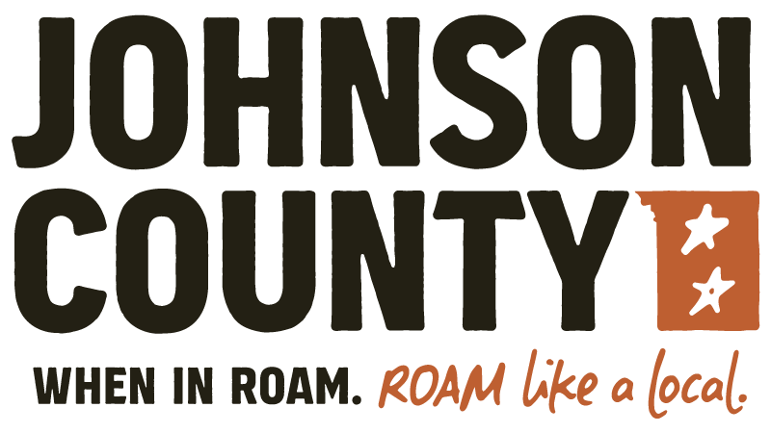
Johnson County Tourism Association
Buffalo * Kaycee
Jon Cordonier, President * Laurel Foster, VP * Jody Sauers, Treasurer Members: Harold Anton, Cole Burnham, Kaitlin Giles, Anita Peoples
Kristin de Galard, Administrative Assistant

TO: Forest Service
DATE: February 16, 2023
RE: Clear Cuts at Pole Creek
Our Community and it’s visitors have enjoyed the Pole Creek Nordic area for many years, it is a well established family fun site. Unfortunately, it is in the middle of the US Forest Service Pole Creek Vegetation Management Project #61834. Documents show proposed clear cuts covering most of the Trail Systems which would devastate the area that is currently somewhat protected from the brutal winds with the trees you are proposing to cut. Pole Creak is an affordable family and visitor friendly winter recreation area that is vital to our tourism and outdoor enthusiasts. It would be a shame to see all the time and money that has been spent to improve the area being thrown to the wind. My understanding is over $150,000 has been provided by the City, County and Rec District to improve the area not to mention the volunteer hours over the many years. It would be a waste to see that all go away.
Tourism is vital to our community and the number one private industry in Wyoming. Pole Creek is a favorite winter recreation area for beginners and more seasoned outdoor enthusiasts. People from all around come to enjoy our mountains and our recreation sites. Without the trees at Pole Creek the area would be blown away in our harsh winds. The trees are our refuge and our protection.
We are asking you to please consider removing the approximately 1,000 acres of the Pole Creek area from your project. As the Marketing arm for all of Johnson County and the Bighorn Mountains, Pole Creek Nordic Area is a gem that we want our community and visitors to enjoy for years to come. A true Winter destination in our beautiful Bighorn Mountains. Please remove Pole Creek from your scope of work for Project #61834.
Thank you from the Johnson County Tourism Association Board Members.

