May 19, 2022

Steve Brown, District Ranger
U.S. Forest Service
Stevensville Ranger Station
88 Main Street
Stevensville, MT 59870

Dear Mr. Brown:
I am commenting on the Bitterroot Front Projects, in extreme western Montana. The project area consists of 143,983 acres along the eastern face of the Bitterroot Range with a western border adjacent to the Selway-Bitterroot Wilderness Area with 97% of National Forest System (NFS) lands located in Ravalli County.
I recognize the intense pressures on our wildlife from habitat loss and climate change, and I advocate for science-based management of public lands for diverse public values, including but not limited to hunting and angling.
It is evident in reading the scoping document that the main focus of this project is on timber harvesting and vegetative treatments. However, there is very little attention to detail on how these activities are going to affect wildlife or their respective habitat or how many miles of temporary or new roads are to be constructed.

Amount of Commercial Logging is Extreme:
The scoping document discloses on page 9 those lands where commercial timber harvesting is not applicable. Even with that, however, the document also discloses that 55,133 acres will be subject to harvest. That amounts to 38.3% of timbered lands within the Project Area being commercially logged
We know the populated areas have a risk to homes and a likelihood of wildfire. However, logging is not the best first step. Below are available resources that should be utilized.
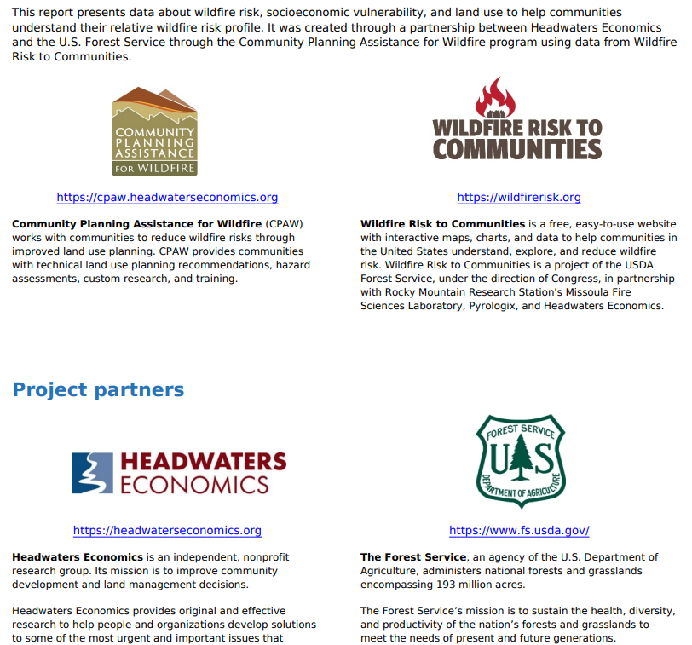
Here is a link to a program in Colorado; https://www.cpr.org/2022/05/18/colorado-wildfires-building-codes/ . This program focuses on educating the local population about what can be done assess wildfire risk and community planning to reduce wildfire risks.
Using Federal Dollars Wisely
Ravalli County is almost 75% federal land. It makes more sense to help protect private lands with the federal dollars than log the Wildland Urban Interface.
Data Source
This is the website that much of the data has been gathered from.
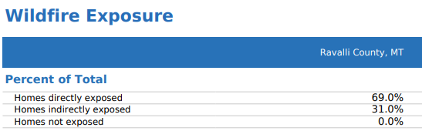
Here is the current drought map. It shows the Bitterroot Front to be in abnormally dry to moderate drought conditions. Montana Ciimate Assessments project this warming trend to continue and is an indicator of changing climates. For a project the size and scope of the Bitterroot Front Project, climate change needs to be an element of evaluation. We know that wildfires will occur, and we need to respond wisely.
The Montana Climate Assessment is a good starting point. Current conditions of hot and dry are predicted to continue.

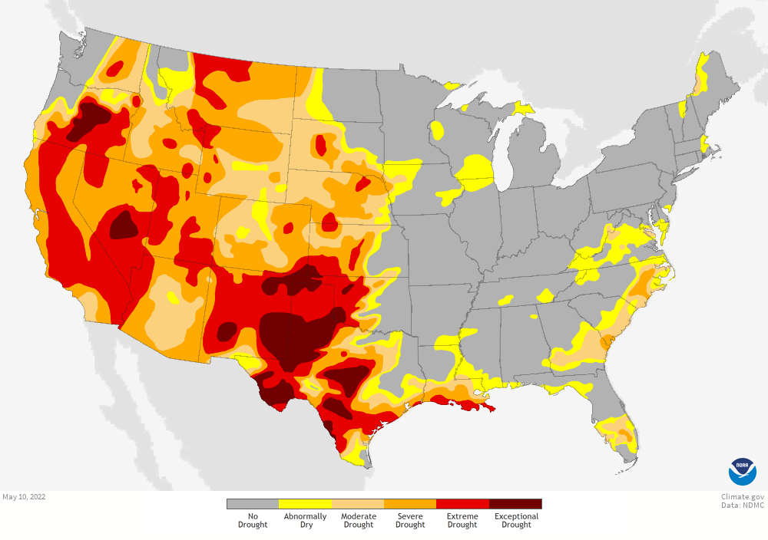
Below is the NOAA seasonal drought prediction, which shows that conditions will not get better either in the near term or as the Montana Climate Assessment shows the far term. Will the relatively small amount of private lands that are affected, it is better to treat, or help to treat the private homes and properties.
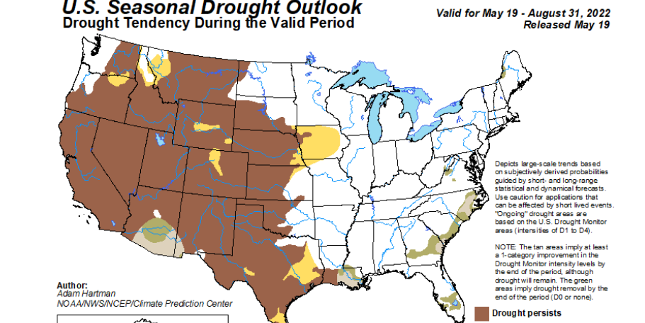

Data Trends
The trend data shows many strong trends; Employment up, Personal income up, Unemployment down, travel and tourism employment at 15.9% but Timber employment at 1.5%. this tells me that tourism is strong, but not timber.
Wildland Urban Interface
The wildland urban interface is 18.4% developed, which tells me that it is not as large as the project maps indicate.
The over designation of WUI lands is expensive and unnecessary. Attention needs to be focused on those lands centered around manmade structures and infrastructure, not on lands such as inventoried roadless areas (IRA) or those lands far removed from development.

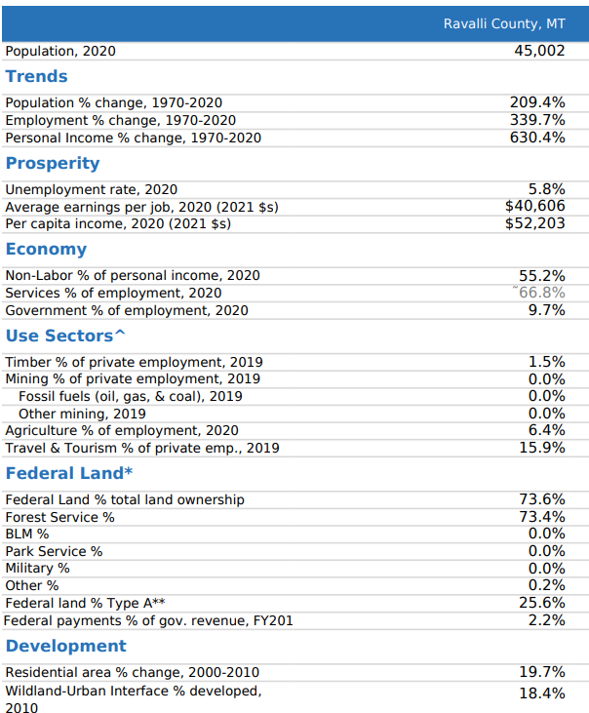

Please accept my scoping comments
Nancy Schultz
420 N 10th Ave
Bozeman, MT 59715
nancyanaconda@msn.com

