22 March 2021

TO: Mt Hood NF & NW Oregon BLM
Attn: Whitney Wirthlin
VIA: https://cara.ecosystem-management.org/Public//CommentInput?Project=54674

Subject: Mt. Hood Wild and Scenic Rivers Planning EA — comments

Please accept the following comments from Oregon Wild concerning the Mt. Hood Wild and Scenic Rivers Planning EA, https://www.fs.usda.gov/project/?project=54674. Oregon Wild represents 20,000 members and supporters who share our mission to protect and restore Oregon’s wildlands, wildlife, and water as an enduring legacy. Our goal is to protect areas that remain intact while striving to restore areas that have been degraded. This can be accomplished by moving over-represented ecosystem elements (such as logged and roaded areas) toward characteristics that are currently under-represented (such as roadless areas and complex old forest).

Thanks you for fulfilling your obligation to prepare a Wild and Scenic River plan.

The proposed action alternative involves:
The proposed action is to adopt a comprehensive river management plan for the nine rivers designated by the Omnibus Act (i.e., Collawash River, Eagle Creek, East Fork Hood River, Fish Creek, Middle Fork Hood River, South Fork Roaring River, and Zigzag River are located solely on lands managed by the Mt. Hood National Forest. South Fork Clackamas River includes National Forest System lands and BLM administered lands, along with a small parcel owned by Portland General Electric. Fifteenmile Creek includes lands owned by the City of Dufur and private landowners.) Specifically, the accompanying comprehensive river management plan includes the following:
• a description of the existing resource conditions including a detailed description of the outstandingly remarkable values;
• desired conditions for protecting river values;
• a determination of recreational user capacities;
• descriptions of land uses, infrastructure, current management actions and potential management actions within the corridor;
• description of instream flow and water quality requirements;
• identification of regulatory authorities of other governmental agencies that assist in protecting river values; and,
• a monitoring strategy to maintain desired conditions.
Much of the content of the comprehensive river management plan is informational and provides a baseline for future management (such as planning context and existing water rights). The proposed action analyzed in this environmental assessment includes only the parts of the comprehensive river management plan that change existing management practices. This includes establishing user capacity and final boundaries for each river, identifying management actions to protect and enhance river values, amending the Mt. Hood Land and Resource Management Plan, and adopting a monitoring plan for wild and scenic rivers.

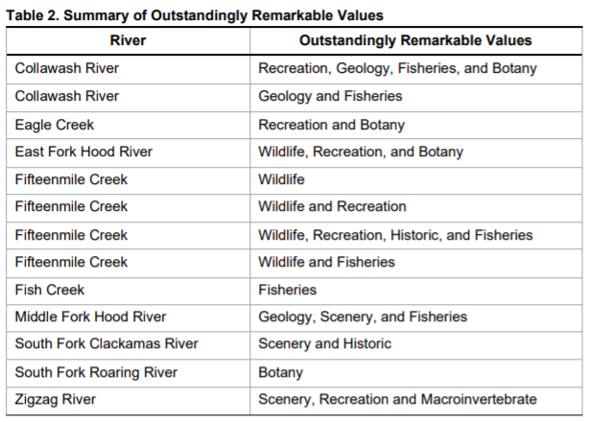

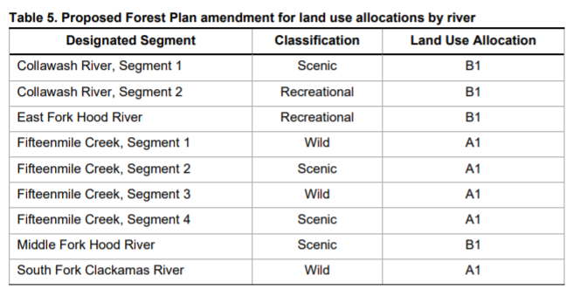

Final Boundaries

With a few exceptions, we are generally OK with the boundary adjustents made by the Forest Service.

Fifteenmile Creek – we urge that the boundary be narrower within the Wilderness and wider below the Wilderness boundary as that will allow for overall better protection of the outstandingly remarkable values.

Middle Fork Hood River – The FS has made the boundary wider in the lava field, and narrower elsewhere. We urge that the final boundary should be narrower in the lava field, because the lava field is not really threatened by development, and the boundary should be wider in the forested areas that would better protect and restore outstandingly remarkable values.

Land Allocations that are most Likely to Protect and Restore ORVs

The Wild and Scenic River corridors should be managed like LSRs. Which is to rely on natural processes to develop and restore conditions supporting outstandingly remarkable values. Careful thinning in dense young managed stands might be helpful in some cases but logging in mature forests and stands over 80 years old is not necessary or desirable to protect and restore ORVs.

The EA (p 24) says that “The majority of water quality impacts to the corridors were caused by past logging and road building [and]These water quality impacts persist today …” This is strong evidence that logging and roads should be avoided to conserve outstandingly remarkable values.

The FS should adopt “A” land use allocations for Congressionally designated Wild and Scenic River corridors, with an exception for variable density thinning in dense young stands (<60 years old) that are accessible from existing roads.

Logging is incompatible with maintaining scenic values in scenic, recreational, and wild rivers. The visual quality objective for vegetation should be “preservation” in all Wild and Scenic River corridors.

Timber sales are a crude tool that have many trade-offs on soil, water, scenery, habitat, carbon etc. The FS should recognize that the effects of so-called unregulated harvest are often just as significant as the effects of regulated harvest. Any goal that can be accomplished with a timber sale can be accomplished by non-commercial thinning or prescribed fire with many fewer trade-offs. This should be the preferred approach in Wild and Scenic River corridors.

The NEPA analysis needs to do a much better job describing the likely effects on ORVs of adopting “B” land use allocations that allow logging. This analysis is missing from the EA.

The NEPA analysis really needs to compare the effects of alternatives, such as alternatives that allow commercial logging outside plantations, and alternatives that do not allow commercial logging except in plantations.

The FS should recognize that the effects of so-called unregulated harvest are often just as significant as the effects of regulated harvest. Any goal that can be accomplished with a timber sale can be accomplished by non-commercial thinning or prescribed fire with many fewer trade-offs. This should be the preferred approach in Wild and Scenic River corridors.

Monitoring

The monitoring plan should include effectiveness monitoring and validation monitoring efforts to improve our understanding of whether commercial logging ad domestic livestock grazing are protective of ORVs, and whether restoration efforts can be better achieved with fewer trade-offs using non-commercial thinning and prescribed fire.

Range Management / Grazing

The Wild and Scenic River Plan should adopt specific standards for livestock grazing in WSR corridors. It is not good enough to rely on forestwide standards & guidelines that are known to lead to unacceptable resource degradation affecting soil, water, riparian, aquatic, vegetation, and scenic vales. Livestock are not well behaved. They tend to loiter in sensitive areas such as riparian areas and springs (especially in relatively dry areas such as Fifteenmile Creek drainage).

Congressionally designated Wild and Scenic River deserve specie protection, not just reliance on overly optimistic generic standards that don’t work very well in the real world.

Each substantive issue discussed in these comments should be (i) incorporated into the purpose and need for the project, (ii) used to develop NEPA alternatives that balance tradeoffs in different ways, (iii) carefully analyzed and documented as part of the effects analysis, and (iv) considered for mitigation.

Note: If any of these web links in this document are dead, they may be resurrected using the Wayback Machine at Archive.org. http://wayback.archive.org/web/

Sincerely,
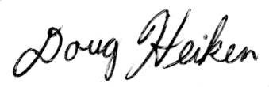
Doug Heiken
dh@oregonwild.org

