November 22, 2023

Kelsey Bean
Powder River Ranger District
1415 Fort Street
Buffalo, WY 82834

Submitted via CARA Site: https://cara.fs2c.usda.gov/Public//CommentInput?Project=64474
Re: Tensleep Climbing Management Plan #64474
Dear Plan Revision Team,
Thank you for considering the following feedback from Access Fund, Bighorn Climbers Coalition (BCC) and the Central Wyoming Climbers’ Alliance (CWCA) regarding proposed concepts for the United States Forest Service’s (Forest Service) Tensleep Climbing Management Plan (CMP). We appreciate the time and effort the Forest Service has invested in developing a climbing management plan that fosters stewardship and access to climbing in Tensleep. We recognize that both climbing and visitation in Tensleep Canyon has been evolving over the years and a CMP is needed to provide climbing opportunities while also effectively managing visitor use to protect local resources. Below are detailed comments to improve the proposed CMP and support sustainable climbing. Access Fund, BCC and CWCA have been engaged in this process for many years and have provided feedback in the past scoping period and a Best Practices Document.

The Access Fund
The Access Fund is a national advocacy organization whose mission keeps climbing areas open and conserves the climbing environment. A 501(c)(3) nonprofit and accredited land trust representing millions of climbers nationwide in all forms of climbing—rock climbing, ice climbing, mountaineering, and bouldering—the Access Fund is a US climbing advocacy organization with over 20,000 members and over 123 local affiliates. Access Fund provides climbing management expertise, stewardship, project specific funding, and educational outreach. Many of Access Fund’s members climb regularly at Tensleep Canyon. For more information about the Access Fund, visit www.accessfund.org.
Bighorn Climbers Coalition
A 501(c)(3) nonprofit organization, the Bighorn Climbers’ Coalition (BCC) mission is to preserve, promote and protect climbing resources and access to climbing resources throughout the Bighorn Mountains and basin. BCC intends to raise funds, obtain grants and organize efforts to improve local recreation areas. This will benefit the climbing community as well as other recreational user groups while decreasing potential negative environmental impacts from climbers. BCC has a history of constructive partnership with local land managers and other local organizations. For more information about the BCC, visit www.bighornclimbers.org.
Central Wyoming Climbers’ Coalition
The Central Wyoming Climbers’ Alliance (CWCA) is a 501(c)3 non-profit organization dedicated to protecting climbing access and resources for today in order to preserve them for tomorrow. For more information about the Central Wyoming Climbers’ Alliance, see https://www.wyomingclimbers.org/.
Comments
Tensleep is considered a world-class climbing destination. Climbing opportunities range from beginner to very difficult. There are over 1,350 routes on over 30 crags (discrete cliffs) that offer a wide spectrum of climbing styles. Access Fund, BCC and CWCA hope to help ensure that climbing activities are sustainable, and that the climbing system is resilient to support the area’s growing climbing community into the future. We provide the following comments and suggestions to inform important elements of this CMP.
Parking, Highway, and Road Safety
Parking on the U.S Highway 16 is limited. The small pull outs located on U.S. Highway 16 are challenging for visitors. Parking, pulling out and walking across the highway creates a public safety hazard. We support the CMP’s proposed infrastructure plans. Added infrastructure such as parking will greatly benefit multiple outdoor recreation groups, local ranchers, businesses, and those traveling through the region by increasing safety and access. The number of parking spaces for the proposed Mondo Beyondo parking area should be identified. If built, the Forest Service should identify whether it intends to implement a parking fee. Existing parking above and below this proposed lot should remain open for additional parking. The Bighorn National Forest should also identify how it will improve the safety and structure of other parking areas along the U.S. Highway 16. We do not support any closures of existing roadside parking spots because these locations are needed for climbing access as existing trailhead parking areas are currently lacking.
Trails and Climbing Access
We support the CMP’s proposed trails and climbing access plan. The adoption of climbing paths as formal trails is an important step in reducing impacts such as erosion, redundant and braided social trails, and will allow Access Fund, BCC, CWCA to support the Forest Service in trail maintenance and stewardship activities. We also support the approved maintenance to these trails. It is currently unclear how the Forest Service will manage these trails in the CMP. We do not support the closure of these trails but rather encourage the Forest Service to adopt these into the official trail network as established user pathways that can be made more sustainable through trail maintenance. The closure of important access paths could:
- Reduce the number of accessible cliffs to climbers.
- Disproportionately affect climbers who climb at more moderate grades, most of which are found in the lower reaches of the canyon.
- Increase the number of visitors to the identified “resource damage and overcrowding” areas such as Mondo Beyondo and Powers Wall and could have an adverse effect on the resource and visitor experience.
We strongly encourage the Forest Service to consult the climbing community in these decisions and create a working partnership with the adaptive community during the planning process to create ADA accessible trails.
Staging Areas
We support the CMP’s proposed action of constructing and hardening staging areas at the base of existing and future developed climbing crags. This will decrease erosion and minimize impacts to cultural and natural resources, and the spread of invasive plant species. Planned out staging areas that are hardened will provide an improved and safer experience to those visiting these staging areas/crags. The Forest Service should provide additional detail regarding the process of removing or re-naturalizing staging areas that may adversely impact cultural and natural resources. The CMP is unclear if the removal of these staging areas corresponds with the closure of certain climbs. Where possible the Forest Service should implement mitigation measures instead of a full closure of a climbing area. Staging area maintenance and stabilization is currently ongoing and should be recognized as such in the CMP as well as the continued education needed to help prevent and reduce erosion.
Leigh Creek Research Natural Area
The Forest Service should clearly state the specific values of Leigh Creek Research Natural Area in the CMP. Research Natural Areas (RNAs) are areas that the Forest Service has designated to be permanently protected and maintained in natural condition. These protected natural areas include unique ecosystems or ecological features; rare or sensitive species of plants and animals and their habitat; and/or high-quality examples of widespread ecosystems. We appreciate the Forest Service’s willingness to work with us regarding the established climbing that is on the border/boundary of this area to ensure that access is maintained to those climbing areas (ChemTrails wall, Godfather boulder, etc.). We request the Forest Service evaluate the impacts climbing may have on the RNA compared to other non-motorized activities which generally are permitted within the RNA. Non-motorized recreation, such as hiking, horseback riding, cross-country skiing, hunting, and fishing is allowed only when it is not a threat to the values for which the RNA was proposed or established. A clear demonstration of how climbing may threaten the values of the Leigh Creek RNA will bring awareness to the values of the RNA and allow climbers to appreciate its ecological importance. The Forest Service should clearly identify the boundary of the Leigh Creek NRA to help prevent future resource damage.
Camping
We support the CMP’s proposal to prohibit dispersed camping along FSR 18 for approximately 1.5 miles from its western intersection with the U.S. Highway 16 to the east. We recognize the Forest Service must monitor the impacts of camping and manage to prevent negative impacts on important natural resources of the area and understand that safety for all user groups must be maintained. We suggest that the Forest Service make available information for visiting climbers on appropriate locations for dispersed camping and paid camping. We suggest the Forest Service complete a new inventory of dispersed campsites to ensure that appropriate sites are maintained and inappropriate sites restored. The Forest Service should also install clear signage to clarify where it is not appropriate to camp.
Health and Human Safety
We support the CMP’s proposed actions to address human and pet waste issues. The installation of vault toilets, signage, kiosks and pet bag dispensers will address previous issues around human and pet waste. We are excited to see these additional resources added as they will significantly reduce negative impacts to the region and provide resources to multiple user groups. The BCC will evaluate the cost savings from no longer needing to pay for the current porta-potties and evaluate if we are able to offer any financial resources to aid in the implementation/building of these facilities.
Geological Resources and Current and Future Route Development
The CMP listed a series of proposed actions to address past conflicts among the climbing community and resource managers about excessive removal of rock, gluing, attaching artificial holds, or using mechanical equipment to create holds where a natural hold did not exist. Below we have listed the CMP’s proposed action and PROVIDE in Bold our recommendations to each proposed action.

Proposed Actions:
- Allow route development to occur on cliff walls not in areas where route development is prohibited (See Tensleep Climbing Plan Proposed Areas of No Development map). The Tensleep Climbing Plan Proposed Areas of No Development map shows the maximum area of cliff walls available to route development. Additional areas of no development may be identified during the environmental analysis process or during implementation of the Climbing Management Plan if there are negative impacts to natural and cultural resources.

We support this action and appreciate a path forward for future route development to continue. We ask the Forest Service to add language specifically allowing fixed protection/anchors to ensure there are no conflicting statements between the CMP and 2019 Climbing Regulations for the Bighorn National Forest (Appendix A). It is our understanding that the moratorium on new route development will remain in place in the Bighorn National Forest outside the Tensleep Recreation Area specifically addressed in this CMP, until a forest wide plan is put in place at a later date.

- Prohibit route development that removes rock from areas except where the rock in its natural position poses a risk to the climbing party or a future climbing party.

We appreciate the Forest Service recognizing that the removal of rock, where it poses a risk to future climbers, is an important process in future route development.

- Prohibit gluing, attaching artificial holds, or using mechanical equipment to create holds where a natural hold did not exist.

We support the CMP’s proposed action of prohibiting the artificial manipulation of climbing holds and routes. The Forest Service should differentiate the difference between gluing or modifying holds via glue and glue-in style fixed hardware.

- Prohibit the placement of new fixed climbing protection on selected crags (See Tensleep Climbing Plan Proposed Areas of No Development map). This prohibition will be located on crags where:
- social concerns and route inventory have indicated that the crag is too crowded for additional route development.

With the exception of areas closed to protect wildlife and the RNA, we do not support closing development to the listed portion of Valhalla, also known as the area mapped as “Resource Damage” in Appendix B-Map 1. We feel that continued development of climbing routes would disperse the concentration of use and reduce crowding concerns. Without the identification of direct impacts associated with new climbing route development we do not support limiting areas for future development. The Forest Service also needs to define “too crowded for additional route development.” What type of analysis, metrics, and process will the Forest Service undergo to determine this type of designation? The Forest Service should be clear and transparent on the metrics used to avoid any confusion and/or the arbitrary or unreasonably subjective designation of “too crowded.”

- wildlife and botanical species or cultural resources are negatively impacted.

We request the Forest Service provide additional information to justify areas closed to new climbing route development based on the wildlife buffers provided in Appendix B-Map 1. The climbing community supports climbing management decisions based on site-specific science and active monitoring data. It is common for climbers to avoid areas on a seasonal basis to protect raptors or other seasonal needs of wildlife in an area. Additional information would assist the climbing community in understanding and respecting this proposed closure. The Forest Service should compile a full inventory of sensitive wildlife, botanical and cultural resources and clearly communicate with the climbing community what data and standards will be used to base a management decision restricting future climbing route development. The Forest Service should provide educational opportunities about these seasonal closures, as additional information will help climbers in understanding and participating in these closures.

- sections of rock wall that are not conducive to route development and where the removal of rock, gluing, attaching artificial holds, or using mechanical equipment beyond fixed climbing protection placements would be needed to develop a route.

We request this be revised to:

Route development where the removal of rock (chipping), gluing, attaching artificial holds or using mechanical equipment beyond fixed climbing protection placements would be needed to develop a route.

The Forest Service generally does not have the expertise to determine “rock wall(s) that are not conducive to route development”—such a standard is highly subjective and in any case and if such expertise does currently exist will this staff/expertise remain throughout the life of this CMP? Thousands of rock faces in the United States were once determined “unclimbable” until a skilled individual took up the challenge to climb the route.

- crags that previously had gluing or attaching of artificial holds and use of mechanical drills to create holds.

We do not support the removal of or restricting access to any existing climbing routes that do not negatively impact natural or cultural resources. Routes that were previously damaged and or stripped of their fixed protection have the potential to be reopened after careful inventory and addition of fixed anchors where needed as long as the work required to rehabilitate these routes does not conflict route development guidelines outlined in this proposed CMP.

- crags located within the Leigh Creek Research Natural Area.

We appreciate the Forest Service’s willingness to work with the climbing community regarding the established climbing that is on the border/boundary of this area to ensure access is maintained to those climbing areas (ChemTrails wall, Godfather boulder, etc.). We request the Forest Service evaluate the impacts climbing may have on the RNA compared to other non-motorized activities which generally are permitted within the RNA. Non Motorized recreation, such as hiking, horseback riding, cross-country skiing, hunting, and fishing is allowed only when it is not a threat to the values for which the RNA was proposed or established. A clear demonstration of how climbing may threaten the values of the RNA will bring awareness to the RNA and allow climbers to appreciate its ecological importance. A well defined boundary should be identified to help prevent future resource damage to the RNA. We appreciate that the Forest Service will keep a one-tenth mile buffer within the RNA open to climbing. Route development should continue within this one-tenth mile buffer unless the Forest Service can demonstrate unacceptable impacts to the values for which the agency established this RNA.

- along FSR 18 during seasonal wildlife closure.

This should be edited to state:

It is our understanding that FSR18 road is closed during migration season for elk. The Forest Service should clearly communicate the scope (time and area) for this closure. Other recreational activities are allowed along the FSR18 (old road) area during the seasonal wildlife closure period (cross country skiing, ice climbing, biking, hiking, camping, hunting etc.). Route development is often best done out of the normal climbing season (summer) because new route development during the climbing off season is much safer for the climbing community as well as any other user groups who might be in these areas during “peak season.” The act of route development should not have much higher impact than regular climbing and other recreation activities in the area. We suggest the Forest Service conduct focused monitoring to understand if climbing route development activities have a negative impact on migrating elk.

For areas that may be closed to protect nesting raptors we request the Forest Service conduct site specific monitoring. Climbing areas across the United States share habitat with cliff-nesting raptors. Seasonal monitoring is suggested to locate exact nest locations each season. We suggest continued nest monitoring to assess the success or failure of the hatchlings, nestlings, chicks, and fledglings. We suggest a viewshed analysis to adequately determine the climbing routes affected by the seasonal closures. Access Fund has produced a Raptor Management Handbook in collaboration with Hawkwatch International and the U.S. Fish and Wildlife Service outlining current best practices for managing climbing and raptor habitat and may be helpful for this CMP.

- areas that are identified as having limited parking and access to the cliff face.

The Forest Service should closely evaluate alternative access points prior to rejecting a proposal based solely on parking access.

- Provide a process for route developers to notify the Forest Service of their plan to develop a cliff face in a bolting proposal form and manage areas with limited access by considering restrictions when necessary.

We support a voluntary notification process for route developers to notify the Forest Service of their plans to develop a cliff face. This process would be put in place to ensure that sensitive wildlife, biological and cultural resources are not harmed, and would also allow the Forest Service to evaluate trail and staging area needs. This process should be included in the draft CMP and be clearly defined. Access Fund and BCC are committed to refining this process to reduce administrative burden on both the Forest Service and route developers.

- Monitor the condition of routes in crags that have previously had gluing or attaching of artificial holds and use of mechanical drills to create holds or were damaged in 2019 and proceed with the following management action:

We do not support the removal or permanent closure of previously developed climbing routes that are not impacting natural and cultural resources and are located outside of the Leigh Creek RNA. The Forest Service should evaluate routes that were previously damaged and or stripped of their fixed protection to evaluate impacts and allow such routes to be reopened to climbing if they are deemed climbable by the climbing community. The climbing community will likely need to add new fixed hardware for some/many of these routes And all repairs could be done in accordance with the development guidelines provided in this CMP. BCC and Access Fund would like to collaborate with the Forest Service regarding the reopening of previously damaged areas to ensure there are no future issues or disagreements within the climbing community.
Justice, Equity, Diversity, and Inclusion (JEDI)
Access Fund urges the Forest to work with the local community to advance inclusive and equitable access to Tensleep Canyon. It is well documented that people of color often use outdoors spaces at lower rates than their white peers. In addition, people from other marginalized communities, such as the LGBTQ and differently abled communities, can face additional challenges to getting out on public lands. We encourage the Forest Service to address environmental justice issues and make similar efforts to engage with communities of color and other underrepresented demographics. Access Fund has staff dedicated to JEDI issues, and is available to offer our time and resources to assist the Forest in applying JEDI principles to this climbing management plan project.
Access Fund, BCC, and CWCA Assistance
The climbing community, the Access Fund, BCC and CWCA are ready, willing, and able to help planners identify and improve the climbing related infrastructure, trail system, roads, and other management needs the Forest may require to provide for the outstanding opportunities found in the Bighorn National Forest. In addition, some aspects of this planning initiative may qualify for Access Fund Climbing Preservation Grant Program or assistance from our Conservation Team program which helps maintain climbing areas throughout the United States by assessing climbing area conservation needs, working with locals to address those needs, and providing training on planning and stewardship best practices to keep those areas healthy.
* * *
Thank you for your consideration of these comments. Access Fund has the experience, local contacts, and resources to help planners craft management strategies that encourage climbing while sustaining the health and integrity of the landscape and the recreation experience. Access Fund looks forward to continuing to work with the Bighorn National Forest. Please keep us informed as this planning process proceeds. Feel free to contact us via telephone at (303) 552-2843 or via email (katie@accessfund.org) to discuss this matter further.
Sincerely,

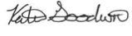
Katie Goodwin, Access Fund Policy Analyst
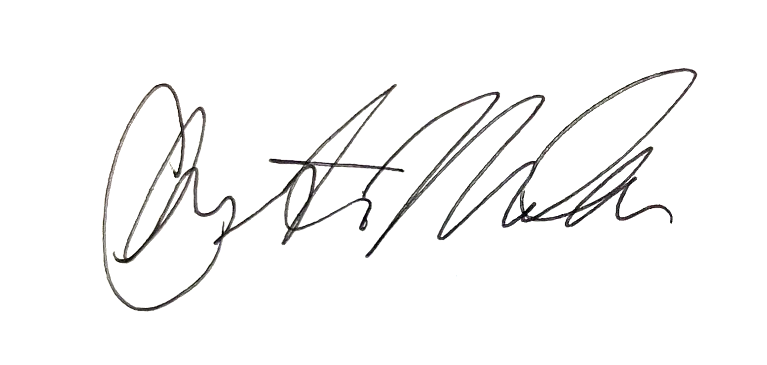
Bighorn Climbers Coalition President
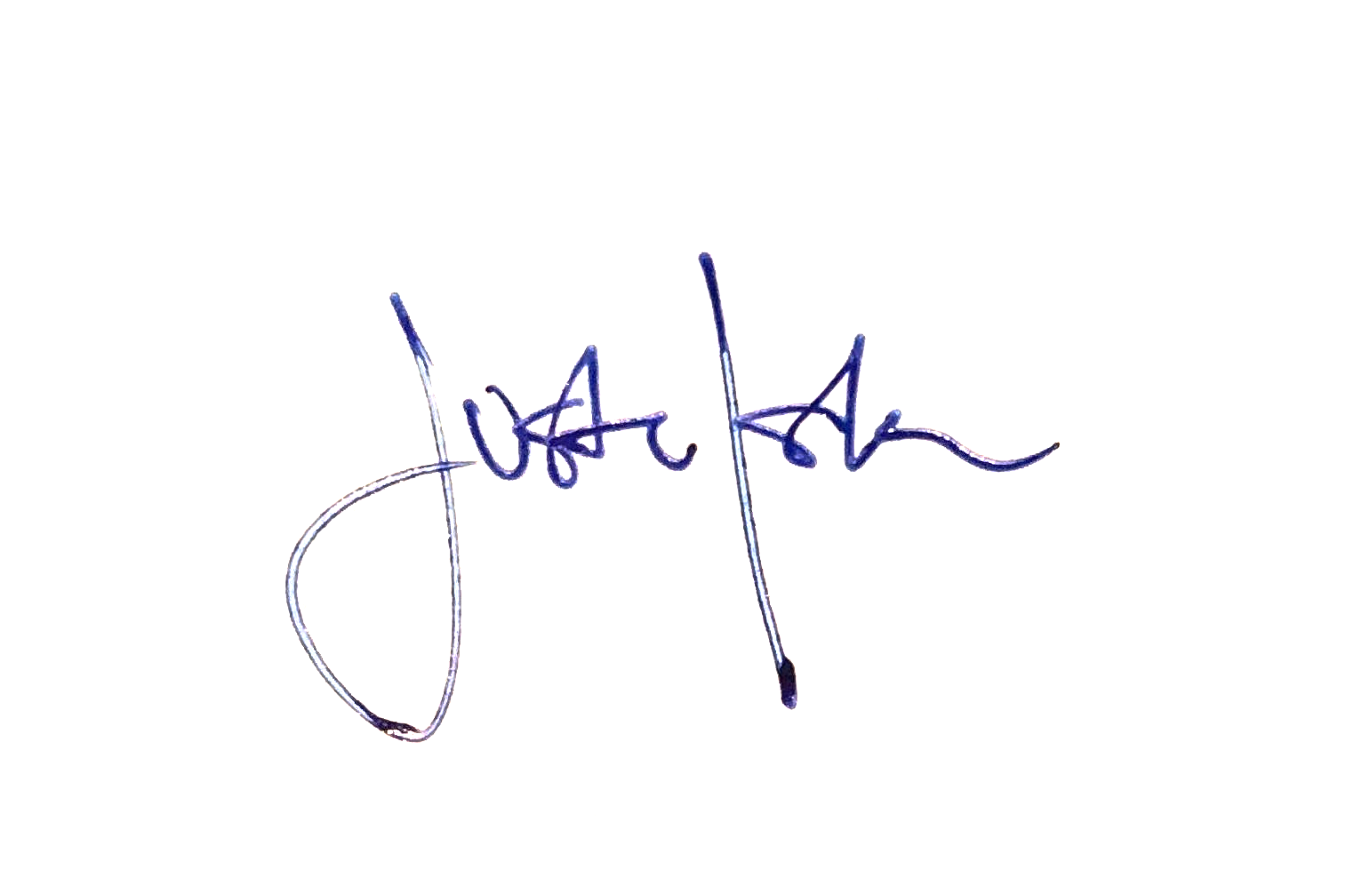
Justin Iskra, Central Wyoming Climbers Coalition

Appendix A

CLIMBING REGULATIONS
Bighorn National Forest

As of July 19, 2019, the USDA Forest Service will be enforcing regulations that prohibit constructing new climbing routes or trails on the Bighorn National Forest, including Tensleep Canyon.
If an individual or group is manufacturing, or creating new routes with any type of permanent hardware or apparatus to include bolts, glue, manufactured hand holds; or modifying routes through chipping or hammering new or existing holds, they will be subject to criminal fines, to include money for restitution to the impacted area.

Pursuant to 16 USC 551;
36CFR§261.9(a) Damaging any natural feature or other property of the United States.

36CFR§261.10(a) Constructing, placing, or maintain any kind of road, trail, structure, fence, enclosure, communication equipment, or other improvement on National Forest system land or facilities without a special-use authorization, contract, or approved operating plan.

The Bighorn National Forest is in the process of writing a climbing management plan, with the purpose of helping protect from degradation the aesthetic of the canyon and the unique climbing attributes found here on the forest.
Your cooperation will only enhance and protect the resources that are currently enjoyed, and ensure that Tensleep Canyon and the Bighorn National Forest will remain a special place for sport climbing into the future.
For questions, information or input regarding the climbing management plan please contact:

District Ranger Traci Weaver
Powder River Ranger District, Bighorn National Forest
307-684-7806

See https://www.mountainproject.com/area/105819641/ten-sleep-canyon.
See https://usfs-public.app.box.com/v/PinyonPublic/file/1344210654817.
See https://usfs-public.app.box.com/v/PinyonPublic/file/1344210654817.
Climbing and Raptors and Adaptive Management Handbook. See: https://d1w9vyym276tvm.cloudfront.net/assets/Access-Fund-Raptor-Handbook.pdf?mtime=20210603122128&focal=none
https://www.fs.usda.gov/about-agency/equity-action-plan
See https://www.accessfund.org/take-action/apply-for-funding/apply-for-a-climbing-conservation-grant and https://www.accessfund.org/pages/conservation-team

