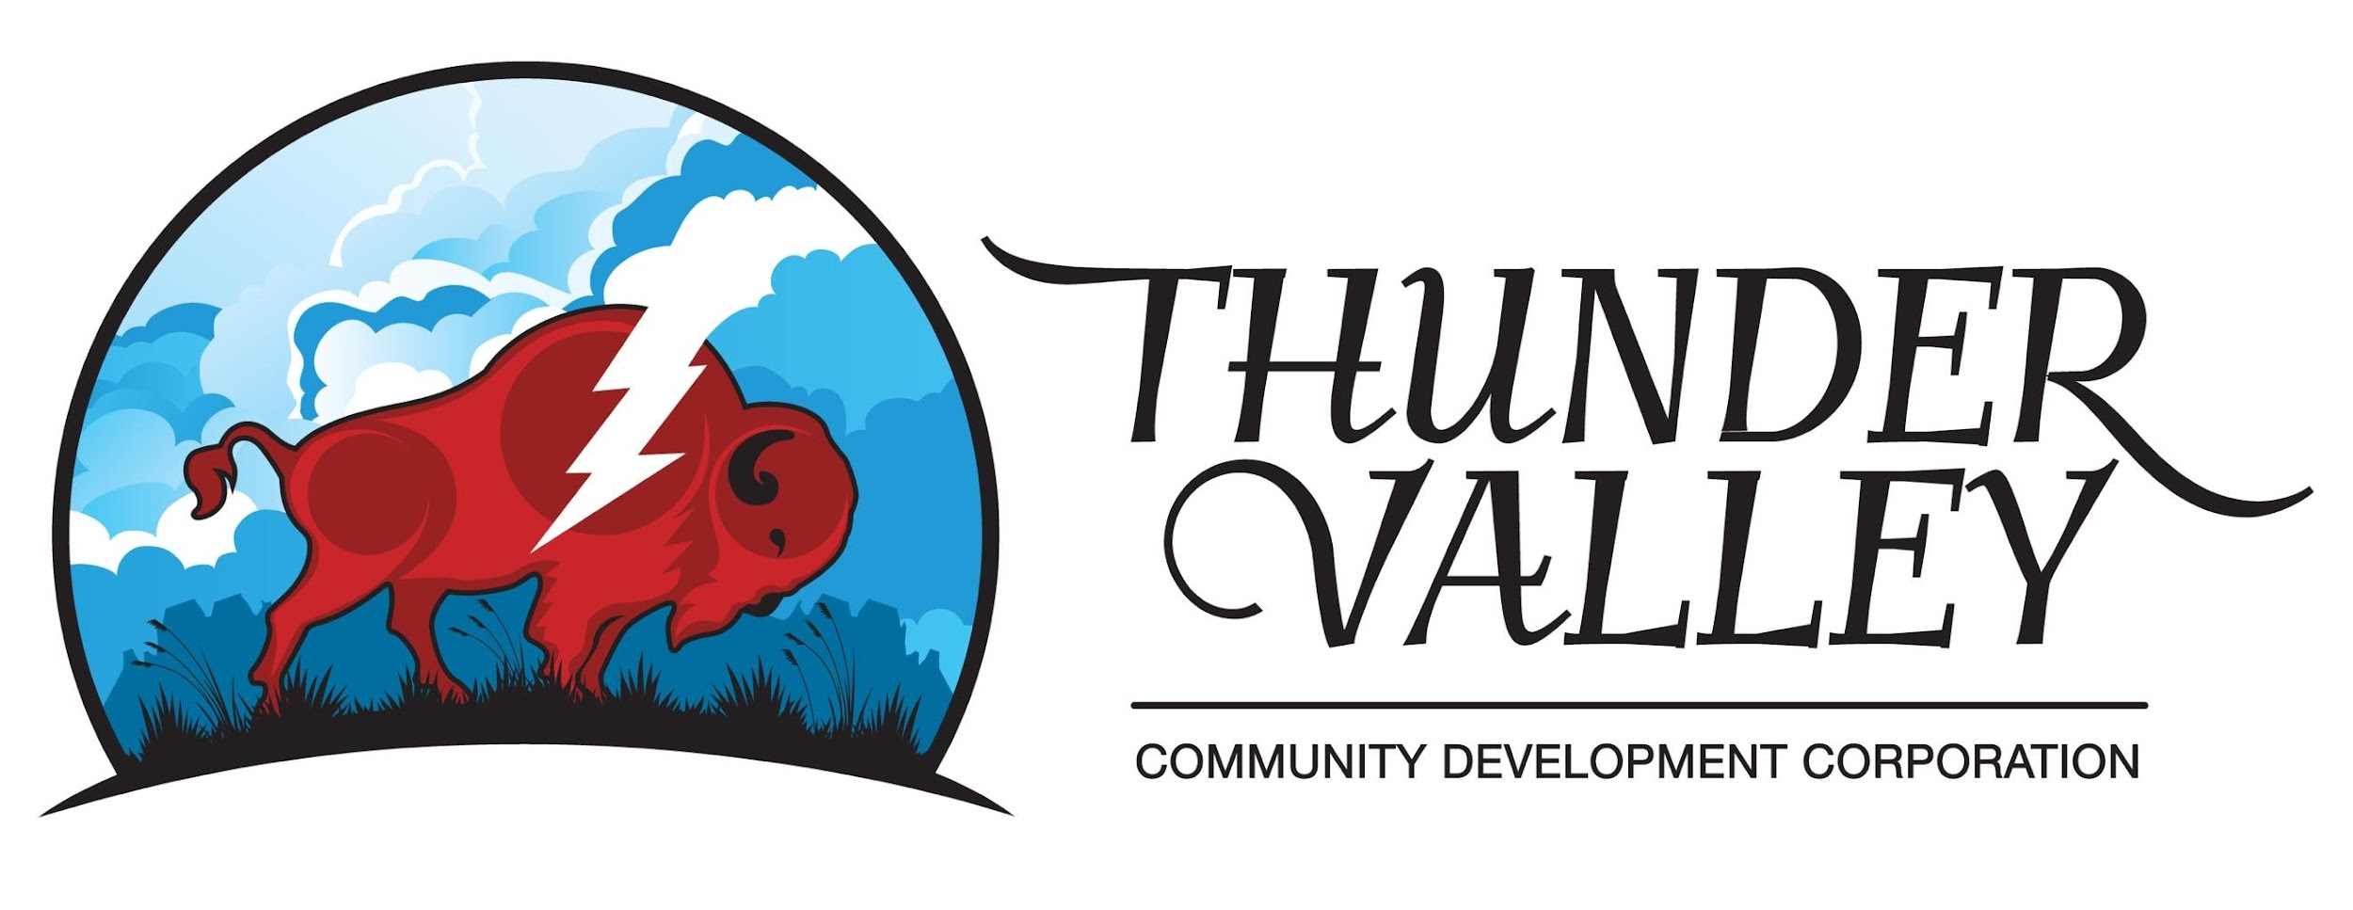
March 6th, 2023

To: Rob Hoelscher, District Ranger
1019 North 5th Street
Custer, SD 57730
Sent via Email: comments-rocky-mountain-black-hills-hell-canyon@usda.gov

Subject: Newark Gold mine drilling project

Dear District Ranger, Rob Hoelscher

The Thunder Valley Community Development Corporation would like to express our concern about the U.S. Forest service to allow for the drilling of gold in our sacred (Pte Sapa) Black Hills. We do not want our land set up for drilling and gold exploration by the Minneapolis F3 Gold company.
Here are the following concerns and questions that we have:

- We would like to see the evidence of two different sources relating to an Environmental Impact Study. We have seen too many environmental study groups in the pocket or in the direct line of interests for the group needing the study. Here is an example of exxon mobiles knowledge of global warming. https://www.europarl.europa.eu/cmsdata/162144/Presentation%20Geoffrey%20Supran.pdf The case outlined by exxon mobile shows they knew for years about global warming possibilities and lied to the public with misleading environmental studies. We would hope Minneapolis F3 gold is not doing the same thing. They may be lying on how safe it is to drill and explore for gold

- We would also like to have an assessment done for Native American Graves Protection and Repatriation Acthttps://www.nps.gov There are sacred burial sites and sacred prayer sites that need to be marked and investigated before drilling or exploration can take place. We would ask that Minneapolis F3 gold does a thorough study to make sure they are within rights at all their locations. We also want them to utilize a 3rd party tribal entity to survey and study the areas they claim to be drilling and exploring.

- We would also like to add that these lands are host to some of our most sacred medicines and traditional foods including: Canpa (Choke cherries), Cansasa ( red willow), Bitter root, Bear root, sage, sweet grass, wild plums, wild potatoes, and buffalo berries just to name a few. Drilling and exploration will destroy these sacred foods and medicines.

One way our medicines will be destroyed is by poisoning the water with cyanide and arsenic. Also destroying the vegetation and wild life by clear cutting and bull dozing the areas for exploration and drilling. Which will affect watersheds, Wild life as well as the destruction of our sacred medicines. The following link was done by earth works and their data as well as their reputation is phenomenal. This will give you an idea of what's to come for our sacred Pte Sapa (Black Hills)

https://earthworks.org/issues/environmental-impacts-of-gold-mining/

- The U.S forest as well as the national park service has illegally taken these lands from our people through various national Forest and protection services acts. The main act that was put into place to accomplish this was the “Sell our starve act of 1877”. The Agreement of 1877, also known as the Act of February 28, 1877. This act single handedly and illegally took away our rights to the Pte Sapa (Black Hills) and put us on reservations. So when you have to give them back to us we do not want them ruined by Minneapolis F3 golds drilling and mining explorations.
Our people have been in existence in this area for hundreds of years. When we signed the 1868 Ft. Laramie Treaty, The Sacred Black hills were our property under that treaty. Honor the treaty of 1868 at fort laramie which specifically designates the Black hills (Pte Sapa) to our people as long as the grass grows and the water flows. This is also a violation of the United States constitution's article 6. This article states that any treaty struck with The United states of America with a sovereign nation is the supreme law of the land. So we ask that you kindly remove yourselves and your money hungry greedy corporations who rape and pillage our earth mother. Specifically Minneapolis F3 gold.

- The effects of gold mining and drilling for gold will have a major effect on our water systems. We know these systems move downstream to other areas and most of all to other people. They will have no idea what they are drinking in their water when it comes to mining and exploring for gold. Has Minneapolis F3 gold shown that this will be safe for our people. Have they made a community effort to educate our people to the dangers of drilling and mining for gold? I would like to see this effort being made to all the people in the area who will experience this first hand. F3 gold needs to put a community education plan in place. We would also like to Specifically mention the French creek drainage system as it moves through to Custer, and Custer state park. This will have a major effect on the millions of dollars that are brought to the state of south dakota in the name of tourism.

- We also understand that this project will only be the beginning of what this company wants to do. If they discover gold who is to say that the power of greed will have the ultimate say so in our sacred lands. They are not from here, they don't belong here, they won't stay here, and will not have to live with the after effects of all the damage that comes from gold mining.

Here is another example of what gold mining companies will do in the name of gold drilling and exploration. Please consider.
https://www.atg.wa.gov/news/news-releases/court-rules-gold-mining-company-violated-law-more-3000-times-okanogan-county

- We are also aware of the practice that utilizes cyanide to extract gold. Where does this cyanide go? Is it going to go into our water systems for all of our people to enjoy in their water ? Minneapolis F3 gold needs to explain to our communities what they will be doing with all the dangerous chemicals utilized to extract, drill or explore for gold.
Below is the link for educational purposes. This will show you and others how much damage gold drilling, exploration and mining will do to our ecosystem here in the sacred Pte Sapa (Black HIlls)

https://earthworks.org/issues/environmental-impacts-of-gold-mining/

We ask the U.S. forest service to say no to this project and to keep all people in mind who enjoy our sacred black hills year round. The people who love our lands love our ways and would want to see our beautiful forest and sacred hills stay pristine and safe from the arm of destruction in the name of greed. People of all nations enjoy our blackhills for many reasons. Hiking, biking, nature walks, boating, hunting, fishing, site seeing, and a host of other beautiful activities. To allow MInneapolis F3 gold to destroy it would be an abomination of our rights and our love for these sacred black hills. We ask the U.S. forest service to stop this gold mine drilling and exploration in its tracks. Keep uranium mining and gold mining out of the Pte Sapa for as long as the grass grows and the water flows. Pila miye pelo.

Sincerely, Kevin Hoch DeCora
Regional Equity director Thundervalley cdc

