January 10, 2020
Tennessee Heartwood 212 Greenleaf St. Chattanooga, TN 37415 423.877.4616 www.tennesseeheartwood.org

Betty Jewett, Forest Supervisor Chattahoochee National Forest 1755 Cleveland Highway Gainesville, GA 30501 770 297-3000

Dear Supervisor Jewett:
On behalf of the Tennessee Heartwood, I wish to submit the following comments on the Foothills Project of the Chattahoochee National Forest. Members of Tennessee Heartwood use the Chattahoochee National Forest for a wide range of uses, including hiking, fishing, hunting, camping, wildlife watching, and other recreation activities. We take an active interest in the management of this forest and offer the following comments in the spirit of good management of our public lands in the Southern Appalachians.
We first wish to address our deep concerns regarding the NEPA (National Environmental Policy Act) process for this project. This is an unprecedented process that is a significant departure from the norms of the Forest Service.
For over forty years, NEPA and NFMA (National Forest Management Act) have provided the general public with a voice in the project-level and long-term management of its National Forests, fostering a democratic spirit of transparency and accountability. The Foothills project is a sharp departure from this.
We were struck by the introduction to the Restoration Plan for the Foothills Landscape Project: “The four pillars of our collaborative effort are trust building, shared learning, transparency, and frequent feedback.” It is hard to see how this attempt to conceal the specifics of this project constitutes a good-faith effort at transparency.
The Foothills project Environmental Analysis (EA) stands to be an overriding document for the long-term future of an enormous part of the entire forest, comprising a scope in area and potential impact that would normally trigger an Environmental Impact Statement (EIS). On those grounds alone, we call for the agency to either reconsider the scope of this project or prepare a document of the depth that such a significant project deserves. At the very least, a comment extension should be added to the 30 days offered.
We stress emphatically that meaningful public comment is not possible under an arrangement where the public has 30 days to comment on a 50-page document that addresses broad “conditions” that have no site specificity. This is a project that covers an acreage size of 10 typical projects that generates an EA. How is it possible for the public to have comments that deal with real site conditions. This is a very refutation of what the agency claims will be “adaptive management”. In every adaptive management process that we have followed or participated in, there is a continuous evaluation of site-specific conditions that begins before scoping and throughout the process and through implementation where the public is an active participant throughout. That is not planned for Foothills.
Why Transparency and Citizen Input Matters
More Boots on the Ground
As agency budget constraints prevent planning teams from being everywhere in the forest, forest users have frequently performed the valuable service of grassroots ecology. From water quality monitoring to identifying previously unknown populations of rare and endangered species, amateur naturalists around the country provide valuable information to the Forest Service and other state and federal agencies. Scores of volunteers are largely responsible for gathering bird sighting data under the Migratory Bird Act. Sportsmen provide valuable field information on game and non-game wildlife populations. Local historians contribute greatly to the Forest Service’s mission of managing the land for cultural heritage values under the Antiquities Act. Citizen participation in forest management goes far beyond helping maintaining hiking trails. Far from seeing the standard NEPA processes as causing “gridlock” in the agency, many forest districts have come to recognize that this effort actually reduces conflicts and improves efficiency.
Meaningful comment cannot be made without some degree of site specificity. The problem with commenting on “conditions” rather than places is that it defeats much of the virtues of citizen input that are listed above. The writer of these comments has participated in National Forest management policy on over a dozen forests in Regions 8 and 9 for over 25 years and has never heard a ranger recommend to make comments more general. Every ranger has said in some form or another to please be specific, as in site specific, as possible.
Conservationists were told throughout the 1990’s and 2000’s that boilerplate, one-size-fits-all objections during public comment periods were not helpful, even frivolous at times i.e. useful, meaningful comment was ground-based. How has that changed? The Chattahoochee no longer wants this?
Stunting “uniqueness” with a stunted process
This refusal to tier this project to specific areas frustrates the ability of the public to make meaningful comment. Considering that the agency has begun in some instances to aggregate comments that lack some supposed standard of “uniqueness” as a single comment, one wonders if the very nature of this analysis will in a “self-fulfilling” way also lump public comment, since the broad nature of the analysis will reduce the potential for said uniqueness. Consider: no comments about a previously little-known heritage site, no comments about a particular species that was recently seen; less on-the-ground knowledge available from those who would provide a view of a stand condition outside the season when Biological Evaluation surveys are conducted. This and more are the things the agency should be hoping for, not trying to stave off, for there is another thing we have ever heard a ranger say: “we have the resources we need to cover everything”.
It is unreasonable to ask the public to guess where logging, roadbuilding, herbiciding, and other potentially significant agency actions will take place based on the very broad outlines showing 40-50 thousand acre chunks of this forest in order to have comments of any real site specificity. One can openly question whether frustrating attempts at substantive comment is actually the point.
It will be interesting to see how the Chattahoochee will lump comments on this analysis. It should be easier to do, since the complexities of comments on what will be hundreds of forest stands will not have to be dealt with.
Past Forest Restoration Failures
The Chattahoochee, along with the rest of the Southern Appalachian forests (Cherokee, the Pisgah, and the Nantahalah) has been engaged various attempts to restore pine-oak forest types for many years. The level of success in these projects has not been particularly encouraging. Throughout all of these forests are failed shortleaf pine projects that have regenerated poplars; “advanced oak regeneration” projects that fail to adequately regenerate oak, often at the expense of healthy second growth oak stands; and “oak grassland” and “oak woodland” projects like the unfortunate Brawley project that have incurred a great deal of expense, what has been ironically called “creating tomorrow’s restoration projects today”.
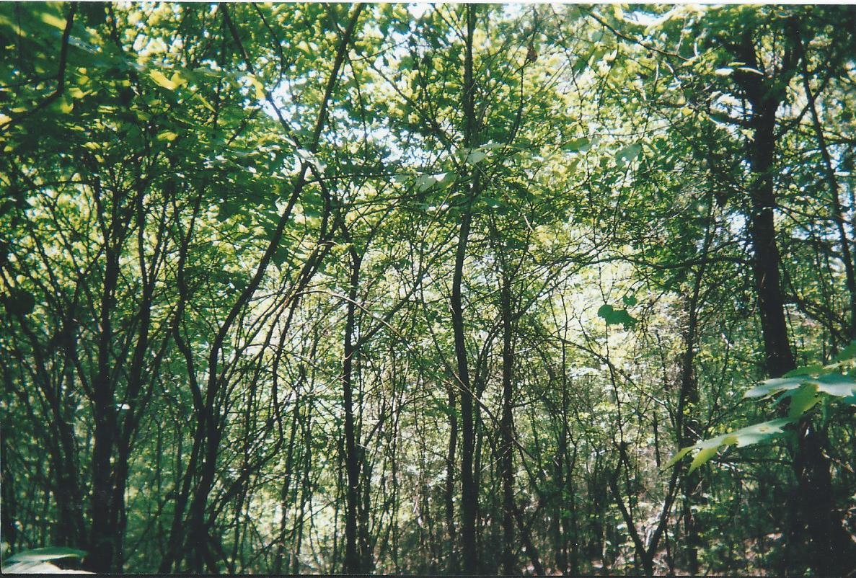
Typical failed shortleaf restoration in the Chattahoochee that is found throughout the Southern Appalachian districts
These kinds of results are common in several forests throughout the Southern region, as the following slides show: (https://www.dropbox.com/s/k74kn80i2jrd24q/Some%20shortleaf%20pine%2C%20pine-oak%2C%20and%20oak-savannah%20restoration%20problems.pptx?dl=0 ).
This is a serious problem for the agency, and one that won’t be fixed by hiding what the agency does. To be quite frank, some districts have begun significant reevaluation of their goals and practices to address how to reach desired future conditions, and, just as significantly, what those desired future conditions are.
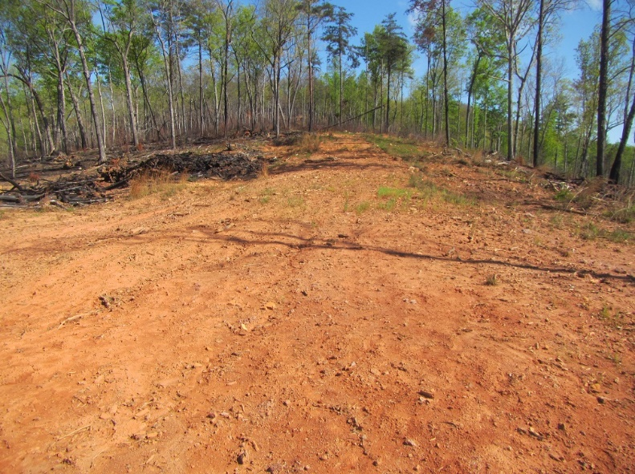
Where much of the desired grasses at Brawley are recruiting- logging decks and skid paths

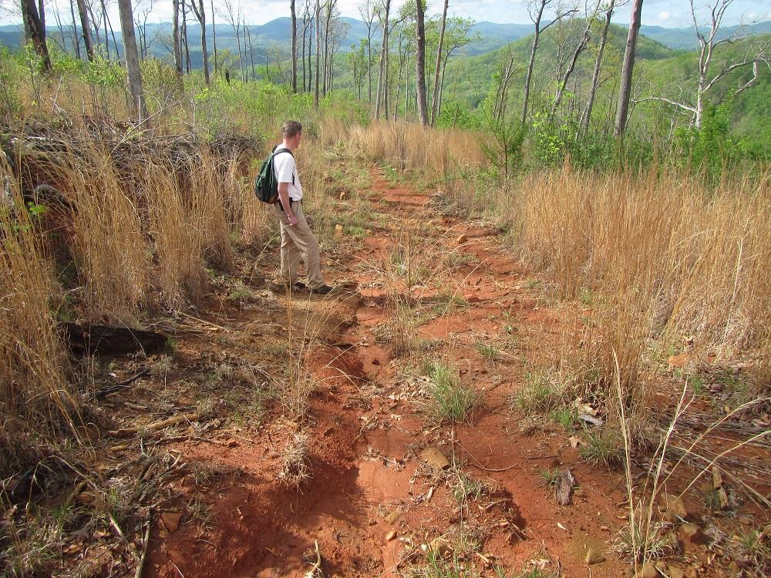
Eroding Skid Path at Brawley
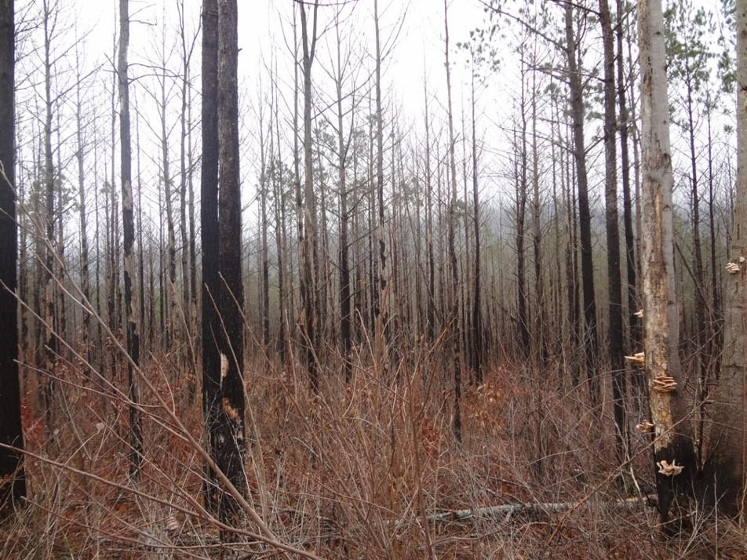
Not much success at this Brawley stand
What we see in this analysis is the same “upland pine-oak” paradigm that features logging, a focus on a few pine and oak species for “natural range of variation”, and a suite of herbicides and burning that has not been effective at mimicking historic stand dynamics patterns.
In all, the past difficulties that the agency has had, shows that it needs more public transparency, not less.
Need to Address Real Biodiversity
Since at least the passage of the Healthy Forests Restoration Act of 2003, the vast majority of National Forest projects have had Forest Health and Restoration as a primary rationale. In the Southern Appalachian districts of the Chattahoochee, Cherokee, Pisgah, and Nantahala National Forests, the focus has skewed to only a few members of oaks (quercus) and pines (pinus). This focus in some districts has been narrow to the point that in regeneration cuts, only three or four species are explicitly hand planted- often shortleaf pine, pitch pine, white oak, and sometimes one of the red oaks. The EA, in keeping with this trend, calls for the planting of shortleaf or pitch pine seedlings in favorable sites. While there is also mention of planting hemlock seedlings, we still are looking at a strong silvicultural skew in the overall goals and design of this project.
This trend has had a cumulative effect throughout the region. There are several tree species with legitimate historic representation that simply are off the conceptual map of the agency, that we will call Other Forest Species (OFS) that are not virginia pine, white pine, or maples. These include post oak, blackjack oak, the entire family of Juglandaceae (walnut, butternut, and the hickories), dogwood, redbud, and black cherry.
One can recommend “leave residual species”, but like in the way that Shortleaf Pine supposedly has been suppressed from reestablishing historic ecological role, it could be very well that suppression of OFS from their historic composition is happening, even if that isn’t fully intentional. It can be argued that a kind of benign neglect is happening with OFS, particularly in how current silvicultural practices may not explicitly target them as undesirable, but make it harder for them to reestablish fully. Secondary effects such as inattentive practices during logging and other silvicultural activities, post-logging erosion, herbicide drift, inappropriate timing or concentration of fire application, and other factors continue to skew down biodiversity. Furthermore, the overall lack of knowledge about these species and a conscious commitment to their role on the landscape at a planning level drives these problems. And finally, the clear targeting of many of them as undesirable historically due to market demands and silvicultural fads have so thoroughly disrupted their presence from historic memory, it is small wonder that even the best forest modeling hesitates to address them adequately. Even now, we often forget how ecologic history affects the discussions we have, such as whether some white pine encroachment may be inevitable in the face of the historic and present loss of keystone species like the American Chestnut and Eastern Hemlock.
This kind of skew is by no means new. It dates back for decades in some parts of the region. Silvics guides going back to the mid-20th century explicitly favored against species such as cherry, the hickories, or post oak. For example, from a 1949 silvics guide Timber stand improvement in the southern Appalachian Region: “Where possible, favor sugar maple, white and northern red oak, ash, basswood, yellow poplar, black walnut, and cucumbertree. On drier sites, black oak, chestnut oak, or scarlet oak should be favored over post oak or hickories. It is questionable whether cleaning would pay in the improvement obtained in the growth of most other hardwoods. In some areas, however, it may pay to conduct weedings for beech, the birches, black cherry, and some of the other oaks.” It should be noted that poplar and maple were “favored” at the time- which might have had an additional hand in their proliferation.
Indeed, the sole reference in the EA to any tree diversity outside of the desired oaks and pines is found in a discussion of “Oak and Pine-Oak Maintenance and Restoration”: In stands where there is a lack of oak seedlings and where fire can be applied regularly, a commercial intermediate thinning or a non-commercial mid-story reduction treatment (tree injection with herbicides) would be implemented (up to 9,200 acres of the 11,200 acres). The intermediate thinning would reduce overstory trees to 40-60 square feet per acre, favoring oaks, hickories, shortleaf and/or pitch pine.
While at least there is a passing reference to maintaining hickory carya species in midstory treatments, there is no mention the other species that make up the mosaic of species found in the forest, such as black cherry, walnut, and dogwood (a declining species). Also, none of these species are mentions as ones to be planted during regeneration. The absence of any language for anything out of the oak/pine paradigm outside of a mention in midstory treatments shows a lack of concern for real tree diversity in this project’s design.
It should be noted that these other species have important ecological functions that are not often understood. For one, hickories are increasingly known for their role in improving soil quality- a stated goal of this project. Hickories concentrate calcium in their leaves, which returns to the soil in an “available” form, improving soil pH in a forest that has many areas with highly acidic soils. In many upland sites that lack other calcium concentrators (redbud,dogwood), hickories are a key soil nutrient builder. Cherry is a key habitat tree, particularly so for black bear, from the well known “cherry gorges” in late spring, to their well-known role as a long-lived denning tree.

There are several questions worth considering that the Environmental Analysis lacks:
- Why have the past pine-oak regeneration/restoration practices had a poor success rate?
- Shouldn’t any new project be smaller and scaled for manageability, particularly since the previous example of Brawley has shown that large, speculative restoration projects require intensive resources and can be tough to stay on top of?
- Will there be stewardship contracting of these cuts? Who will do them, and what accountability standards will be in place?
- What are some other species besides a few pines and oaks that deserve attention in the canopy?
- How can the agency facilitate ecological processes that promote the complexity of old growth forest structure?
- Where should natural processes fit in the management “toolbox”?
- How well trained are personnel at forest restoration? Are they familiar with reference stands (like the ones listed in the Region 8 Old Growth Guide?) Have they studied what healthy reference sites really look like, and not just in terms of trees?
- Shouldn’t the agency by now be looking at forest communities more complexly past the FSVEG classification system?
- Should the agency perhaps seek resources for research and training on restoration in a targeted, manageable way?
- How can the agency revamp its monitoring and evaluation mission that really gathers meaningful data, particularly in a way that facilitates communication with other districts? A project this size should really be asking that kind of a question.
- How about looking at restoration failures from the 90’s and 2000’s and put some energy into those sites in a targeted way?

Some other forests are beginning to really address these questions. For example, the neighboring South Zone of the Cherokee, has done a comprehensive analysis of logging practices on sites with sensitive soils of concern. It also is taking the unprecedented step of doing work on White Pine monoculture sites that includes planting species beyond the “desired” white oak/shortleaf focus, and will be planting Post Oak, Cherry, and several Hickory species.
To be honest, fifty pages is a pretty paltry document for a project of this magnitude. There simply needs to be not only more analysis in the covering-the-bases sense, but some honest hard look at where the forest has been and where it really needs to go.
Roads
Obliteration and revegetation of unnecessary roads result in a beneficial cumulative impact to overall watershed health. If the unauthorized roads went through a one-time road obliteration and rewilding, there would be no future need for regrading and other maintenance. Adding roads to the system perpetuates problems beyond that of the life of the project. These problems are well-known and have an extensive literature:
- The expense of maintaining these roads is a common budgetary problem for the agency.
- High road volumes tax the time and resources of law enforcement.
- Road blowouts, erosion, stream siltation, and culvert replacement are typical soil and hydrology issues.
- Roads become vectors for invasive and nuisance species
- Roads contribute to forest fragmentation.

Forest Service directives such as the Roads Rule of 2001 recognize the need to curb runaway road proliferation and to better serve and maintain its core inventory. The agency currently is concerned about the ability to maintain road volumes: “Current funding is inadequate to manage the forest road system. Less than 20 percent of forest roads are fully maintained to planned safety and environmental standards. The backlog of reconstruction on forest roads is estimated to be more than $8.4 billion due to inadequate regular maintenance.”
According to the President’s budget 2015, national annual road appropriations for Forest Service Roads have decreased 7% between 2013 and 2015, and operations and maintenance allocations decreased by 10%. This follows a long trend of declining funding for forest roads. The Forest Service has reduced the total number of road miles in the national forests by approximately 7,000 miles over the last 10 years (USDA Forest Service, 2014). The current 2015 budget funds maintenance for only 9,200 out of 204,600 miles of high clearance and 102,000 miles of closed roads. (USDA Forest Service, 2014). As of 2003, the road maintenance backlog nationwide for the USFS was more than $10 billion (USDA Forest Service, 2003).
There is a growing body of evidence of showing how roads of all utility/development levels can have significant impacts. Recent research in Virginia reveals that even small dirt roads in a National Forest can fragment and negatively affect woodland salamander populations. Roads are also a known avenue for the spread of non-native invasive plant species (Semlitsch et al., 2007)
If roads are properly maintained or decommissioned there is less runoff in storms and consequently less sediment delivered into drinking water supplies. Studies show that it is more cost effective to reduce erosion and sedimentation than treat the damages to habitat, streams, and species. Madej has shown that although road removal treatments do not completely eliminate erosion associated with forest roads, they do substantially reduce sediment yields .
Research also shows that fully recountouring a decommissioned road is in the best interest of aquatic ecosystems and water quality, although the process itself may have its own short-term environmental impacts. Recontouring rehabilitates key hydrologic dynamics and increases the ability of the soil to store carbon and nitrogen.
While the EA lists about a dozen miles of roads that might qualify for a “full decommissioning”, there will be 360 miles of new bulldozer paths to facilitate prescribed burning, and an untold number of miles of new “temporary” roads. This is a recipe for disaster.
The role of roads as a vector for invasive species is well known and a serious problem. As is well-known, the “temporary” nature of logging and firebreak roads is often anything but, and certainly are not temporary enough to prevent yet more invasives proliferation. This is setting up the forest for what will certainly be a large herbicide project in the future to curtail this spread.
That not even a cursory estimation of “temporary” roads that would be built for this project is not a responsible action to take from an ecological, logistical, or economic standpoint. As has been cited above, the costs of roads, regardless of their service level, has been identified by this agency again and again as one of the absolute core problems of National Forest management. The various directives meant to reign in road proliferation and their many primary and secondary costs calls for at least a reasonable estimation of what will be required for this project. Road layout has been a basic part of project design for decades. It is disappointing that two years into this proposal that a deeper financial and ecological analysis for the roads issues in the project aren’t well addressed.
Herbicides
The potential for up to 74,500 acres of herbicides for this project is staggering. This, compounded with the likely future effects of high volumes of logging and road building on invasive species proliferation that will require more herbicides, is significant, and yet another reason why this project cannot go forward as proposed.
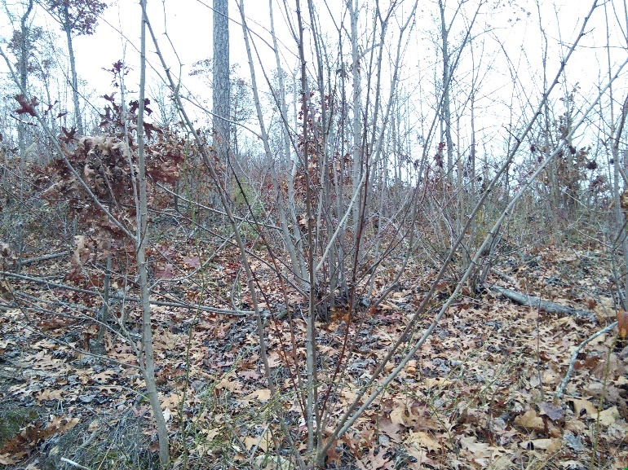
Ineffective herbiciding- Brawley project

Time for a New Vision
Far from being innovative or flexible, the Foothills Project is a retread of the same silvicultural goals and practices that have been going on for decades that have invited increasing public scrutiny. The difference this time is that the agency wishes to hide from this scrutiny. If the agency were confident about continuing its current path, it would not seek to overturn what public trust is has build under a veil of secrecy. We call on the Chattahoochee to reconsider Foothills and renew a commitment to transparency. Only then can it get past a management paradigm that has met with mixed success.

Sincerely,
Davis Mounger
On Behalf of Tennessee Heartwood

George Meredith Jemison, George Henry Hepting. Timber Stand Improvement in the Southern Appalachian Region. US Department of Agriculture. Misc. Publication 693. 1949.
“CALCIUM CONTENT OF HARDWOOD LITTER FOUR TIMES THATFROMPINE;NITROGENDOUBLE”. Research Notes of the Southern Research Station. No.14. US Department of Agriculture. 1952. https://www.srs.fs.usda.gov/pubs/osn/osn_se014.pdf
“Pignut Hickory” Glendon Smalley. USDA Technical Report. http://dendro.cnre.vt.edu/dendrology/USDAFSSilvics/19.pdf
“Characteristics of Black Bear Dens in the Southern Appalachian Region” William G. Wathen, Kenneth G. Johnson and Michael R. Pelton. Bears: Their Biology and ManagementVol. 6, A Selection of Papers from the Sixth International Conference on Bear Research and Management, Grand Canyon, Arizona, USA, February 1983 (1986), pp. 119-127
Forest Service website. http://www.fs.fed.us/eng/road_mgt/overview.shtml. Date accessed: April 21, 2013.
Marsh, D.M. et al. 2005. Forest Roads as Partial Barriers to Terrestrial Salamander Movement. Conservation Biology 19(6). http://fwf.ag.utk.edu/mgray/wfs493/Marshetal2005_ForestRoads.pdf
Semlitsch, R.D. et al. 2007. Salamander abundance along road edges and within abandoned logging roads in appalachian forests. Conservation Biology 21(1). http://www.leap.missouri.edu/MOLEAP/pubs/Semlitsch%20etal.%202007.pdf
Madej, M.A. 2001. Erosion and sediment delivery following removal of forest roads. Earth Surface Processes and Landforms 26: 175- 190. http://pubs.er.usgs.gov/publication/1008202
Runoff from storm events is also significantly decreased (Lloyd, Lohse, Ferre, 2013). Lloyd, R.A. et al. 2013. Influence of road reclamation techniques on forest ecosystem recovery. Frontiers in Ecology and the Environment.11(2).

