Proposed Acton for Lolo National Forest
To whom it may concern,

I am speaking on behalf of a handful of avid backcountry snowmobilers located in the greater Missoula area. I am very familiar with the areas I am discussing with you and would be more than happy to be reached out to for further comment weather that be in person or via email or phone call. I want to make sure our collective voice is heard and that the Forest Service reads and interprets this letter and takes this into immense consideration when coming to a final decision travel plan. I hope the final decision is made with the interest of Montana’s diverse group of recreators at heart and not from pressures from special interest groups whose interests and full-time jobs are to flood your offices with false information and demand letters. At the end of the day we are all people who wish to enjoy exploring our vast mountains on our snowmobiles. Snowmobiles do not harm these ecosystems. We ride on top of 10 feet of snow and when the snow melts so, do out tracks. A pack string of horses and summer backpackers pose more damage to these sensitive ecosystems than our machines do. During the winter months animals that call these areas home find lower elevation areas to winter. We do not disturb them. If anything, snowmobilers are stewardess of the areas we recreate in.
Montana boasts over 30 million acres of state and federal lands which amasses nearly one third of the entire state, some of which span millions of acres of vast mountains. Of that 30 million acres, over the snow access has been significantly reduced since the early 2000s and at this current juncture over the snow access is facing more cuts in open and available spaces to backcountry ride snowmobiles. The 1986 forest plan has 223,915 acres with an RWA designation. The current plan has identified 1,157,133 additional acres for RWA consideration. My personal opinion is that we have enough wilderness and RWA designated wilderness in Montana. Why do we need more? For the people who call Montana home, our access to these areas is at severe risk. Multi use recreation is facings a large threat in Montana and that directly affects the recreation opportunities people like myself have here. I have witness over the year’s some areas my parents and grandparents use to explore via over the snow motorized use dwindle away. I am fearful that within the next few years we will not have any open backcountry areas to enjoy operating our snow machines on. That is not right.
Snowmobiling is much more than riding on a groomed trail. The only times I use a groomed trail or a logging road is to seek access to Alpine country. Such country where you can ride up on top of a ridge and overlook thousands of acres of pristine winter wonderland just waiting to be explored. Please do not take this opportunity away from us. We are your working-class citizens of Western Montana and we look forward to riding our machines in the vast backcountry that is our back door. If this pace keeps up our backcountry access will be eliminated. The unfair thing is that we single out people of older age or people who are not physically able to physically explore these areas without the use of snowmobiles
The purpose of this comment is to discuss over the snow access to areas that have historically been accessible to over the snow motorize travel, but are in jeopardy of losing that in and around the Great Burn RWA along the Montana and Idaho Boarder and the Beaver Ridge area. Snowmobiling is the least impactful method of motorized access. The areas I outline are very remote and without over the snow access only a very select few individuals have the physical ability to enjoy this beautiful country. We should not be looking to single out people from exploring areas that have historically been open for multi-use, or areas that do not meet official wildness designations. We do not damage the country we explore when we are on the snow. We pay taxes to use our public lands and shutting people out from being able to enjoy this country is not right.
First, I would like to bring attention to the area accessible via the Hoodoo Pass. I would like to see this area reopened to over the snow access to the following areas: Hoodoo pass south east along the MT ID boarder to include over the snow access to Hoodoo lake, Hidden Lake, Heart Lake, Lightening Peak, Pearl Lake, Dalton lake, Trio Lakes, and Goose Lake over towards Crater Mountain. This area is outlined on Exhibit A

Secondly, I would like to bring attention to the area accessible via Fish Creek road and Surveyor Creek. I would like to see over the snow access available to the following areas: Schley Mountain south west to the Montana Idaho Boarder to include the Irish Basin, Kid Lake and the Kid Lake Basin (ID), Kelly Lake (ID) Cedar Logs Lake, Mud Lake, Admiral Peal, and Mile Post 711. Also accessible via Survey Creek over the snow access south down the MT ID board to include the Cache Creek basin, Cache Lake, Leo Lake and Shale Mountain. This area is outlined on Exhibit B and C.

Third, I would like to bring attention to the area accessible via Shot Gun Creek (HWY12) and FS road 500. I would like to see over the snow access available to the following areas: The Williams Range to include Williams Lake, Williams Creek, Rhodes Peak, Blacklead Mountain to include Goat Lake and Silver Creek and Cayuse creek drainages. This area is outlined on Exhibit D

Lastly, I would like to bring to attention the Beaver Ridge area accessible from Lolo Pass and Shoot Creek. I would like over the snow access available to the following areas: Beaver Ridge basin to include Beaver Ridge, Beaver Lake, Shoot Creek, South fork of Spruce Creek, Spruce Creek, Spruce Lake, Grimes Lakes, and Moose lake. This area is outlined on Exhibit E.

Thank you for your consideration in keeping snowmobiling open in Western Montana.

Exhibit A
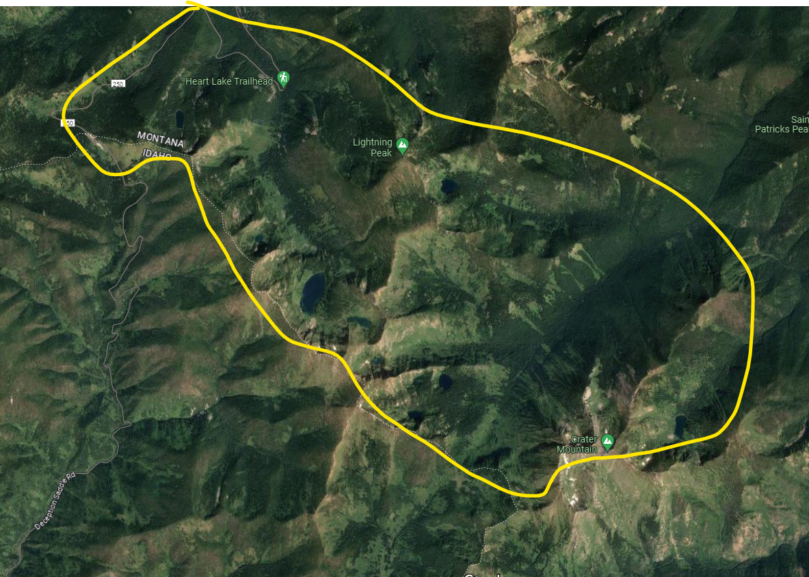

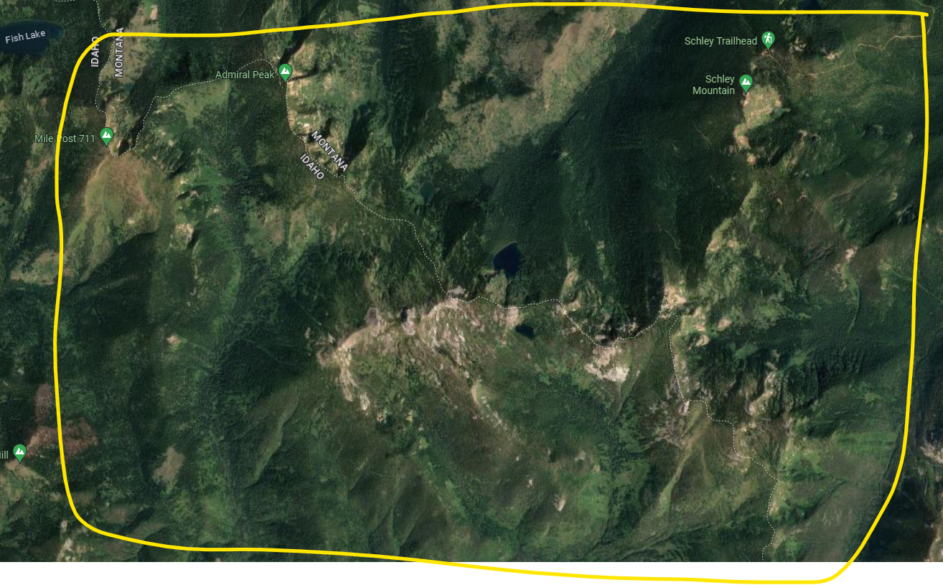
Exhibit B

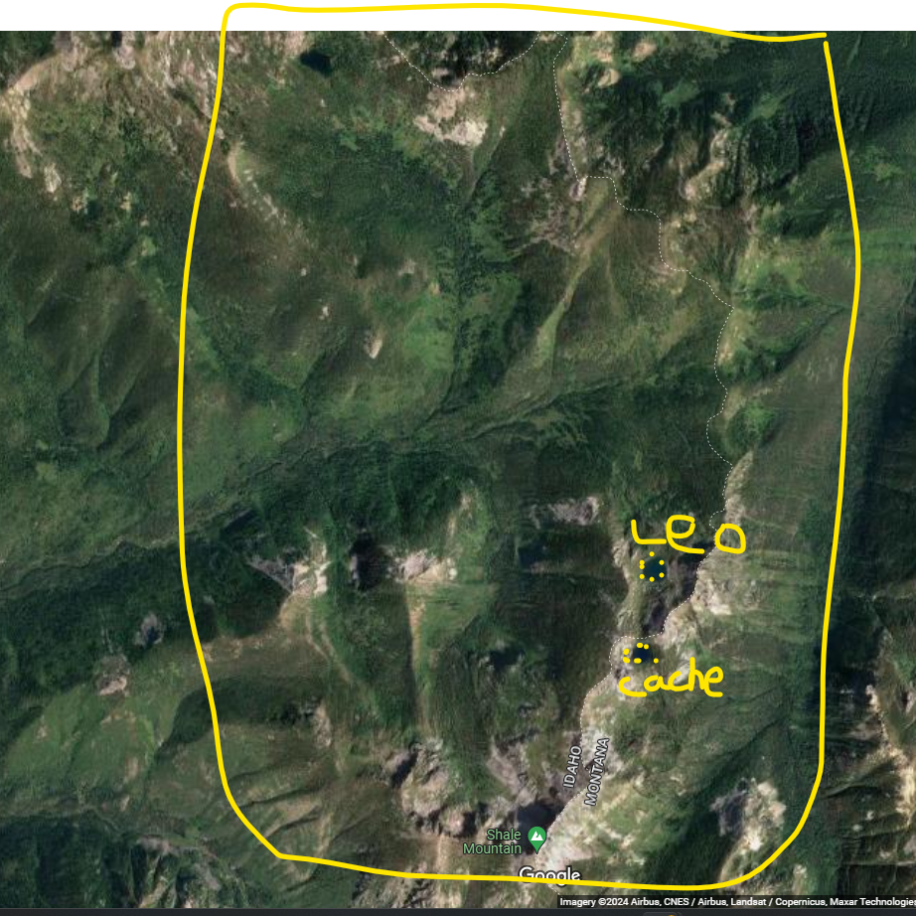
Exhibit C

Exhibit D
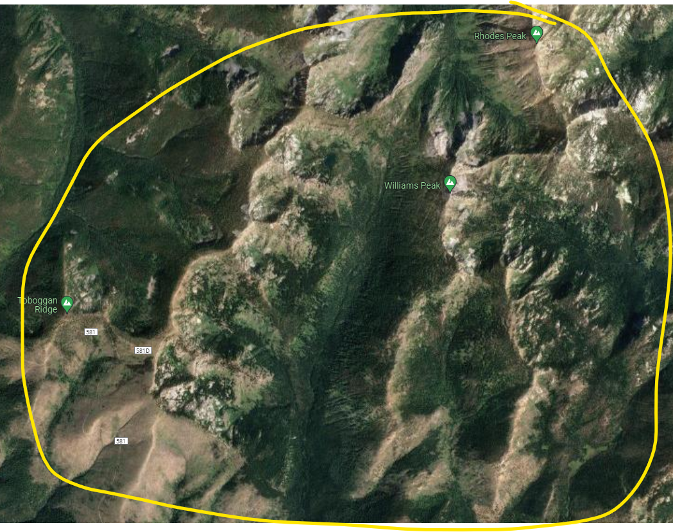

Exhibit E
