When Midas Gold Corp. asked me to join its board six years ago as an independent director, I felt the need to thoroughly kick the tires on the project and the company proposing it. As a result of that due diligence, I concluded that Stibnite is a unique mining project that will restore environmental damage done by historic mining in the district while bringing immense economic benefits. My confidence that this project should be approved has grown significantly as I have continued to rigorously vet it as an independent board member. For these reasons, I strongly support Alternative 2, the modified Midas Plan of Restoration and Operations (PRO).

I’ll first explain how I came to serve on the board, which will provide relevant context to then describe in more detail why I support the modified PRO.

It’s rare for someone to join the board of a mining company at the suggestion of a conservation group, but that is what happened in my case. Midas extended the invitation at the suggestion of leaders at the Idaho Conservation League (ICL).

ICL suggested me because of my unique background. More than 100 years and five generations ago, my family was one of the first to drive livestock from the Wood River Valley over Galena Summit and into the Bear Valley for summer grazing northeast of what is today Stanley. The famous steaks at the Pioneer Saloon in Ketchum are served on plates that have the brands from the early ranching families in the area on them. The “A” on the plate is the Allred brand. The cabin the family lived in during those summers was about 50 miles south of the proposed Stibnite Gold Project in what my family called the “sheep preserve”. I grew up on stories of that early family history. I was taken by the images the stories evoked of what that country was like a century ago. The story of Silas Allred fishing, for example, with a pitchfork because the salmon were so thick in the nearby streams instilled in me a reverence for the wildland experiences this region can provide.

My love for the unique beauty and environmental values of central Idaho’s high country deepened as I accumulated my own experiences there. Growing up, I backpacked, camped, and fished there with my dad, grandma, aunts and uncles, and cousins. On many backpacking trips, my dad told stories of maintaining the trail we were hiking when he was a Forest Service employee in the 1960s and 1970s. Frequently, we would stop for a break at a crosscut he’d made where a tree had fallen across the trail and he would instruct me on the use of wedges to keep the chainsaw from hanging up. Camping where he had camped years before on a trail maintenance trip, he would tell the story of how Devil, the family’s spirited Palomino gelding that the Forest Service paid him to use, spooked at the sight of a bear. On another backpacking trip, I heard about my dad and uncles waking up in our same camping site to find only a few fish heads left from the twenty fish that had been left hanging the night before on the wire strung ten-feet high between trees. Gratefully, Dad waited until the hike out to tell me that story and the detail about the bear tracks just beyond their tent.

I more fully appreciated the uniqueness of these experiences after I graduated from Twin Falls High School in 1983. My education took me to the East Coast, the Bay Area, and Los Angeles. After completing my PhD at UCLA, I joined the faculty at Columbia University in New York City in 1995. I remember walking out of my office onto Broadway after teaching a doctoral seminar shaking my head as I wondered how I had strayed so far from my roots. I was then recruited in 1998 by Harvard’s Kennedy School of Government to occupy their first professorship dedicated to negotiation and conflict resolution.

Still missing my native Idaho, I was delighted when participants in my executive education courses from the Forest Service, BLM, and EPA pushed me to think more deeply about how to apply what I knew about conflict resolution to solving public lands problems in the west. Those discussions eventually led to an agreement with Dale Bosworth in 2002 when he was Forest Service Chief. I committed to focusing one of my graduate seminars on applying dispute resolution best practices to how the Forest Service could more effectively navigate its NEPA processes to reach sound decisions that serve the broad public interest and reduce unnecessary and dysfunctional conflict with competing stakeholders. In return, Chief Bosworth committed to making senior staff available to my students and to allowing the two students who developed the best ideas and I to brief the Chief and senior staff at Forest Service on our recommendations at the conclusion of the course.

About the same time, the Nez Perce Tribe and the North Central Idaho Jurisdictional Alliance, an organization of local governments in and around the Nez Perce reservation, asked me to mediate a broad set of jurisdictional disputes they had been having for years. The conflict had become so heated that when Governor Phil Batt intervened fearing bloodshed a few years earlier, he had twelve state troopers and two ambulances on hand. Over the course of three years, we successfully negotiated a framework for effective government-to-government relations based on mutual trust and respect.

These initial forays into dispute resolution in the west grew into many subsequent engagements. Over the next several years, I flew west from Boston regularly to spend thousands of hours as a mediator and facilitator of collaborative processes that involved all the major environmental groups, multiple federal agencies (including the Forest Service, BLM, BIA, USFWS, EPA, and Bureau of Reclamation), Tribes, ranchers, mining companies, and sportsman. The disputes ranged from R.S. 2477 roads, to hydroelectric dams, to clean water standards in Indian Country.

In 2003, with our second child on the way, Christine and I decided that I would resign my position at Harvard and we would move back home to Idaho, where I could focus on my applied work and our children could have the experiences I had growing up there. At both a professional and personal level, it was a deeply satisfying move.

Professionally, I became more involved with finding wise solutions for conflicts unique to the west. In those efforts, I became close to the Idaho Conservation League. I was invited to speak at Wild Idaho shortly after moving back to make the case that ICL could accomplish more on the ground by emphasizing collaboration when they had responsible partners to work with. I became closer to the Nez Perce, Shoshone-Bannock, and Coeur d’Alene Tribes, working with each on different initiatives. I was invited by Idaho’s five tribes and five Latino groups to help them collaborate on a range of policy issues. These experiences broadened my understanding for, and deepened my commitment to, Idaho’s diverse communities.

These relationships deepened further after the Idaho Democratic Party made the unusual move of asking me, an independent, to be their nominee for governor in 2010. In that campaign I was proud to stand with ICL publicly and often in support of their proposed Boulder/White Clouds wilderness area. At a debate sponsored by Boise’s City Club, I described how effectively ICL had worked with Congressman Mike Simpson and a diverse range of stakeholders to craft a proposal that would serve the various interests at play. I was proud to stand with the Nez Perce Tribe in opposing permits over-sized loads on Highway 12.

One of my most satisfying experiences after that campaign was founding in 2011, and then facilitating for its first seven years, the Upper Blackfoot Confluence (UBC), a collaborative partnership between three mining companies (Simplot, Bayer, and Nutrien) and two conservation groups (ICL and Trout Unlimited) to improve the Upper Blackfoot River. Given my family’s history and my own experience working summers on my family’s ranch, it was gratifying to work with Upper Blackfoot ranchers to to restore dozens of miles of native Yellowstone Cutthroat Trout habitat, work that was directed by the conservation partners and funded by the mining partners. The UBC and related work convinced me that a new era of mining was possible in which responsible, principled mining companies worked collaboratively with Tribes, conservation groups, and agencies, to cleanup legacy impacts and conduct new mining activities in environmentally responsible ways.

Personally, the move back to Idaho was also thoroughly satisfying. It gave Christine and our three kids the kind of experiences in the mountains of central Idaho that Allreds had been savoring for over 100 years. The preceding twenty years of living in several of the country’s largest metropolitan areas and the perspective that comes from being a father put those experiences into sharper relief. Backpacking, horseback riding, and fishing with the sixth generation of Idaho Allreds drove my commitment to this ruggedly beautiful portion of the earth deep into my bones. Without exaggeration, the time with Christine and our kids in the Idaho backcountry are the fondest of my life. It is impossible for me to adequately convey the satisfaction that comes from instilling in them the same sense of peace, wonder, and grounding that has come to me from feeling a deep connection to such a special place.

It was this combination of experiences, commitments, and relationships that led ICL to suggest to Midas Gold Inc. that they invite me to join the board and led Midas to follow that suggestion. It was not initially obvious to me that I should accept. There is nothing more valuable to me than my reputation as an honest broker with good relations across the range of western stakeholders who works effectively for solutions that make sense for everyone. As much as I believe that sound mining can be done in environmentally and socially responsible ways, I was cleareyed, given my experiences, that mining companies do not always conduct themselves this way.

I had long talks with friends at ICL and the Nez Perce Tribe to get their perspective. I also had extensive discussions with Midas management and board members, learning about the project in greater detail and probing their commitment to environmental stewardship and to the range of affected stakeholders, including the Tribes and local communities. The more I learned, the more confident I became that I should accept the invitation. In fact, I concluded that I had not seen a solution that served the diverse and often competing interests of western stakeholders better than the Stibnite Gold Project. I also had never engaged with a mining company with a deeper, more genuine commitment to environmental stewardship and stakeholder interests, what we now refer to as an ESG (Environmental, Social, and Governance) commitment, than Midas. I became satisfied that Midas would take the perspective of conservation groups and Tribes as seriously as I did. Six years into my experience on the board, I’m far more convinced of the soundness of this project than I was at the time.

In a world in which environmental and economic interests so often trade against one another, the Stibnite Gold Project is singular in its ability both to significantly improve the environment and bring hundreds of excellent jobs and $1 billion in economic investment to Idaho. Mining operations in the Stibnite district began about the same time Silas Allred homesteaded the Cove Ranch and began driving livestock to within 50 miles of the project site. We should be frank and acknowledge that historic mining (and sometimes grazing) was practiced in ways that had devasting impacts on an ecosystem that I love. Just a few miles from the Frank Church Wilderness, the Yellow Pine pit is an ugly scar on the landscape that blocks migration to what had been historically productive salmon spawning habitat in Meadow Creek. The historic tailings and adits release unacceptable levels of mercury and arsenic into tributaries feeding the East Fork of the South Fork of the Salmon River. Blowout Creek contributes enormously to sediment loading in those streams.

As we frankly acknowledge the impacts of historic mining in the Stibnite district, we should similarly acknowledge that no credible, superior alternative exists to the modified Plan for Restoration and Operations for addressing those impacts. Restoring this spectacular place on earth will require tens-of-millions of dollars and years of skilled, dedicated commitment. To believe that there is another route to dedicating the money and commitment required for this work is to believe in a fairy tale. It is the prospect of operating a financially viable mining operation that creates the only realistic way that the funds to undertake such a mammoth cleanup can be raised.

Midas Gold Corp’s management and board, and the management and boards of its subsidiaries, recognize that there will not be, and should not be, any opportunity to develop a financially viable mine without a corresponding commitment to, and investment in, restoration. Because of this recognition, we have been frank with shareholders that the commitment to restoration specifically, and ESG generally, is the only way this project can be permitted and operated. Shareholders not only recognize this, they are attracted to invest in Midas because they understand that sound environmental stewardship and collaborative engagement with conservation, tribal, and community interests is a sound mining business model in 2020 and beyond.

The part of my experience with Midas of which I’m most proud is the degree to which we have pursued a plan that is not “just enough” environmental restoration to get a permit. I was proud of Midas’ original PRO and the commitment in contained to frontload much of the restoration, including restoring fish passage at the beginning of the project. But I have particularly relished, encouraged, and participated in the relentless push to optimize the project that has resulted in the modified PRO, a plan that is even better both economically and environmentally than the original PRO. It’s the product of tens-of-thousands of hours of engagement with Tribes, conservation groups, community members, and others that generated thousands of pages of environmental baseline testing and analysis, trade-offs analysis, and optimization studies reflecting an investment of tens-of-millions of dollars.

Some in the mining industry critique Midas’ pro-active approach in advance of the Draft Environmental Impact Statement (DEIS). Since some tribes and conservation groups will demand more whatever a mining companies offer in the DEIS, they argue, companies should hold back some commitments to the environment and community to offer later in response to the inevitable demands for more. I’m proud that this has not been the Midas way. We have worked pro-actively to optimize early in the process because we don’t need our arms to be twisted to do the right thing. It’s how we want to conduct business for ourselves and the standard we want to set for the industry.

From my decision to accept the invitation to join the Midas Gold Corp’s board until today, I have been driven by a long-term vision. Eighty years from now, at the turn of the 21st to 22nd century, I want my children’s children to hear not only Silas Allred’s stories of how the central Idaho high country teamed with wildlife when he first came into it at the turn of the 19th to the 20th century. I want them to also hear the story of how early in the 21st century, I worked to make sure we restored the environment from the impacts that European Americans’ created in the first hundred years we were here when we were too focused on profit and too little attendant to protecting the remarkable world we inhabit. My vision is for my children’s children to hear those stories as their parents take them camping in the Bear Valley, backpacking in the Frank Church Wilderness, and fishing in a restored Meadow Creek thick with spawning salmon.

My family and I recently moved back to the East Coast when I accepted an offer to become the Executive Director of the National Institute for Civil Discourse in Washington D.C. Here, I work with Tom Daschle, Christie Todd Whitman, Dan Glickman, Katie Couric, Colin Powell, Madeleine Albright and others from our board to build the nation’s capacity to engage our political differences more constructively. The intensity of a world capital supercharged by partisan rancor with which I contend daily has me again longing for the peace and serenity of Idaho’s backcountry. Even when not physically there, the connection to it, running from my family’s past and to its future, provides solace.

I strongly support Alternative 2, the modified Plan of Restoration and Operations, so that future generations, including of my family, can experience the restored environmental values of a spectacular corner of the planet. It is the best option for achieving that vision.

Sincerely,

Keith Allred

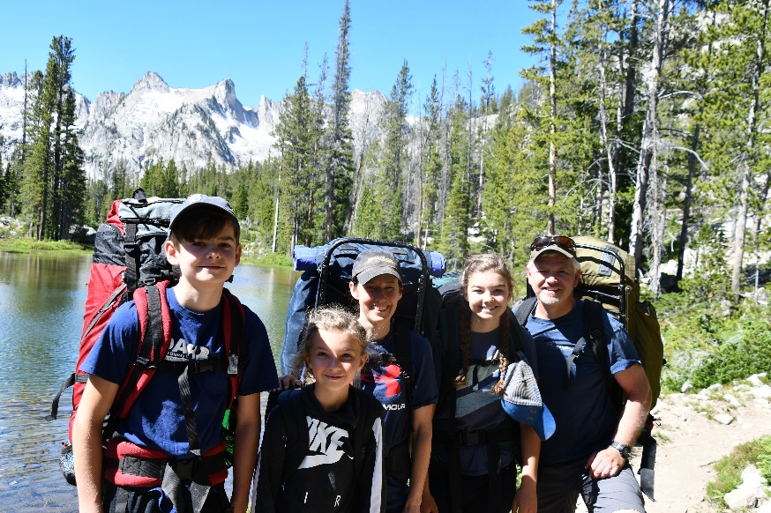
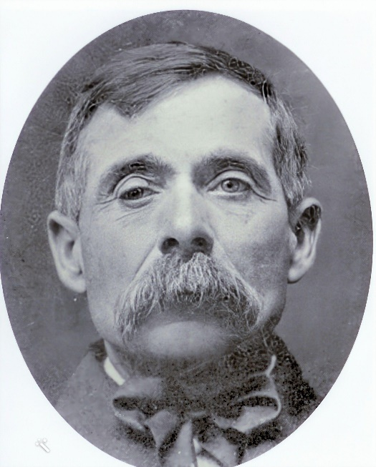
Keith & Christine Allred Family
5th and 6th Generation of Idaho Allreds
Alice Lake, Sawtooth Mountains
July 2019

Silas Allred
1st Generation of Idaho Allreds
Blaine County
Circa 1910

