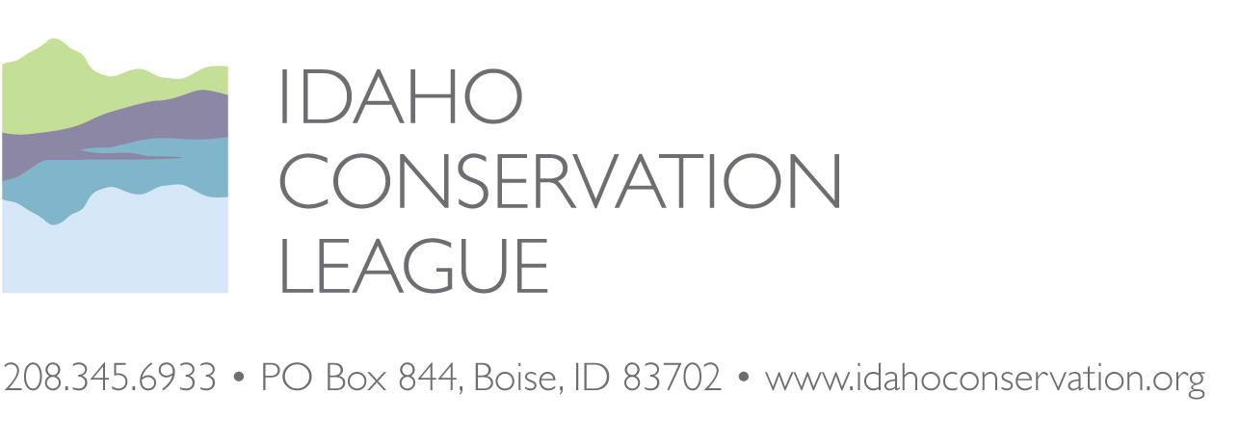
September 18, 2020

Ms. Erin Phelps
New Meadows District Ranger
Payette National Forest
P.O. Box J
3674 Highway 95
New Meadows, ID 83654
(208) 347-0300

Electronically Submitted Through Project Webpage: https://cara.ecosystem-management.org/Public//CommentInput?Project=36507

RE: The Idaho Conservation League’s Scoping Comments for the Rapid River Travel Management Project

Dear Erin:

Please accept the Idaho Conservation League’s scoping comments for the Rapid River Travel Management Project on the New Meadows District of the Payette National Forest. Since 1973, the Idaho Conservation League (ICL) has a long history of involvement with public lands issues. As Idaho’s largest state-based conservation organization, we represent over 30,000 supporters who advocate for responsible travel management and the protection and restoration of natural resources, particularly in wild and natural settings like those associated with the Wild Rapid River.

The Idaho Conservation League (ICL) has a long history of involvement with Rapid River Travel Management planning. Conflicting management direction, specifically between the Act establishing the Hells Canyon National Recreation Area in regards to Wild and Scenic Rivers (36 CFR 292.44(b)(2)) and the Payette National Forest Snow Free Travel Plan Record of Decision for the Council and New Meadows Ranger Districts (USDA Forest Service 2009) culminated in litigation and a subsequent settlement between ICL, The Wilderness Society, the Hells Canyon Preservation Council and the U.S. Forest Service. We appreciate the Forest Service dedicating resources to craft a lasting resolution on the issue of travel management in the Rapid River watershed through this Environmental Assessment.

We believe that an emphasis on non-motorized travel within the Wild Rapid River corridor and throughout the adjacent watershed is appropriate for several reasons, including the protection of water quality and fisheries, traditional and cultural resources, and to honor Congress’ intent when the Rapid River was designated Wild when it established the Hells Canyon National Recreation Area (HCNRA) in 1975. The Forest Service should seek to provide motorized recreational opportunities on the watershed divide and outside of the Raid River Drainage. Our scoping comments for the forthcoming analysis are found in the following pages, as well as potential alternatives that should be studied to help resolve this on-going issue.

Thank you for considering our comments, and we look forward to working with the Payette National Forest on this and future projects. Should you have any questions regarding our comments or alternative proposals, please do not hesitate to contact us.

Respectfully submitted,
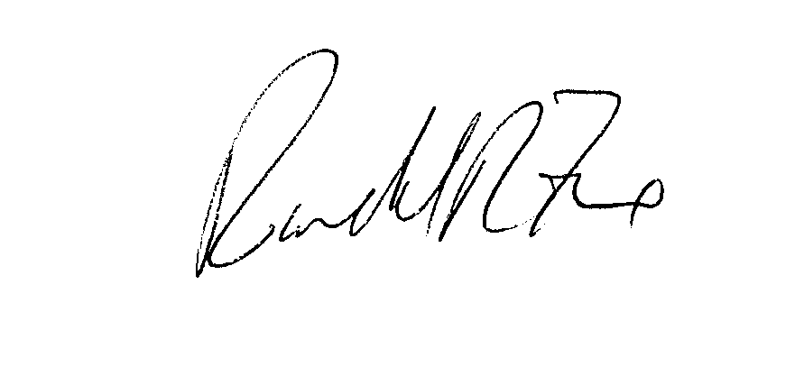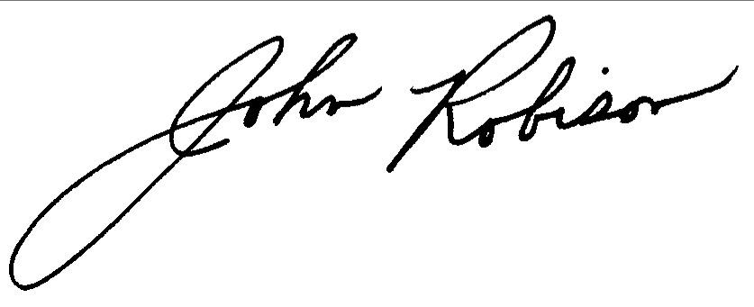
Randy Fox John Robison
Conservation Associate Public Lands Director
Idaho Conservation League Idaho Conservation League
rfox@idahoconservation.org jrobison@idahoconservation.org
(208) 345-6933 x 110 (208) 345-6933 x 113

The Idaho Conservation League’s Scoping Comments for the Rapid River Travel Management Project

Rapid River Travel Management
The Payette National Forest (PNF) intends to address the travel restrictions and proposed use designations for Trails 177, 183, 184, 187, 188, and 362. This issue arose when the PNF wrongfully designated these trails for motorized travel and recreation within the Congressionally designated Wild Rapid River corridor (USDA Forest Service, 2009). The Hells Canyon National Recreation Area (HCNRA) Act of 1975 (PL 94-199) and its implementing regulations paid special attention to the Rapid River Drainage, its water quality, and its fisheries given the significance of the watershed to the overall anadromous fish populations of Idaho. As stated in 36 CFR 292.44(b)(2), motorized and mechanized travel are not allowed in the designated Rapid River Wild and Scenic River Corridor:

(b) Wild and Scenic Rivers. The following standards and guidelines apply to the use of motorized and mechanical equipment in the Wild and Scenic Rivers category in the HCNRA.

(2) The use of motorized and mechanical equipment on designated Forest Service roads, trails, and airstrips is prohibited on wild and scenic river segments classified “wild” except as provided for by the authorized officer upon a determination that such use is necessary for the administration of the river or to protect and enhance the values for which the river was designated.

The HCNRA Act and its implementing regulations clearly supersede the Snow Free Travel Plan adopted by the Payette National Forest in 2009. The Forest Service inappropriately designated the trails at issue for motorized travel. The scoping documents for the current project indicate the Forest Service intends to honor these stipulations by removing Trail 177, as well as Trail 362, from motorized/mechanized consideration. However, the Forest Service proposes to designate sections of trails 183, 184, 187, and 188 outside the Wild and Scenic River corridor for motorized travel. Given the topography in this area, we are concerned that designating trail segments up to the river corridor boundary for motorized use will create additional conflicts and resource damage. In our experience in similar situations and geographies, signage, designated turn-arounds locations and barriers will not discourage motorcyclists or mountain bikers from riding another quarter-mile to reach the Wild and Scenic Rapid River. Law enforcement officers rarely travel to this remote region of the forest so it is hard to imagine that the proposed travel designations will be adequately enforced.

The Rapid River Inventoried Roadless Area (IRA) encompasses 78,522 acres, split between the Payette National Forest (57,676 acres) and the Nez Perce-Clearwater National Forest (20,846 acres. With only 5.8 miles of unclassified road and 0.1 mile of classified road within the IRA boundary, the natural integrity and appearance of the area remains high. This remote IRA retains its natural complexity and wild character due to the, “limited access and the relative ease of control at access points...contribute to the manageability of the area,” (Appendix C, Payette National Forest Inventoried Roadless Areas, p. c-236). Amending the Rapid River Travel Management Plan to allow for single-track motorized/mechanized travel and recreation within the IRA and Rapid River watershed would effectively diminish these attributes, creating additional management challenges for an agency with ever decreasing and limited capacity.

The Rapid River IRA is also a popular destination for backcountry hunters, with limited motorized access providing sportswomen and men with the opportunity to hunt in a remote, wild area without motorized disturbance. This hunting unit is one of the few in Idaho that allows hunters to purchase over-the-counter elk and deer tags. Motorized access would alter the character of the area, likely attracting hunters less interested in backcountry hunting opportunities.

Big-game does not represent the sole wildlife species that would be potentially affected by motorized access. Approximately one third of the IRA consists of potential habitat for lynx, a federally designated Threatened species. This habitat is generally found on the upper slopes of the major drainages. Further, “Habitats for several Region 4 sensitive species are also found in the roadless area. Unconfirmed sightings of wolverine have been reported, and the remoteness of the area suits the animal’s basic requirements. Habitat also exists for flammulated owl, white-headed and northern three-toed woodpecker, northern goshawk, mountain quail, boreal owl, great gray owl, and spotted frog,” (Appendix C, p. 237). The Rapid River and its tributaries found within the IRA also contain habitat for three Threatened fish species - steelhead trout, Chinook Salmon, and bull trout. Westslope cutthroat trout are also found within the IRA. Because such a wide variety of federally listed, sensitive, or indicator species are found within the IRA, we recommend the Forest Service consult with Idaho Fish and Game, U.S. Fish and Wildlife Services, and NOAA-Fisheries regarding motorized recreation and access in the IRA.

Outstanding Remarkable Values (ORVs)
When the Rapid River was designated Wild in the HCNRA Act, a comprehensive Wild and Scenic River study was not completed to identify the Outstanding Remarkable Values (ORVs) found within the river corridor and on adjacent lands to help determine Forest planning and management direction. The PNF conducted a resource management assessment to identify the ORVs associated with the Rapid River so management could be directed to protect or enhance these values. The Forest Service concluded that these ORVs are:

- Traditional Use, Cultural
- Prehistoric Cultural Resources
- Historic Cultural Resources
- Scenery
- Fisheries
- Water Quality

We note that the Forest Service identified Water Quality as an ORV, one of the few water bodies in Idaho found to meet these criteria. Additional uses/resources evaluated but not identified as an ORV were:

- Recreation
- Geology
- Wildlife
- Vegetation/Botany

The assessment of ORVs for the Rapid River are found in Appendix K of the Hells Canyon National Recreation Area Comprehensive Management Plan FEIS. This analysis unequivalently determined that the Forest Service management plans should be developed to protect and enhance the water quality, fisheries, Traditional cultural use, and prehistoric and historic cultural resources over the public’s desire for expanded recreation. The Idaho Conservation League recommends the Forest Service honor its own resource determinations by adopting a management plan that preserves the identified ORVs by properly managing non-motorized/mechanized recreation activities.

While recreation is clearly a component of the landscape and Forest Plan, recreation itself was not identified as an ORV and must be managed in a way that supports the identified ORVs. The Forest Service proposal partially accomplishes this in part by clarifying routes that should be non-motorized but errs in setting the public and Forest up for failure by allowing motorized access to the very edge of the corridor that has a high likelihood of violations and resulting negative effects to the ORVs.

To be clear, ICL has supported the designation of motorized and mechanized trails that lead up to and stop at the boundaries of protected areas. These examples include cherry stems for motorized vehicles in Wilderness Study Areas and designated Wildernesses. However, these situations include additional elements such as obvious, historical and enforceable turn around locations and topographies that prevent illegal motorized use within the protected areas, such as overlooks above steep canyon walls. It does not appear that these elements are present in the proposal to authorize motorized use to the Rapid River Wild corridor.

When Congress established the HCNRA, designating the mainstem and West Fork of the Rapid River as Wild, it did so with the intent to protect water quality and fisheries habitat associated with anadromous fish species like Chinook salmon and steelhead, and native Bull trout. All three species have since been listed as Endangered, Threatened, or Sensitive since the Wild Rapid River was established, making this unique landscape even more critical for habitat conservation and water quality protection. The Conference Report for the HCNRA Act reflects the special attention paid to the Rapid River’s water quality and fisheries, and the Forest Service’s obligation to carefully manage adjacent public lands within the watershed. As stated on page 10 of the Committee on Interior and Insular Affairs, House Report No. 94-607 (October 31, 1975) (emphasis added):

A specific provision is included which prohibits the Secretary from undertaking or allowing any activities on Federal lands which would impair the water quality of the Rapid River. Although the National Forest lands outside of the wild river corridor along the main stem and portions of the west fork of the Rapid River are not included in the recreation area, the Committee intends through this section that the Secretary exercise particular care in the management of the lands of this drainage. The salmon hatchery located along the river is vital to the management of this fisheries resource, and the water quality of the river must be assured.

While adjacent lands and watersheds are not directly supported in the Wild and Scenic Rivers Act of 1968, Congress provides us with its justification for including the Rapid River in the HCNRA Act, as well as their intent to protect the lands that support and maintain these justifications. We strongly recommend the Forest Service adopt a travel management policy that honors the intent of Congress who exhibited the foresight to protect this remote and pristine river and watershed.

Roads and motorized trails are well documented sources of erosion and sedimentation that adversely impact water quality and fisheries habitats. For any and all alternatives, the Forest Service needs to fully analyze the potential impacts of recreation to the water quality and fisheries of the Wild Rapid River. These analyses should include slope/gradient studies to determine the feasibility of constructing stable and sustainable turn-around areas outside the river corridor in the steep Rapid River drainage. The Forest Service should also assess the impacts of existing trails, both motorized and non-motorized, to see if additional maintenance or trail design upgrades are needed. We also recommend the agency assess the probability of user-created trails becoming established, analyze the feasibility of restricting motorized travel beyond the current and proposed designated turnaround points and factor in the agency’s ability to enforce these closures. Further, the Forest Service should propose measures to avoid the formation of user-created trails through outreach, education and enforcement, develop protocols to detect unauthorized routes, and establish triggers for the corrective actions and the timely rehabilitation of unauthorized routes. Finally, we suggest the Forest Service include a comprehensive study of the agency’s capacity and ability to construct and adequately maintain both non-motorized and motorized/mechanized trails in this remote area. ICL recommends the Forest Service retain the current non-motorized status within the Wild Rapid River watershed to protect water quality and avoid sedimentation directly attributable to motorized recreation.

Project Alternative
We do not believe that the proposed action is a sensible or tenable solution. Designating the sections of trails 183, 184, 187, and 188 outside the Wild and Scenic River corridor for motorized and mechanized travel and ending those designations at the corridor boundary should be rejected for several reasons. First, it is unrealistic to expect that motorcyclists and mountain bikers will turn around and go back the way they came when they reach the boundary of the river corridor. Constructing turn-arounds and placing barriers will not solve this problem. Violations will occur frequently as law enforcement officials are rarely going to patrol this remote region.

Secondly, the proposed action violates the intent of the Hells Canyon National Recreation Area Act. While it is true that the regulations implementing the HCRNA only explicitly prohibit motorized and mechanized use in the designated Wild and Scenic River corridor, the Conference Report for the Act indicates that Congress also clearly intended that the surrounding lands would be given special management consideration to ensure that the Rapid River, its water quality, its fisheries, and its outstandingly remarkable values will be protected.

Third, land management consistency is paramount for successful resource conservation and enhancement. We note that all of the trails within the portions of the Rapid River Drainage that are managed by the Nez Perce-Clearwater National Forests and the Hells Canyon National Recreation Area are designated as non-motorized. We recommend that the PNF manage the upper watershed in a manner that reflects consistency amongst the three land management units and the Payette National Forest Plan. As illustrated in the scoping notice, the interior of the watershed is allocated to the Aquatic/Terrestrial Management Prescription Category in the Forest Plan. Eliminating or minimizing motorized travel would allow for stronger water quality and fisheries protection while maintaining the remote nature and wild character of the watershed.

Although the Rapid River watershed has not been officially recommended for wilderness designation by the Forest Service, it has been identified by ICL and other conservation organizations as a potential wilderness area. Allowing motorized access in the Rapid River watershed would decrease the value of many of the identified Outstanding Remarkable Values and create obstacles that may affect a future wilderness recommendation and designation.

Finally, the proposed action does not actually increase the number of high quality recreational opportunities because it does not result in the kinds of loop opportunities that motorcyclists and mountain bikers often seek. Instead, the proposal mixes potentially discordant uses across the landscape and increases the risks of travel management violations and resource damage compared to the status quo. With expanded motorized recreation to the edge of the corridor, the quality of the experience for recreationists on these trails will be degraded.

Instead, we propose an alternative that consolidates non-motorized use in the interior of the Rapid River Drainage and are open to exploring new opportunities for motorized use outside of the interior of the watershed (Figure 1). Specifically, we propose the following alternative:

- Segments of trails 177, 183, 184, 187, and 188 within the Rapid River Drainage (including segments inside and outside the designated Wild and Scenic River corridor) should be permanently designated for non-motorized and non-mechanized travel only.

- Additionally, we propose changing the travel designations of the following trails from motorcycle use to non-motorized travel only: the segment of trail 187 from its junction with road 112 to its junction with trail 328; the segment of trail 328 from its junction with trail 187 to its junction with trail 362; and the segment of trail 362 from its junction with trail 328 to its junction with trails 228, 229, and 517.

- The segment of trail 279 that is currently designated for motorcycle use should be changed to non-motorized travel only.

- The segment of trail 191 that is currently designated for ATV use should be designated for non-motorized travel only. ATV users frequently go past the end of the designated route at Paradise Flat, violating the travel management plan.

- To provide alternative motorized recreational opportunities, we are open to the designation of the following non-motorized trails for motorcycle use: the segment of trail 178 between its junctions with trails 519 and 358; trail 226; the segment of trail 229 from its junction with road 129 to its junction with trail 231; and trail 358.

It appears that some of the proposed motorcycle trail designations may cross corners of the designated Wild and Scenic River Corridor near Lick Creek Lookout. This could be rectified by rerouting these trail segments outside of the Corridor. While there is a population of northern Idaho ground squirrels in this area, we wonder if decommissioning old trail segments could mitigate any new trail segments. The Forest Service should consult with Idaho Fish and Game and the U.S. Fish and Wildlife Service regarding this possibility.

We recommend that the Forest Service develop this alternative, assess the environmental outcomes and compare this with other alternatives. At the end of this process, the selected alternative should accomplish the objectives of protecting the Rapid River’s water quality, its fisheries, and its outstandingly remarkable values, while providing high-quality recreational opportunities consistent with these values. In order to comply with the Payette Forest Plan’s emphasis on aquatic and terrestrial habitat preservation within the interior of the watershed (MPC 3.1) and semi-primitive recreation outside the watershed (MPC 4.1c), the selected alternative should also largely consolidate non-motorized recreational opportunities within the interior of the watershed and consolidate motorized recreational opportunities on the watershed divide and outside of the watershed. The selected alternative should also create additional loop opportunities for recreationists that can be more easily enforced and reduce potential user conflicts. We are aware that other entities, individuals and the Forest Service may propose other alternatives or components of alternatives. ICL would be interested in listening to these proposals and building on areas of agreement.

Figure 1. ICL’s Proposed Rapid River Trails Project Alternative
