Public comment for East Crazy Inspiration Divide Land Exchange

- It is not convincing that the exchange of Parcels 8, 9 and 10 for Parcel J is for the benefit of the public. Some negative points:
  - It is not consolidation of lands
  - The Forest Service already holds an easement for the trail in sections 9 and 15 so your statement that the FS will be able to more efficiently manage the trail corridor is weak.
  - The majority of parcel J is already subject to a conservation easement that preserves habitat and open space values.
  - The SW corner of Parcel 8 intrudes very close to Inspiration Divide Trail, reducing the primitive nature of the trail if Parcel 8 is developed.
  - Parcels 8, 9 and 10 are nearly entirely composed of ridgetops which are wildlife corridors
  - The convoluted easterly boundaries of Parcel J are ridiculous as they attempt to hug the boundary of the trail. Without the benefit of a survey, it is not possible to ensure that the trail is located on the lands being acquired.
  - The new boundaries in Sections 9 and 15 of T.7S., R.2E. will be excessively expensive to survey.
- Possible actions of reparation for the negatives introduced by the Inspiration Divide exchange:
  - There is a conservation easement on T.7S., R.2E. Section 23 (adjacent to Parcels 8, 9 and 10). Ask for a conservation easement to be placed on Parcels 8, 9 and 10 that would preserve the wildlife corridor quality.
  - Create the boundaries of Sections 9 and 15 of T.7S., R.2E. by connecting a few strategic angle points with straight lines. (See examples that follow.) Acquired lands do not need to be described as aliquot parts. (Look up Brackett Creek Land Exchange by Battle Ridge cabin if you need an example.) This would make a more suitable boundary, eliminate the need for trail re-route and greatly reduce the cost of the boundary survey.
  - Have the private party conduct the survey in Sections 9 and 15 or at least pay for it.
- The consolidation result shown in Figure 10 is impressive, but lack of administrative access from the east could make it very difficult for FS to manage the lands.
- You do not discuss the reasoning for leaving the tiny piece of private ownership in the NW corner of Section 13, T4N, R11E. It hugely detracts from the benefit of acquiring Section 13 to leave 25 acres in the creek drainage right along the trail and available for development. Possible actions of reparation:
  - A conservation easement restricting uses on the remaining private parcel would be more in line with goals for this area.
  - Make the landowner pay for the survey and posting of this tiny remainder parcel. It will be very expensive to survey and very easy for any development to creep over the boundaries unless they are well posted.
- If Sweetgrass Creek canyon remains in ownership of ranch operations, it will fit well into FS goals for the area. A conservation easement on Section 8 as a stipulation of acquisition from the FS would ensure that it isn’t overrun with development if sold to a new landowner in the future.
- The expected loss of wetland acreage from this land exchange is considerable and mitigation proposals should be included to make up for the loss.

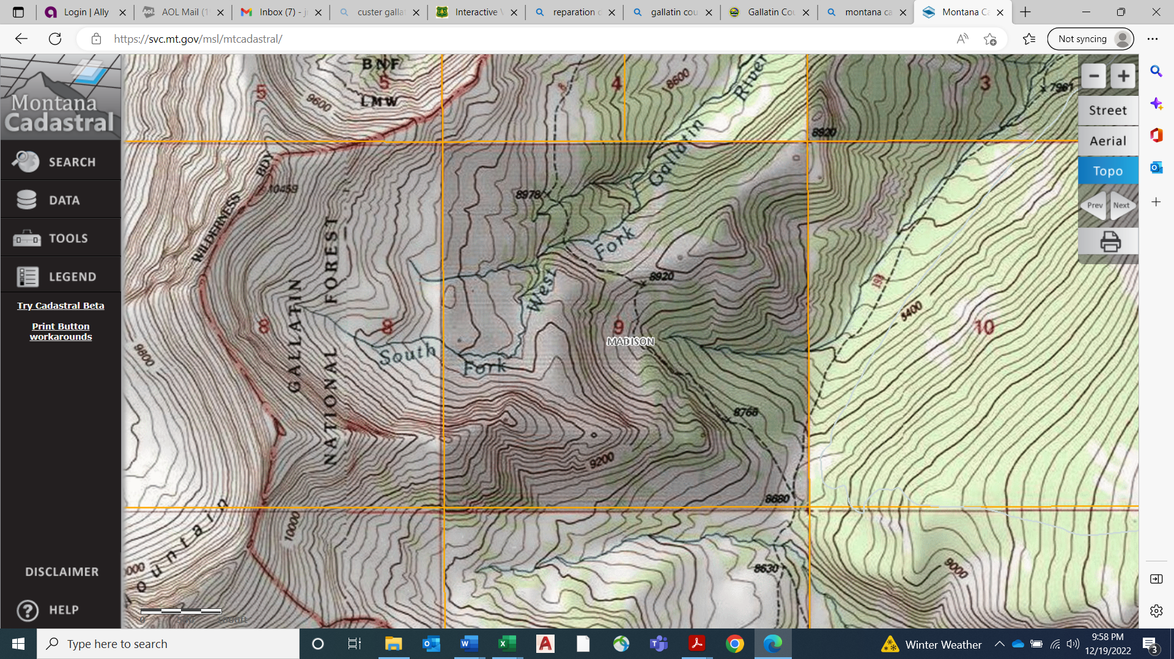
T7S, R2E, Section 9

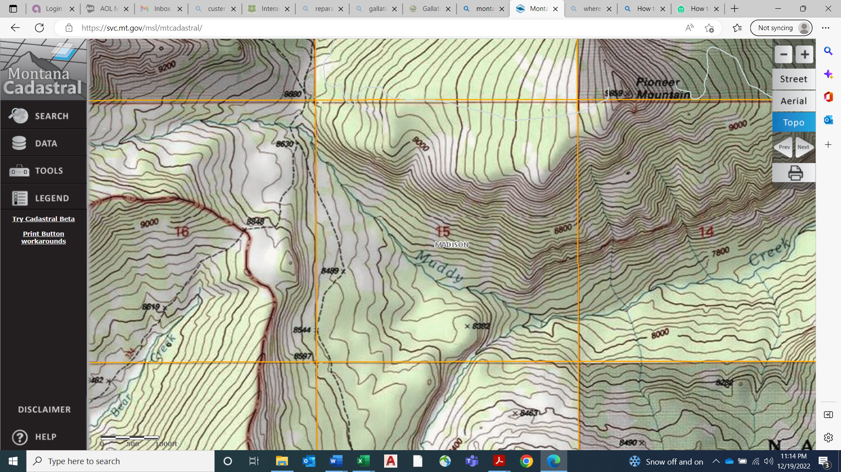
T7S, R2E, Section 15

