Rocky Mountain Elk (Cervus elaphus nelsoni)

Species Assessment Draft
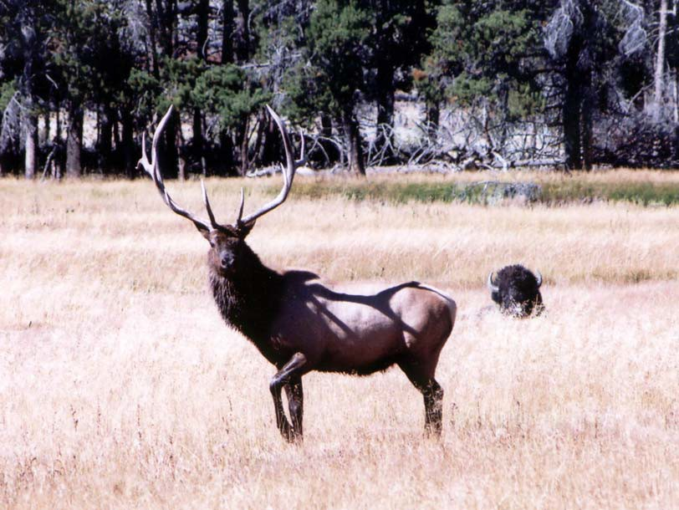
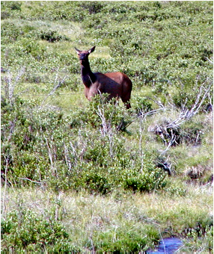
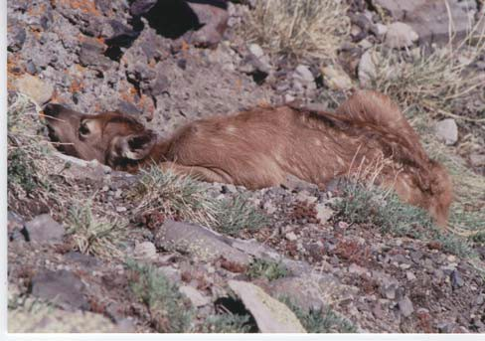

Prepared for the Grand Mesa, Uncompahgre, and Gunnison National Forests May 2005
A Species Assessment was prepared for Rocky Mountain Elk by Tom Holland1, 2001 Updated by Matt Vasquez2 with contributions by Leslie Spicer2, 2005
1 Forest Wildlife Biologist, Grand Mesa, Uncompahgre, and Gunnison National Forests
2 Biological Science Technician (Wildlife), Gunnison Ranger District

Reviewed and Edited by: Clay Speas, Forest Fisheries Biologist and Tom Holland, Forest Wildlife Biologist

Photo Credits: Top: Bull elk in Yellowstone National Park; Bottom left: Cow elk on the Forest; Bottom right: Elk calf on the Forest. Photos by Matt Vasquez.

TABLE OF CONTENTS
INTRODUCTION 5
HABITAT CRITERIA USED IN FOREST-WIDE HABITAT EVALUATION 5
2001 MIS Habitat Criteria 5
2005 MIS Habitat Criteria 5
MANAGEMENT STATUS AND NATURAL HISTORY 9
Management Status 9
Biology and Ecology 10
Wildlife-Habitat Relationships 11
Population Status and Trend 13
Historical Population Status 13
Current Population Status 13
Factors Influencing Elk Population Numbers and Causes of Population Fluctuations 14
CONSERVATION 14
Threats 14
Management Recommendations 14
LITERATURE CITED 15
APPENDICES 18

LIST OF TABLES

Table 1. | Habitat structural stage definitions | 9
Table 2. | Acres of elk habitat on the Forest based on habitat quality | 9
Table 3. | Habitat parameters for modeling Rocky Mountain elk habitat on the Forest | 10
Table 4. | 1991 Amended Land and Resource Management Plan standards and guidelines for elk habitat
 | management | 11
Table 5. | 1991 Amended Land and Resource Management Plan standards and guidelines for travel
 | management objectives for elk | 12
Table 6. | Potentially suitable Rocky Mountain elk habitat on the Forest by vegetation cover type and habitat
 | structural stages | 14

LIST OF FIGURES

Figure 1. | Elk summer foraging habitat on the Forest as modeled by R2Veg | 7
Figure 2. | Elk winter foraging habitat on the Forest as modeled by R2Veg | 8
Figure 3.  Figure 4. | Habitat types  Rocky Mountain elk population estimates and trend for nine DAUs that include acreage within | 13
 | the Forest, 1980-2003 | 15
Figure 5. | Elk population estimates compared to population objectives for all DAUs combined that include  acreage on the Forest | 15

INTRODUCTION

In the 1991 Amended Land and Resource Management Plan for the Grand Mesa, Uncompahgre and Gunnison National Forests (Forest), Rocky Mountain elk (from here on referred to as elk) were identified as a management indicator species (MIS) due to its association with early succession spruce-fir, Douglas-fir, lodgepole pine, aspen, and shrub vegetation types (USDA Forest Service 1991). For the current Forest Plan revision, elk have been retained as a MIS. MIS have a dual functionality: 1) to estimate the effects of planning alternatives on fish and wildlife populations (36 CFR 219.19 (a) (1)) and 2) to monitor the effects of management activities on species via changes in population trends (36 CFR 219.19 (a) (6)). Elk have been retained as a MIS, primarily to address travel management objectives and because of their high economic importance to the state of Colorado and communities surrounding the Forest.

This document addresses the elk’s suitability as a MIS and MIS selection criteria. This report updates the 2001 MIS Assessment for Rocky Mountain Elk on the Forest, and can be used as a supplement to the 2001 MIS Assessment. Detailed information on the species management status and natural history, biology, distribution, abundance, habitat, and ecology at the Forest-level is summarized in the current report.

The goal of this assessment is to summarize historical and current literature on elk to provide land managers and the public with an objective overview of this species within the Forest. Peer reviewed scientific literature and summarized data are the primary information sources used in this report. Local data sources (District wildlife biologists and the Colorado Parks and Wildlife (CPW) staff) were consulted to provide information on distribution, localized abundance, and habitat condition for the Forest. This assessment provides recommendations for the current Forest Plan revision in terms of integrating elk habitat requirements into Forest management planning. This report is a working document that will be updated periodically as new information becomes available from peer-reviewed scientific literature and through monitoring of this species on the Forest. For instance, CPW is conducting two long-term studies focused on elk population drivers and elk landscape distribution throughout much of the GMUG. The distribution information produced from these studies can help drive decisions regarding elk habitat management and trail based recreation on the GMUG.

HABITAT CRITERIA USED IN FOREST-WIDE HABITAT EVALUATION

2001 MIS Habitat Criteria

In 2001, potential suitable habitat for elk on the Forest was identified based on the Natural Diversity Information Source (NDIS) database produced by the CPW, which depicts seasonal concentration areas including summer and winter activity areas and major calving areas for elk. NDIS data revealed that the Forest is utilized primarily as spring, summer, and fall range by elk. NDIS data further revealed that most elk calving occurs on the Forest in sagebrush, Gambel oak and aspen ecosystems. Lower elevations of the Forest, along with adjacent BLM and private lands, were shown to provide winter range during moderate to severe winters, with the Forest providing a high percentage of winter range at higher elevations during mild winters. Essentially all vegetation types present on the Forest, especially those in the early successional stages near hiding cover, provide suitable elk habitat because they provided the habitat needs necessary to meet the life requirements of elk depending on the season.

Rationale

The CPW NDIS database identified elk seasonal concentration areas and elk habitat distribution on the Forest. Elk are a habitat generalist typically associated with early succession vegetation including spruce-fir, Douglas-fir, lodgepole pine, aspen, and mountain shrub. Although a habitat generalist, elk dependence on early successional vegetation represents a large number of wildlife species that are also dependent on early successional vegetation.

2005 MIS Habitat Criteria

We utilized the CPW NDIS database to determine where seasonal concentration areas, major calving areas, summer, winter, and severe winter range. In conjunction with NDIS data, Geographic Information System vegetation data, R2-Veg, was used to model potential elk habitat on the Forest (Figures 1 and 2). The R2-Veg database was produced by aerial photo interpretation in conjunction with some field verification; this is a working database with updates taking place periodically. At the Forest-level, R2-Veg should reliably depict suitable elk habitat on the Forest. R2-Veg attributes used for habitat modeling include vegetation cover type, vegetation species mix, habitat structural stage, canopy cover, and patch size - for thermal cover areas (Table 1).

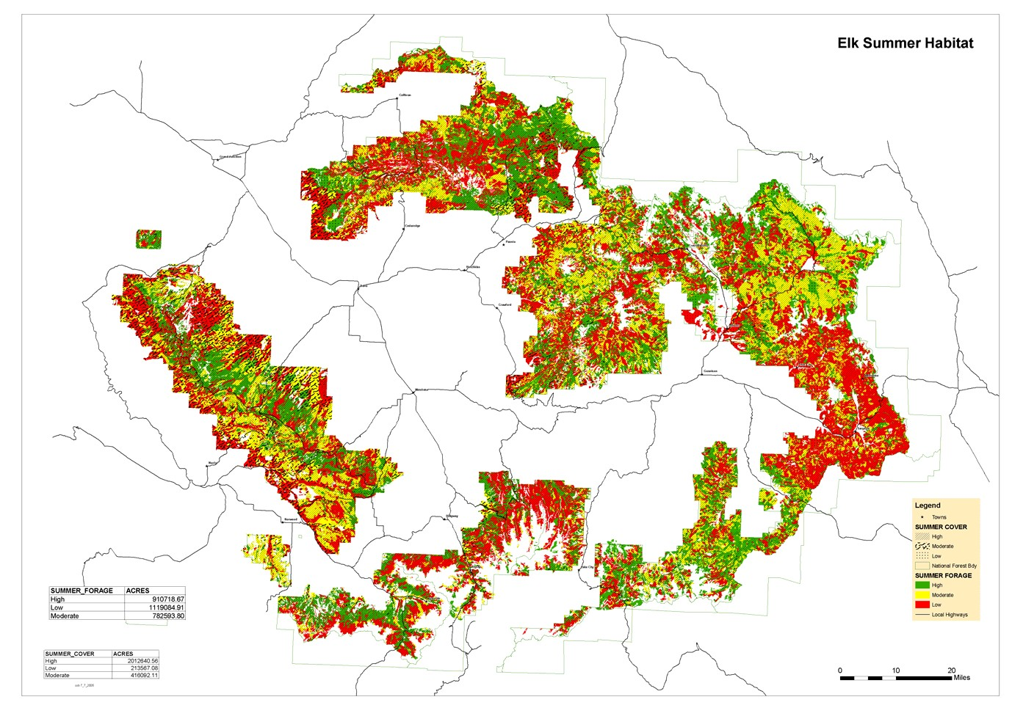
Figure 1. Elk summer foraging habitat on the Forest as modeled by R2Veg

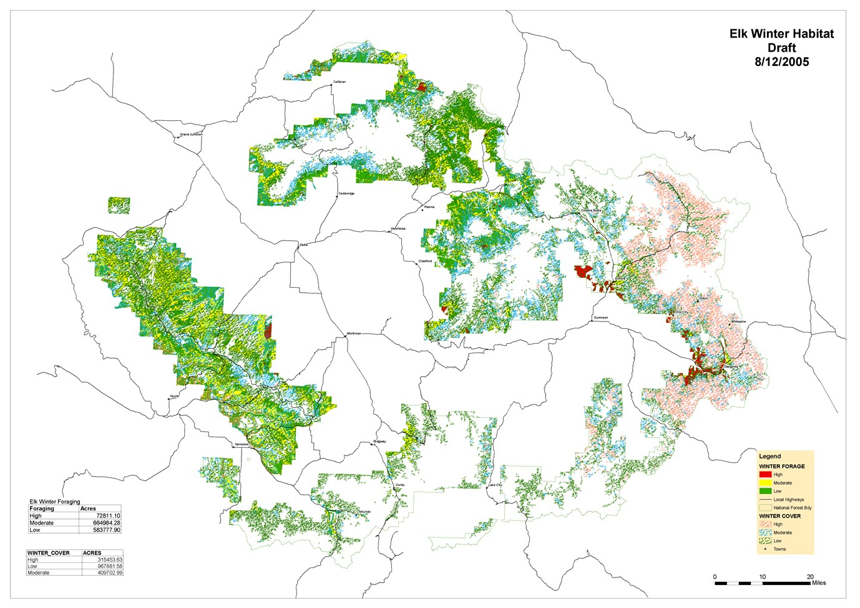
Grand Mesa, Uncompahgre, and Gunnison National Forests Rocky Mountain Elk (Cervus elaphus) Species Assessment

Figure 2. Elk winter foraging habitat on the Forest as modeled by R2Veg.

Table 1. Habitat parameters for modeling Rocky Mountain elk habitat on the Forest.

High Quality (Optimum) Moderate Quality (Marginal) Low Quality (Poor)
Summer
Habitat Parameter Summer Foraging Summer Cover Foraging Summer Cover Summer Foraging Summer Cover

Aspen 1, 2, 3a, 3b, 4a, 4b,
5
Cover Type and Habitat Structural Stage^
3b, 3c, 4a, 4b, 4c, 5
3c, 4c 2, 3a

Douglas-fir 1, 2, 3a 3b, 3c, 4b, 4c, 5 3b, 4a 3a, 4a 3c, 4b, 4c, 5 Gambel Oak 1, 2, 3a, 4a 3c, 4c 3b, 4b 2, 3a, 3b, 4a, 4b, 5 3c, 4c, 5
High Elevation Riparian¹ 1, 2, 3a 3b, 3c, 4b, 4c, 5 3b, 4a 3a, 4a 3c, 4b, 4c, 5 2
Lodgepole Pine 1, 2, 3a 3b, 3c, 4b, 4c, 5 3b, 4a 3a, 4a 3c, 4b, 4c, 5 Mountain Grassland² 1
Mountain Shrub³ 1 2 2
Pinyon-Juniper 3c, 4c 1, 2, 3a, 4a 2, 3a, 3b, 4a, 4b, 5 3b, 3c, 4b, 4c, 5
Ponderosa Pine 1, 2, 3a 3b, 3c, 4b, 4c 3b, 4a, 4b, 5 3a, 4a, 5 3c, 4c Sagebrush 1 2
Spruce-fir 1, 2, 3a 3b, 3c, 4b, 4c, 5 3b, 4a 3a, 4a 3c, 4b, 4c, 5 Wet Meadow* 1

Winter Foragingº Winter Coverº
Winter
Foraging Winter Cover Winter Foraging Winter Cover

Aspen 1, 2, 3c, 3a, 4a, 4b, 5 3c, 4c 3b, 4c 3a, 3b, 4a, 4b, 5

Douglas-fir 3c, 4c, 5 3b, 4b 1, 2, 3a, 3b, 3c, 4a, 4b, 4c, 5
3a, 4a

Gambel Oak 1, 2, 3a, 4a 3b, 4b 3b, 3c, 4b, 4c 3c, 4c, 5 2, 3a, 4a, 5
High Elevation Riparian¹ 1, 2, 3a 3b, 4a 3b, 3c, 4b, 4c, 5 3c, 4b, 4c, 5 2, 3a, 4a Lodgepole Pine 1, 2, 3a 3b, 3c, 4b, 4c, 5 3b 3a, 4a 3c, 4a, 4b, 4c, 5
Mountain Shrub³ 1 2 1 Pinyon-Juniper 1, 2, 3a 3c, 4c 4a 2, 3a, 3b, 4a, 4b, 5 3b, 3c, 4b, 4c, 5
Ponderosa Pine 1, 2, 3a, 4a 3b, 4b, 5 3b, 3c, 4b, 4c 3c, 4c 3a, 4a, 5
Sagebrush 1 2 2
Wet Meadow* 1

Winter Cover Habitat Variables
- Tree Canopy Closure ≥ 70% multiple layering 40 - 69% single or multiple layering;
and ≥ 70% single layering

if < 40%, then classify as foraging habitat

- Tree Canopy Height ≥ 12 m ≥ 3 m if < 3 m, then classify as foraging habitat

- Habitat Interspersion: Distance of Cover From the Cover-forage edge
- Minimum Size of Thermal Cover Areas
< 100 m 100 - 200 m > 200 m

4 ha
4 ha
4 ha

Winter Foraging Habitat Variables

- Tree Canopy Closure < 40% < 40% < 40%
- % Deciduous Tree Canopy ≥ 50% 25 - 49% < 25%

- Habitat Interspersion: Distance of Forage From the Cover-forage edge
- Elevation
< 100 m

<9,000 ft.
100 - 200 m

<9,000 ft.
Road Density/Use Habitat Effectiveness**
>200 m

<9,000 ft.

100% - 80% < 80% - 55% < 55%
Primary Roads 0 - 0.5 mi per square mi > 0.5 - 1.5 mi per square mi > 1.5 mi per square mi
Secondary Roads 0 - 0.71 mi per square mi > 0.71 - 2.142 mi per square mi > 2.142 mi per square mi Primitive Roads 0 - 1.0 mi per square mi > 1.0 - 3.0 mi per square mi > 3.0 mi per square mi

Adjusted Road Density (for square mile areas that have a combination of primary, secondary and primitive roads)
0 - 0.5 mi per square mi > 0.5 - 1.5 mi per square mi > 1.5 mi per square mi

Habitat Use and Roads: Zone of Influence***
Habitat > 0.5 mi from a road Habitat between 0.25 - 0.5 mi from a road
Habitat < 0.25 mi from a road

^ Habitat structural stages and cover types are based on the Habitat Capability Model (Ver. 4.0, USFS Rocky Mountain Region, last updated 1993) in conjunction with literature review.
¹ High elevation riparian comprises all riparian areas that occur within or adjacent to Forest, meadow, and shrubland cover types.
² Mountain grassland includes FOR, GAF, GFE, GPO, and GRA cover types.
³ Mountain shrub includes SAL, SHR, SMS, SSN, and SWI cover types.
* Wet meadow comprises the GWE cover type.
** Refer to Forest Plans Standards and Guidelines (III - 77) regarding habitat effectiveness for elk in terms of adjusted road density based on coefficients for primary, secondary, primitive, and closed roads. For the habitat analysis, a 0.25 mi buffer will be applied for trails, and a 0.50 mi buffer will be applied for roads.
*** Apply two multiple buffer rings spaced 0.25 mi apart around roads to determine a zone of influence. Classify habitat as low quality if it falls within 0.25 mi of a road, moderate quality if it falls between 0.25 to 0.5 mi of a road, and high quality if it falls greater than 0.5 mi of a road.
º A 60:40 ratio of forage to cover habitat was considered optimum for winter elk habitat by several authors (Thomas et al. 1979, Smith 1985, Brown 1991).
C and G. Elk are typically associated with Forest edges (Cairns and Telfer 1980) and foraging often occurs within 200 m of cover (Thomas et al. 1979, Smith 1985).
- To provide adequate protection for herds of elk, thermal cover areas need to comprise a minimum area of 4 ha (Wisdom et al. 1986).

Field verification, particularly for project-level analysis, may be required to determine the reliability of habitat modeling at the stand level.

Elk habitat modeling using R2-Veg is an attempt to produce elk habitat maps for the Forest that are further refined than seasonal range distribution maps. By producing refined habitat maps for elk, foraging and cover habitat within known summer and winter range areas on the Forest have been identified in terms of optimum, marginal, and poor habitat quality. Factors influencing elk habitat quality include habitat structural stage, tree canopy closure and canopy height, habitat interspersion (distance of cover and forage habitat from the cover-forage edge), size of thermal cover areas, percent deciduous tree canopy (for winter foraging), and road density (habitat effectiveness). Table 2 summarizes acres of modeled summer and winter habitats on the Forest.

Table 2. Acres of elk habitat on the Forest based on habitat quality.

Habitat Parameter | Habitat Quality
 | High | Moderate | Low | Total
Winter Forage | 72,811 | 664,984 | 583,778 | 1,321,573
Winter Cover | 315,454 | 409,703 | 967,882 | 1,693,039
Summer Forage | 910,719 | 782,594 | 1,119,085 | 2,812,398
Summer Cover | 2,012,641 | 416,092 | 213,567 | 2,642,300

Rationale

Elk are a habitat generalist, capable of utilizing most habitat types present on the Forest. However, specific habitat types are used depending on the season and not all habitat types on the Forest are used by elk at all times of the year. Importantly, identifying seasonal habitat use areas on the Forest is critical to gauging the effects of management activities on elk, particularly travel management activities and its influence on habitat effectiveness. Numerous literature sources support the habitat criteria used to model elk habitat on the Forest, including Thomas et al. (1979), Wisdom et al. (1986), Smith (1985), and Brown (1991).

MANAGEMENT STATUS AND NATURAL HISTORY

Management Status

  - The NatureServe database (www.natureserve.org/explorer) documents that throughout its range, elk have a ranking of G5; it is globally secure and common, widespread and abundant. It is also considered secure nationally and within the state of Colorado.

  - USFS Department of Agriculture, GMUG National Forests: species is designated as a Management Indicator Species (MIS).

  - Colorado Parks and Wildlife: CPW manages elk under their Big Game Hunting Regulations.

Existing Regulatory Mechanisms, Management Plans, and Conservation Strategies

Under the National Forest Management Act (NFMA) the Forest Service is required to sustain habitats that support healthy populations of native and desired non-native plant and animal species on national forests and grasslands, including Management Indicator Species such as elk. Elk populations are intensively monitored by CPW, and CPW elk population data is used extensively by the Forest in land management decisions. Additionally, the Forest recognizes the economic importance of elk to the state of Colorado and the communities surrounding the Forest and works cooperatively with the CPW to meet elk management objectives. The Forest’s 1991 Amended Land and Resource Management Plan includes standards and guidelines for elk habitat management (Table 3).

Table 3. 1991 Amended Land and Resource Management Plan standards and guidelines for elk habitat management.

Management Activities General Direction Standards and Guidelines

Aquatic and Terrestrial Habitat Management

Habitat Improvement and Maintenance
Manage for habitat needs of indicator species.

Maintain habitat for viable populations of all existing vertebrate wildlife species.

Use both commercial and noncommercial silvicultural practices to accomplish wildlife habitat objectives.

Deer and Elk. Provide hiding cover within 1000 ft of any known calving areas.
Deer, Elk, Black Bear, and Goshawk: In areas of historic shortage of dry season water, where there is less than one source per section, create one source per section.
Maintain habitat capability at a level at least 40% of potential capability. (This standard varies with specific management area guidelines)
In Forested areas, maintain deer or elk cover on 60% or more of the perimeter of all natural and created openings, and along at least 60% of each arterial and collector road that has high levels of human use during the time deer and elk would be expected to inhabit the area.
Cover should be located and measured perpendicular to the road. Gaps between cover along roads should not exceed 0.25 mi. Roads with restricted use could provide for less cover.
Maintain cover along 40% of each stream and river.
In diversity units dominated by Forested ecosystems, the objective is to provide for a minimum habitat effectiveness of 40% through time. Habitat effectiveness will be determined by evaluating hiding and thermal cover, forage, roads, and human activity on the roads. Cover should be well distributed over the unit. Hiding and thermal cover may be the same in many cases. Minimum size cover areas for mule deer are 2-5 acres and for elk 30- 60 acres.
In diversity units dominated by non-Forested ecosystems, maintain deer and elk hiding cover as follows:

% of Unit Forested % of Forested Area in Cover 35-50 At least 50%
20-34 At least 60%
<20 At least 75%

Improve habitat capability through direct treatments of vegetation, soil, and waters. Maintain edge contrast of at least medium or high between tree stands created by even-aged management.
These levels may be exceeded temporarily during periods when stands are being regenerated to meet the cover standard, or to correct tree disease problems, in aspen stands, or where windthrown or wildfire occurred. Maintain hiding cover along at least 75% of the edge of arterial and collector roads, and at least 60% along streams and rivers, where trees occur.
Alter age classes of browse stands in a diversity unit, no more than 25% within a ten-year period.

In the 1991 Amended Land and Resource Management Plan, elk were also specified as a MIS for travel management, and in the current Forest plan revision, elk were also retained as a MIS for travel management objectives. Elk habitat effectiveness is influenced by the density of open roads and motorized trails, and by the amount of human activity on those roads and trails (Table 4).

Table 4. 1991 Amended Land and Resource Management Plan standards and guidelines for travel management objectives for elk.
Management Activities General Direction Standards and Guidelines

Transportation System Management
Manage public motorized use on roads and trails to maintain or enhance effective habitat for elk.

Manage road use by seasonal closure if: Use causes unacceptable wildlife conflict or habitat degradation.
Keep existing roads open to public motorized use unless: Use conflicts with wildlife management objectives.
Objective level of habitat effectiveness for elk within each fourth order watershed is at least 40%. (This standard varies with specific management area guidelines)
Habitat effectiveness will be determined by evaluating, in combination, hiding and thermal cover, forage, road density and human activity on roads. The HABCAP model accomplishes this analysis.

Biology and Ecology

Fitzgerald et al. (1994) provides detailed information on the biology, ecology, distribution, and life history requirements of elk for the state of Colorado, which are summarized below. Patton (1992, 1997) provides a detailed life history account for Rocky Mountain elk, which is also summarized below. For a complete life history for elk (Patton 1992, 1997) refer to Appendix A.

Elk are large ruminants that exhibit sexual dimorphism. Males (bulls) are significantly larger in size, weigh more than females (cows), and carry antlers that are shed yearly in later winter or early spring. Elk are generalist feeders, being both grazers and browsers. They are able to digest large quantities of low quality forage. Grasses, shrubs (including sagebrush), aspen twigs and bark are important winter forage components. In some areas of Colorado dead leaves also comprise a portion of their winter diet (Hobbs 1981). Generally, forbs are more important during late spring and early summer. Grasses increase in importance as the summer progresses, carrying into the fall (Fitzgerald et.al. 1994). In some areas of Colorado 77-90% of the summer diet is composed of grasses and browse constitutes 56% of the winter diet (Boyd 1970).

Under normal circumstances elk are nocturnal or crepuscular with regard to their activities. Elk tend to rest during the daytime, seeking shade and cover with good visual range. During winter elk do seek cover but may bed out on open slopes in the snow.

Many elk populations are migratory, while others are not. Elk typically exhibit altitudinal migrations, using different ranges for winter, spring (transitional), summer and fall (transitional). Summer ranges tend to be at higher elevations with winter ranges being at lower elevations. Mature bulls and cows, calves and young bulls are usually in separate herds during the spring and summer. The groups come together during the rut.

Breeding activities begin in late summer and are usually completed by the end of October. Mature bulls acquire harems consisting of cows with their calves. Females breed yearly, having up to three estrous cycles if initial breeding is unsuccessful. Yearling females are capable of breeding but only 29% of the yearling females carry calves into the fall. The success rate for mature females in Colorado is 76% (Freddy 1987). Bulls three years and older usually perform the majority of breeding. Yearling bulls that breed typically have a low conception rate.
Adult cows normally produce one calf per year with twins being rare. Female bands will migrate together to calving grounds from their winter and spring ranges. The female will isolate herself from the herd to bear her calf. Calving sites are usually found where water, cover and forage are in close proximity. Two to three weeks after the calf is born, the cow and calf return to the herd.

Wildlife-Habitat Relationships

In Colorado, elk are generally found above 6,000’ (1,800 m.). They utilize a variety of habitats, which include lodgepole (Pinus contorta), spruce-fir (Picea englemannii & Abies lasiocarpa), Douglas-fir (Psuedotsuga menziesii), quaking aspen (Populus tremuloides) and mountain shrub types in conjunction with high mountain alpine meadows and lower elevation meadows and pastures, depending on the season. Elk require a combination of open meadows for foraging and woodlands for hiding cover, calving and thermal regulation (Figure 3).
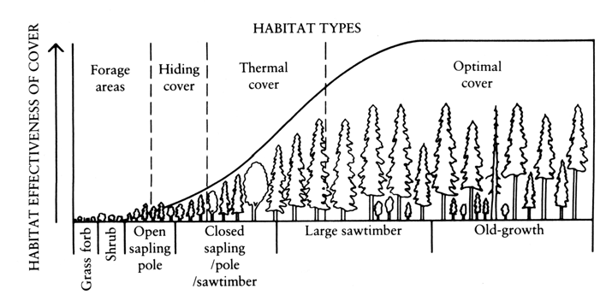
Figure 3. Development of stand conditions through time and cover habitat effectiveness (From
Morrison et al. 1992).

The use of open areas by elk tends to decrease 110 yards (100 m) from the forest edge. Slopes from 15-30% are preferred (USFS 2002). Ideal winter range includes north and northeast slopes consisting of densely wooded lowlands for cover, combined with south and southwest facing slopes for foraging opportunities. High quality transitional range usually includes meadows or pasture, aspen groves, and other woodland types that provide high quality forage enabling elk to gain weight prior to winter. Open water availability is important in association with

the habitat types described. Elk can extract some water from consumed plants in the summer and eat snow during winter (NRCS 1999).

Elk herds on the Forest are altitudinal migrants, using high elevation woodlands consisting of spruce-fir, Douglas- fir, aspen and/or lodgepole pine stands combined with alpine and sub-alpine meadows during the summer.
Transitional ranges include lower elevation aspen stands in conjunction with montane coniferous Forests. Winter range includes low elevation aspen, gamble oak, pinyon, juniper, sagebrush, especially where sagebrush slopes interface with ponderosa pine and aspen groves. Agricultural fields also provide winter range habitat used by some elk in areas adjacent to the Forest. Willow covered stream corridors are also important, used both for cover and forage on the Forest. Aspen is an especially important habitat component, potentially used by elk year round for forage, cover and calving.

Based on the U.S. Forest Service habitat structural stage classifications for dominant cover types, aspen stands classed 1 through 3C would provide a likely food source. Mature aspen stands in the 4A-5 habitat structural stages provide cover habitat, with food value at certain times of the year. Aspen stands within the 3A-4A habitat structural stages have the greatest potential for calving, providing enough understory cover and forage for cows and calves.

Cover requirements provided by spruce-fir, Douglas-fir and/or lodgepole would be in the 4A-5 habitat structural stage classes. Dense pole sized (3A-3B) stands also provide cover but may inhibit elk movement and provide little foraging opportunity. Regenerating conifer stands and shrublands (habitat structural stages 2T and 2S) may provide foraging and cover opportunities during the winter and summer, and may also be used for calving during the summer. During severe winters shrublands become critical for elk survival, in addition to lower elevation aspen stands. Parks, meadows and pastures, as previously mentioned, are a critical component within the life requirements of elk. These areas provide the majority of the grasses and forbs that elk depend on during spring, summer and fall.

Based on the habitat structural stage and habitat type requirements for elk, the Forest has an adequate mosaic of these habitats to support elk populations (Table 5). In terms of elk habitat acres by habitat quality, refer to Table 2.

Table 5. Potentially suitable Rocky Mountain elk habitat on the Forest by vegetation cover type and habitat structural stage.
Cover Type | 1 | 2 | 3A | 3B | 3C | 4A | 4B | 4C | Total
Aspen |  | 4,743 | 55,301 | 211,399 | 41,446 | 23,567 | 227,148 | 176,278 | 739,881
Cottonwood Riparian |  |  | 248 | 100 |  | 2,530 | 1,532 | 42 | 4,452
Gambel Oak |  | 291,383 | 472 | 82 |  | 416 |  |  | 292,353
Mountain Grassland | 462,355 |  |  |  |  |  |  |  | 462,355
Mountain Shrub |  | 165,073 |  |  |  |  |  |  | 165,073
Sagebrush |  | 101,838 |  |  |  |  |  |  | 101,838
Wet Meadow | 4,573 |  |  |  |  |  |  |  | 4,573
High Elevation
Riparian (Blue |  |  | 101 | 242 | 560 | 234 | 597 | 836 | 2,570
Spruce)
Bristlecone  Pine/Limber Pine |  |  | 2,261 | 1,630 | 45 | 2,104 | 1,877 | 33 | 7,950
Douglas-fir |  |  | 3,396 | 8,226 | 2,416 | 8,848 | 16,192 | 6,590 | 45,668
Lodgepole Pine |  | 758 | 7,100 | 124,674 | 54,741 | 4,658 | 49,472 | 38,887 | 280,290
Pinyon-juniper |  |  | 28,542 | 37,121 | 625 | 29,956 | 39,064 | 1,554 | 136,861
Ponderosa Pine |  | 251 | 10,530 | 13,060 | 94 | 42,180 | 44,102 | 965 | 111,183
Spruce-fir |  | 269 | 38,910 | 99,888 | 11,933 | 72,923 | 322,729 | 201,388 | 748,040
Total | 466,928 | 564,315 | 146,861 | 496,422 | 111,860 | 187,416 | 702,713 | 426,573 | 3,103,088

Population

Population Status and Trend
Historical Population Status

Elk populations on the Forest were extirpated in the late 1800s except for a few individuals. These small bands were augmented with elk relocated from Yellowstone in the early 1900s. With new game laws in place, elk began making a comeback in the ‘50s and ‘60s. Elk populations rose from the ‘80s to the early to mid ‘90s and have since dropped to levels that were characteristic of the late ‘70s and early ‘80s in many data analysis units.

Current Population Status

Elk populations are intensively monitored by the CPW. Annual harvest and census data is used to estimate elk populations within specified geographic areas known as data analysis units (DAUs). Several DAUs overlap the boundaries of the Forest while some occur entirely within the boundary of the Forest. Currently, most elk herds in the state of Colorado are at or near population objectives.

The Forest contains either all or at least a portion of nine elk DAUs (Appendix B). Population estimates for these DAUs were analyzed to examine population trend since 1980 (Figure 4).

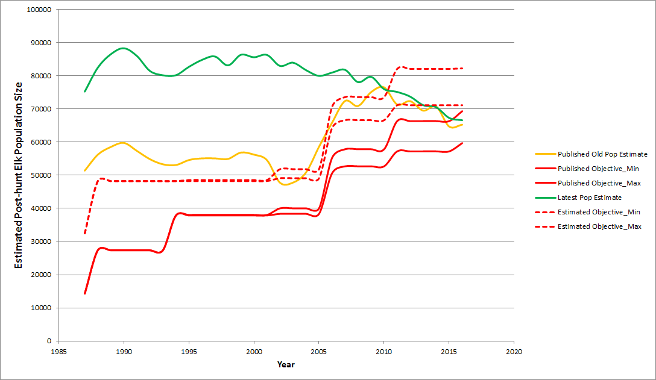
Figure 4: Elk post-hunt population size estimates for 1986 through 2016 for nine herds of the GMUG. Green line represent most current estimate of elk. Solid orange line represents population size estimates derived from older information (methods and data), but published annually by CPW. Dotted red lines represents estimated population size objectives. Solid red line represents the old objectives established at time of herd management plan creation, but often on population size estimates derived form the older information.

The total population estimate for all DAUs combined that include acreage on the Forest were above population objectives from 1980 through 2009 (Figure 4) . Intentional efforts conducted by CPW to harvest elk and reduce the elk population, along with declining elk recruitment rates (Figure 5 and Figure 6) have reduced elk populations to now be under the objectives desired by stakeholders. Population estimates from 1986 through 2016 have indicated a long-term declining trend in elk numbers. The graph also illustrates when models changed in the early 2000's to better utilize the data CPW collects, This model change resulted in an automatic increase in estimated population of 30%, on average. Ideally, any currently approved population objective would have been adjusted at that time based on public desires: maintain the elk population, or increase or decrease. This did not happen, so consequently there has been a disconnect between old objectives based on the old model (roughly 30% below new population estimates and new objectives had they been adjusted along with the model). New objectives based on the new model is the only remedy, but other higher priorities within CPW have prevented many herd plans from being updated. One option, when dealing with objectives that have not been updated, is to compare the old objective + 30% to the current population estimate to gauge whether the current population is above, within, or below what the public desired as expressed in the last approved herd management plan.

Calf elk recruitment, the addition of a calf being born and surviving year to join the population as a yearling, is a concern CPW staff are monitoring across all elk populations, but especially herds that have declining observed calf:cow ratios. Figures 5 and 6 illustrate the declining observed calf:cow ratios across the GMUG. To address the declining trend in recruitment, CPW has initiated a pilot elk study with 2 study areas, one on the Uncompahgre Plateau and the other in southeast Colorado near Trinidad. The study plan includes capturing and collaring adult female elk in the winter and checking pregnancy rates and body condition, while fitting pregnant cows with vaginal implant transmitters to be able to capture and monitor the survival of calves from the previously collared cows. Newborn calves were then captured and fitted with expandable GPS collars to monitor survival and habitat use in relation to collared cows. While one major aspect of the study is to assess calf survival, CPW staff plans to use the acquired GPS data from the adult females and calves to model seasonal habitat use and proximity to roads. CPW will also analyze habitat use patterns in relation to hunting seasons and general recreational use. One theory for the declining calf:cow ratios on the Uncompahgre was density-dependence affects causing a decrease in calf recruitment as the population was exceeding carrying capacity, however, calf recruitment has continued to decline even as the elk population has been estimated to decrease by 25%. CPW staff are trying to evaluate if pregnancy rates, habitat condition, stress, or predation are limiting calf recruitment on the Uncompahgre Plateau.

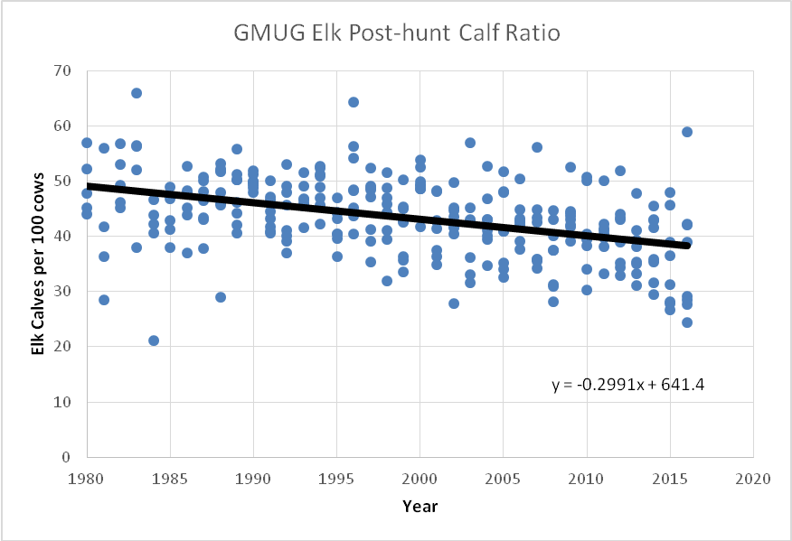

Figure 5. Elk calf ratios for defined elk herd management unit (DAUs: E14, E20, E24, E25, E35, E41, E43, E52) overlapping the GMUG by year. Each data point represents a single calf ratio estimate from a defined herd. Linear trend line indicates elk calf ratios GMUG wide have declined by approxiimately 10 calves per 100 cows in an approximate 30 year time period.

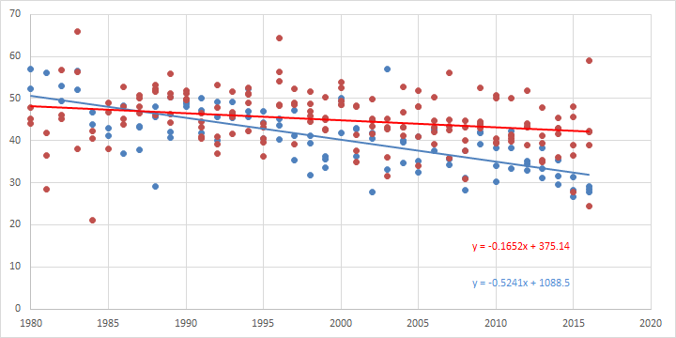
Figure 6: Calf recruitment rates for the GMUG elk herds. Red dots and line = E14, E52, E41, E43, and E25 (Gunnison Basin and Grand Mesa). Blue dots and line = E20, E24, E35 (Uncompahgre Plateau and Montrose area).

Population

Factors Influencing Elk Population Numbers and Causes of Population Fluctuations

Over the last two decades many elk herds in Colorado have changed their habits due to the ever-increasing destruction of habitat through development and the increasing disturbance by humans in their natural habitats. To avoid disturbance, many elk herds move to winter ranges on private lands early in the season. Game damage problems have become common in areas where elk use large tracts of private land to avoid hunting pressure or other disturbances such as Off-highway vehicles (OHV). Numerous factors may influence elk habitat preference, seasonal distribution, and habitat use. These include snow depth, forage quality and availability, competition with domestic livestock, and disturbance from human activity, all of which in turn may influence population numbers and cause population fluctuations. Impacts on elk that occupy the Forest include habitat alteration from recreational activities, primarily trail-based recreation, logging, mineral development, and livestock grazing. If habitat alteration or disturbance is severe enough, areas may become unsuitable, forcing elk into less disturbed areas on Forest or nearby adjacent private lands.

CONSERVATION

Threats

Management activities that negatively impact elk are primarily related to the long-term cumulative effects of all human activities on elk habitats. Human disturbances associated with roads and trails influence elk habitat effectiveness, and growing private development, especially in elk migration corridors and winter range, may also affect elk number and distribution. Some riparian areas and meadows on the Forest are in fair or poor condition from livestock and wild ungulates contributing to higher utilization levels on these important foraging areas.

Management Recommendations

Timber harvest, thinning, and prescribed fire are management activities that can be used to improve elk habitat and ensure the maintenance of food and cover requirements provided roads are closed to prevent human access. In the long term, quality habitat for elk is dependent on projects specifically designed to provide understory forage

recovery, especially away from streams and riparian vegetation to distribute elk use, and to improve small parks and openings through meadow maintenance and thinning near these sites. Browsing on seedlings and saplings by livestock and wild ungulates, has affected aspen regeneration in some areas of the Forest in the past, but new information suggests regeneration is occurring in some areas due to decreased domestic and wildlife utilization. Habitat improvement projects designed to promote aspen regeneration, combined with habitat improvement projects that distribute elk use over large areas, may allow for aspen recovery and improvement of elk habitat. Effective Travel Management Plans and maintaining road densities of 1 mile/sq. mile will also minimize disturbance to elk, helping to keep then on Forest lands where adequate harvest of animals can be attained.

The 1991 Amended Land and Resource Management Plan provide standards and guidelines for elk habitat management (Tables 2 and 3). For additional management recommendations see the Resources Section of Appendix A.

LITERATURE CITED

Boyd, R.J. 1970. Elk of the White River Plateau, Colorado. Tech. Bull. Colorado Div. Game, Fish, and Parks. 25:1-126

Brown, R.C. 1991. Effects of timber management practices on elk. Arizona Game and Fish Department Resources Branch Technical Report No. 10.

Cairns, A. L., and E.S. Telfer. 1980. Habitat use by 4 sympatric ungulates in boreal mixedwood Forest. Journal of Wildlife Management 44:849-857.

Fitzgerald, J.P.; C.A. Meaney; and D.M. Armstrong. 1994. Mammals of Colorado. Denver Museum of Nat. His. Univ. Press of Col. Niwot, CO. 467 pp.

Freddy, D.J. 1987. The White River elk herd: a perspective, 1960-85. Tech. Publ. Colorado Div. Of Wildl. 37:1- 64.

Hobbs, N.T., J.E. Ellis and D.M. Swift. 1979. Composition and quality of elk diets during winter and summer: a preliminary analysis. Pp. 47-53, in North American elk: ecology, behavior, and management (M.S. Boyce and L.D. Hayden-Wings, eds.). Univ. Wyoming, Laramie, 294 pp.

Morrison, M.L., B.G. Marcot, and R.W. Mannan. 1992. Wildlife-habitat relationships: concepts and applications. The University of Wisconsin Press, Madison, Wisconsin.

NatureServe. 2005. NatureServe Explorer: An online encyclopedia of life [web application]. Version 4.4. NatureServe, Arlington, Virginia. Available http://www.natureserve.org/explorer. (Accessed: May 2005).

NRCS and Wildlife Habitat Council. 1999. American Elk (Cervus alaphus). United States Dept. of Agri. Fish & Wildlife Habitat Management Leaflet. No. 11.

Patton, D. R. 1992. Wildlife habitat relationships in Forested ecosystems. Timber Press, Portland, Oregon, USA.

Patton, D. R. 1997. Wildlife habitat relationships in Forested ecosystems. Revised edition. Timber Press, Portland, Oregon, USA.

Smith, K. 1985. A preliminary elk (Cervus elaphus) management plan for the Edson wildlife management area. Fish and Wildlife Division, Edson, Alberta.

Thomas, J.W., H. Black Jr., R.J. Scherzinger, R.J. Pedersen. 1979. Deer and elk. In Thomas, J.W., ed. Wildlife habitats in managed Forests-the Blue Mountains of Oregon and Washington. Agric. Handb. 553. Washington, DC: U.S. Department of Agriculture: 104-127

USDA Forest Service. 1991. Amended Land and Resource Management Plan for the Grand Mesa, Uncompahgre, and Gunnison National Forests. Delta, CO.

United States Forest Service. 2002. Biological Data and Habitat Requirements: Wildlife Species: Cervus elaphus. United States Dept. of Agri. www.fs.us/database/feis/wildlife/mammal/ceel/biological_data_habitat_requirements.

Wisdom, M.J., L.R. Bright, C.G. Carey, W.W. Hines, R.J. Pedersen, D.A. Smithey, J.W. Thomas, and G.W. Witner. 1986. A model to evaluate elk habitat in western Oregon. Publication No. R6-216, USDA Forest Service, Portland, Oregon.

Appendix A

A COMPLETE LIFE HISTORY FOR ELK
Compiled by Patton (1992, 1997)

SPECIES
Common name: Elk
Scientific name: Cervus elaphus
Subspecies:
Cervus elaphus subsp. nelsoni (Rocky Mountain elk) Cervus elaphus subsp. manitobensis (Manitoba elk) Cervus elaphus subsp. roosevelti (Roosevelt elk) Cervus elaphus subsp. nannodes (Tule elk)
Taxonomy:
Order: Artiodactyla Family: Cervidae
Weight: 227-363 kg (500-800 lb)
Adult cows weigh about 272-295 kg (600-650 lb)
Newborn calves weigh between 14 and 16 kg (30 and 35 lb) Maximum ecological longevity: 20 years
Young per year: Generally 1, twins are rare Gestation period: 210-225 days
Breeding season: September-October, with several estrous cycles. Mating: Polygamous
Young born: May-June, usually in a secluded area. Cow-calf groups are formed and maintained through summer.
Annual increase: 15-30 percent
Antlers: Only males have antlers. Mature bulls have 6 points, male calves have buttons. Yearling bulls can have spikes without brow tines. Antlers are shed in March-April. Growth starts in May and continues until August when velvet is rubbed off. Weight of antlers is 11-14 kg (25-30 lb).
Dentition: I0/3, C1/1, P3/3, M3/3 = 34
All permanent teeth are present at 36 months.
Major distribution: States of Arizona, New Mexico, Colorado, Utah, Nevada, California, Washington, Oregon, Idaho, Montana, Wyoming, and Provinces of British Columbia and Alberta. Elk can live Either in mountains or plains.
Behavior: Gregarious. Bulls collect a harem of cows and calves. Young nonbreeding bulls are tolerated in harem. Combat between mature bulls for control of harem can result in death. Summer-winter migration or nonmigratory.

HAZARDS
Severe winters, drowning, rutting combat.

PREDATORS
Mountain lions (mostly on young), coyote (mostly on young), bears.

DISEASES
Anthrax, anaplasmosis, brucellosis, tick-born fever, foot rot, eperythrozoonosis, chronic wasting disease.

RESOURCES
Winter food: Mostly grasses and shrubs. Summer food: Transitions from grasses to forbs. Water: Free water is needed.
Management Practices: Food and cover requirements and management practices vary according to habitat conditions that the local population has adapted to. It is not wise to use data from another area far

removed from the local management situation until there has been an effort to validate the data. Some general guidelines follow that may be applicable for local populations. Elk should be free from human disturbance; some recommendations are as follows:
- 1.6 km (1 mi) of road/2.58 km2 (1 mi2) of habitat for primitive type roads.
- 0.8 km (0.5 mi) of road/2.58 km2 (1 mi2) of habitat for secondary roads.
- 0.4 km (0.25 mi) of road/2.58 km2 (1 mi2) of habitat for primary roads.

Approximately 40 percent of the occupied habitat should be in the following cover classes: hiding (20 percent) and thermal (20 percent).

Hiding cover is any vegetation capable of hiding 90 percent of a standing elk at 60 m (200ft).
Thermal cover is a Forest stand at least 12 m (40 ft) in height with tree canopy cover of at least 70 percent. This is achieved in many closed sapling-pole stands and by all older stands. The other 60 percent of the habitat can consist of openings of 12 to 16 ha (30 to 40 ac) or distances across an opening of 365 m (1200 ft).
Water sources need to be no more than 1.6-2.4 km (1-1.5 mi) apart for maximum habitat use. Space: In general, depending on habitat quality, a small herd (30-50) of elk requires approximately
400 ha (1000 ac) each of winter or summer habitat.

HUMANS
Disturbance by humans is a major management problem in many areas.

MAJOR REFERENCES
Severson, K.E., and A.L. Medina. 1983. Deer and elk management in the Southwest. J. Range Manage. Monogr. No. 2., Soc. For Range Manage., Denver, CO.
Thomas, J.W., and D.E. Toweill, eds. 1982. Elk of North America: Ecology and Management.
Wildlife Management Institute. Stackpole Books, Harrisburg, PA.

Grand Mesa, Uncompahgre, and Gunnison National Forests Rocky Mountain Elk (Cervus elaphus) Species Assessment

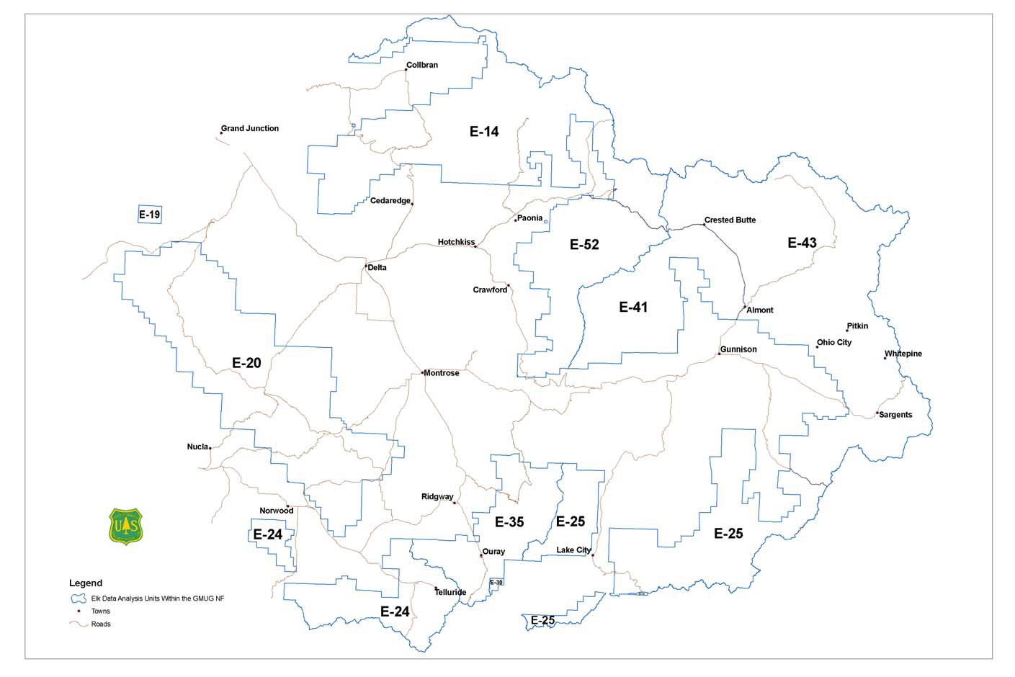
Appendix B. Elk Data Analysis Units on the Forest

Appendix C. Elk population estimates compared to population objectives for each Data Analysis Unit that contains acreage on the Forest, 1980-2003 Data Analysis Unit
 | E-14 | E-19 | E-20 | E-41 E-43  Population Objective |  | E-52 | E-24 | E-25 | E-35 | Total
 | 10,500 | 2,400 | 3,050 | 3,500 3,500 |  | 2,350 | 10,200 | 4,500 | 2,900 | 39,400
Year |  |  |  | Population Estimate
1980 | 9,744 | 584 | 6,247 | 4,096 | 4,514 | 2,475 | 9,512 | 4,753 | 3,929 | 45,854
1981 | 9,903 | 586 | 6,508 | 3,778 | 4,441 | 2,609 | 10,241 | 4,736 | 4,584 | 47,386
1982 | 10,359 | 774 | 6,789 | 4,246 | 4,737 | 2,906 | 10,975 | 4,894 | 5,238 | 50,918
1983 | 10,946 | 797 | 7,256 | 4,263 | 5,754 | 3,004 | 12,005 | 5,407 | 6,355 | 55,787
1984 | 9,765 | 841 | 5,886 | 3,915 | 4,956 | 2,638 | 12,085 | 4,827 | 5,407 | 50,320
1985 | 10,155 | 941 | 6,040 | 4,461 | 5,519 | 2,714 | 13,918 | 4,897 | 5,458 | 54,103
1986 | 11,970 | 1,112 | 6,526 | 4,871 | 5,923 | 3,344 | 18,222 | 5,392 | 5,977 | 63,337
1987 | 13,494 | 1,189 | 6,949 | 5,519 | 6,751 | 4,021 | 18,129 | 6,187 | 6,913 | 69,152
1988 | 15,010 | 1,246 | 7,926 | 5,987 | 7,252 | 4,551 | 18,083 | 6,830 | 7,797 | 74,682
1989 | 16,072 | 1,393 | 9,079 | 6,073 | 7,294 | 4,753 | 18,438 | 7,004 | 7,892 | 77,998
1990 | 16,189 | 1,569 | 9,758 | 5,586 | 6,479 | 5,123 | 18,747 | 6,858 | 8,229 | 78,538
1991 | 16,168 | 1,697 | 9,953 | 5,195 | 6,210 | 4,838 | 18,112 | 6,975 | 8,143 | 77,291
1992 | 14,551 | 1,761 | 9,334 | 4,921 | 6,127 | 4,912 | 17,730 | 6,603 | 6,660 | 72,599
1993 | 13,228 | 1,832 | 8,034 | 4,967 | 5,832 | 4,358 | 17,187 | 6,773 | 6,048 | 68,259
1994 | 13,229 | 2,006 | 8,449 | 5,218 | 5,872 | 4,428 | 17,104 | 6,710 | 5,923 | 68,939
1995 | 13,317 | 2,067 | 8,701 | 5,529 | 6,112 | 4,517 | 17,598 | 6,770 | 5,909 | 70,520
1996 | 13,924 | 2,239 | 8,707 | 4,599 | 5,516 | 4,731 | 19,393 | 6,697 | 5,701 | 71,507
1997 | 14,135 | 2,308 | 8,773 | 4,693 | 5,241 | 4,619 | 18,808 | 6,809 | 5,657 | 71,043
1998 | 13,188 | 2,335 | 8,453 | 4,336 | 4,689 | 3,841 | 15,744 | 7,360 | 5,620 | 65,566
1999 | 12,687 | 2,401 | 8,623 | 4,270 | 4,664 | 3,857 | 14,878 | 7,683 | 5,558 | 64,621
2000 | 11,060 | 2,365 | 9,135 | 3,880 | 3,723 | 3,836 | 12,093 | 7,002 | 5,659 | 58,753
2001 | 11,670 | 2,710 | 9,110 | 3,850 | 3,820 | 3,840 | 14,260 | 5,510 | 5,390 | 60,160
2002 | 10,020 | 2,850 | 11,040 | 3,580 | 3,480 | 3,260 | 13,850 | 4,540 | 5,710 | 58,330
2003 | 11,460 | 2,860 | 9,990 | 5,400 | 4,180 | 3,350 | 16,710 | 4,530 | 5,400 | 63,880

