Forest Plan Revision April 18, 2020
903 3rd Street
Kamiah, ID 83536

Please accept these comments on the draft forest plan revision for the Nez Perce Clearwater National Forest. We are frustrated that you did not extend the comment period during this unprecedented Covid-19 pandemic, which has disrupted many lives, including ours.
We have lived in the region since 1988 and since then the wildlands of the NPCNF have been a big part of our lives and those of our children in their formative years. We have hiked many, many areas of the Forest. We also have lived other places where whole habitats have been destroyed by bad management and overuse. These wilderness and roadless lands of the forest are so much more than just timber harvest and motorized recreation lands, and it's very disappointing to see this draft forest plan promising to destroy their natural qualities and character.
This document is very perplexing. The FS has not picked a preferred alternative. Instead there is a mishmash of several alternatives, each a little bit different than the others, but none of them emphasizing any particular approaches to management. The understanding is the FS will combine parts of each of the alternatives in its proposed action. This is quite confusing for concerned citizens to comment on, and probably also violates NEPA. Also, it is very difficult to understand why the FS is eliminating at least 17 management areas, each emphasizing different values, and replacing them with three management areas, of which logging is an emphasis in two of the three, the only two where it is legally possible.
Climate Change Crisis. Humanity is facing its greatest challenge ever in the human-caused climate crisis, and the draft plan doesn't even acknowledge this challenge. The forests and trees of the NPCNF could be a big part of the solution instead of a big part of the problem. Undisturbed forest soil is a large reservoir for sequestered carbon and old growth forest trees sequester large volumes of carbon also if left standing. Studies show that timber harvest, the associated disturbance of the soil, and the burning that occurs whether it is slash piles or increased forest fires due to the harvest activities, actually adds carbon pollution to the atmosphere. The forest plan revision should have an over-riding theme of carbon sequestration instead of logging and the associated carbon pollution to the atmosphere.
Timber Harvest: The alternatives propose increasing timber harvest anywhere from 200 to 500%. At current timber harvest volumes in the forest of around 50mmbf, much of the forest is below basic standards for fish and wildlife habitat, old growth etc.. The front country, that which has seen prolific harvest and the concomitant degradation of natural resources in the past, is in bad shape and it is hard to imagine adding insult to injury with more harvest. This leaves the roadless backcountry to make up this proposed increased volume. Unfortunately, this will be where the trees come from if this plan is adopted.
Roadless Lands; There are 1.5 million acres of roadless lands left in the NPCNF and they are priceless. Their ecological value to society as wildlife habitat, pristine watershed, fisheries habitat, and carbon reservoir is far greater than the value of the trees that could be removed from it in actions which will worsen our climate change crisis. The draft plan alternatives recommend a small portion of this for wilderness which is totally inadequate. An incomplete Meadow Creek recommendation, omission of Weitas Creek, Lochsa Slope, Pot Mountain, Fish and Hungery, Upper North Fork, Gospel Hump Additions, Weir Creek, Moose Mountain, John Day and many other roadless areas from most or all of the alternatives is unacceptable. There should be an alternative which protects all of these priceless areas from human impact.
Old Growth: Old growth is immensely important for the survival of several old growth-dependent species including fisher, pileated woodpecker, and goshawk as well as for carbon sequestration. Historical levels of old growth were 20-30% in these forests. The 1987 plan had standards which require 10% old growth forest-wide and 5% within any given watershed - considerably less but at least something. The draft plan has nowhere near even this inadequate level of protection. In addition the NPCNF has not done adequate monitoring to even know whether 1987 old growth standards are being met. Typically the FS talks up recruitment old growth with the assumption that forest in stages prior to old growth can be managed to achieve old growth characteristics. There is absolutely no scientific evidence that this can be done. First the NPCNF must do the monitoring to determine how much true old growth is remaining on the forest and where it is, and then since there is no evidence we can ever manage current forests to achieve true old growth, all current old growth must be preserved to a maximum of 20-30%.
Fish Habitat: Quantifiable standards for fish bearing streams are essential for native fish including endangered steelhead. The current plan has quantifiable standards for fish habitat including 300 ft buffer zones and maximum allowable levels of cobble embeddedness for streams. The draft plan effectively cuts the buffer zones to 150 ft and has no standards for cobble embeddedness. This is unacceptable. The draft plan should have quantifiable standards at least as stringent as the 1987 plan.
Roads: Road building in the CNPF is very problematic. There are unstable soils and weather events that cause road slumps, landslides and blow outs. See the photo at the end of this document from 2017 on the road to Cayuse landing. This is not the exception. In our time in traveling in and caring about this forest, we have seen many road blow outs. We remember several big slides on Kelly Creek several years ago and a huge slide on Skull Creek on the 1990s that created a temporary lake. The more logging you propose, the more roads you have to build, which means more slides and damage to water quality. The current roadless areas should remain roadless because roads are extremely damaging.
Recreation and access: We do not support Alternative X, which has the highest percentage of motorized recreation. Alternative W at least provides some contiguous non-motorized areas in the northern part of the forest (unlike the broken-up snaking of motorized corridors in that area in the other alternatives). But W doesn’t protect West Meadow Creek or Pot Mountain. The concept of primitive recreation surrounded by a maze of motorized trails (alternatives Y and Z) is totally insane. One may as well go camp next to the Freeway. Again, your alternatives are confounding, especially without a preferred alternative. If there are motorized corridors in these areas, wildlife, water quality and unique wilderness values will suffer. Nonmotorized recreation is the most sustainable and will protect water quality and wildlife. For non-motorized recreation, we hope to see more trail maintenance, as many, many “trails” in the CNPF are impassable. The video places a lot of emphasis on the desire of motorized users for loop trails, but non-motorized users would just like existing trails maintained, made passable and left non-motorized.
Quantifiable Standards. The 1987 current plan has some quantifiable standards. These are important when used with monitoring to insure conservation of resources such as old growth, or fish with respect to high quality spawning habitat. The current draft plan has almost none of these and instead has unenforceable, qualitative standards.
In conclusion, the draft plan emphasizes logging at unsustainable levels at a great cost to all other resources and also exacerbates climate change. It is a giant step backwards from the 1987 plan and lacks enforceable standards that were part of that plan. The NPCNS should analyze the citizen's proposal put forth by FOC which is informed by the most recent science, emphasizes the outstanding wild, natural and appropriate recreational values of the forest, and would also help to address climate change through carbon sequestration.
We are greatly saddened to think what will happen to our forest if this plan is enacted.

Sincerely,
Dr. Alan R. Poplawsky
Diane M. Prorak
2108 Vandal Dr
Moscow, ID 83843
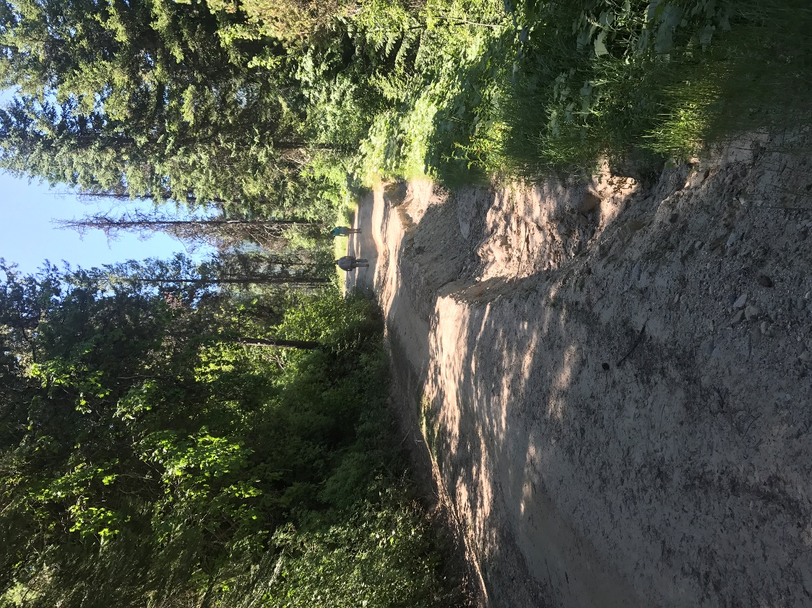
July 2017, the slumping road towards Cayuse Landing

