To: US Forest Service

Re: response to scoping letter about proposed Mendenhall Glacier facility improvements

Date: January 8, 2021

From: John Neary

Your proposed changes to facilities at the Mendenhall Glacier Recreation Area continue to lack the vision needed for a project that will span generations, and it will unacceptably alter wetland habitat near a sensitive salmon stream. I have submitted comments previously on these issues which you’ve ignored. Your current proposal lacks any substantial change from a year ago. The two issues you outline, crowding by more visitors and impacts to fish and wildlife, are not specific enough to evaluate all concerns. Where is your issue about climate change and how it is dramatically changing the ecology and human experience of the Mendenhall Glacier Recreation Area? The Forest Service needs to demonstrate solutions that do not burn fossil fuels and do not contribute greenhouse gases to our atmosphere. Renewable energy is a positive, organizing theme for our future and it is wholly lacking in your proposal.

Instead, you propose to expand parking spaces at the end of the Glacier Spur Road rather than solutions to traffic congestion that don’t bury sensitive wetlands under rock. If you don’t have the wisdom to recommend remote parking and electric circulating trams, why not at least strike a deal with the City of Juneau to use their circulating electric buses from the docks to MGVC? This would allow more visitors easy access within the same footprint of parking. The encroachment of parking spaces near Steep Creek will create more urban noise along the walkways and threaten the waters with oily engine waste.

Expanding the exhibit floor and other amenities of the Visitor Center is long overdue but why not include a new exhibit about glacier science and climate change which has already been designed? You should also push for LEED certification of this historic building by upgrading the heating system to heat pumps, preferably with geothermal power that also heats other new buildings. These efforts would demonstrate leadership by the Forest Service in tackling climate change while fulfilling federal executive orders and regulations designed to increase building efficiency.

Your proposed “alternative energy” motorboats on the lake are still controversial with Juneau residents. Recently there have been battery-electric propulsion systems developed that would offer cleaner operations, like the vessel pictured below from a Juneau company called Tongass Rain. Your proposal should require something like them and your dock design should allow for their operation.

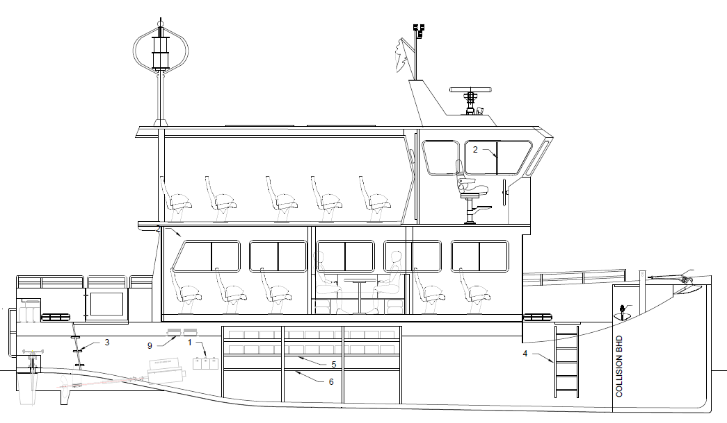

In summary, the Forest Service has an opportunity to cooperate with the City of Juneau to fulfill a partnership that is beneficial to all. As stewards of the premier destination for visitors to Juneau you have the unique responsibility to help the city fulfill ambitious goals outlined in the Juneau Renewable Energy Strategy. Your responsibility also extends to the million visitors from around the world who are forecast to annually visit this destination to see a glacier that is shrinking from view. It’s far more important to guide them to a sustainable future powered by renewable energy, than to simply cram more into the same space using technology from the last century. Please be bold and forward-thinking in your next version of this proposal.

Sincerely,

John Neary

17735 Pt. Stephens Rd.

Juneau, AK 99801