14 September 2019

US Forest Service
Petersburg Ranger District
c/o Carey Case, Project Leader
PO Box 1328
Petersburg, AK 99833-0383

Re: Comments on Central Tongass Project #53098

My lifelong residency in the Central Tongass community of Petersburg, Alaska began in 1961. Prior to that I lived in logging camps with my family in Neets Bay (1954 to about 1958) and Ratz Harbor (roughly 1958-1960 – though I was quite young, I do remember seeing a fish trap there in 1958 before they were outlawed as a result of the vote for Alaska statehood) as my father was a faller for different companies. He also was the first faller in Coffman Cove (1961).

I rarely comment on US Forest Service activities, however, the vagueness inherent within the proposed “Central Tongass Project #53098” leads me to support the “No Action” alternative.

I can still support small sales for local or domestic use, but I am adamantly opposed to exporting round log old growth. Since this plan is enabling the export of old growth timber, I opt for the “No Action” alternative of the Central Tongass Project.

The fact that this plan fails to address specific actions, and instead is wholly fabricated as an approach to minimize public outreach and commentary also leads me to opt for the “No Action” alternative.

The timber supply issue has been resolved through decades of excessive harvest, and it has run its course. Like it or not, the reality is that the timber industry has basically taken a 100-year supply of timber in 80 years or less (my estimate from a lifetime of living, working, and wandering throughout the Tongass). And while the boom years of the mills and 50-year contracts enabled the settlement of Alaska and good employment opportunity for my father and many others, those days are gone.

As a multiple use forest, the timber industry has already reached, if not exceeded its share of the best and easiest to get, and should have no claims on, or priority over other industry’s dependance on the Tongass, i.e., fisheries, tourism, subsistence, or let’s face it, carbon capture.

I oppose further large-scale incursions into the timber base of the Central Tongass, and I support the NO ACTION ALTERNATIVE of this plan.

ADDENDUM

I have been unable to submit my comments online using both Safari and Firefox for the
https://cara.ecosystem-management.org/Public/CommentInput?project=53098
Forest Service web page due to the site issuing “error” messages on 14-15 September 2019 (see attached screen shots).

Because of this, I had intended to submit my comments in person at the Petersburg Ranger District tomorrow, 16 September 2019, and obtaining a date-stamped receipt. I am able to do this because I reside in Petersburg, Alaska on Mitkof Island, and happen to be physically present at this time. The fact is, my intentions for some time were to be subsistence moose hunting all of this week, instead of dealing with bureaucratic rigmarole like this.

However, I find that the website is back online this morning (16 September 2019), so once again my plan for submitting my comments on the Central Tongass Progress #53098 has changed, and I am doing so electronically instead of hand-delivery.

I am not suggesting that the Forest Service website is offline due to some nefarious act designed to limit my rights to comment, however, it does fall in line with the pattern of the Central Tongass Project #53098. That is, the non-specificity of timber harvest activity, and probable approach toward minimizing public outreach and commentary which I cite in my comment letter — Paragraph 4 on Page 1 of this submission.

The entire Central Tongass Project #53098 needs to be scrapped, and resubmitted at a later date. The “No Action” alternative is the only responsible way to resolve this issue.

Attachments (4)

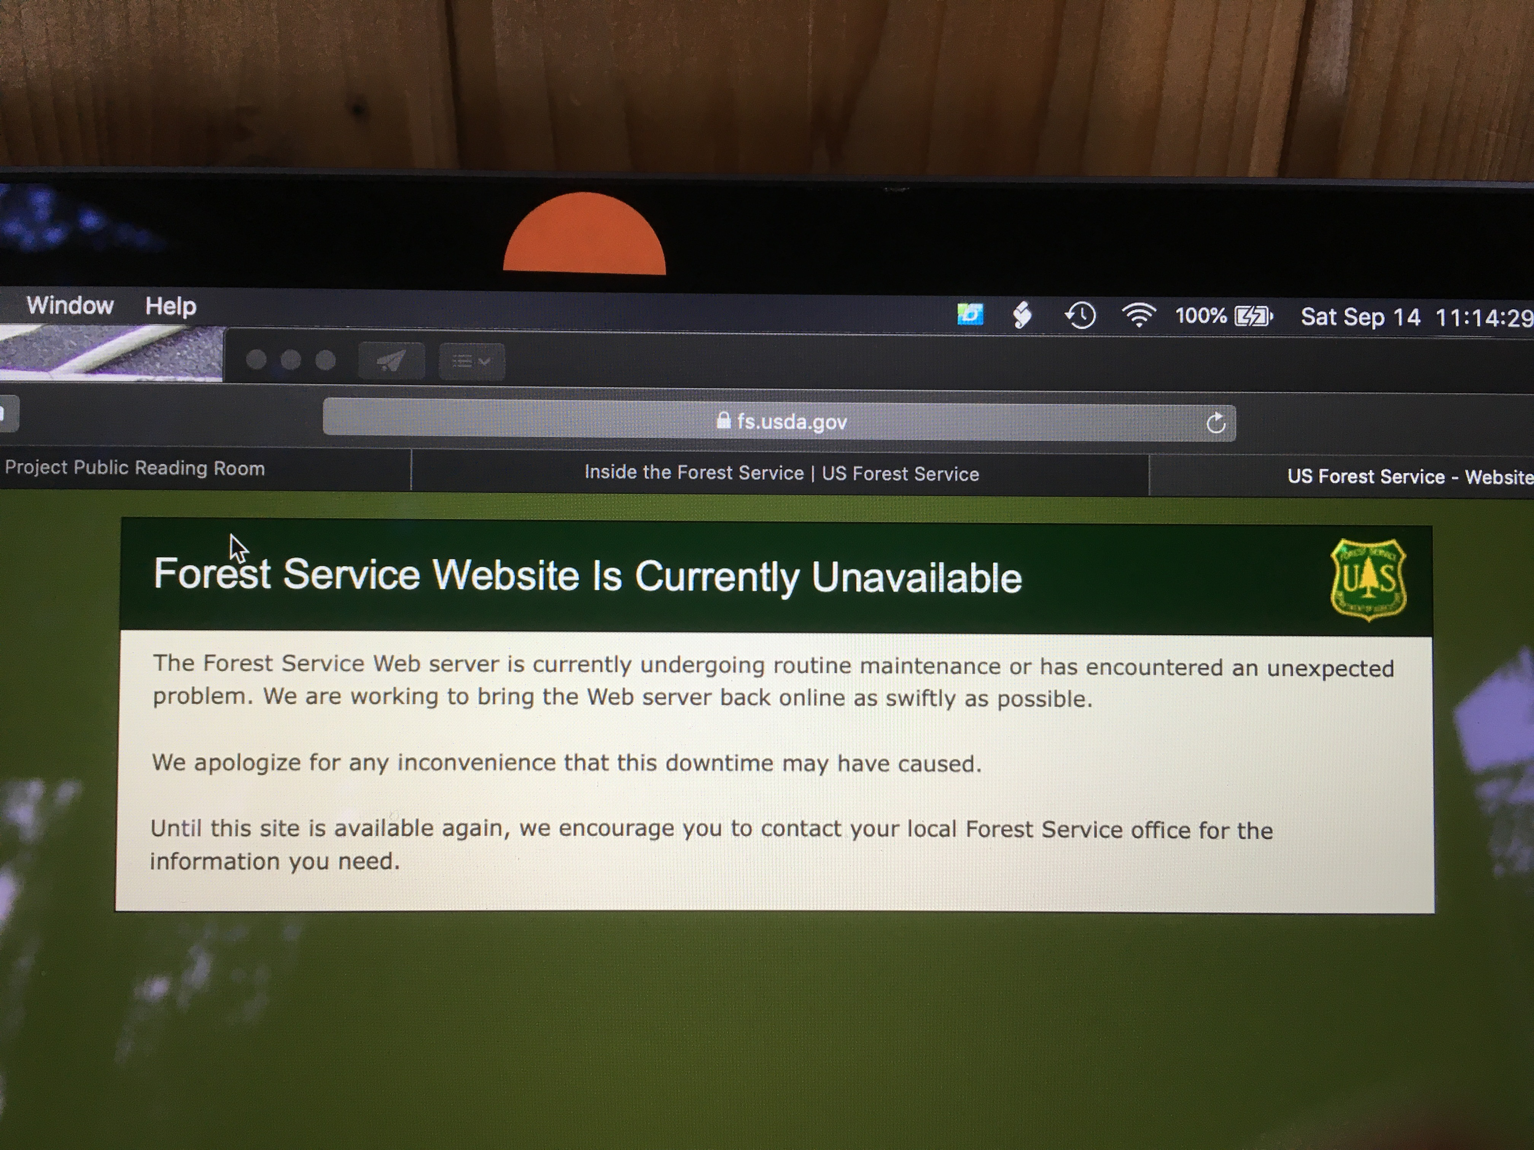

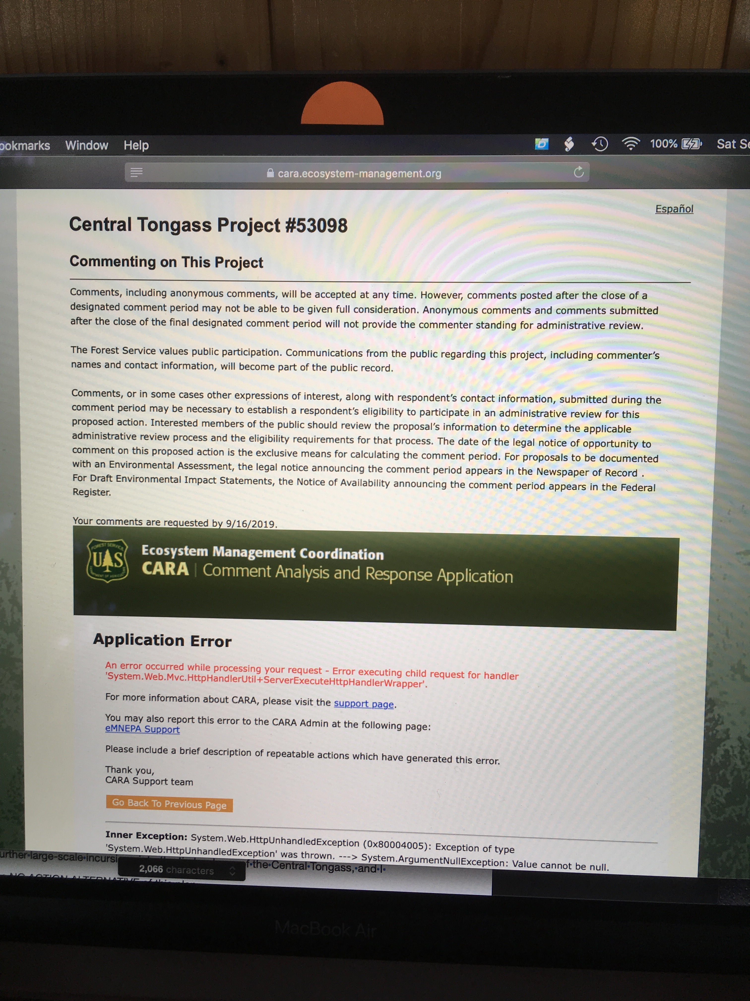
ATTACHMENT 1
ATTACHMENT 2
ATTACHMENT 2
ATTACHMENT 2

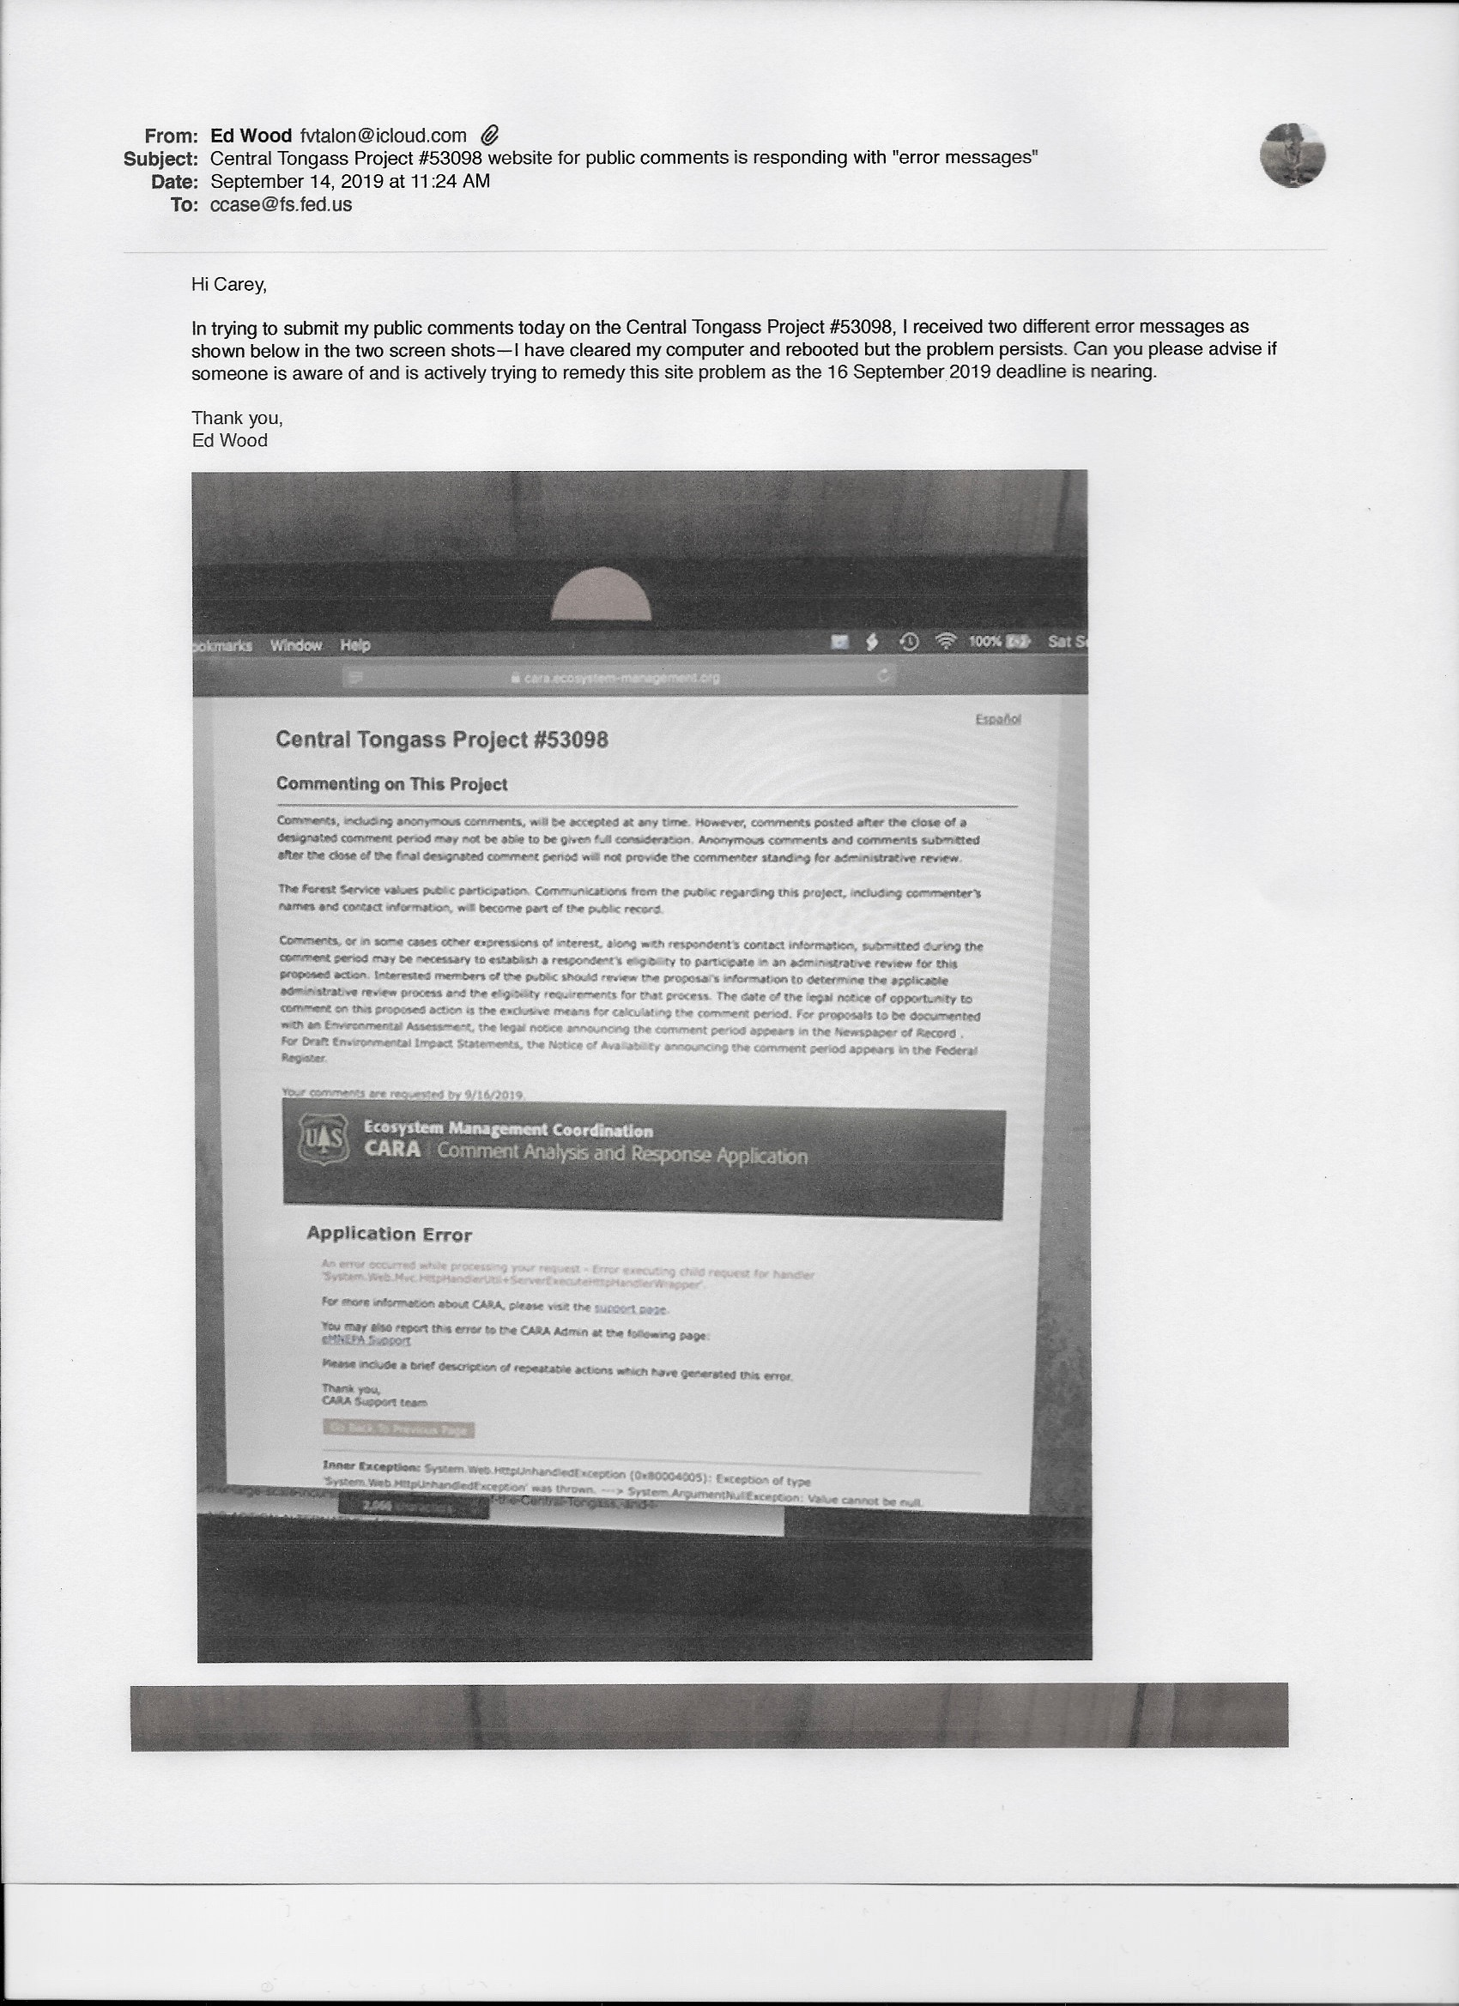
ATTACHMENT 3 - Page 1

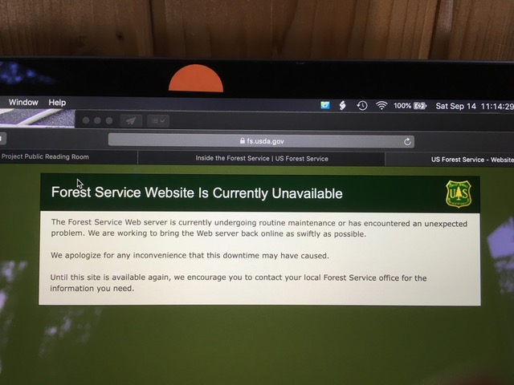
ATTACHMENT 3 - Page 2
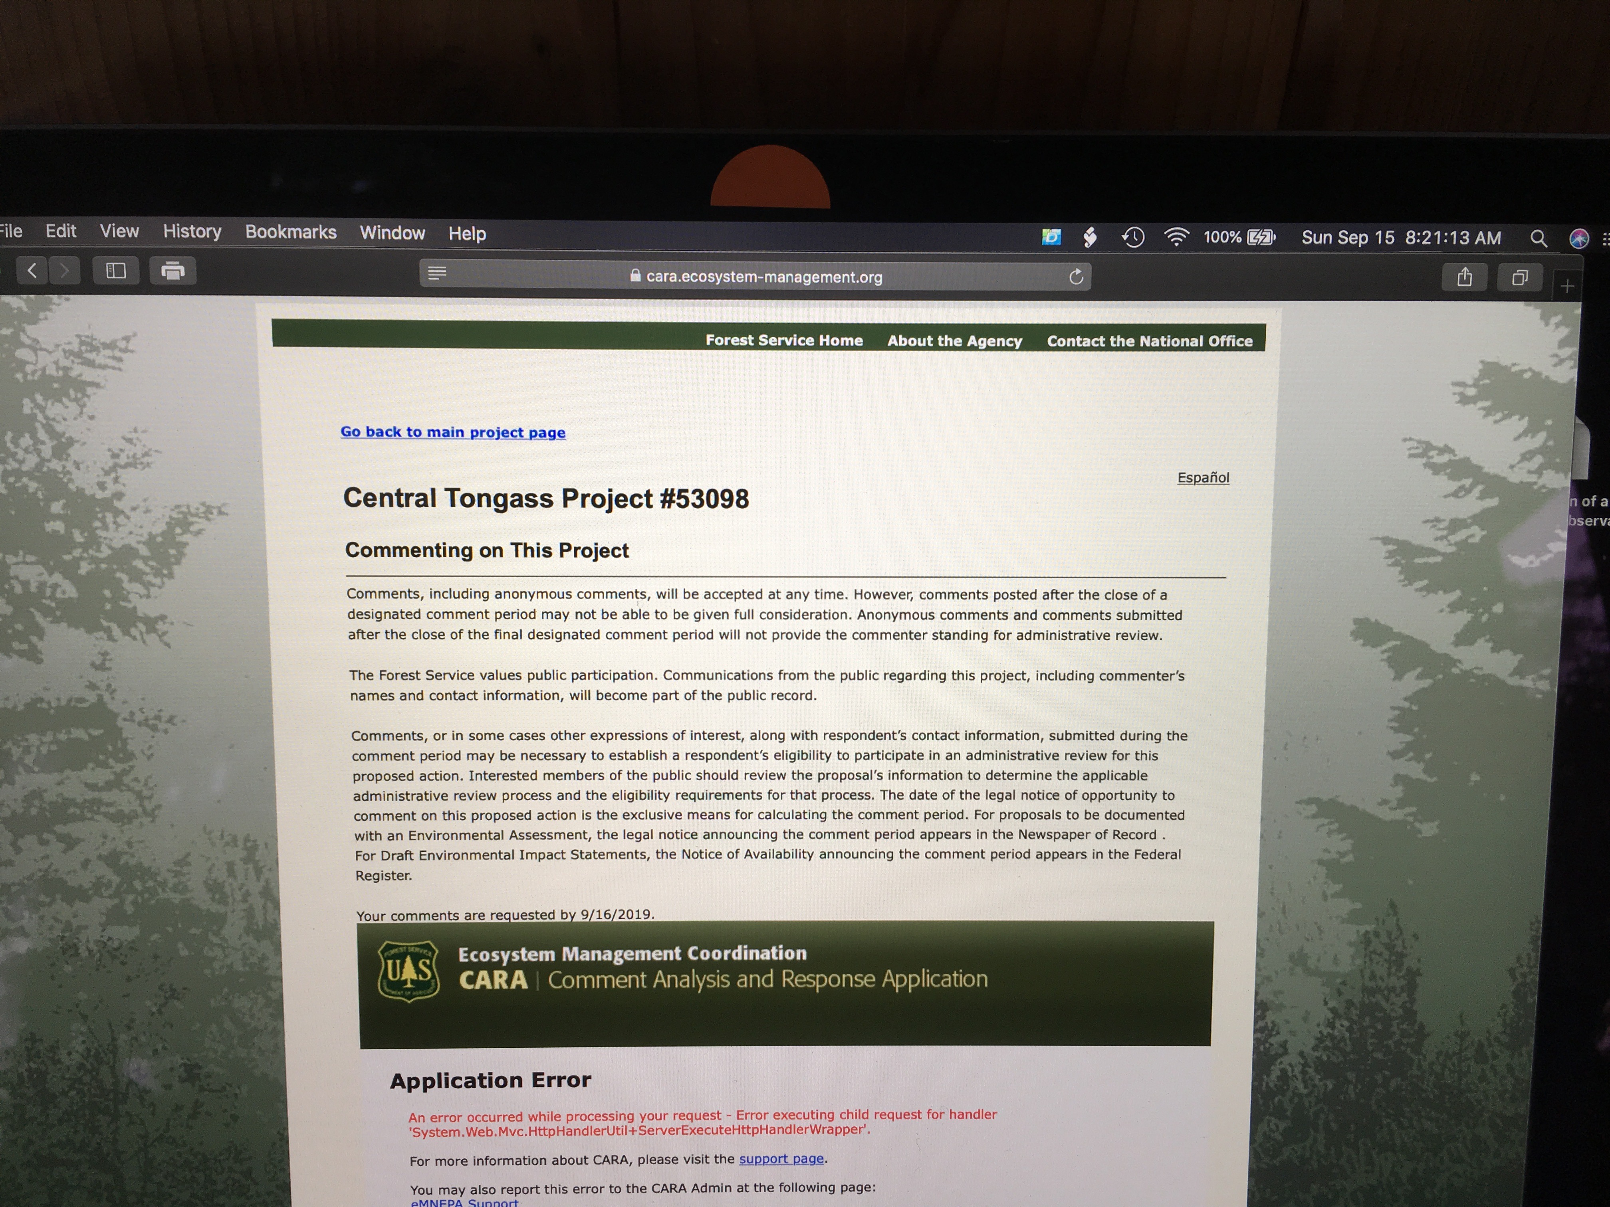
ATTACHMENT 4

