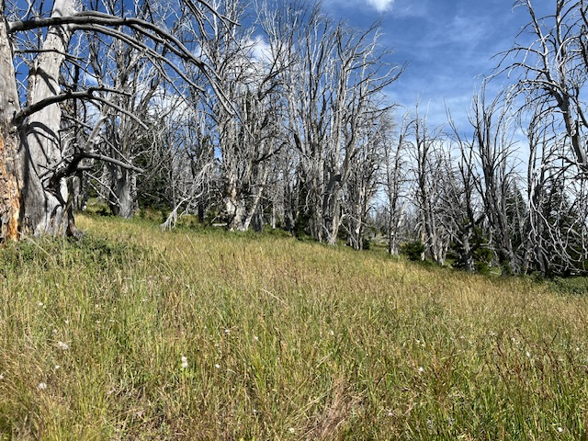

The new Old Growth definition includes dead snags as shown in this picture. This runs contrary to the public’s perception of the current Old Growth definition.