Northwest Forest Plan Comments

I am a natural history and science writer and author working on a new book specifically on the significance of the Pacific Northwest remaining ancient (old growth ) forests for biodiversity through the lens of birds as “guides” to every vertical layer. I have decades of experience a writer focused on western forests and wildlife.
The Northwest Forest Plan Amendment as proposed will be devastating to biodiversity, climate refugia, carbon capture and storage to fight climate change, roadless areas that are key to preventing fragmentation, and critical bird habitat. I object to opening the 6.5 million acres designated as Late Successional Reserves (LSRs) to any logging, roading, mowing, mastication, etc. The NWFP was a landmark effort that required the Forest Service at last to shift focus from logging mature and old-growth forests to protecting them—for wildlife, habitat, and ecosystem function.
Could the NWFP have been better in 1994? Absolutely. Major mature and old-growth forests were left out of the LSRs and were put in the matrix areas open to logging. A big oversight in the Amendment was not to address that; we need far more LSRs and in a protected status. A huge network of logging roads is webbing throughout the forests in the last 30 years and expanding int ecologically sensitive areas. We need to curb that, close roads, and rehabilitate them to return wildlife connectivity to our fragmented forests.
Still, those 6.5 million acres of LSRs are quietly “working” as lifelines for our imperiled species, for protecting headwaters, safeguarding our clean water, and doing an amazing job of capturing and storing far more carbon than forests anywhere else in the world. They are our allies in the fight against climate change. So why would the Forest Service want to wreck what’s working? Every alternative besides A marks a sharp turn toward logging that means weakening and fraying intact forests and releasing carbon from logging, as well as curtailing the critical roles of mature and older forests are doing every day to capture and store carbon.
I liken the Northwest Forest Plan Amendment’s focus on opening the LSRs to logging as akin to Elon Musk’s DOGE taking a chainsaw to the federal government—firing thousands of employees indiscriminately. Sadly, we will only find out much later how needed the employees are for what we care about most—like public health. People are not seeing what they take for granted. Firing our federal employees wil lead to worsening of diseases, tainted meats, polluted waters, and more species going extinct. Because our last remnant intact Pacific Northwest Forests can’t speak up and shout out to us—“Hey, we are doing an incredible service on planet earth every day”—they are also in jeopardy. We can hire people back. We can’t put up an old-growth forests once logged and roaded—far different than natural disturbances. These forests are the most resilient to wildfire, the most important to combatting climate change, and the most critical for biodiversity.
Given the Trump administration’s executive order to prioritize logging over endangered species and over all other values (clean water, recreation, carbon storage, etc.), this is the worst time possible to undo the Pacific Northwest Forest Plan and let political winds shift to wreak havoc—even far worse than what the Amendment now proposes. The slashing of the federl workforce translates to the loss of ecologists, biologists, hydrologists, soil scientists and more—all who would be critical to assuring any actions going forward are carried out with knowledge and on-the-ground monitoring. The efforts to get rid of NEPA and to go around the ESA also will threaten these last wild forests even more.
Alternatives—Ranked worst to better
The worst Alternative is D (highest levels of logging an even lifting rare species survey requirements in some areas). The second worst is the proposed action Alternative B (that raises the ages for what qualifies as mature and old-growth,)getting rid of the protections for the unlogged mature forests of the LSRs, and even adding more clearcutting in Matrix lands, and seriously increasing logging in dry forests. Alternative C sounds enticing with “emphasis on natural processes” but the devil is in the details—still allowing logging in the LSRs and weakening the definitions of mature and old growth. B, C, and D also allow salvage logging after wildfires—extremely detrimental to forest recovery, wildlife, and the health of the soils and streams. I oppose all salvage logging, except selectively where trees might fall on roads or houses.
Alternative A appeals in some ways. I’d take that over the others. However, I do support some changes to the NWFP that strengthen not weaken protections, consult with tribes, and are not suppressing fires that are beneficial to the natural ecology.
Give Old-Growth Trees Priority When Firefighting—Stop Deliberate Back Burns
Firefighting strategies must change to prioritize saving old-growth –not lighting ancient groves with 500-year old trees on fire in the heat of August for back burns, or cutting down big trees indiscriminately. Fires typically burn in ways that leave a mosaic of burned and unburned groves—even when intense—and that mosaic is key for wildlife habitat, for regeneration, etc. But then firefighting goes in and burns everything green that remains in pockete, then the fire is far more damaging.
When claiming that wildfire is the number one threat to old growth (logging still is), then look at why that might be. Firefighting must change as part of the equation. And it can be done in ways that are still protecting communities. We also need to do far more to stop human-caused ignitions that often coincide with the hottest, dryest, windiest times—whether from power lines or careless campfires.
I specifically saw the aftermath of firefighting damage after the Lookout Fire of 2023 within the 6,500 acres of old growth of the HJ Andrews Experimental Forest (See attached photos from an approved field visit in July of 2024 with authorized personnel from the experimental forest).
A huge road was bulldozed across Lookout Ridge that never was connected to another one and failed to serve any purpose for firefighting. I saw back burns of high intensity through wild forests that would have likely served as a green mosaic and natural refugia within other burned areas. I witnessed indiscriminate logging of hazard trees—that seems far beyond what was needed for human safety. The priority wasn’t to save old growth in firefighting. All this happened at the forest renowned internationally for old-growth research.
On the HJ Andrews post-fire field tour, I also saw excellent examples of burned trees that survived well with green needles flourishing the next summer—trees that might typically be cut down in “salvage” logging. We walked through low intensity fire, mixed intensity, and high intensity burns. While the statistics say that two-thirds of the 22,000-acre research forest burned—that doesn’t reflect the way of wildfire.
The real problem? We have far too few old growth forests remaining after more than a century of aggressive logging. We need more forests returning to mature and then old growth conditions for the future—and that means not cutting them down.
The best thing we can do is to honor the natural resiliency, complexity, and biodiversity of older forests by stepping back and letting the forests handle what they can do far better than we can with chainsaws that nature never evolved to handle.
Along with keeping the LSRs intact, allowing wildfires, and preventing backfires and reducing hazard tree cutting of old growth from firefighting, we must let more of the matrix forests become old-growth over time. We can use science to nudge them in the right direction—especially tree plantations that lack species diversity, age diversity, snags, and downed logs. Do the management in these places not in the intact forests—whether burned or not burned.

Support for Extending Old and Large Tree Protections to Matrix Lands—Carbon Storage—with changes
I support the Amendment’s proposal to protect older and large trees left in the matrix lands from logging—but that definition again should keep the age at 80 years, not above. I strongly oppose raising that age in all cases to the 120 and even 150-year threshold for east side forests.
Given the climate crisis and the superior ability of older trees to capture and store the most carbon, we ought to set that diameter level to 18 inches so the mature trees can become old. Please see this science-based story I wrote for Columbia Insight in October 2022: “The Secret Power of Old Growth” https://columbiainsight.org/the-secret-power-of-old-growth/
To appreciate the importance of the largest trees—and allowing more of them to become old for carbon—please see this part and the link to Dr. Lutz’s study: (Citation:
“The large trees are important and even cutting a few of them down has a real effect on carbon,” says Lutz, the lead author of a 2018 study, “Global Importance of Large Trees.” One of Lutz’s study plots was within the Wind River Experimental Forest in the Gifford Pinchot National Forest in Washington.
Its key finding? The largest 1% of trees in mature and older forests comprises 50% of the biomass, storing half a forest’s carbon. A living tree is half water; the part that’s not water is half carbon. A tree’s ability to stockpile carbon increases rapidly with diameter. A tree with a two-foot diameter stores about 1.7 tons of carbon; a five-foot-diameter tree stores 19.2 tons.
“If you take out the top 1% of the trees you have taken out half the carbon above ground,” says Lutz.

Logging Makes the Climate Crisis Worse
Logging exacerbates the climate crisis—so the emphasis on logging in this Amendment will make the wildfires worse, the threats to communities worse, and harm birds and biodiversity. See this part of the story I wrote with link to this published paper:
Harris, N.L., Hagen, S.C., Saatchi, S.S. et al. Attribution of net carbon change by disturbance type across forest lands of the conterminous United States. Carbon Balance Manage 11, 24 (2016). https://doi.org/10.1186/s13021-016-0066-5

“In contrast, a 2016 study documented that the number-one source of carbon emissions from western forests is timber harvest at 66%, with fire at 15%. Logging slash disrupts intact soils that release carbon, as does transport, processing and manufacturing. These emissions counter any stored-carbon benefit in wood products that also end the once-living trees’ potential.”

Protect Climate Refugia, Microhabitats, Microclimates for Birds and Biodiversity
The Northwest Forest Plan Amendment fails to value the biodiversity provided by older forests with multiple layers, trees of different species and heights, highly diverse understory, plentiful snags, multiple downed trees, and natural gaps in an overall closed canopy from natural disturbance events of tree fall, windfall, rain, and lightning. Biodiversity and resiliency to climate change go hand in hand. The health of our forests depends on the ability to support thousands of species in intricate relationships---many that are poorly understood, and many that fray and break from logging, roads, and machinery.
I’d like to draw your attention to a few important science papers and ask that you read, review, and cite as part of next steps. These add important research to inform the Amendment on microclimates, microhabitats, and the significance of the older intact forests to buffer species from the heat for climate change.
Frey, Sarah J. K.; Hadley, Adam S.; Betts, Matthew G. 2016. Microclimate predicts within-season distribution dynamics of montane forest birds. Diversity and Distributions. 22: 944-959. doi:https://doi.org/10.1111/ddi.12456

Matthew G. Betts, Ben Phalan, Sarah J. K. Frey, Josée S. Rousseau, Zhiqiang Yang. Old-growth forests buffer climate-sensitive bird populations from warming. First published: 18 December 2017

Kim, H., McComb, B. C., Frey, S. J. K., Bell, D. M., & Betts, M. G. (2022). Forest microclimate and composition mediate long-term trends of breeding bird populations. Global Change Biology, 28, 6180–6193. https://doi.org/10.1111/gcb.16353

Protect Species of Greatest Conservation Need
Forests with high biodiversity support threatened Spotted Owls, threatened Marbled Murrelets and Humboldt’s Marten in coastal forests, and a host of species of greatest conservation concern as cited by Oregon Department of Fish and Wildlife (See https://www.oregonconservationstrategy.org/ocs-strategy-species/). There’s a similar list for Washington ( https://wdfw.wa.gov/species-habitats/at-risk/swap). I will focus on my state of Oregon.
Amphibians
Specific to forests those species that must be protected include many amphibians:
https://www.oregonconservationstrategy.org/ocs-strategy-species/amphibians/
I can address the Cascades Torrent Salamander from the research I did for a January 2025 published article in National Wildlife magazine ( See: https://www.nwf.org/Magazines/National-Wildlife/2025/Winter/Conservation/Andrews-Experimental-Forest-Fires). This salamander is under consideration for a federal listing under the Endangered Species Act.
PhD student Christopher Cousins is finding that Cascades Torrent Salamanders need connected forests for the adults to venture overland from one stream to another—critical for genetic diversity for the salamanders to cross to other streams, as well as for stable populations. This adds to what is already known –as in this statement from the ODFW strategy species description (linked above): “This species requires continuous access to cold, silt-free water and moist adjacent forest.”
In the article about Cousins, I wrote: “Inhabiting icy headwaters at elevations around 3,000 feet, the big-eyed amphibian is sensitive to forest streams warming and drying up. That’s a concern as mountain snowpack dwindles in a hotter climate, leading to a decrease in late-summer flows from snowmelt.”
I cite that part, because intact forests are key to resilience in a hotter climate, to keeping cold streams cold and buffering the droughts from dwindling snowpacks. For verification, please see this research: https://research.fs.usda.gov/treesearch/65464 Citation: Thurman, Lindsey L.; Cousins, Christopher D.; Button, Sky TC.; Garcia, Tiffany S.; Henderson, Alysha L.; Olson, Deanna H.; Piovia-Scott, Jonah. 2022. Treading water: Conservation of headwater-stream associated amphibians in Northwestern North America. In: DellaSala, Dominick A.; Goldstein, Michael I., eds. Imperiled: The Encyclopedia of Conservation. Elsevier. 2: 499-513. https://doi.org/10.1016/B978-0-12-821139-7.00112-4.
Note this key part of the abstract: “Headwater streams of the Pacific Northwest of North America are home to 52 amphibian species, spanning a diversity of taxa and life histories. Headwater stream-associated amphibians occur both within coldwater-stream channels and throughout adjacent riparian habitat, reflective of the important role of old-growth forests in providing cool, moist microclimates for these sensitive species. “
Birds—Steep Declines—Critical to Save Habitats
Before turning to the ODFW species list of birds, the big picture is critical to consider. The Amendment needs to include the findings from the latest State of the Birds report of March 2025. See: https://www.audubon.org/magazine/sweeping-new-report-shows-us-birds-declining-sharply-across-range-habitats The trends are sobering—birds are in grave trouble and their numbers are plummeting. The news is even worse than a few years before in 2019 when scientists documented North America has three billion fewer birds than in 1970. Here is the link to the State of the Birds 2025 report: https://www.stateofthebirds.org/2025/
The executive summary for forest birds shows a steepening of declines for two key reasons: “Over 50% of western forest birds are declining due to habitat degradation from fire suppression and industrial timber management.”
Too much of the Northwest Forest Plan Amendment steers toward industrial timber management that will exacerbate the worsening conditions. The answer to“fire suppression” is not to log, thin, mow, and masticate –that is no substitute for the fire that forests do rely on as they have for thousands of years. Allowing wildfires to burn in backcountry and focusing on home hardening and land use planning preventing more homes being built in the interface should be the strategy. Bringing fire back into the landscape through tribal inclusion and co-management and honoring cultural burning is important. I support this and it’s far past time that the tribes are part of the future of their homeland. I add the one word of caution-not to log before prescribed burns. Bring back fire carefully and gently.
Oregon –birds species of greatest conservation need
The Oregon bird section for species of highest conservation need includes species that must be part of any Amendment to assure they are protected and their specific habitats: https://www.oregonconservationstrategy.org/ocs-strategy-species/birds/. Please look at each forest bird and attend to what they need. I will give a few examples here.
American Three-toed Woodpeckers are “ rare and locally distributed in Oregon. Given their apparent dependence on older forests and diet specialization, reductions in snag availability due to fire suppression and forest health management may limit distribution.” Salvage logging is hugely detrimental to this woodpecker. We have a shortage of snags. The proposed amendment’s emphasis on salvage logging is problematic in multiple ways—and a key one is impact to woodpeckers.
Black Swifts nest behind waterfalls in forests, are highly sensitive to disturbance, and depend on aerial insects that are in steep decline. Intact headwater forests are critical to the future of swifts and waterfalls—assuring there will be water in a drying climate.
Great Gray Owls are dependent on abundant snag habitat for nests, and on the birds that build the nests—especially Northern Goshawks. When Great Gray Owl chicks fledge, they cannot fly for two weeks and depend on small diameter leaning trees against large trees as ramps. The over-emphasis on thinning out young trees is destructive to many birds needing what are always targeted as “ladder fuels.” This speaks to why it’s so important to not “manage” these forests to be the way people seem to like them—tidy, neat, and without all the “messiness” that is essential to biodiversity.

East Side Forests
I spend much of my outdoor time recreating on the Deschutes National Forest Half of the Forest falls under the NWFP and half under the East Side Screens. We would be far better off with the East Side Screens—preventing trees 21” DBH and bigger from being logged—than with the proposed amendment to the NWFP.

I strenuously object to the simple categorization of the forests here as “dry” and in need of major thinning throughout. This seems like an excuse for massive logging to the detriment of many wildlife species mentioned above and including the White-headed Woodpecker on the east side. I was shocked to see the age of what’s considered old-growth raised to 150 years. It should be 80 years. And no tree over 21” DBH should be cut.

So many of the forests here are mixed coniferous with fire return intervals that can be 60, 80, 100, and even 300 years or more. Many of those forest types evolved with fire that was of higher intensity. Only in select places are the forests pure ponderosa pine with frequent fire intervals and low intensity fires as the norm. I have no problem with noncommercial thinning of small ponderosas before prescribed fire, but do not support the commercial “thinning” that I’ve witnessed off Century drive—cutting big trees that could be storing and capturing carbon and hauling them off in truck loads.

I’ve also seen firsthand on the Forests what so-called “restoration” looks like to make Bend safer from fire. I’m appalled to walk in favorite forests with miles and miles of mowing, masticating, and churning of soil with heavy equipment, causing soil compaction and destroying the mycelial network of roots that keeps the forest healthy. Far from forest health—this is a weakening of forests that makes trees more vulnerable than they already are to the worsening drought, leading to more trees dying, and more wildfire threat. This practice is terrible for the understory plants. Many are flowering shrubs—manzanitas, bitterbrush, ceanothus, and currants. Not only are the blooms critical for our severely declining pollinators, but the insects also associated with them are critical for birds, especially when raising their chicksl

I do not support anything in the Amendment that would continue this disastrous approach. What I would prefer to see is funding going to communities to be firewise and to do things that might be helpful—like more prescribed burning at the right times (not bird nesting season in spring) that brings fire back where it’s needed.

What True Restoration Looks Like—an Alternate Economic Vision for Communities
The Northwest Forest Plan Amendment is flawed in looking to commercial logging as the way to support communities. The entire economic section in the Amendment needs to be drastically altered. There’s a serious lack of vision as to what could truly sustain communities in the long run. Instead, I propose a restoration economy based on the true meaning of “restoration” –by making amends for the mess we’ve made with logging and thousands of miles of logging roads causing landslides, erosion, and destruction of streams—as one example.
Here's my starter list of restoration jobs for the forest. Instead of subsidizing below-cost timber sales, subsidize jobs that make the forests we’ve wrecked with logging, roads, clearcuts, and logging better—good for the climate, good for fire resiliency, good for future generations:
- Road Fixes: Closing roads, fixing and replacing culverts, rehabilitating roads so they can return to natural forest, and placing high priority on the roads that are the worst culprits for landslides, sedimentation into streams, and impacting wildlife corridors. Also, roads that when closed can allow fragmented old growth forests and roadless areas to reconnect.
- Rehabilitation of Clearcuts: No spraying, planting more native species where needed, and other science-based solutions to returning these scarred landscapes to health.
- Tree Plantation Habitat Work: See this science paper on bird species in plantation and clearcuts for recommendations on how to enhance: https://www.sciencedirect.com/science/article/abs/pii/S0378112720316716
  - Please review and add this related paper : (citation: Scott H. Harris, Matthew G. Betts, Bird abundance is highly dynamic across succession in early seral tree plantations, Forest Ecology and Management, Volume 483, 2021.
- Addressing the wildfire threat wisely: Programs that fund carefully done prescribed burning at the right times and with tribal co-leadership. Firewise community projects. Burying power lines.

The Amendment a should scrap the economic direction of exploitation and focus on what’s really bringing dollars to the Northwest—Recreation. People don’t want to recreate in clearcuts, logged over lands, around massive piles of slash, and mowed, masticated, and churned earth. They want wild forests, towering trees, and trail experiences. What does that take? First—protecting the very forests now being proposed to be cut down for local mills (many not equipped anymore for big trees and should not ever return to that).
The more fisheries are restored from past damages by removing dams, bringing back beavers, protecting riparian areas, allowing natural flooding, etc., the better will be the fishery. From a recreation standpoint, that brings floods of dollars from flyfishing. Similarly, closing roads and much of the restoration work cited above would stimulate the wildlife economy—hunting, birding, wildlife viewing.
To see the huge economic power of birding alone, please see this graphic pasted here from the March 2025 State of the Birds report:
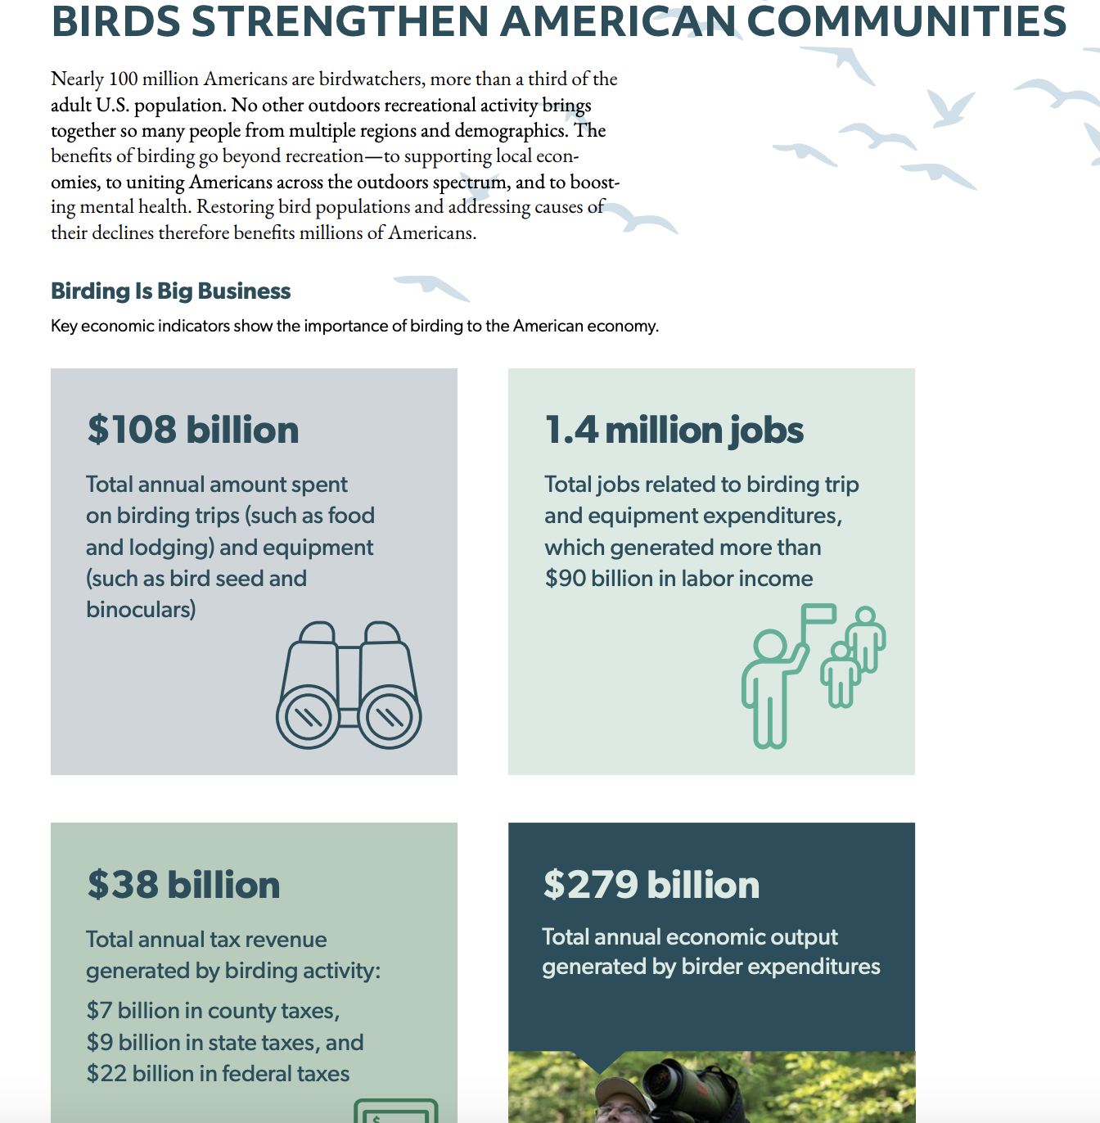

Fund birding and hiking trails-- not roads. Make sure we have trail crews to maintain them. There’s a growing economy in long distance hiking as well as shorter hikes. People are craving wild places to hike beyond our far too few Wilderness areas. See this link: https://americanhiking.org/resources/economic-benefits-of-trails/
What makes people want to live and stay in a rural community? Preserving the natural beauty—not wrecking it with logging. In addition to the restoration jobs mentioned, there ought to be jobs as biologists, botanists, bird guides, naturalists, hiking guides, shuttle services for hikers, and lodging for visitors. What provides those jobs? Nntact national forests—not logged, roaded, and wrecked. What gives real protection from wildfire exacerbated by climate change? Drastically cutting fossil fuel emissions as the highest priority (logging is the #1 source of carbon emissions in Oregon).

Thank you for this opportunity to comment. I love Oregon deeply and the wild forests and ecosystems that remain. I want to see true stewardship that honors the practices of tribes over the millennia to be in a relationship of reciprocity, and never taking more than we need, and treating the lands, waters, rocks, trees, and animals as our brethren. We are part of nature. We need to be far humbler and spend far more time listening to the land and honoring these last wild forests that are precious.

