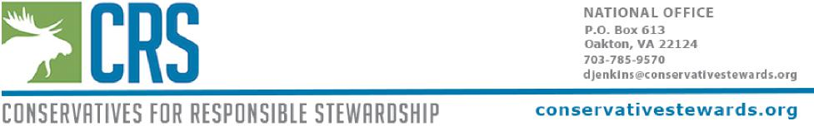

December 13, 2019

Ken Tu, Interdisciplinary Team Leader

Alaska Roadless Rule

USDA Forest Service

P.O. Box 21628

Juneau, AK 99802

Dear Mr. Ken Tu:

On behalf of Conservatives for Responsible Stewardship (CRS), a national grassroots organization of stewardship-minded conservatives, and its more than 14,000 members, I write to urge the U.S. Forest Service (USFS) to choose the “no action” alternative for the Draft Environmental Impact Statement (DEIS) and the proposed Alaska Roadless Rule (Alternative #1). Keeping the Roadless Area Conservation Rule (Roadless Rule) in place in Alaska will protect taxpayers from uneconomical and heavily subsided logging activities and road construction.

As a taxpayer funded boondoggle, logging in Tongass National Forest is worse than Solyndra. A recent report from Taxpayers for Common Sense found that timber sales on the Tongass have cost the American taxpayers roughly $600 million since 1999, or $30 million per year on average in 2018 dollars—and that is with the Roadless Rule in place.*0F*1 Weakening the Roadless Rule to prop up even more subsidized uneconomical logging activity would be a fiscal nightmare.

Since its promulgation in 2001, the Roadless Rule has limited wasteful and environmentally damaging roadbuilding and logging on millions of acres of Forest Service land across 38 states. Limitations on these activities have helped protect against taxpayer losses and conserve high-value national forest lands.

A key strength of the Roadless Rule is that while it protects some of America’s last remaining undeveloped national forests, it also provides flexibility for activities such as mechanized recreation, hydropower development, mining operations and access roads, fire prevention and public safety, and the maintenance of

1 Taxpayers for Common Sense, “Cutting Our Losses: 20 Years of Money-Losing Timber Sales in the Tongass” (2019),<https://www.taxpayer.net/wp-content/uploads/2019/09/TCS-Cutting-Our-Losses-2019-.pdf>.

connections between communities. The Rule is also flexible in that it allows the Forest Service to accommodate reasonable needs for road building and logging in roadless areas. In fact, the agency has approved all 58 projects that have been proposed in Tongass roadless areas since the Roadless Rule went into effect.

The importance of the Roadless Rule is especially apparent in the Tongass National Forest. Due to high road building and transportations costs, lack of sawmill capacity, and low timber values, the Tongass has the least economically efficient timber sale program in the National Forest System.

Maintaining existing Roadless protections in Alaska will help save taxpayers millions of dollars by limiting costly new road building in harsh and inaccessible terrain. Road construction costs on the Tongass average $185,000 per mile, and can be as high as $322,378 per mile on steep slopes, with maintenance and repair costs averaging $50,000 per mile.*1F*2

These costs are largely absorbed by the USFS, which already has a $3.2 billion maintenance backlog resulting from its massive 371,000-mile road network. Continuing to burden this system by adding more roads will either defer more critical infrastructure maintenance or will force additional funding allocations from Congress. We strongly oppose the waste of taxpayer money to subsidize a program that does not net value back to the taxpayers.

From the 1950s to the 1990s, the Tongass yielded significant amounts of timber for pulp, paper, and lumber, and supported thousands of jobs in Southeast Alaska. But since then, market forces have drastically changed that industry, and today the Tongass supports fewer than 100 timber jobs, which account for less than one percent of regional employment. Tourism and fishing, on the other hand, represent 26 percent of jobs in the region. A total exemption from the Roadless Rule will not revive Southeast Alaska’s failing timber industry and will directly threaten the thriving and sustainable fishing and tourism industries.

The Tongass contains some of the largest remaining tracts of temperate old-growth rainforest in the world, helping make it the country’s single most important national forest for carbon storage and climate change mitigation. The forest holds about 650 million tons of carbon, representing roughly half of 2017 U.S. carbon dioxide emissions from the electric, industry, transportation, agriculture, and commercial/residential sectors.*2F*3 Carbon stored in the Tongass makes up about 11 percent of the carbon currently stored in U.S. forests.*3F*4

2 Alexander, S. J., Dr., Henderson, E. B., & Coleman, R. (2010). Economic Analysis of Southeast Alaska: Envisioning a Sustainable Economy with Thriving Communities [Abstract]. *Forest Service Alaska Region,* p. 1-98.

3 Tongass National Forest. Draft Environmental Impacts Statement Rulemaking for Alaska Roadless Rule, p. 3-124, section Carbon Storage Aboveground.

4 *Ibid*.

If logged, much of this stored carbon will be released into the atmosphere, accelerating climate change. Any “second growth” trees will not store nearly as much carbon. By simply not clearcutting these areas and keeping the Roadless Rule in place, the Tongass can continue to be a low cost part of our country’s response to climate change.

It is critical that Alaska’s national forests be managed in a fiscally responsible way. Timber harvesting on national forests is a viable multiple use activity, providing jobs and producing valuable products. However, from an economic and environmental standpoint, we cannot justify opening up more roadless areas in the Tongass for timber sales for the reasons stated above. Keeping the Roadless Rule intact will safeguard the government from incurring needless debt, align the Tongass’ management direction with the realities of Southeast Alaska’s commercial trends, and help fight climate change.

While speaking of America’s great forests and other natural wonders, President Reagan wisely pointed out, “This is our patrimony. This is what we leave to our children. And our great moral responsibility is to leave it to them either as we found it or better than we found it.”

Thank you for considering our request that the Forest Service pursue a fiscally responsible, environmentally sound course of action by selecting Alternative #1, the “no action” alternative.

Respectfully,

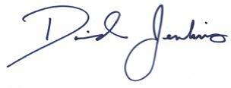

David Jenkins   
President