Climate Change Vulnerability Assessment for the Spotted Owl (Strix occidentalis) across three unique subspecies

By:
Amy Munes and Elizabeth Ng

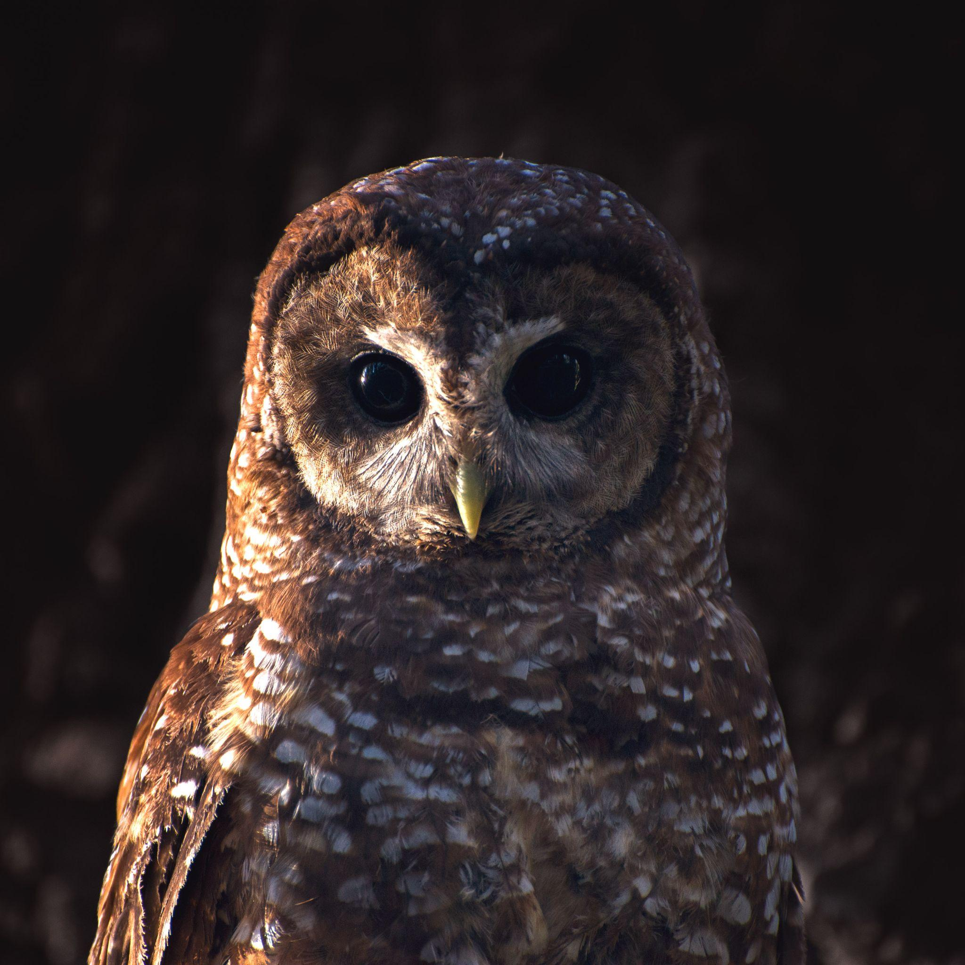

TABLE OF CONTENTS

- Abstract……………………………………………………………………...…………….2
- Introduction
  - Ecological Significance and Conservation Status……………………………...… 2
  - Climate Sensitivity.…………………………………..……………….………...…3
  - Conceptual Model………………………………………………….…………...…4
- Description of Data
  - Distribution Data………………………………………………….………...……..5
  - Climate and Habitat Data………………………………………….………...….…6
- Analysis
  - Review of Exposure
    - Historical……………………………………………….………………….6
    - Future………………………………………………….…………………..8
- Adaptation Strategies
  - Climate Change……………………………………..……………….…………...11
  - Barred Owls…………………..…………………………...…………………..... 12
  - Monitoring……………..……………………………………………………….. 13
- Conclusions………….………………………………………………………….………. 13
- References…………………………………………………….…………………….……14

ABSTRACT
The spotted owl (Strix occidentalis) is an apex avian predator native to western North America and comprising three subspecies. Spotted owls are considered specialists, dependending on old growth forest, and thus frequently serving as ecological indicator species. All three subspecies have been rapidly declining due to land use changes and exacerbated disturbance. In this vulnerability assessment, we investigated their exposure to novel climate change and proposed suitable adaptation strategies given their sensitivity. As summers get increasingly hotter and more dry, we propose prioritizing climate micro-refugia, bringing low-severity fire back to the landscape through fuel treatments, and barred owl removals. These strategies will contribute to the return of heterogeneous old forest habitat that may allow for the persistence of spotted owls in the face of rapid, anthropogenic climate change.

INTRODUCTION
Ecological Significance and Conservation Status
The spotted owl (Strix occidentalis) is an avian predator native to the western United States. All three subspecies of the spotted owls, Mexican (MSO; ssp. lucida), California (CSO; ssp. occidentalis), and Northern (NSO’ ssp. caurina), depend on complex mature forests for nesting, roosting, and foraging in their respective ranges (Bias and Gutiérrez 1992). Spotted owls are among the most studied species worldwide (Lõhmus, Asko 2004, Gutiérrez 2008) and due to its strong habitat associations, has frequently served as a barometer for old-forest health (Jones et al. 2016). As a top predator, spotted owls can have strong top-down effects on the entire ecosystems they occupy (Pace et al. 1999, Wood et al. 2019). Indeed, because of the ecological importance of this species, spotted owls frequently serve as a driver and constraint for forest management activities (Collins et al. 2017, Kramer et al. 2021).
Due to regional decline in mature forests and generalized habitat loss from logging and urbanization, spotted owl populations are declining across all three ranges at rapid rates (Gutiérrez 2008, Franklin et al. 2021, Jones et al. 2023, California Department of Fish and Wildlife in press). The MSO and NSO are currently listed as threatened, while the CSO is listed as near threatened and declared a “species of special concern” (California Department of Fish and Wildlife). The CSO is additionally up for listing as a threatened species as of 2023 due to recent subpopulation concerns. Indeed, the spotted owl faces a variety of climate change induced threats, including, but not limited to, competition with the regionally invasive barred owl (Strix varia), climate change amplified disturbance regimes, like severe drought and fire, and habitat loss from urban development and logging (Jones et al. 2016, 2018, Hofstadter et al. 2022).
Spotted owls are historically adapted for hot, dry summers, cold winters, and frequent low-severity fire. Indeed, spotted owls have dense plumage comparable to boreal owls and select cold roosting sites, usually toward the bottom of drainages, during the summer for thermoregulation (Barrows 1981). However, rising temperatures are exacerbating fire and drought, and exceeding their thermal tolerance (McGinn et al. 2023). In the rise of climate change, mature forest has become essential climate refugia for many species including the spotted owls, adding to the necessity of this habitat (McGinn et al. 2023). Indigenous fire exclusion and natural ignition suppression over the past century has also led to forest densification and fuel build up (Collins et al. 2017). This abundance of fuel may act as ladder fuel, thus in the event of a fire, effectively increasing the severity and spread of wildfire (Stephens et al. 2018). Landscape-scale water stress from increased forest density and climate change has increased drought severity (Asner et al. 2016). Drought can exacerbate fire spread through dry fuel build up and leave trees vulnerable to bark-beetle invasions (Crockett and Westerling 2018).
Forest managers are striving to implement fuel treatments to reduce ladder fuels and effectively limit fire spread (Collins et al. 2010). However, removal of this understory can have negative effects on spotted owl prey that relies on dense understory brush, effectively limiting spotted owl foraging (Ward and Noon 1998, Ganey et al. 2016, Gallagher et al. 2019). In concern over the effects of fuel treatments on spotted owls, as well as cost and effort as limiting factors, fuel treatments are not being implemented at a sufficient scale (Cova et al. 2023).
Climate change between the early 1900s to the 1970s in the form of increased temperatures and decreased precipitation in a forested Canadian corridor likely contributed to the barred owls invasion to spotted owl habitat from the north (Monahan and Hijmans 2007; USFS 2023). As a competitively dominant species, barred owls have displaced spotted owls from historic breeding sites leading to declines in recruits (Franklin et al. 2021, Rockweit et al. 2023). Barred owls are also known to mate with spotted owls, negatively affecting viability and exposing spotted owls to novel pathogens (Long and Wolfe 2019). Barred owl lethal removals have been successfully implemented in the CSO range, where barred owls are not yet established. These removals have led to near barred owl extinction from the CSO range and successful recolonization by spotted owls (Hofstadter et al. 2022). However, this success is likely due to the early start on removals, unlike in the NSO range, where barred owls have established in the thousands and have actively extirpated spotted owls in Canada.
With the right course of action we can curb the effects of climate change that put spotted owls at risk of extinction. In this assessment, we assessed and summarized specific climate vulnerabilities that are putting spotted owls at risk. Then we compared their historic and future exposure to climate variables like temperature and precipitation and proposed suitable responses to these anticipated changes.

Climate Sensitivity
To help us understand how spotted owls are susceptible to climate change we calculated a vulnerability assessment score. Developed by the U.S. Forest Service, the System for Assessing Vulnerability of Species (SAVS) uses habitat, physiology, phenology, and biotic interactions to give a numerical value between -20 and +20 to assess the climate risk of a species. Spotted owls scored a 12.58, with habitat vulnerability accounting for 34% of the total score (table 1). Climate change associated increases in fire and drought has resulted in massive turnover of old growth forest to homogenous early-seral forest. Old growth forest buffers fire severity and promote spotted owl nesting habitat (Lesmeister et al. 2021). As spotted owl’s plumage and physiology is adapted to historical climate conditions, climate change may quickly exceed their thermal tolerance (Weathers et al. 2001). The biotic interactions vulnerability score was also relatively high, but had the highest uncertainty, which is appropriate given the relatively recent invasion of barred owls into western forests. The uncertainty indicates lack of available information in the literature, signaling where more monitoring and research is needed. Phenology had a relatively low score, likely due to spotted owl’s lack of migration of dependence on phenological cues. Thus, we focused our analysis and adaptive strategies on spotted owl habitat, thermal tolerance, and the barred owl invasion.

Table 1. Based on the system for assessing vulnerability of species (SAVS) to climate change scoring system, spotted owls are vulnerable to climate change due to habitat constraints, physiology, and biotic interactions. However, there is little evidence indicating there is a disruption in phenology but there is a relatively high level of uncertainty
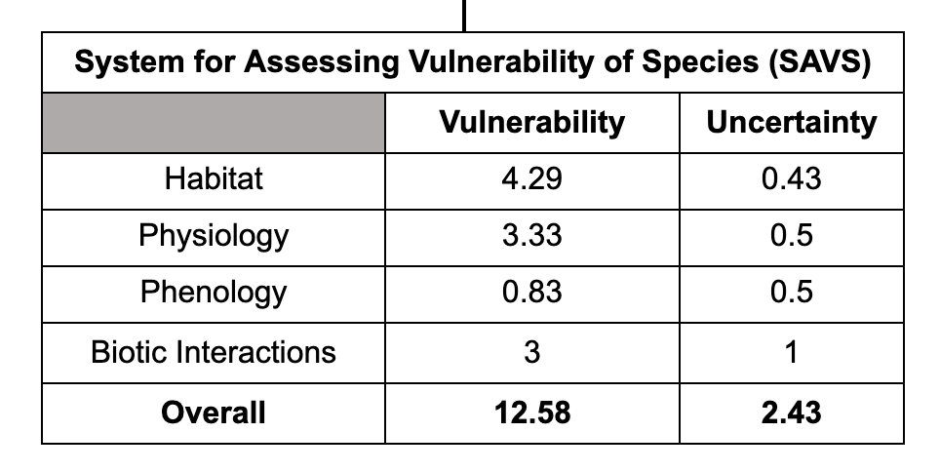

Conceptual Model
We developed a conceptual model to illustrate the vulnerability of spotted owls and the threats that put them at risk of extinction (Figure 1). The top four elements that impact spotted owl populations include anthropogenic factors such as exclusion of indigenous fires and urbanization, as well as climate factors like precipitation and temperature. In many instances, these factors are synergistic, for instance, anthropogenic factors like urbanization contribute to climate change. These factors lead to habitat change, barred owl invasion, and nest failure, all contributing to a decline in spotted owl populations.
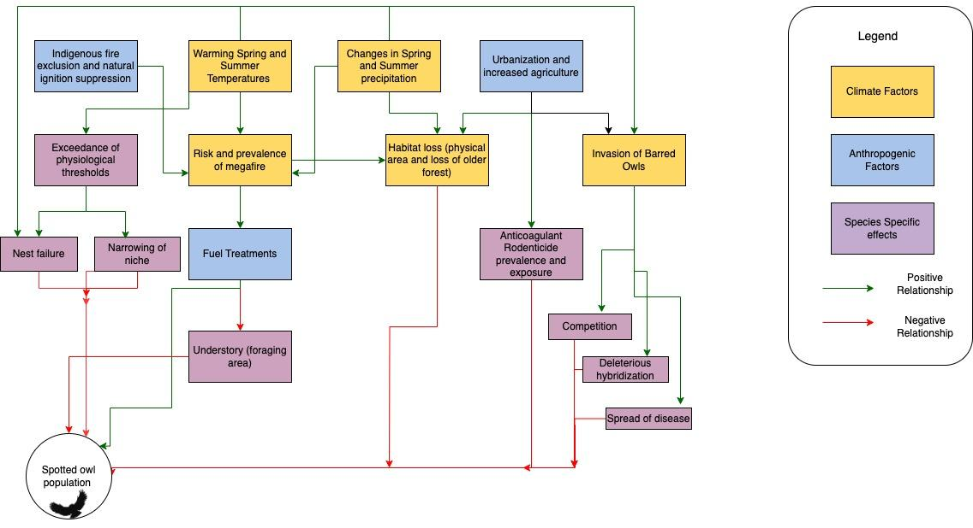
Figure 1. Conceptual model of climate and anthropogenic induced risks to spotted owl populations. It is noted that climate factors are largely influenced by anthropogenic causes. Red lines indicate a negative relationship, where the line drawn from a box to another box indicates the first box causes the secondary box to decrease. Green lines indicate vice versa, where the first box causes the secondary box to increase.

DESCRIPTION OF DATA
Distribution data
We used species occurrence data from the Interface to the Global Biodiversity Information Facility API in the rgbif package in R (R Core Team 2022, Chamberlain and Boettiger 2017). These data were acquired through species accounts from the iNaturalist platform. Due to the sensitive nature of the species conservation status, GPS locations were “jittered” by 27 to 30 kilometers as not to disclose specific locations to the public. Each logged spotted owl detection GPS location is displayed in figure 2.

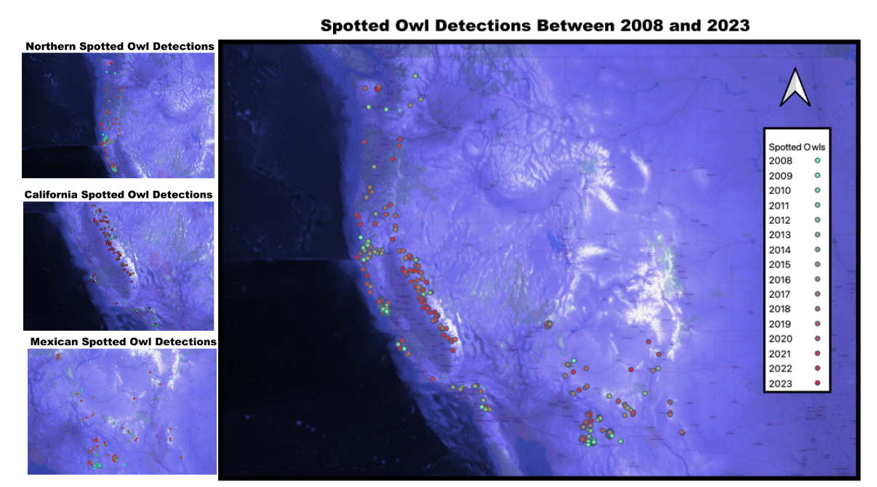

Figure 2: Maps showing iNaturalist citizen science data of spotted owls detected through their ranges (due to the sensitivity of the species, positions are staggered up to 30 km) between 2008 and 2023, with the color gradient of the points indicating the year detected and map color gradient represents elevation change. All spotted owl detections are shown on the right and individual species (Northern, California and Mexican spotted owls) detections are shown on the left (QGIS).

Climate and Habitat data
Climate data associated with the GPS points were accessed through PRISM Climate Group, based at Oregon State University, through R-Studio (R Core Team 2022). The historic PRISM climate data were acquired through various monitoring networks to get the best climate estimates from specific GPS points. Our analysis used the means of each climate variable (temperature or precipitation) from all GPS points each year for the month of interest (May and July). We chose to look at May, a critical time for spotted owl development, when climate factors can impact growth rates as well as overall health of potential recruits (Mikkelsen et al. 2022). July was also a month of interest as it is the hottest month of the year, and would likely be the time when temperatures most exceed spotted owl thermal limits (Weathers et al. 2001). The future projections and habitat data were accessed through the Climate Mapper web tool Climate Toolbox. We assessed how climate is expected to change by the end of the century (2070–2099) if emissions sustain their current trajectory (8.5 RCP). We investigated long term changes to help inform managers of the long-term consequences of altered climate and disturbance to a climate sensitive species.

REVIEW OF EXPOSURE
Historic
Physiological constraints contributed to spotted owl vulnerability, which stems from their inability to tolerate modest increases in temperature as adults and sensitivity to precipitation as nestlings. Spotted owl adults, though impacted by heat stress in late summer months, can move to cooler areas of the forests such as drainages or cool dark areas with heavy canopy cover. However nestlings and recent fledglings are unable to move to these areas at a young age. Additionally, nestlings are vulnerable to climate stress through precipitation in early spring, before they grow more water resistant adult feathers and can effectively thermoregulate. Cold temperatures and heavy rains have negative impacts on nestlings growth (Mikkelsen et al. 2022), and May is a key month for nestling development (Gutiérrez 2008). Analysis of mean climate variables in May revealed an increase in temperature increase and between 2008 and 2022 in all spotted owl habitats, precipitation decreased over this same timespan (Figure 3).

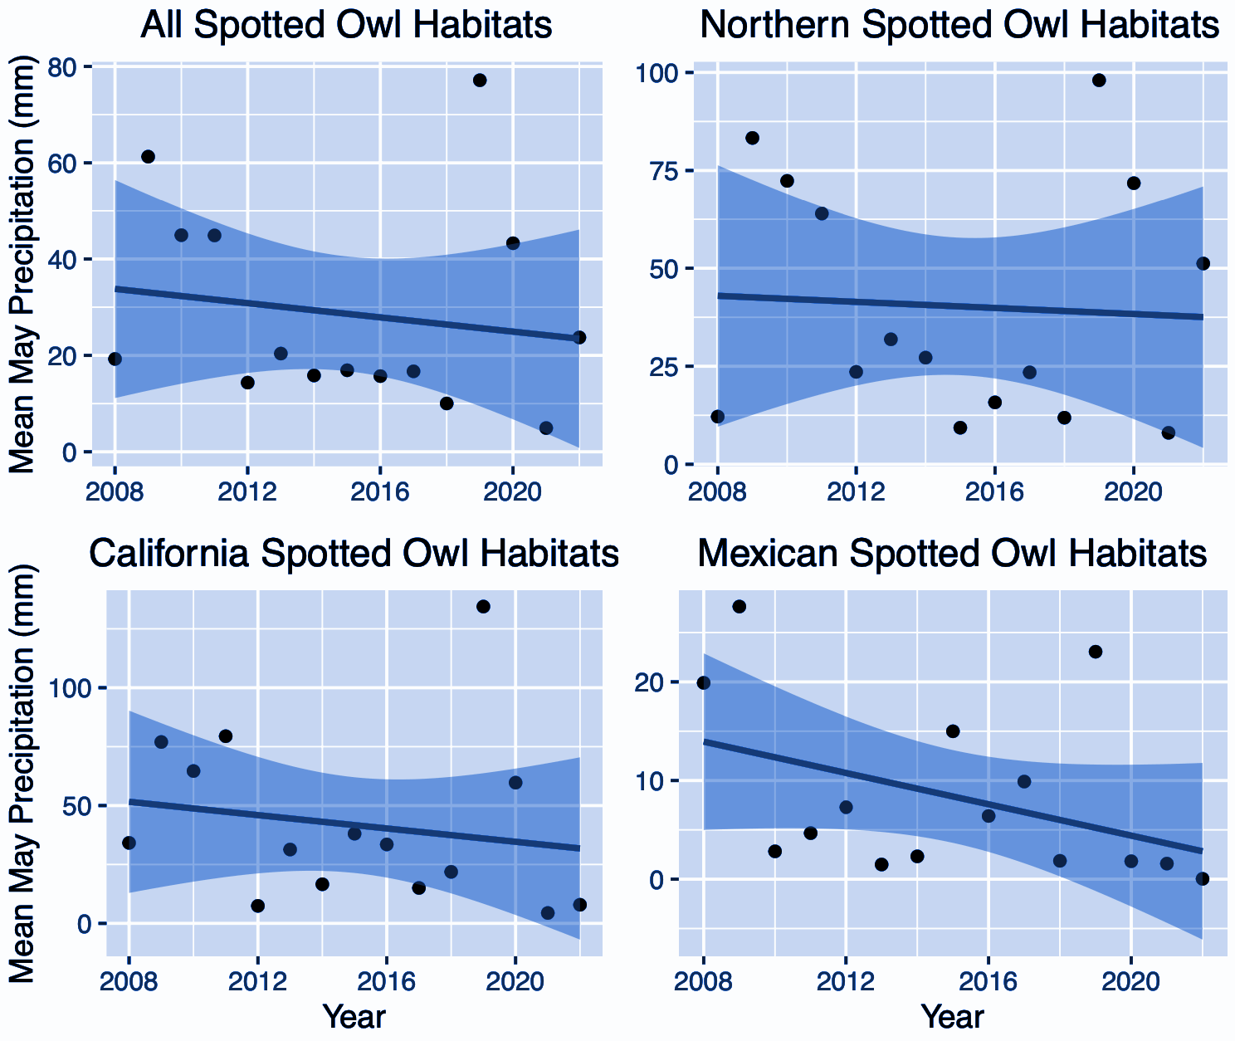
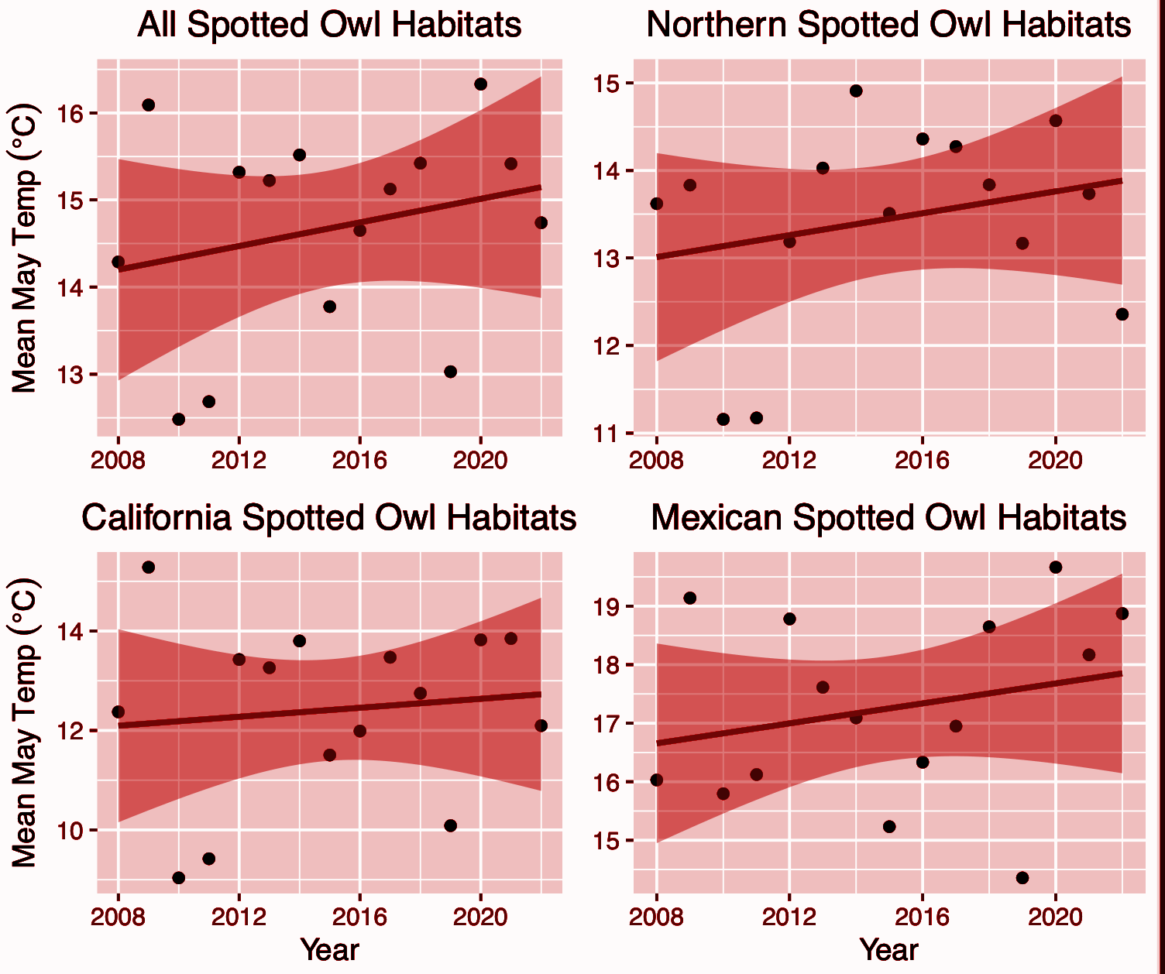

Figure 3: The four panels on the left (red) show mean May temperatures, and the four on the right (blue) show mean May precipitation each year between 2008 and 2022. These data were sourced from PRISM, and were derived from the mean temperature and precipitation estimates from mean latitudes and longitudes of spotted owl detections by year. Each plot shows mean variables (temp or precip) from all spotted owl species detections (Top left by color; n=500), Northern spotted owls (top right by color; n=221), California spotted owls (bottom left by color; n=95), or Mexican spotted owls (bottom right by color; n=184). PRISM Climate Group, accessed 17 Nov 2023.

Although spotted owls are vulnerable to landscape scale heat stress, cooler microclimates within their ranges during a critical developmental stage could potentially serve as refugia for developing spotted owls. CSO adults can only tolerate modest temperature fluctuations and show signs of heat stress between 30 and 34℃ (Weathers et al. 2001). Temperatures in July, when juveniles are newly fledged, steadily increased as the years progressed (figure 4), and will be above the upper limits of their physiological threshold for thermal tolerance in much of the MSO range by the end of this century (Weathers et al. 2001; figure 5).
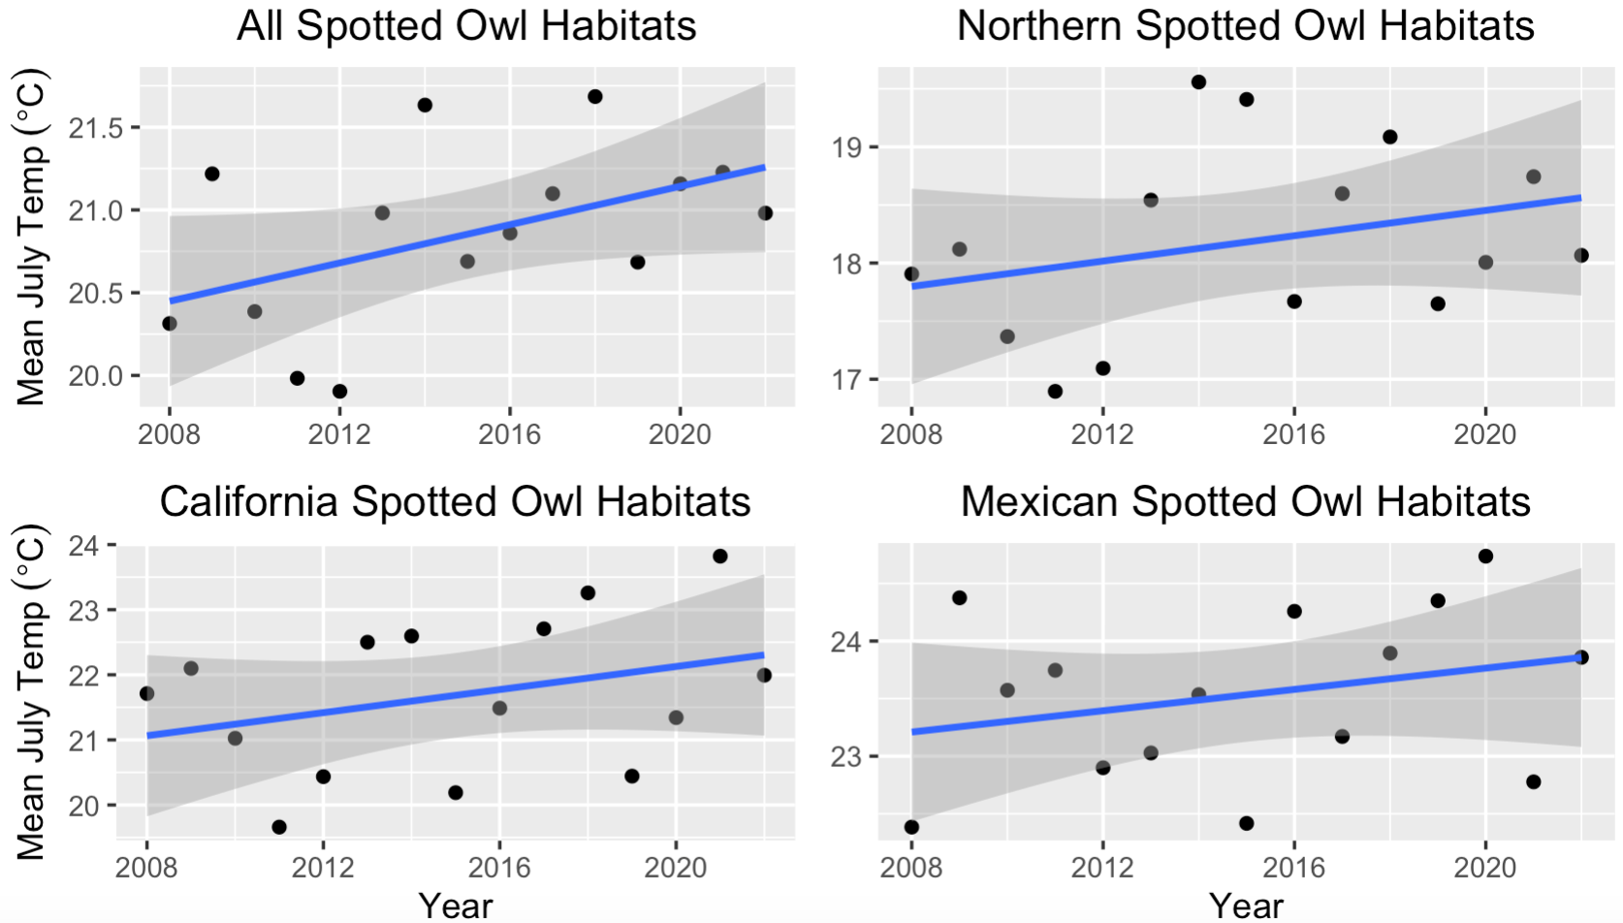

Figure 4: Mean July temperatures each year between 2008 and 2022. These data were sourced from PRISM, and were derived from the mean temperature from mean latitudes and longitudes of spotted owl detections by year. Each plot shows mean temp from all spotted owl species detections ( n=500), NSO (n=221), CSO (n=95), or MSO (n=184). PRISM Climate Group, accessed 18 Nov 2023.

Future
Temperatures are expected to increase, with the most extreme temperature increases being in the southern portions of spotted owl ranges. These increases in temperature will exceed the threshold of thermal tolerance in some areas of spotted owl ranges by the end of this century. As the southern portions of their ranges increase in temperature, spotted owls seem to be shifting north in response (figure 8). In addition to the increase in temperature, precipitation is projected to decrease in most of the NSO habitat. However, areas within the MSO and CSO ranges are projected to increase in precipitation by the end of the century (figure 5). These climate change projections are assuming emissions will stay at the same trajectory they are today. Precipitation declines in NSO habitat may mean increases in drought, with subsequent vegetation loss.
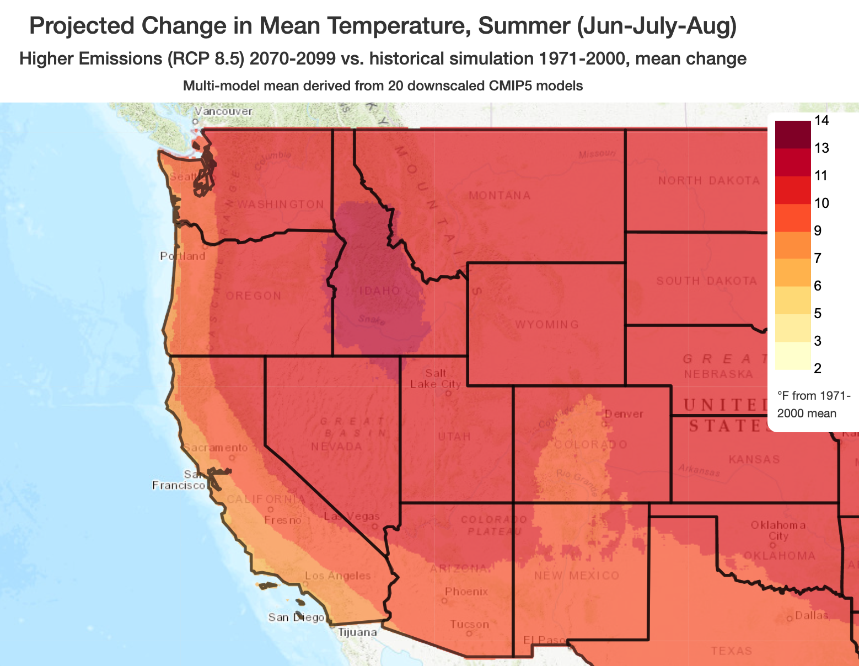
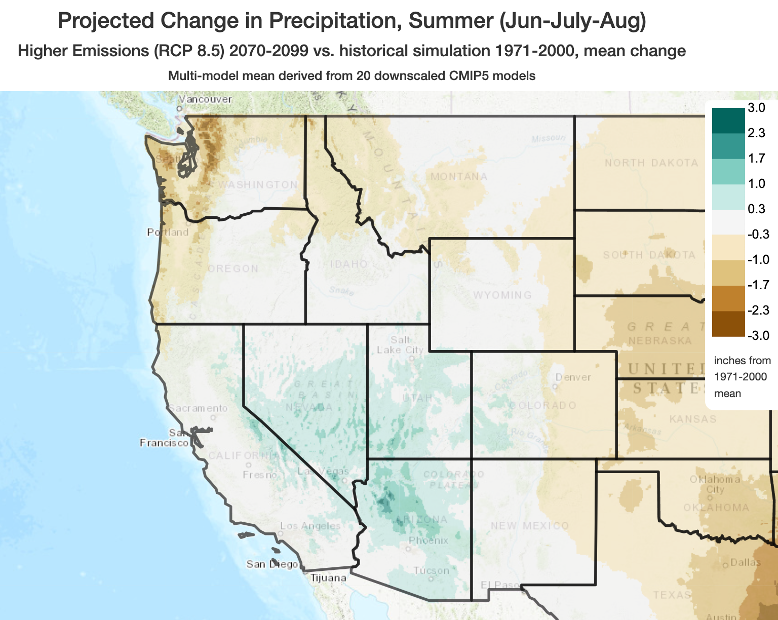
Figure 5: Projected mean summer (June through August) temperatures (degrees F; left) and projected change in precipitation (inches; right) across spotted owl detection areas between 2070 and 2099 if emissions stay at their current trajectory (Climate Mapper web tool. Climate Toolbox, accessed November 18, 2023).
Extreme fire is expected to increase on the landscape in all spotted owl ranges in the next century, if emissions increase at the expected rate based on current output (Figure 6). The NSO will see the largest increase in extreme fire days in the northern regions of their range. Fire's impact on spotted owl occupancy varies depending on the intensity, patch size, and return interval of the regime (Roberts et al. 2011). Although low severity fire can have positive effects on spotted owl habitat and persistence, large-scale megafire dominates the west-coast, and an increase in this disturbance will have persistent negative effects on spotted owl populations (Jones et al. 2021, Cova et al. 2023).

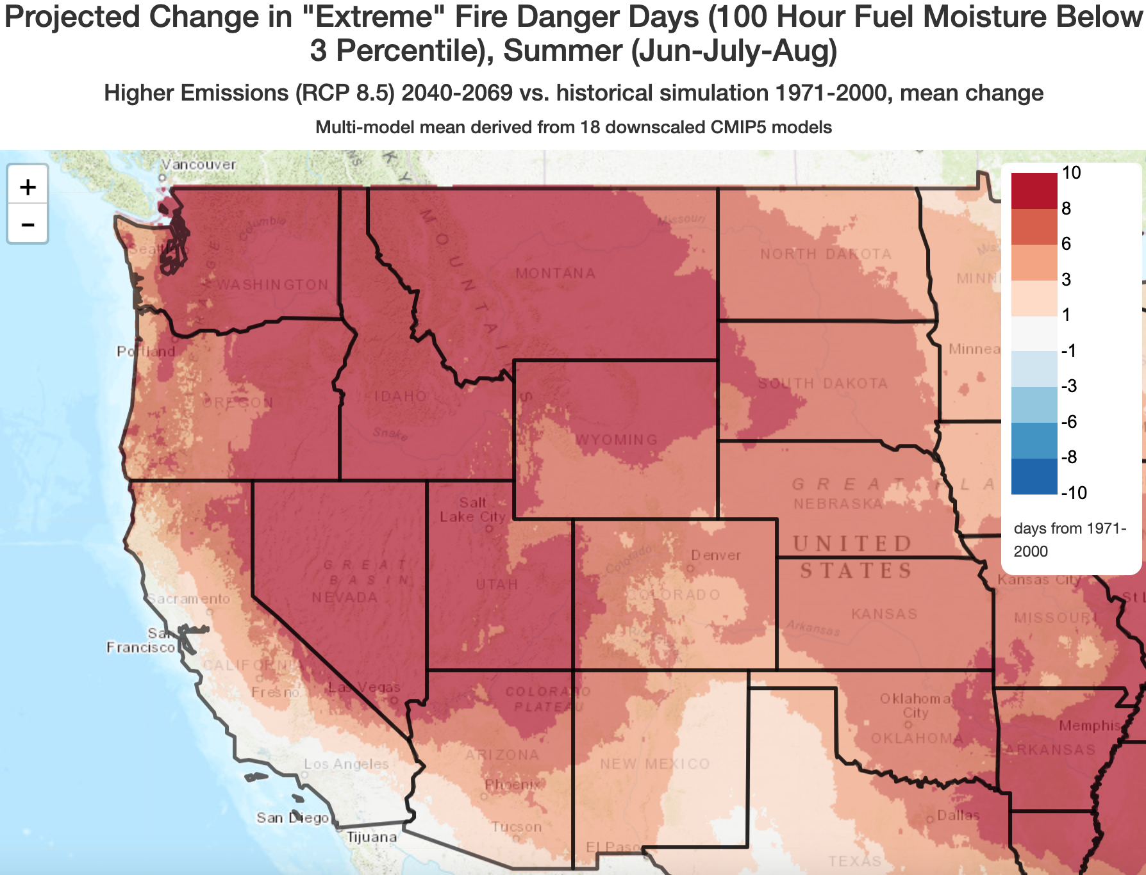

Figure 6: Map of the western US showing the number of days fire is projected to change on the landscape between historic records (1971-2000) and future projections (2040-2069; Climate Mapper web tool Climate Toolbox, accessed November 4, 2023).

Additionally vegetation is predicted to shift to entirely different habitat types by the end of the century. This change is going to be especially drastic for NSO, where the mixed conifer forests are projected to shift to warm mixed forest types with or without fire suppression (figure 7). Spotted owls are specially adapted to mixed old growth conifer forests and depend on this habitat for nesting and roosting. This extreme habitat alteration will likely NSO to the eastern margins of their range where habitat will be limited. On the other hand, mixed conifer vegetation is projected to increase in the MSO range, especially if fire is used to maintain healthy forest structure. We are already seeing shifts in habitat use by spotted owls, possibly as a result of habitat loss and biotic interactions associated with the impacts of climate change. Without fire suppression, we see better retention of conifer forest in the NSO, CSO, and MSO range, and less conversion of forested area to shrubland.

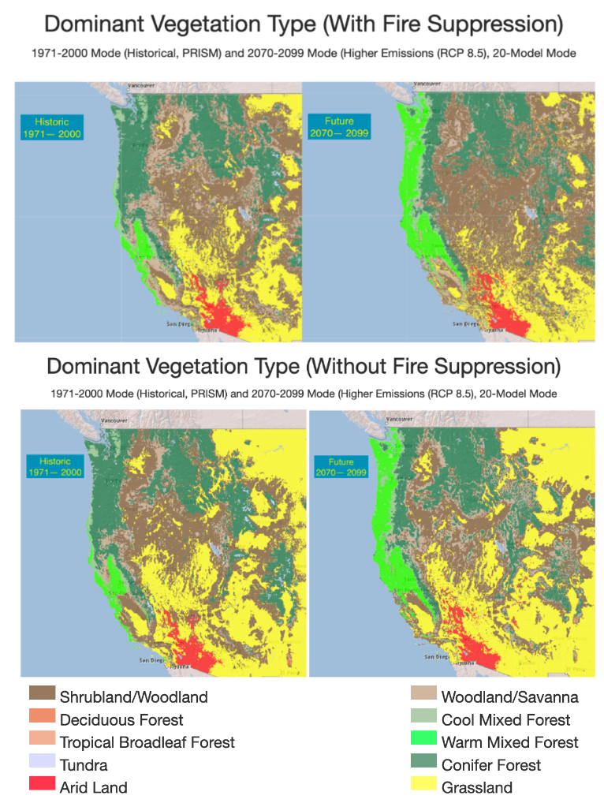
Figure 7: Map of the western US showing the projected vegetation type change on the landscape between historic records (1971-2000) and future projections (2070-2099; Climate Mapper web tool Climate Toolbox, accessed November 22, 2023).

We analyzed how the spotted owl detections changed latitudinally each year for each species using linear regression in R-Studio (R Core Team 2022). Results from the analysis indicated that overall spotted owl detections did not significantly shift between years 2008–2023 (no CSO detections in 2008, 2010, or 2015 and no MSO detections in 2011, 𝜶 = 0.05, n = 500, p-value = 0.1). However, when separated by species, the CSO (n = 95, p-value = 0.0002), NSO (n = 221, p-value = 0.003), and MSO (n = 184, p-value = 0.02; figure 8) showed significant differences in latitude between years. The CSO and MSO both had more detections in northern latitudes over time but NSOs were detected more south over the same time period. The northward shifts are likely from increasing temperatures and human development pushing them to higher latitudes, and likely higher elevations for the MSO.

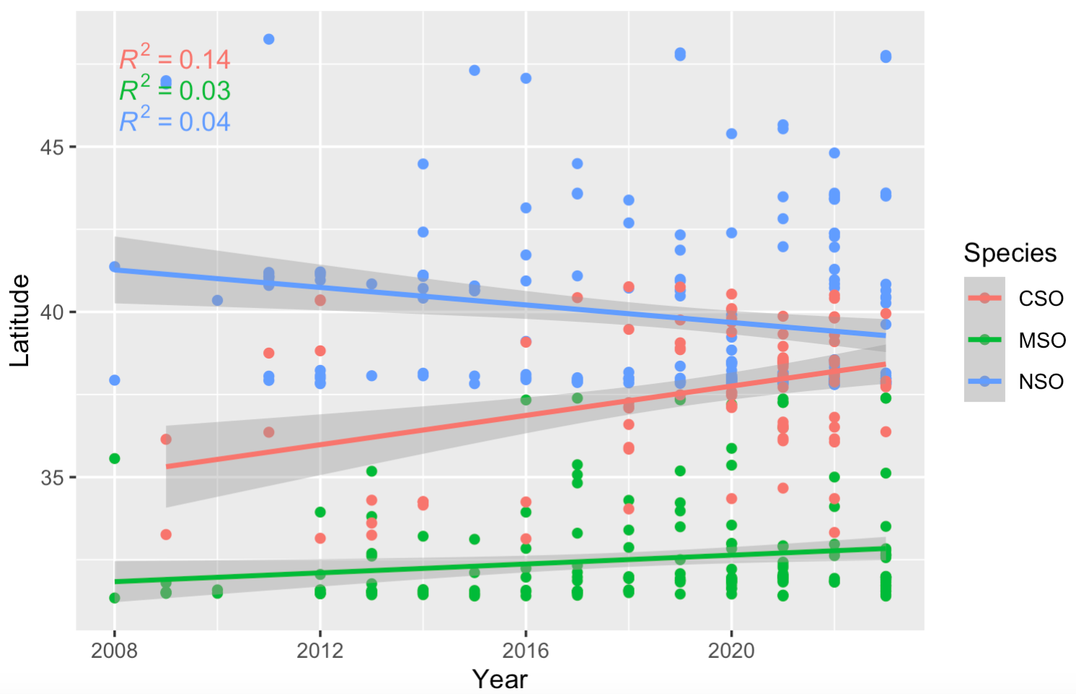

Figure 8: Linear associations of how detection changed by latitude each year (2008–2022) for each species of spotted owl (CSO = California spotted owl; MSO = Mexican spotted owl; NSO = Northern spotted owl) (Chamberlain and Boettiger 2017).

ADAPTIVE STRATEGIES
Climate change
We first propose to maintain and create habitat resilience that allows for the successful dispersal of new recruits in addition to recovering and maintaining healthy genetically diverse populations of each subspecies. Specifically, we would like to focus on NSO in forests of Oregon and Northern California, as well as the CSO in the Sierra Nevada mountains of California, and the MSO in the mountains of Arizona, New Mexico, Colorado, and Utah.
Since it is projected that climate change will increase temperatures and decrease precipitation in most spotted owl habitats, we propose to preserve or regenerate climate refugia. Spotted owls do not typically move around during the day as it puts them at risk of being detected by larger more aggressive predators. However, when temperatures exceed their thermal range, they will move downslope into drainages and riparian areas where there is often more vegetative cover and cooler microclimates. In order to maintain climate microrefugia, older forest health must be maintained. To promote these conditions, we suggest restricting clearcut logging in drainages. To reduce the risk of high severity fires we should increase implementation of fuel treatments, including a combination of both mechanical thinning and prescribed burns. By implementing more fuel treatments, we can lower fuel loads while promoting regeneration of native fire-resistant understory currently smothered by highly flammable invasive plants. These fuel treatments will also help maintain healthy old growth mixed conifer forests and help increase the rate at which old growth features return to the landscape. As demonstrated in the vegetation projections, fire as management is essential for limiting conversion of forest to shrubland. While some fuel treatments are currently being implemented, the pace and scale of these treatments remains insufficient (Knight et al. 2022).
These treatments should be implemented across the landscape on as much land as possible within the spotted owl ranges, we would work with public and private landowners as well as Indigenous tribes to achieve our goals. Existing old growth forests with frequent spotted owl occupancy, such as Protected Activity Centers (PACs) and surrounding areas should be prioritized for resilience management. While no logging is currently allowed on PACs, this also restricts fuel treatments (USFS 2023). We propose changing this and allowing modest fuel treatments on PACs. This would be implemented for at least 30 years, possibly indefinitely to maintain stability on the forested landscape not only for spotted owls but for all inhabitants of the forested areas. If possible, it would be ideal to return fire to the landscape through Indigenous cultural and prescribed fire, though immense effort to repair this relationship and return land would be necessary by USFS and Parks Service.

Barred owls
When looking at latitudinal shifts, it seems counter-intuitive that NSO are moving south, while CSO and MSO are moving north. However, this difference in NSO movements may likely be attributed to their aggressive displacement by barred owls. When we consider climate warming, it matches their physiological threshold for all subspecies to shift northward, but barred owls may be limiting dispersal in Oregon and Washington. Thus, to facilitate this shift, we must continue barred owl removals, especially in these suitable climate areas. In the CSO range, barred owl removals have been highly successful in barred owl extinction and CSO recolonization. Although barred owls are established in much higher numbers in the NSO range, implementing more drastic removals may be the key to maintaining their success as a subpopulation. We must work with private landowners and Tribal groups to promote removals on this land, as many source populations perpetuate on these areas where removals are restricted.
Unfortunately, Washington and Oregon NSO habitats have been inundated with barred owls, beyond the point where they can be extirpated. Therefore, barred owls removal priorities should focus on specific areas within the NSO range that have high quality habitat and recent NSO occupations (Yackulic et al. 2014). In addition, NSO habitat in the western California does not have as high a number of barred owls as Oregon and Washington and could therefore be a potential large area of refugia for NSO as they are pushed south. As noted previously, the narrow corridor that separates NSO from CSO, is an important clinch point for controlling the invasion of barred owls into the Sierra Nevada Mountains, where CSO reside. Controlling barred owls through this corridor should help avoid CSO populations from being pushed by climate change and development in the south and the barred owls to the north. Fortunately, as barred owls are invading from the north, MSO habitats have had the least barred owl invasion and are relatively easily controlled in these areas. For spotted owls to persist on the landscape, barred owls must be removed in perpetuity.

Monitoring
As both of these initiatives rely on knowledge of the presence of spotted owls and barred owls, we suggest that acoustic monitoring across these regions continues. Acoustic monitoring has proven to be effective at detecting invasive predators (Hofstadter et al. 2022) and monitoring endangered species and disturbances across landscapes (Kramer et al. 2021, Kelly et al. 2023). Additionally, bioacoustic monitoring can spread a larger area, with lower cost and effort, less emissions from driving, and less disruption to wildlife (Shonfield and Bayne 2017). Continued support in existing ranges and further funding towards non-surveyed regions will aid in monitoring and protecting this species.

CONCLUSION
As the climate changes at an unprecedented pace, it is increasingly essential to focus our efforts to promote landscape resilience to decrease extreme fire risk in mature forests across the western U.S. To avoid further megafires, we should implement mechanical thinning of dense forests and conduct prescribed burns to keep the fuel loads down to reduce fire severity and spread. This will, in turn, promote forest resilience through heterogeneity. Additionally, we must prioritize riparian areas and drainages in high quality habitats. As temperatures continue to rise, these microclimates will serve as climate microrefugia for spotted owls approaching their thermal limit, allowing for persistence through heat waves. Fuel treatments and prescribed burns will help promote fire-resistant native understory in these areas. Lastly, we must continue barred owl removals in the NSO range, with a priority on the CSO-NSO dispersal corridor. Spotted owls have been declining over the past century due to land use changes, climate change, and the barred owl invasion. Without the implementation of some, if not all, of these techniques, spotted owls, and the suite of old-forest species that occupy the same habitat niche, will likely be unable to persist.

REFERENCES
Asner, G. P., Brodrick, P. G., Anderson, C. B., Vaughn, N., Knapp, D. E. and Martin, R. E. 2016. Progressive forest canopy water loss during the 2012–2015 California drought. – Proc. Natl. Acad. Sci. 113: E249–E255.
Barrows, C. W. 1981. Roost Selection by Spotted Owls: An Adaptation to Heat Stress. – The Condor 83: 302.
California Department of Fish and Wildlife. Spotted Owl Observations Database Information.
Chamberlain, S. A. and Boettiger, C. 2017. R Python, and Ruby clients for GBIF species occurrence data.
Collins, B. M., Fry, D. L., Lydersen, J. M., Everett, R. and Stephens, S. L. 2017. Impacts of different land management histories on forest change. – Ecol. Appl. 27: 2475–2486.
Cova, G., Kane, V. R., Prichard, S., North, M. and Cansler, C. A. 2023. The outsized role of California’s largest wildfires in changing forest burn patterns and coarsening ecosystem scale. – For. Ecol. Manag. 528: 120620.
Crockett, J. L. and Westerling, A. L. 2018. Greater Temperature and Precipitation Extremes Intensify Western U.S. Droughts, Wildfire Severity, and Sierra Nevada Tree Mortality. – J. Clim. 31: 341–354.
Franklin, A. B., Dugger, K. M., Lesmeister, D. B., Davis, R. J., Wiens, J. D., White, G. C., Nichols, J. D., Hines, J. E., Yackulic, C. B., Schwarz, C. J., Ackers, S. H., Andrews, L. S., Bailey, L. L., Bown, R., Burgher, J., Burnham, K. P., Carlson, P. C., Chestnut, T., Conner, M. M., Dilione, K. E., Forsman, E. D., Glenn, E. M., Gremel, S. A., Hamm, K. A., Herter, D. R., Higley, J. M., Horn, R. B., Jenkins, J. M., Kendall, W. L., Lamphear, D. W., McCafferty, C., McDonald, T. L., Reid, J. A., Rockweit, J. T., Simon, D. C., Sovern, S. G., Swingle, J. K. and Wise, H. 2021. Range-wide declines of northern spotted owl populations in the Pacific Northwest: A meta-analysis. – Biol. Conserv. 259suppl 109168 259: 1.
Gutiérrez, R. J. 2008. Spotted Owl Research, A Quarter Century of Contributions to Education, Ornithology, Ecology, and Wildlife Management. – The Condor 110: 792–798.
Hessilt, T. D., Abatzoglou, J. T., Chen, Y., Randerson, J. T., Scholten, R. C., Werf, G. van der and Veraverbeke, S. 2022. Future increases in lightning ignition efficiency and wildfire occurrence expected from drier fuels in boreal forest ecosystems of western North America. – Environ. Res. Lett. 17: 054008.
Hofstadter, D. F., Kryshak, N. F., Wood, C. M., Dotters, B. P., Roberts, K. N., Kelly, K. G., Keane, J. J., Sawyer, S. C., Shaklee, P. A., Kramer, H. A., Gutiérrez, R. and Peery, M. Z. 2022. Arresting the spread of invasive species in continental systems. – Front. Ecol. Environ. 20: 278–284.
Jones, G. M., Gutiérrez, R. J., Tempel, D. J., Whitmore, S. A., Berigan, W. J. and Peery, M. Z. 2016. Megafires: an emerging threat to old-forest species. – Front. Ecol. Environ. 14: 300–306.
Jones, G. M., Kramer, H. A., Berigan, W. J., Whitmore, S. A., Gutiérrez, R. J. and Peery, M. Z. 2021. Megafire causes persistent loss of an old-forest species. – Anim. Conserv. 24: 925–936.
Jones, G. M., Shirk, A. J., Yang, Z., Davis, R. J., Ganey, J. L., Gutiérrez, R. J., Healey, S. P., Hedwall, S. J., Hoagland, S. J., Maes, R., Malcolm, K., McKelvey, K. S., Sanderlin, J. S., Schwartz, M. K., Seamans, M. E., Wan, H. Y. and Cushman, S. A. 2023. Spatial and temporal dynamics of Mexican spotted owl habitat in the southwestern US. – Landsc. Ecol. 38: 23–37.
Kelly, K. G., Wood, C. M., McGinn, K. A., Kramer, H. A., Sawyer, S. C., Whitmore, S. A., Reid, D., Kahl, S., Reiss, A., Eiseman, J., Berigan, W. J., Keane, J. J., Shaklee, P. A., Gallagher, L., Munton, T. E., Klinck, H., Gutiérrez, R. J. and Peery, M. Z. 2023. Estimating population size for California spotted owls and barred owls across the Sierra Nevada ecosystem with bioacoustics - ScienceDirect. – Ecol. Indic. <https://doi.org/10.1016/j.ecolind.2023.110851>.
Knight, C. A., Tompkins, R. E., Wang, J. A., York, R., Goulden, M. L. and Battles, J. J. 2022. Accurate tracking of forest activity key to multi-jurisdictional management goals: A case study in California. – J. Environ. Manage. 302: 114083.
Kramer, A., Jones, G. M., Whitmore, S. A., Keane, J. J., Atuo, F. A., Dotters, B. P., Sawyer, S. C., Stock, S. L., Gutiérrez, R. J. and Peery, M. Z. 2021. California spotted owl habitat selection in a fire-managed landscape suggests conservation benefit of restoring historical fire regimes. – For. Ecol. Manag. 479: 118576.
Lesmeister, D. B., Davis, R. J., Sovern, S. G. and Yang, Z. 2021. Northern spotted owl nesting forests as fire refugia: a 30-year synthesis of large wildfires. – Fire Ecol. 17: 32.
Lõhmus, Asko. 2004. Raptor Habitat Studies - the state of the art. – Raptors Worldw. 280–296.
Long, L. L. and Wolfe, J. D. 2019. Review of the effects of barred owls on spotted owls. – J. Wildl. Manag. 83: 1281–1296.
Monahan, W. B. and Hijmans, R. J. 2007. Distributional Dynamics of Invasion and Hybridization by Strix spp. in Western North America. – Ornithol. Monogr. 55–66.
Pace, M. L., Cole, J. J., Carpenter, S. R. and Kitchell, J. F. 1999. Trophic cascades revealed in diverse ecosystems. – Trends Ecol. Evol. 14: 483–488.
Roberts, S. L., van Wagtendonk, J. W., Miles, A. K. and Kelt, D. A. 2011. Effects of fire on spotted owl site occupancy in a late-successional forest. – Biol. Conserv. 144: 610–619.
Rockweit, J. T., Jenkins, J. M., Hines, J. E., Nichols, J. D., Dugger, K. M., Franklin, A. B., Carlson, P. C., Kendall, W. L., Lesmeister, D. B., McCafferty, C., Ackers, S. H., Andrews, L. S., Bailey, L. L., Burgher, J., Burnham, K. P., Chestnut, T., Conner, M. M., Davis, R. J., Dilione, K. E., Forsman, E. D., Glenn, E. M., Gremel, S. A., Hamm, K. A., Herter, D. R., Higley, J. M., Horn, R. B., Lamphear, D. W., McDonald, T. L., Reid, J. A., Schwarz, C. J., Simon, D. C., Sovern, S. G., Swingle, J. K., Wiens, J. D., Wise, H. and Yackulic, C. B. 2023. Range-wide sources of variation in reproductive rates of northern spotted owls. – Ecol. Appl. 33: e2726.
Shonfield, J. and Bayne, E. 2017. Autonomous recording units in avian ecological research: Current use and future applications. – Avian Conserv. Ecol. 12: 14.
Stephens, S. L., Collins, B. M., Fettig, C. J., Finney, M. A., Hoffman, C. M., Knapp, E. E., North, M. P., Safford, H. and Wayman, R. B. 2018. Drought, Tree Mortality, and Wildfire in Forests Adapted to Frequent Fire. – BioScience 68: 77–88.
Weathers, W. W., Hodum, P. J. and Blakesley, J. A. 2001. Thermal Ecology and Ecological Energetics of California Spotted Owls. – The Condor 103: 678–690.
Wood, C. M., Gutiérrez, R. J. and Peery, M. Z. 2019. Acoustic monitoring reveals a diverse forest owl community, illustrating its potential for basic and applied ecology. – Ecology 100: 1–3.
Yackulic, C. B., Reid, J., Nichols, J. D., Hines, J. E., Davis, R. and Forsman, E. 2014. The roles of competition and habitat in the dynamics of populations and species distributions. – Ecology 95: 265–279.
Bias, M. A. and Gutiérrez, R. J. 1992. Habitat Associations of California Spotted Owls in the Central Sierra Nevada. – J. Wildl. Manag. 56: 584–595.
California Department of Fish and Wildlife. n.d. “Spotted Owl Observations Database Information.” Accessed October 9, 2023. https://wildlife.ca.gov/Data/CNDDB/Spotted-Owl-Info.
Chamberlain, S. A. & Boettiger, C. R Python, and Ruby clients for GBIF species occurrence
Data. 2017. https://peerj.com/preprints/3304v1, doi:10.7287/peerj.preprints.3304v1.
Collins, B. M., Stephens, S. L., Moghaddas, J. J. and Battles, J. 2010. Challenges and Approaches in Planning Fuel Treatments across Fire-Excluded Forested Landscapes. – J. For. 108: 24–31.
Gallagher, C. V., Keane, J. J., Shaklee, P. A., Kramer, H. A. and Gerrard, R. 2019. Spotted owl foraging patterns following fuels treatments, Sierra Nevada, California. – J. Wildl. Manag. 83: 487–501.
Ganey, J. L., Iniguez, J. M., Hedwall, S., Block, W. M., Ward, J. P., Jr., Jonnes, R. S., Rawlinson, T. A., Kyle, S. C. and Apprill, D. L. 2016. Evaluating Desired Conditions for Mexican Spotted Owl Nesting and Roosting Habitat. – For. Sci. 62: 457–462.
Hegewisch, K.C., Abatzoglou, J.T., Chegwidden,O., and Nijssen, B., ' Climate Mapper' web tool. Climate Toolbox (https://climatetoolbox.org/) accessed on [October 30, 2023].
Hofstadter, D. F., Kryshak, N. F., Wood, C. M., Dotters, B. P., Roberts, K. N., Kelly, K. G., Keane, J. J., Sawyer, S. C., Shaklee, P. A., Kramer, H. A., Gutiérrez, R. and Peery, M. Z. 2022. Arresting the spread of invasive species in continental systems. – Front. Ecol. Environ. 20: 278–284.
Jones, G. M., Gutiérrez, R., Tempel, D. J., Whitmore, S. A., Berigan, W. J. and Peery, M. Z. 2016. Megafires: an emerging threat to old-forest species. – Front. Ecol. Environ. 14: 300–306.
Jones, G. M., Keane, J. J., Gutiérrez, R. J. and Peery, M. Z. 2018. Declining old-forest species as a legacy of large trees lost. – Divers. Distrib. 24: 341–351.
McGinn, K. A., Zuckerberg, B., Pauli, J. N., Zulla, C. J., Berigan, W. J., Wilkinson, Z. A., Barry, J. M., Keane, J. J., Gutiérrez, R. J. and Peery, M. Z. 2023. Older forests function as energetic and demographic refugia for a climate-sensitive species. – Oecologia 202: 831–844.
Mikkelsen, A. J., Lesmeister, D. B., O’Reilly, K. M. & Dugger, K. M. Feather corticosterone reveals developmental challenges in a long-term study of juvenile northern spotted owls. 2022. Funct. Ecol. 36, 51–63.
PRISM Climate Group, Oregon State University, (https://prism.oregonstate.edu), created 4 Feb
2014, accessed, Nov 2023.
“QGIS.org (2021). QGIS Geographic Information System. Open Source Geospatial Foundation Project. http://qgis.org”.
R Core Team. 2022. “R: A Language and Environment for Statistical Computing.” Vienna, Austria: R Foundation for Statistical Computing. https://www.R-project.org/.
Roberts, S. L., van Wagtendonk, J. W., Miles, A. K. and Kelt, D. A. 2011. Effects of fire on spotted owl site occupancy in a late-successional forest. – Biol. Conserv. 144: 610–619.
Sipari, S., Khalil, H., Magnusson, M., Evander, M., Hörnfeldt, B. and Ecke, F. 2022. Climate change accelerates winter transmission of a zoonotic pathogen. – Ambio 51: 508–517.
Ward, J. P. and Noon, B. R. 1998. Habitat Selection by Northern Spotted Owls: The Consequences of Prey Selection and Distribution. – The Condor 100: 79–92.
Weathers, W. W., Hodum, P. J. & Blakesley, J. A. Thermal Ecology and Ecological Energetics of California Spotted Owls. The Condor 103, 678–690 (2001).
Yackulic, C. B., Reid, J., Nichols, J. D., Hines, J. E., Davis, R. and Forsman, E. 2014. The roles
of competition and habitat in the dynamics of populations and species distributions. – Ecology 95: 265–279.

