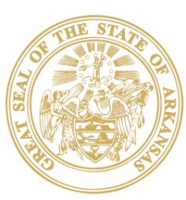

STATE OF ARKANSAS
SARAH HUCKABEE SANDERS
GOVERNOR

July 29, 2024

Secretary Tom Vilsack
U. S. Department of Agriculture
1400 Independence Avenue, SW
Washington, DC 20250

Dear Secretary Vilsack:

Arkansas is on a fast track to becoming one of America’s best year-round outdoor recreation destinations. As First Gentleman and as the Chairman of the Natural State Initiative Advisory Council, I am working with our state’s public, private, and nonprofit leaders to make that happen. The Trails at Mena project will help us achieve that goal, cementing Arkansas’ status as one of our nation’s elite mountain biking destinations, so I am writing in support of the request for a Special Use Permit.

My family and I are avid outdoor enthusiasts. Last year I had the opportunity to visit all 52 of Arkansas’ beautiful state parks, including Queen Wilhelmina state park. Arkansas is well positioned to become a leader in outdoor recreation, grow tourism and the outdoor economy, and improve health and quality of life for our people.

The Trails at Mena project is one of the keystones of that effort. A unique partnership between the state, federal government, non-profits and the local community, the Trails at Mena will be a powerful model for what happens when we work together to promote conservation, outdoor recreation and economic revitalization in small towns and rural communities.

Thank you for your team’s willingness to work with us on this project and I hope you strongly consider its approval.

Sincerely,

Bryan Sanders
First Gentleman of Arkansas
Chairman of the Natural State Initiative Advisory Council

