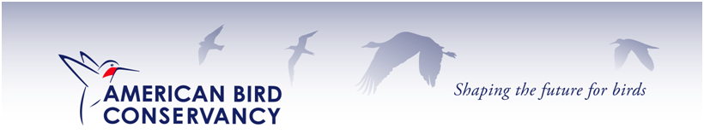
July 5, 2016

Colville National Forest Plan Revision Team
765 South Main St
Colville, WA 99114
colvilleplanrevision@fs.fed.us
https://cara.ecosystem-management.org/Public/CommentInput?Project=45826

To Whom It May Concern:

On behalf of American Bird Conservancy, which conserves native birds and their habitats throughout the Americas, we respectfully submit the following comments on the proposed forest plan revision for the Colville National Forest. American Bird Conservancy (ABC) is a 501(c)(3) non-profit organization dedicated to the conservation of native birds and their habitats throughout the Americas.

Our primary interest in this plan revision focuses on avian species of conservation concern. A suite of species associated with ponderosa pine, including White-headed and Lewis’s Woodpeckers, Williamson Sapsucker, and Flammulated Owl, are in need of conservation action. Minimum standards for snag retention and limitations on post-fire logging are essential for the plan to maintain sufficient suitable habitats for these species. Large-diameter ponderosa pine, Douglas-fir, and western larch are particularly important snags to retain because they meet the requirements of multiple species of cavity excavators (Haggard and Gaines 2001, Lyons et al. 2008) and have the longest residence times.

In addition, management of post-fire landscapes is of concern for species such as the Black-backed Woodpecker that depends on snag forests, also known as high-quality early seral habitat. Limits on post-fire logging are essential to retain sufficient snags for this and other cavity nestser needs large amounts of snags.

The DEIS states: “The availability of large and old trees and large snag habitat is generally lacking in many forest types because of past management practices and altered disturbance regimes. Restoration of these key habitat components is important for several surrogate wildlife species”

We agree with this statement and would like to emphasize the need to do this for cavity nesters. However, it is important to note in the DEIS on Wildlife, all the woodpeckers get a low grade for their ability to come back to their historic abundance (viability scores) – the first letter is the projected ability to come back based on current habitat conditions, second is the historic grade (A is much better than F).

Surrogate Wildlife Species Current Viability Outcome Historical Viability Outcome

Black-backed Woodpecker C A
Lewis’s Woodpecker C/D A
Pileated Woodpecker C A
White-headed Woodpecker D/E A

While DEIS’s recommendation for snags is acceptable in dry forest types, it does not provide enough specific provisions to protect the old growth that provide the source for large snags. Moreover, without specific restrictions, firewood cutters in the region pose a serious threat to snag retention.

We urge that additional protections, such as diameter limits on cutting large trees such as that currently provided by the current Eastside Screens which prohibits logging trees over 21” in most circumstances. A prohibition on post-fire logging in mature and old-growth forests would also be beneficial for snag recruitment and retention over long periods of time.

Thank you for this opportunity to comment.

Sincerely,
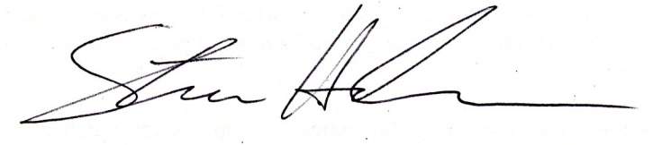
Steve Holmer
Senior Policy Advisor
American Bird Conservancy
202 234 7181 ext. 216
sholmer@abcbirds.org

