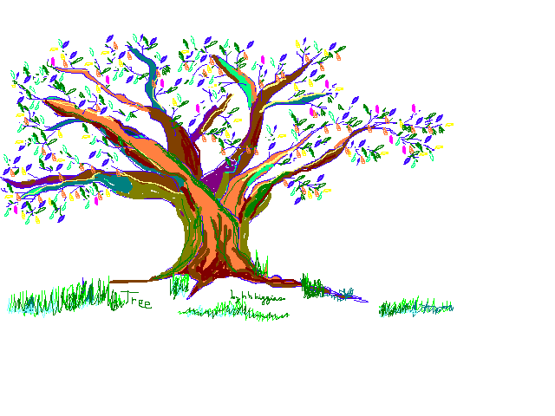

Trees by h h higgins (c. 1987, 2012, 2023)

Trees with new buds in the spring

Work for green leaves—that’s the thing!

Even old leaves in the fall

And barren branches, after all,

Are all about those shiny greens—

That’s what crinkled grey bark means;

Throw that sun down on this dirt –

Leaves keep earth from getting hurt;

Along with native grasses’ aide

Give Nature’s Crest a rest in shade.

Summer’s assaults?—shelter’s spawned

Underneath a frond of Palm

Or sprig of Pine, or Liquidambar

Nothing much can get your dander

Up as long as there are trees

Tossed and tickled by a breeze.

Watch gross misfortune pass us by!

Those silhouettes against the sky

Of sunset branches, leaves unfurled

Like happy banners save this world

With messages from ancient wood

Instructing us how to be good

And bright and kind as flowers, bees;

These do their work with saintly ease.

Heat disappears from this valley

Near rocky stream and deep-shade tree.

Oh Elms! Without your majesty

This ground could be the Mojave!

Trees talk and so may hear our plea:

Liriodendron set us free!

So trees! Let’s imitate in mime

And so assure our place in time.

\* \* \* \* \*