January 9, 2015

Sally Jewell, Secretary

U.S. Department of the Interior

Dan Ashe, Director

U.S. Fish and Wildlife Service

Dear Secretary Jewell and Director Ashe,

Enclosed you will find a hard copy of Ganey et al. (2014), a study of wintering habitat selection by Mexican spotted owls, which is relevant to much of the content in our Petition, received by your offices via FedEx on December 23, 2014, to list the California spotted owl as threatened or endangered under the ESA. While Ganey et al. (2014) was published, and available, at the time that we submitted the Petition to you, we were not aware of this study until early January of 2015. Therefore, we submit this letter, briefly describing and summarizing the relevant findings of Ganey et al. (2014), and a hard copy of the study itself, as an addendum to our Petition.

Ganey et al. (2014) investigated the wintering movements of Mexican spotted owls in the Lincoln National Forest of New Mexico, defining owls that moved to a wintering area as those located, with radio-telemetry, roosting >2 km away from their nest/roost core multiple times between November 1st and April 15th. Five spotted owls satisfied these criteria. Of those five, four of them moved up to 14 km from unburned old forest nest/roost cores to winter in mixed-severity fire areas (>5 years post-fire). Ganey et al. (2014) found that small mammal prey abundance (biomass) was 2 to 6 times greater in the mixed-severity fire wintering areas than it was in the unburned old forest of the corresponding nest/roost cores, and found greater small mammal prey species richness in the mixed-severity fire areas. Ganey et al. (2014) also found that the mixed-severity fire wintering areas were approximately equivalent in elevation and forest type, so the movement could not be explained by a desire among the owls to seek warmer, drier, lower-elevation habitat over winter. Ganey et al. (2014) noted that their results corroborated results of Bond et al. with regard to California spotted owls and mixed-severity fire in the Sierra Nevada, and concluded that the occurrence and existence of mixed-severity fire areas are important, and beneficial, for the conservation of spotted owls, including over winter when the owls are often most vulnerable, and when the owls’ survival is frequently at greatest risk. Ganey et al. (2014) noted the following: “The fact that they moved to areas with richer food resources suggests that they may have been seeking greater prey abundance during a season when prey for Mexican Spotted Owls are suspected to be scarce…”

We also sent this letter, and a pdf of Ganey et al. (2014), to your email addresses ([exsec@ios.doi.gov](mailto:exsec@ios.doi.gov), and [dan_ashe@fws.gov](mailto:dan_ashe@fws.gov)). Please let me know if you have any questions. Thanks.

Sincerely,

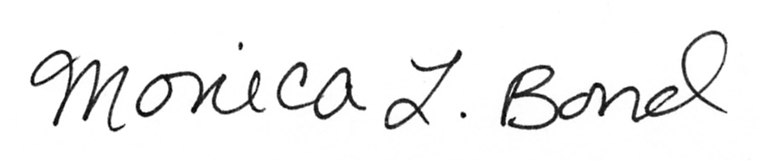 

Monica Bond, Principal Scientist Chad Hanson, Ph.D.

Wild Nature Institute John Muir Project of Earth Island Institute

P.O. Box 165 P.O. Box 897

Hanover, NH 03755 Big Bear City, CA 92314

(415) 630-3487 (530) 273-9290