Colville Forest Plan Revision Team 765 South Main Street

Colville, WA 99114

To Whom It May Concern:

May 25, 2016

Please accept the following comments from the Oroville Chapter of the Pacific Northwest Trail Association (PNTA)regarding the Draft Colville National Forest Proposed Land and Resource

Management Plan. As a local chapter of the PNTA, our interest in the forest plan revision centers around the Pacific Northwest National Scenic Trail (PNT). The mission of the PNTA is to promote, protect, and maintain the PNT in a manner that makes a lasting contribution to the recreation, education, and enjoyment of present and future generations. We care about the trail and are willing to put in time to make it better.

Our comments are specifically about the proposed management of the PNT. The page and line numbers refer to the draft land management plan.

Page 90-91,MA-DC-NT-01,National Recreation Trails and MA-DC-NT-02, National Scenic Trails.

Line number 2513 seems to label the desired conditions in lines 2514 through 2536 as applicable only to National Recreation Trails and lines number 2538 through 2564 only applicable to National Scenic Trails. There are places in the text where the phrase "nationally designated trails" is used, which implies the whole desired condition section is directed towards all nationally designated trails. This is confusing. We suggest rewriting this section so that it is applicable to all nationally designated trails and changing the label to read - *MA-DC-NT-01, Nationally Designated Trails.* This would rid the section of repeated and similar direction that only adds to the length of the document and ambiguity about where to apply direction.

Where a separate desired condition statement unique to a national recreation or to a national scenic

trail is needed, it could be labelled as such. Lines number 2534-2536 provide a good example of a unique desired condition applicable only to national recreation trails and could be labelled *MA-DC-NT-OX. National Recreation Trails.*

Page 70, FW-STD-LG-01,Stock Driveways.

We support prohibiting the designation of stock driveways on the PNT. The proposed plan should also include a standard prohibiting creation of new water developments for stock or placing of salt blocks within a *Y,* mile of the trail. This standard would protect the physical integrity of the trail by not attracting and concentrating stock near or along the trail.

**Page 92, MA-OBJ-NT-01, Pacific Northwest National Scenic Trail.**

The stated objective of relocati ng 10 to 15 percent of the trail miles from roads to a non-motorized setting is low. Only 5-7 *Y,* miles of trails would be relocated after 15 yea rs. The objective should be

cha nged to read - *"Within 15 years of plan implementation, relocate* ***30 to 40 percent*** *of the trail miles currently located on roads into a non-motorized trail setting."*

We estimate about 50 miles of the PNT is currently located on roads. The Colville N F conta i ns about 140 miles of the PNT. An objective of 30-40 percent would mean the Forest relocates 15 to 20 m iles of tra il withi n 15 yea rs. That is an average of 1-2 miles of trail relocated per yea r. Relocation should include relocati ng road m i l es to existing trails as well as developing new trails where needed. That is a

reasona bl e objective and shows the Forest's com m itment to ma nagi ng a nationa lly recogn i zed tra il.

**Page 92, MA-GDL-NT-04. Wlldland Fire Suppression.**

We support th is language that promotes protection of the PNT d uri ng wi ld land fire suppression. The

guideli ne should be strengthened by ad d i ng d i rection to employ m i ni m um im pact tools and tactics when ma nagi ng wildla nd fire or prescribed fire.

The last sentence, "use of red chemica l fire retarda nts where there would be a lasting visua l effect should be avoided", should be restated as a standard that reads as follows. *Use of chemical fire retardants, regardless of pigment color, shall be avoided where there would be a lasting visual effect.* Fi re retard ant drops, rega rd less of pigment, can have a big visua l im pact beca use they usua lly cover la rge areas and the un natura l color persists for yea rs.

**Page 93, MA-SU-NT-01. Suitable Uses.**

Facilities, developed recreation. This tabl e shows that "facil iti es, developed recreation" may be

authorized. This seems to contrad ict the desired cond ition i n l ines num ber 2556 to 2559, wh ich puts a n emphasis on "unaltered landsca pes." The text should be changed to allow existi ng developed recreation facilities, but not allow new developed recreation facilities.

Mecha nized recreationa l use. We support allowi ng mou ntai n bi kes on the PNT where perm itted. The Kettle Crest section of the PNT is already regiona lly and nationally recogn ized for h igh qua l ity mou nta i n bi ki ng. Mou nta i n bikers use loca l lodgi ng, gas, food, a nd shops. This brings more recreation tou rism dollars to the loca l economy. According to the 2015 Economic Analysis of Outdoor Recreation in

Washi ngton State ( Briceno, **T.,** Schundler, G. 2015. Economic Ana lysis of Outdoor Recreation i n Washi ngton State. Ea rth Econom ics, Tacoma, WA), bicycle rid ing is one of the top five recreationa l activities and the th i rd highest recreationa l activity by expend itu re i n Wash ington state.

Page 109, MA-GDL-SIA-01.Permitted Grazing.

We support this guideline. The PNT will attract more and more recreational users because of its national significance and outstanding recreation opportunities. It is important to the quality of recreation experience to have a clearly defined trail to follow.

Wilderness recommendations.

This comment is directed to wilderness recommendations generally and is not specific to any alternative.

A wilderness designation that surrou nds the PNT is a benefit because it would support a nd protect the scenic and ecological integrity of the trail corridor. The PNT corridor desired condition for "unaltered landscapes where generally only ecological changes occur" would be easily delivered through a wilderness designation.

On the other hand, wilderness designation can be a challenge when it comes to maintaining a trail. Trails are expensive to mainta in when only hand tools are allowed. The more miles of the PNT within wilderness the costlierit will be to maintain the PNT to standards.

Earlier in this comment letter we supported mountain biking along the Kettle Crest portion of the PNT. Mountain bikes are not allowed in wilderness. The Forest should consider the major loss of a regional and nationa l mou ntai n biki ng asset along the length of the Kettle Crest if th is area is designated as wilderness.

There are tradeoffs that go along with a wilderness designation. We neither support or oppose wilderness designations along the PNT. I nstead, with th is comment, we support the Forest Service taking a hard look at the trade-offs.

Thank you for your consideration of these comments. Sincerely,

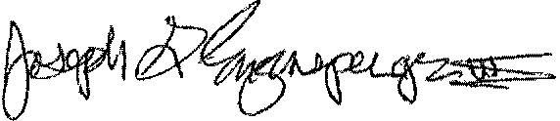

Joseph Enzensperger President

Okanoga n Chapter of the Pacific Northwest Trail Association PO Box 912

Oroville, WA 98844

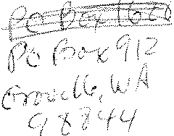 



,- ;"'i

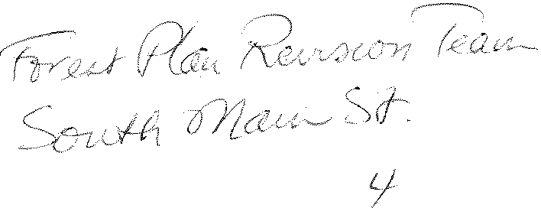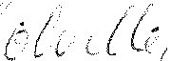

*{ ··· 1/,:f*

\..



**S'3i i 4$2507 C004**

'I 1I I11I11I I I1·I 'l1• I!• I1l1I1l I1ll' 1·ljI1 l·11'• 11•It1I1l• I ii•llI 1