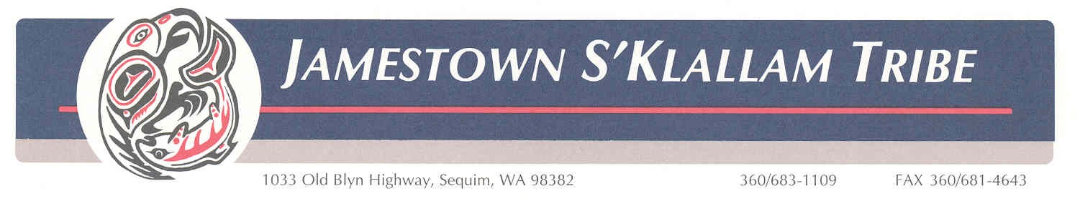

March 17, 2025

Name: Hilton Turnbull
Position: Habitat Conservation and Restoration Manager
Address: 1033 Old Blyn Highway
Sequim, WA 98382

Re: Northwest Forest Plan Amendment Comments

Dear Mr./Ms.

The Jamestown S’Klallam Tribe (hereafter “JST” or “the Tribe”) is a federally recognized Tribe. Along with the other signatories to the 1855 Treaty of Point No Point, the Tribes are co-managers of the natural resources within our ceded areas, with the common goal of managing and preserving natural resources for the benefit of current and future generations.

We are writing to support Alternatives B and D. The Tribe does not support Alternative C or the No Action alternative.

We recognize that Alternatives B and D are distinct and offer different management approaches and pathways to improving the health and resilience of Forests under the Northwest Forest Plan. However, both Alternatives are a significant improvement from the current Plan. The improvements include:
- greater emphasis on improving overall forest conditions and health across all age classes through proactive restoration.
- greater emphasis on fire preparedness and fuels reductions.
- increased adaptability to the effects of climate change, with greater ability to implement adaptive management
- supporting local economies through increased timber production, while being guided by conservation and long-term ecosystem health goals; and
- significantly improving tribal engagement throughout project planning and implementation.

Additionally, we commend the Federal Advisory Committee for the inclusion of tribal members on the Committee and the inclusion of tribal inputs throughout this process.

Despite our strong support for Alternatives B and D, we do have concerns that have not been fully addressed. We hope the ongoing issues below will be prioritized at the Regional level until they are fully addressed in a future Plan update. Our concerns are as follows:
- The impacts from unpermitted gathering of forest products (berries, mushrooms, cedar boughs, etc.), and efforts to reduce these practices, are not sufficiently addressed. The level of use and exploitation has become so pronounced in many areas that the ability of tribal citizens to exercise their treaty right to gather is severely diminished, and we have conservation concerns. Similarly, organized timber theft on Olympic National Forest has become routine and common place.
- The impacts of uncontrolled recreational use, and plans to reduce these impacts, are not sufficiently addressed. In some areas the high levels of use are resulting in ecological damage, such as erosion, the displacement of wildlife, water quality issues, and more. This is impacting Treaty reserved rights to fish, hunt and gather. We would like the issues around gathering and recreational impacts to be addressed at the largest scale possible to ensure that impacts are not shifted between Forests if one Forest unilaterally changes its management approach.
- Aquatic resources risk degradation from deferred road maintenance and abandonment. Capacity at the individual Forest level for the implementation of treatments has been inconsistent. We would like greater emphasis on implementing approved projects, instead of beginning new NEPA processes while not implementing projects that have already undergone NEPA review and approval.

Tribes are uniquely positioned to form effective partnerships with the national forests they are associated with. The Jamestown Tribe looks forward to continuing our longstanding working relationship with the Olympic National Forest.

In summary, we recognize that Alternatives B and D of the Northwest Forest Plan Amendment provide substantive improvements over the current Plan and will support both.

Sincerely,

Hilton Turnbull, Habitat Conservation and Restoration Manager
