Invasive Species
Edward Monnig

The Proposed Action’s recognition of invasive species, both terrestrial and aquatic, as significant stressors on natural processes is a notable advance from the original Forest Plan. Counteracting these species impacts requires partnerships between the Forest Service, the State and County agencies, private organizations, and concerned citizens.

The Forest Service can have relatively little effect on the introduction of aquatic invasive species, except to insure its own activities do not contribute to their spread. I applaud the State of Montana for its a robust boat screening and inspection effort for recreationists to prevent the spread of aquatic invasive species.

Although forest management activities can be a major vector of terrestrial invasive species, recreational use of the forest has become a bigger player in the spread of invasive species, particularly non-native vegetation. The author and his wife recently camped at Twin Bridges Recreation Area, a BLM/State of Idaho site on the Salmon River. We arrived late and when we woke in the morning we realized we were camping in the middle of a huge goat weed infestation. Anyone who has trail-biked or walked pets off paved roads from Nevada to Idaho can testify to the damage that the thorny seed heads can inflict (see photo below). These and other species equally destructive to our ecosystems are coming our way, often transported by
Goat weed seed heads have impressive thorns projecting in all directions. These thorns can puncture bike tires, injure pets, and cause other severe ecosystem problems.
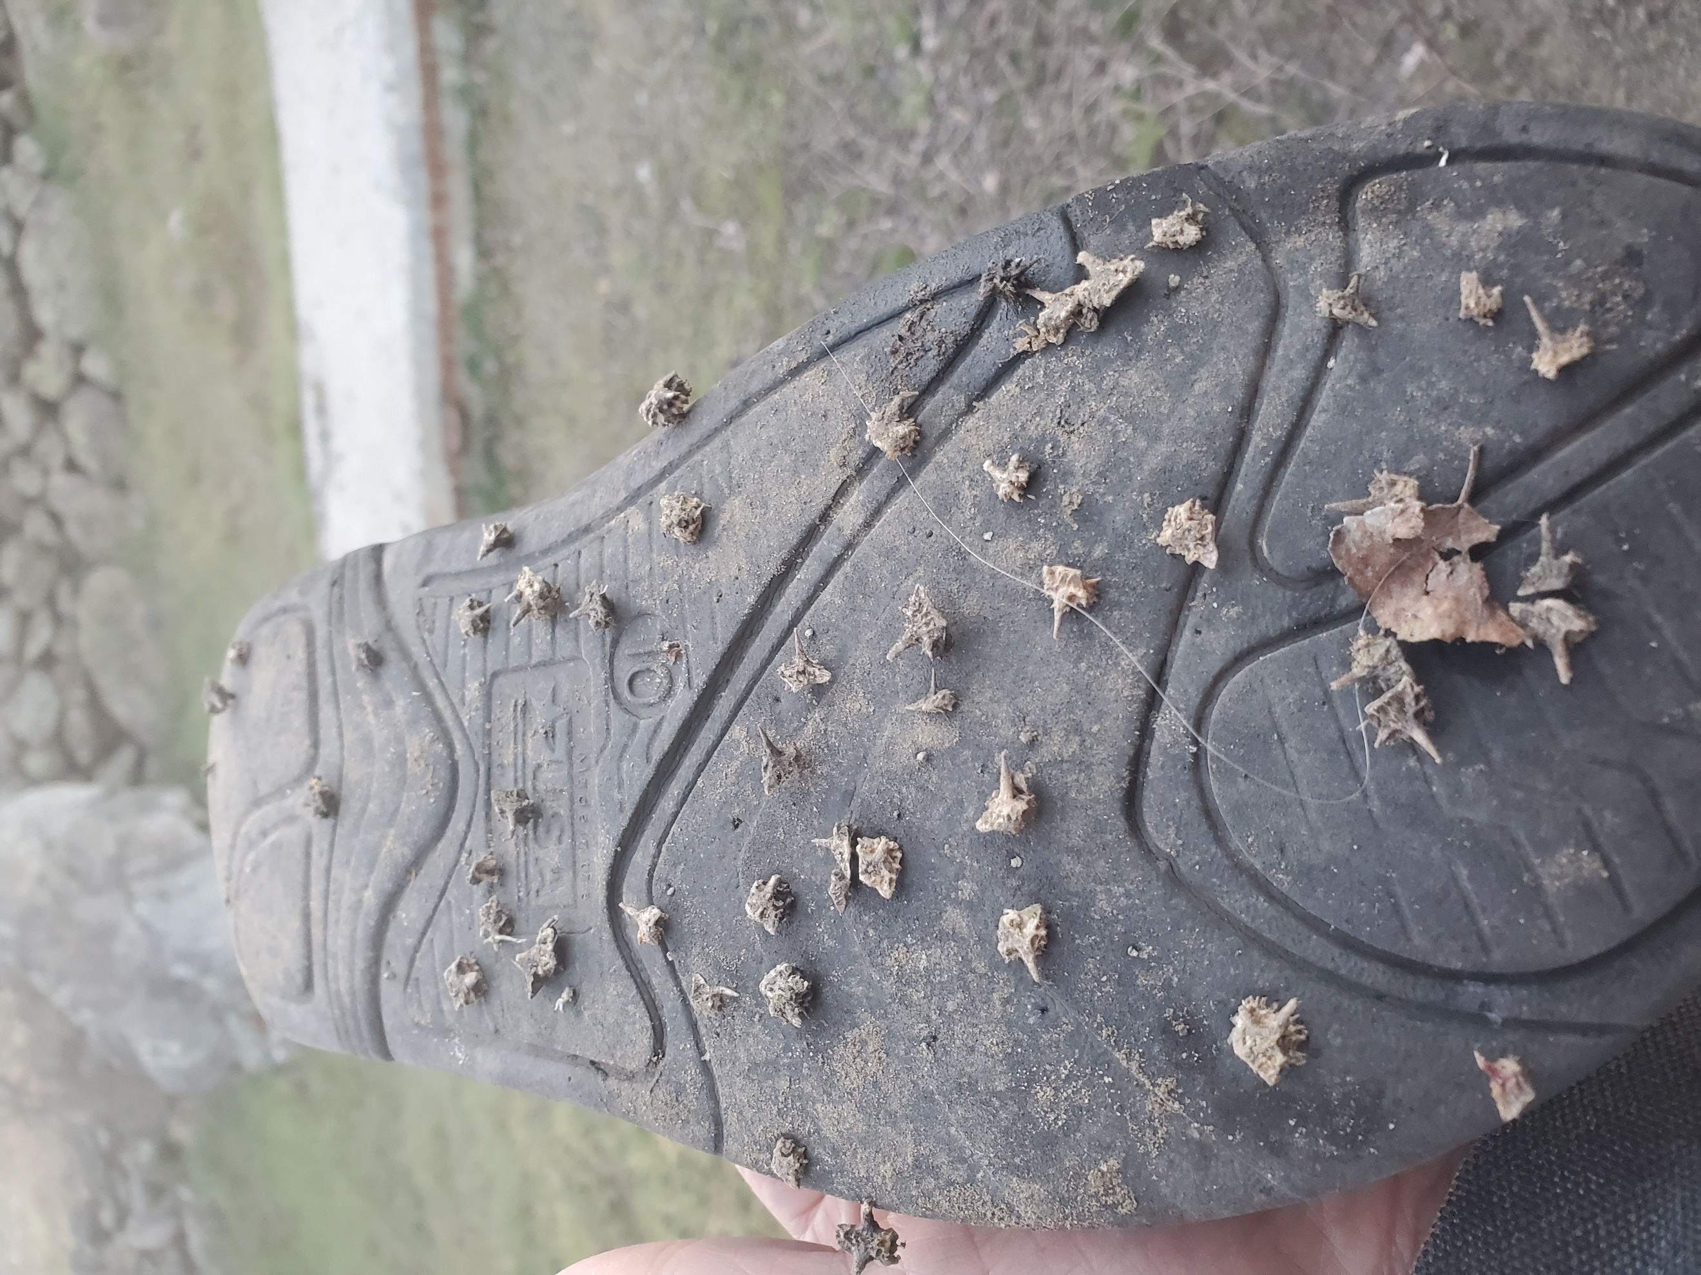
recreationists.

To counteract such threats, we need early detection and aggressive control action.

The revised Forest Plan must contain an objective that every recreation site on the Forest be inspected at least once per year for the presence of new invaders. If new invasive species are detected, Forest Plan components must commit the Forest to vigorous control action to eliminate these new invaders and slow the spread of established State-listed non-native plant species.

The possible spread of invasive species must also be a serious consideration in managing dispersed recreation, such as dispersed camping.

