Bitterroot Front Project EA Comments

September 15, 2023

Ranger Stephen Brown
Stevensville Ranger District
Bitterroot National Forest
88 Main Street
Stevensville, MT 59870

Please accept the following comments respectfully submitted by the Montana Chapter of the Sierra Club (MTSC). The MTSC is also a signatory to the comments submitted by the Friends of the Bitterroots (FOB) and other conservation organizations on September 15, 2023. This letter serves as a supplement to those comments submitted by FOB.

While the proposed project raises multiple areas of concern, we are focusing on two specific issues.

Failure to Protect Grizzly Bear Connectivity Areas

The 2012 National Forest Planning Regulations contain specific planning obligations for the National Forest units to fulfill. In particular, the new regulations have substituted two provisions §219.8 and §219.9 for the 1982 regulations’ “maintain viable populations of forest vertebrates” standard. These new sections seek to meet the mandate of NFMA that forest plans “provide for the diversity of plant and animal communities…” 16 USC §1604(g)(3)(B). In relevant part §219.8 states:

(a) Ecological Sustainability. (1) Ecosystem Integrity. The plan must include plan components, including standards or guidelines, to maintain or restore the ecological integrity of terrestrial and aquatic ecosystems and watersheds in the plan area, including plan components to maintain or restore structure function, composition, and connectivity, taking into account: (emphasis added)

(ii) Contributions of the plan area to ecological conditions within the broader landscape influenced by the plan area.

(iii) Conditions in the broader landscape that may influence the sustainability of resources and ecosystems within the plan area.
In parallel language §219.9 Diversity of plant and animal communities, in relevant part, states:
- Ecosystem plan components. (1) Ecosystem Integrity. The plan must include plan components, including standards or guidelines, to maintain or restore the ecological integrity of terrestrial and aquatic ecosystems and watersheds in the plan area, including plan components to maintain or restore their structure, function, composition, and connectivity. (emphasis added)
It is clear from the language of these regulations that connectivity planning is central to forest planning, even at the project level. Indeed, it is so central that “plan components, including standards or guidelines” addressing connectivity must be included in the forest plan. Despite the lack of a revised forest plan under the 2012 Forest Planning Regulations, the BNF is required to consider and plan for connectivity at the project level. Thus, the Bitterroot Front project analysis must include consideration of impacts to connectivity.
In the case of Endangered Species Act (ESA) listed species such as the grizzly bear, Section 7 of the ESA imposes a duty to conserve those listed species and to act to achieve survival and recovery of the species (Sierra Club v. Glickman, 156 F3d 606 (5th Cir 1998)). The courts have found that connectivity of the Greater Yellowstone Ecosystem (GYE) population to other populations is necessary for recovery of the grizzly bear under the ESA (Crow Indian Tribe v. United States of America, No. 18-36079 (9th Cir., 2020)). Despite any recent ESA rule changes, the requirement to contribute to recovery is core to the ESA statute and necessary in order to achieve its stated goal to conserve species and the ecosystems upon which they depend. The project area abuts the Selway-Bitterroot Recovery Area designated by the US Fish and Wildlife Service (USFWS) core habitat for grizzly bears. As such, the project area, especially the inventoried roadless areas in the western portions of the project area, merit analysis for proposed activity effects on security in areas that could harbor grizzly bears in the near future and certainly within the project time frame. Indeed, the Wildlife Effects Analysis acknowledges:

“The entire Bitterroot National Forest in the Bitterroot Mountains was designated as part of the Bitterroot Grizzly Bear Recovery Zone in the Grizzly Bear Recovery Plan (Servheen 1993). All of western Montana west of U.S. Highway 93 and south of Interstate 90 was identified as part of the Bitterroot Grizzly Bear Experimental Population Area in the Record of Decision Concerning Grizzly Bear Recovery in the Bitterroot Ecosystem Final Environmental Impact Statement (USFWS 2000).” (PF-Wildlife-001 at 9)

Moreover, recent studies authored by Interagency Grizzly Bear Study Team scientists indicate
that the project area could function as a linkage area with the GYE. The van Manen et al7 and Peck et al8 studies show that a major portion of the project area could function as a connectivity area between the GYE and the Northern Continental Divide Ecosystem grizzly bear recovery areas (Figure 1). Peck et al made the following comments about the probability of grizzly bear use in these zones: “[t]herefore, with the exception of areas with low numbers of predicted passages (e.g., wide open valleys), we anticipate that sporadic bear sightings and possible interactions with humans may occur almost anywhere along the gradient of our model predictions.” Connectivity is an essential element of both survival and recovery of ESA listed species and accounting for it and preserving it is a major emphasis of the 2012 Forest Planning Rules. Specific, appropriate project requirements that are clear and affirmative boundaries are needed to achieve the duty imposed by Section 7 of the ESA.” Thus, connectivity for grizzlies must be explained and supported by the best available science (36 CFR §219.3 and §219.4). Such an explanation is not present in the current DEA in violation of the ESA and NEPA requirements for disclosure and analysis of environmental impacts. The BNF needs to address grizzly connectivity in consultation and avoid interfering with recovery by reducing connectivity values of the project area.

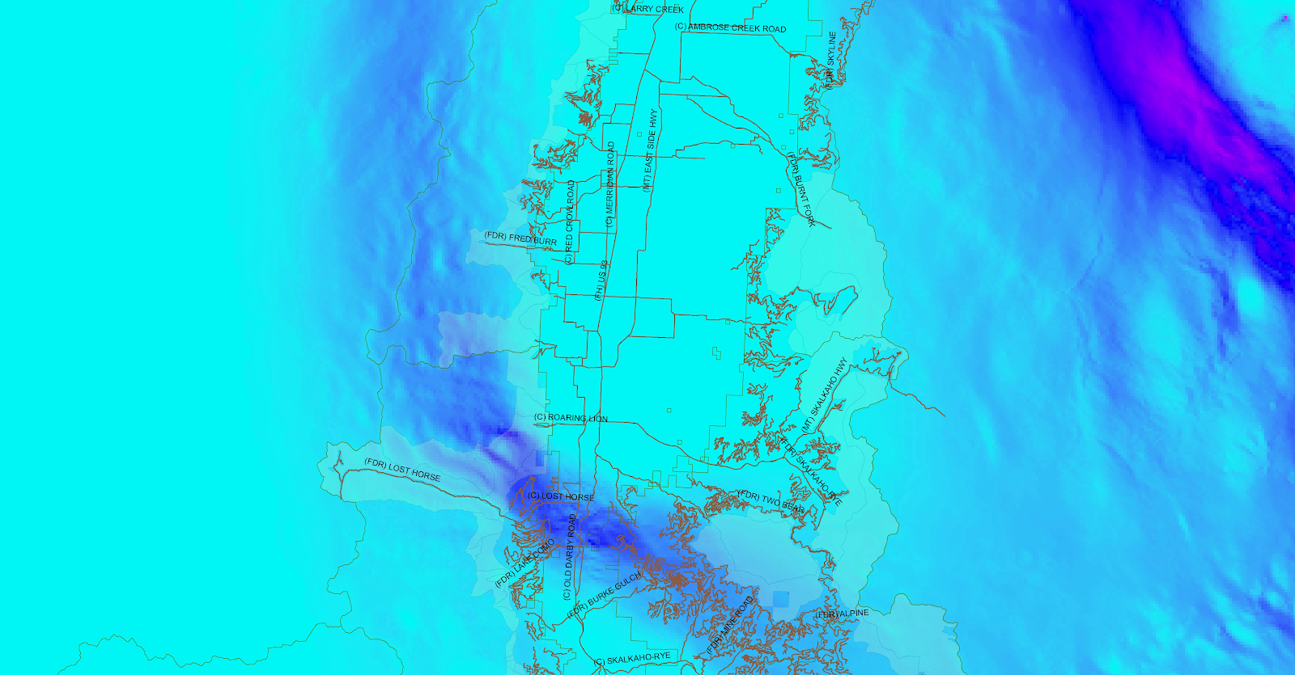
Figure 1. Bitterroot Front Area and van Mannen et al (2017) Grizzly Bear Connectivity Areas. The BNF Ranger District Boundaries in the Bitterroot Front area that correspond to the project boundary are mapped on grizzly connectivity areas with increasing connectivity probability as the color darkens from aquamarine to blue as modeled initially by van Mannen et al and subsequently reported by Peck et al as well. Data for the grizzly connectivity areas found at: https://www.sciencebase.gov/catalog/item/59149ee6e4b0e541a03e9a58

Even more recently, Sells et al (2023), modeled movement to the Bitterroot Ecosystem grizzly recovery area. They recommended “[c]onservation efforts in the Northern Rockies could be targeted in areas predicted by this study to be important for connectivity among grizzly bear populations “(Sells et al at 11) Their work reveals that the Bitterroot Front is a major connectivity area running north-south in the Bitterroot Ecosystem (Figure 2-5) possessing the highest habitat values. In addition, the figure depicts grizzly bear locations outside the designated recovery areas (red stars in Figure 2) and it is clear that bears are being located at the north and south ends of the Bitterroot Front project area.

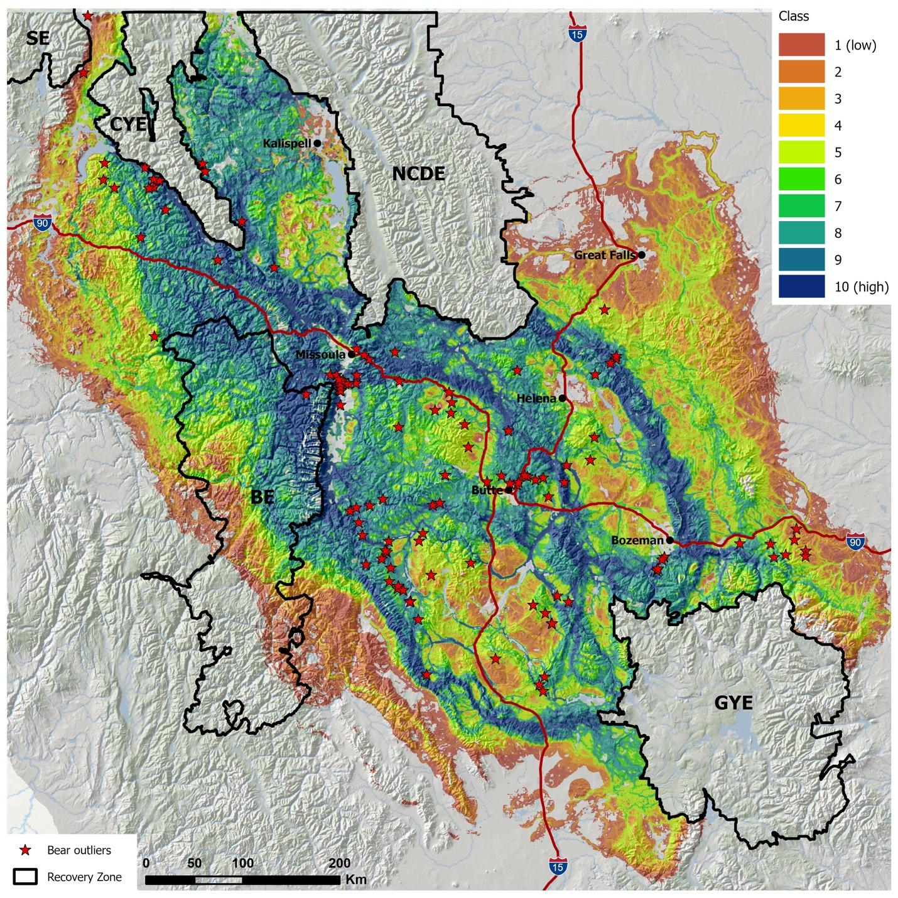
Figure 2. Figure 3 from Sells et al 2023. Female grizzly directed model connectivity paths. The darker the color the higher the connectivity value. Red stars indicate grizzly bear locations outside designated recovery areas. Data can be found at https://www.sciencebase.gov/catalog/item/6491b29bd34ef77fcb004434

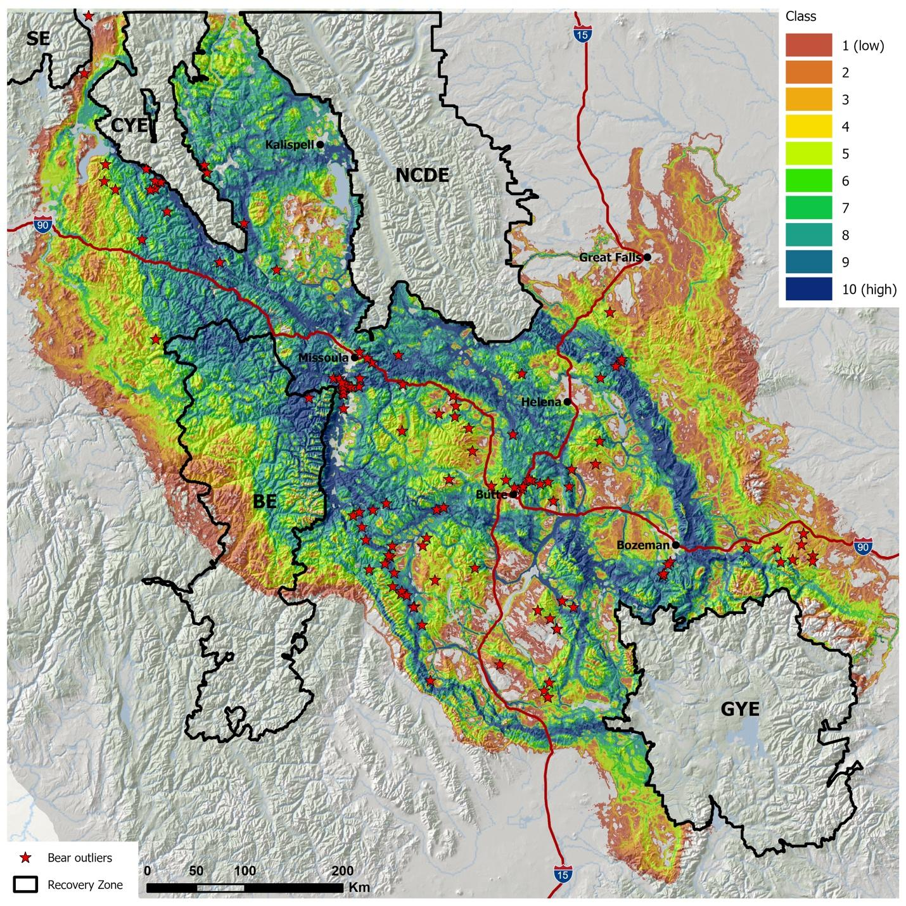
Figure 3. Figure 4 from Sells et al (2023). Male grizzly modeled directed connectivity paths. The darker the color the higher the connectivity value. Red stars indicate grizzly bear locations outside designated recovery areas. Data can be found at https://www.sciencebase.gov/catalog/item/6491b29bd34ef77fcb004434

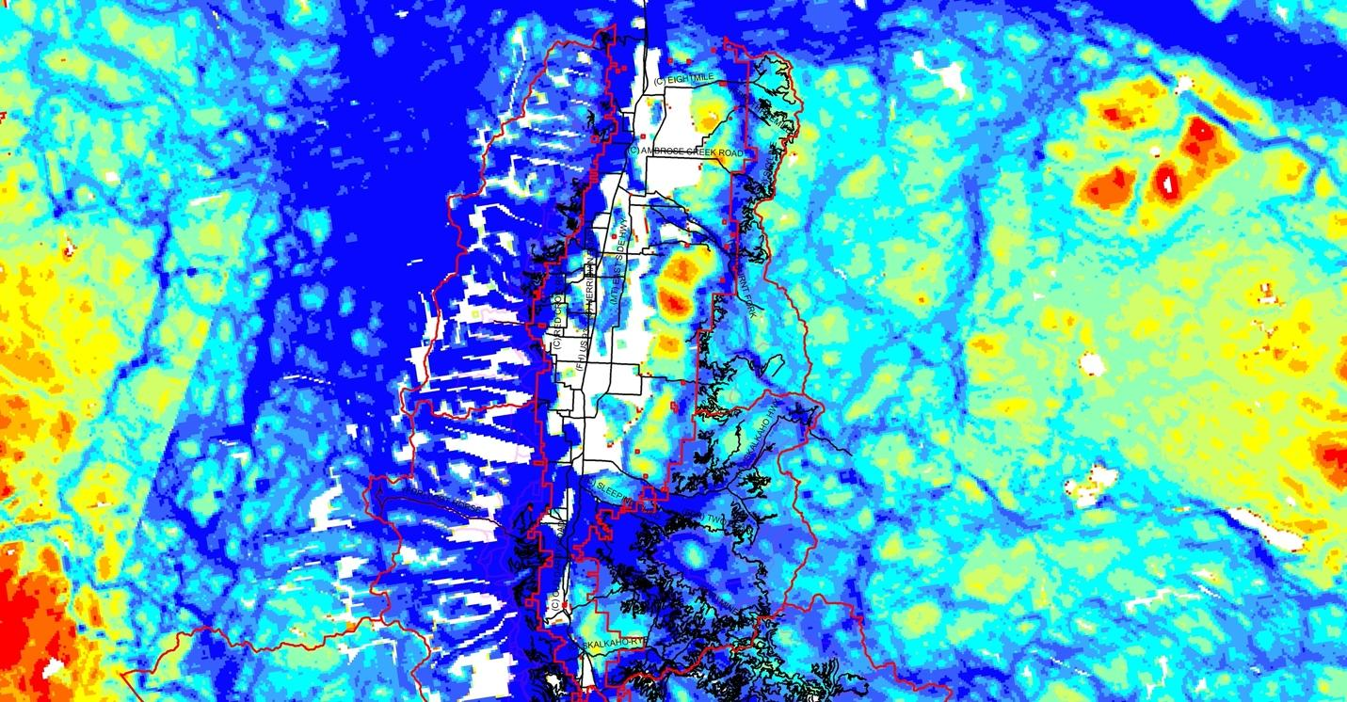
Figure 4. Bitterroot Front project area detail of Sells et al (2023) directed female grizzly connectivity. Blue is the highest value grizzly bear connectivity/habitat. Bitterroot National Forest Ranger district boundaries are in red and roads are black.

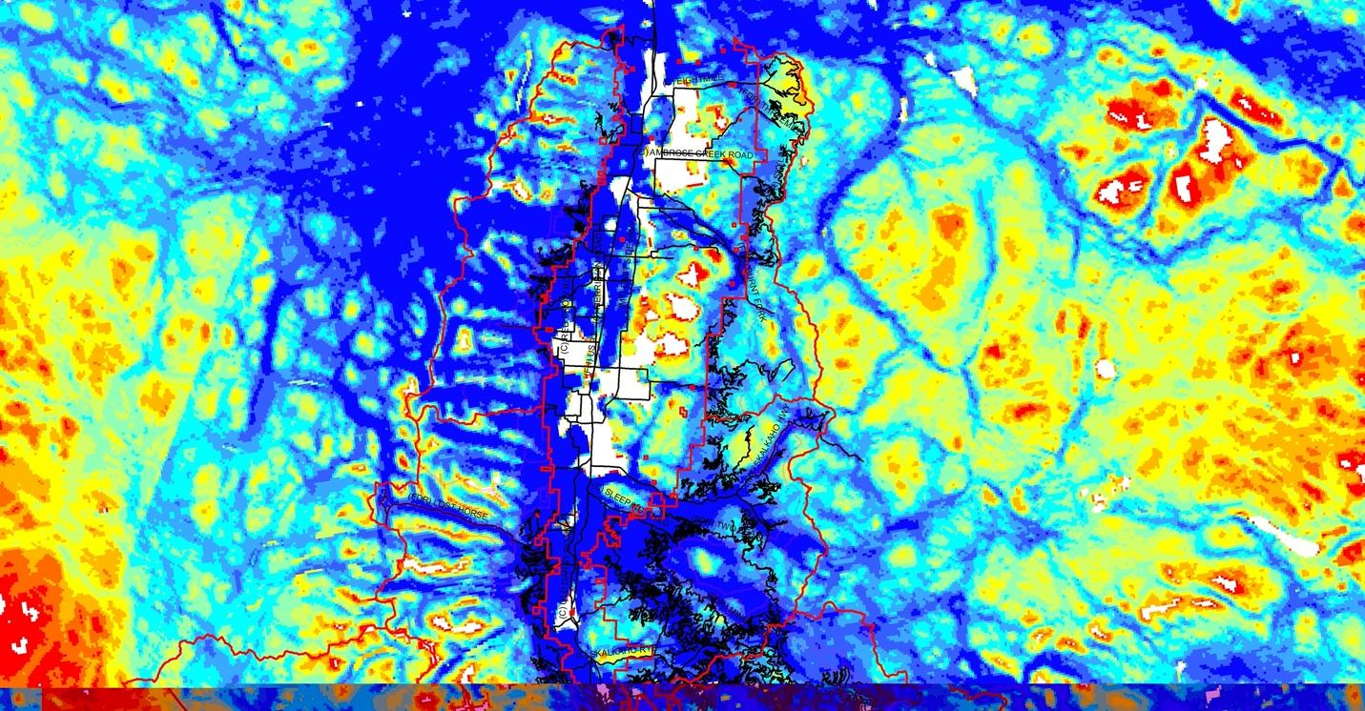
Figure 5. Bitterroot Front project area detail of Sells et al (2023) directed male grizzly connectivity. Blue is the highest value grizzly bear connectivity/habitat. . Bitterroot National Forest Ranger district boundaries are in red and roads are black.

As a result, to meet the requirements of Section 7 of the ESA and the 2012 Forest Planning Rules elucidated above, there must be an in-depth analysis and firm, definite standards for protection of grizzly habitat values within the project area. This would include examining:

- The effects of new roads, permanent and temporary, on grizzly bear use, movement
and habitat security. Reductions of open road density recommended. Avoiding new
roads and immediate removal and restoration of temporary roads recommended for
grizzly habitat effectiveness and security;

- The effects of new trails or changes in trail use and the potential for increasing human
encounters;

- The effects of vegetation management, including commercial, non-commercial and
prescribed fire on grizzly bear use, movement and habitat security; and

- Limitations on re-entry (10 years recommended) following management activities.

These mitigations are largely absent from the project design. No limitation on re-entry is found in the DEA or Wildlife and Federally Recognized Species Effects Analysis (PF-Wildlife-001 or Wildlife Effects Analysis). Open road density is not reduced. No reference to science or even the mention of vegetation management or prescribed fire effects is found in either document.

The Bitterroot Front DEA/Wildlife and Federally Recognized Species Effects Analysis (PF-Wildlife-001) does state “temporary roads would be restored after activities have been completed.” (PF-Wildlife-001 at 9) However, this does not specify how soon after. Moreover, to prevent interference with connectivity to the greatest extent possible, temporary roads should be restored immediately following completed treatment activities. This proposed project fails to adequately protect grizzly bears as required under the ESA and NFMA.

The DEA relies in part on proposed decommissioning of roads to reduce road density and compensate for the reopening and building of approximately 11 miles of roads (DEA-105). However, road decommissioning depends on funding beyond the proposed project, and frequently USFS environmental analyses document goals of total road decommissioning that are not achieved. Thus, road decommissioning, especially in areas where new roads are built, cannot be seen as reducing the impacts of roads on grizzly bear occupancy and movement.

In reality, closing roads to only administrative use is not 100% effective either. In the Kootenai NF a total of 117 breached barriers and gates were found in 2020 and 2021 in grizzly bear habitat (Center for Biological Diversity et al v.USFS, 2023 U.S. Dist. LEXIS 144726). Reliance on administrative closures of otherwise passable roads is misplaced and ineffective and cannot offset the road density effects on habitat suitability for grizzlies.

We request revision of the Biological Assessment and re-initiation of consultation with USFWS
based on the above information, a finding of significant effects under NEPA and preparation of
an Environmental Impact Statement fully analyzing and avoiding impacts of the project on
grizzly connectivity.

The DEA contains little evidence of any of the required analysis stating:

Detailed analyses of the species’ analysis areas, the environmental baseline, the existing condition, and effects on these species with regards to the ESA are documented in the draft biological assessments and Wildlife and Federally Recognized Species Specialist Report (USFS 2023e-i, PF-WILDLIFE-001). DEA-115

Table 26 of the DEA (109) and Table 2 of the Wildlife Effects Analysis (PF-Wildlife-001 at 3) both refer to the draft Biological Assessment (BA) for detailed analysis. However, the BA is not available in the project documents provided to the public through the Pinyon documents system (see https://www.fs.usda.gov/project/?project=57341&exp=overview). In addition, the BA has not been produced despite a request to do so (see attached Appendix 1). As a result, the BNF has failed to disclose publicly its full rationale for the choices it has made and the project design with respect to mitigation of effects on grizzly bears in violation of NEPA and NFMA.

What is clear is that within the body of the DEA and the Wildlife Effects Analysis no examination exists of how project activities will affect grizzly bear connectivity or any recognition of the best available science on the subject. Generalizations and assurances of minimal or temporary impact are unsupported by a detailed analysis required by the ESA, NFMA and NEPA. There are likely significant effects on grizzly bear activity. The proposed project clearly requires an EIS and likely jeopardizes grizzly bear recovery in the Bitterroot Ecosystem in violation of Section 7 of the Endangered Species Act.

Failure to Protect Elk Security Areas

The proposed project will severely impact elk security habitat. The Bitterroot National Forest’s analysis acknowledges that the large-scale logging, including clearcuts; road building and increased access will make elk far more vulnerable. These actions will reduce security habitat, and open up elk to a far larger kill by human hunters. The analysis states:

“Implementation of the proposed project would have some short-term negative impacts on elk habitat and hiding cover, but this is not expected to reduce the project area’s carrying capacity for elk. Elk would become somewhat more vulnerable to mortality due to hunting or poaching, due to improved access on roads used for hauling logs and longer sight distances through treatment areas. Treatments would reduce the canopy closure in some units by reducing overhead canopy to some extent, which could reduce thermo-regulatory benefits. Whether thermal cover is necessary for individual elk survival or elk population viability seems open to question. Large amounts of winter range thermal cover do not seem necessary to support the State’s elk population goals on the Bitterroot National Forest.”

While the analysis goes on to state that over the long term, elk could gain some forage by opening the forest canopy, the lack of specificity for where the logging and what intensity it would occur makes this impossible to evaluate. The increased sight distance resulting from the intensive logging will result in a far larger kill of elk, and ultimately a reduction in the population there.

MTSC acknowledges that the forest conditions along the Bitterroot Front pose a threat to some homes in the area that adjoin the forest. However, the massive scale of this project is unwarranted. A better approach that would balance the interests of both wildlife and the need for wildfire mitigation in the WUI, would be smaller scale, more selective treatments immediately adjacent to existing homes and more frequent controlled burning. The lack of specificity in this project proposal makes it impossible to evaluate its effects on wildlife, wildlife habitat and endangered and threatened species. It also would have a severe impact on elk and other big game security habitat, and ultimately result in a reduction in elk populations and public hunting opportunities on these public lands.

Finally, while the Bitterroot National Forest compares this project to other treatments in the valley, the other projects cited are all smaller scale, targeted treatments. The massive scale of this project coupled with its vague analysis of wildlife impacts violates the clearly stated requirements of NEPA.

References:

van Manen, F.T., Peck, C.P., Costello, C.M., Haroldson, M.A., Landenburger, L.A., Roberts, L.L., Bjornlie, D.D.,and Mace, R.D., 2017, Potential movement paths for male grizzly bear (Ursus arctos) dispersal between the Northern Continental Divide and Greater Yellowstone Ecosystems, 2000-2015: U.S. Geological Survey data release, https://doi.org/10.5066/F72V2F2W.

Peck, CP, van Manen, FT, Costello, CM, Haroldson, MA, Landenburger, LA, Roberts, LL, Bjornlie, DD, Mace, RD (2017). Potential paths for male-mediated gene flow to and from an isolated grizzly bear population. Ecosphere 8(10): e01969. Doi.org/10.1002/ecs2.1969

Sells, S, Costello, C, Lukacs, P, Roberts, LL, Vinks, MA (2023). Predicted connectivity pathways between grizzly bear ecosystems in Western Montana. Biological Conservation 284: 110199.

Appendix A: BA Request

---------- Forwarded message ---------
From: Brown, Stephen - FS, MT <steve.brown2@usda.gov>
Date: Fri, Sep 8, 2023, 2:21 PM
Subject: RE: [External Email]Bitterroot Front BA
To: Len Broberg <len.broberg@gmail.com>

Hello Mr. Broberg,
Thank you for your email.

We do not make draft specialist reports or biological assessments available until they are finalized. They are a work in progress and are considered pre-decisional. Once the BA has been finalized and submitted we will make it available as part of the official project record.

Thank you,
Steve

Error! Filename not specified. | Steve Brown  District Ranger  Forest Service  Bitterroot National Forest  Stevensville Ranger District  p: 406-777-5461  steve.brown2@usda.gov  88 Main St.  Stevensville, MT 59870  www.fs.fed.us  Error! Filename not specified. Error! Filename not specified. Error! Filename not specified.  Caring for the land and serving people

Appendix B: Attachments sent under separate cover

- Sellers et al article regarding Grizzly connectivity (see reference section above for full citation)

- Center for Biological Diversity v. USFS 2023 U.S. Dist. Lexis 144726

