9/21/15

Elaine Kohrman, Forest Supervisor
Cibola National Forest
2113 Osuna Road, NE
Albuquerque, NM 87112

RE: Comments on Phase 2 Inventory of Lands That May Be Suitable For Wilderness-Sandia RD

Ms. Kohrman,

Please consider this letter my formal comments on the Cibola National Forest’s Phase 2 Inventory of Lands That May Be Suitable for Wildnerness. I attended one of the public meetings regarding this inventory, and learned a lot about the process.

Being personally acquainted with polygons D5-ADJ5 and D5-ADJ6, I confined my research to these two areas. It was quickly apparent that neither of the polygons met even the basic criteria for wilderness consideration.

Polygon D5-ADJ5 encompasses some old mining areas that left behind road systems, runoff ditches, and areas denuded of vegetation. There are also areas of exposed tailings from mining operations. In addition to these historical elements, this polygon features several structures built and maintained by the Forest Service itself. Doc Long’s picnic area with its shelters, tables, and other improvements is encompassed within polygon D5-ADJ5. Please see attached aerial views of Polygon D5-ADJ5. 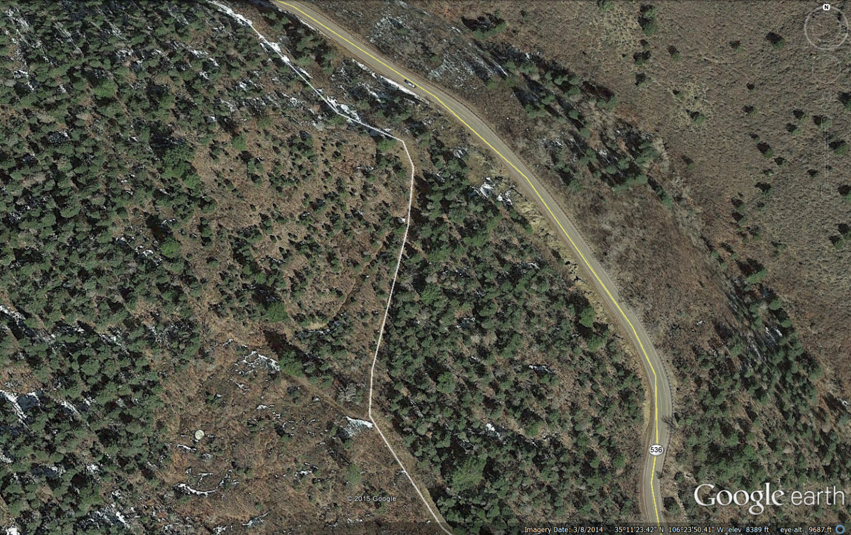
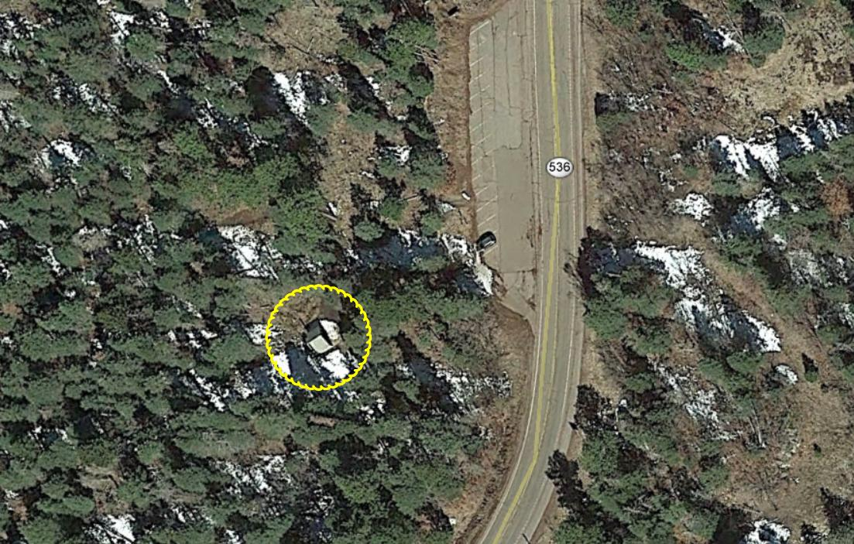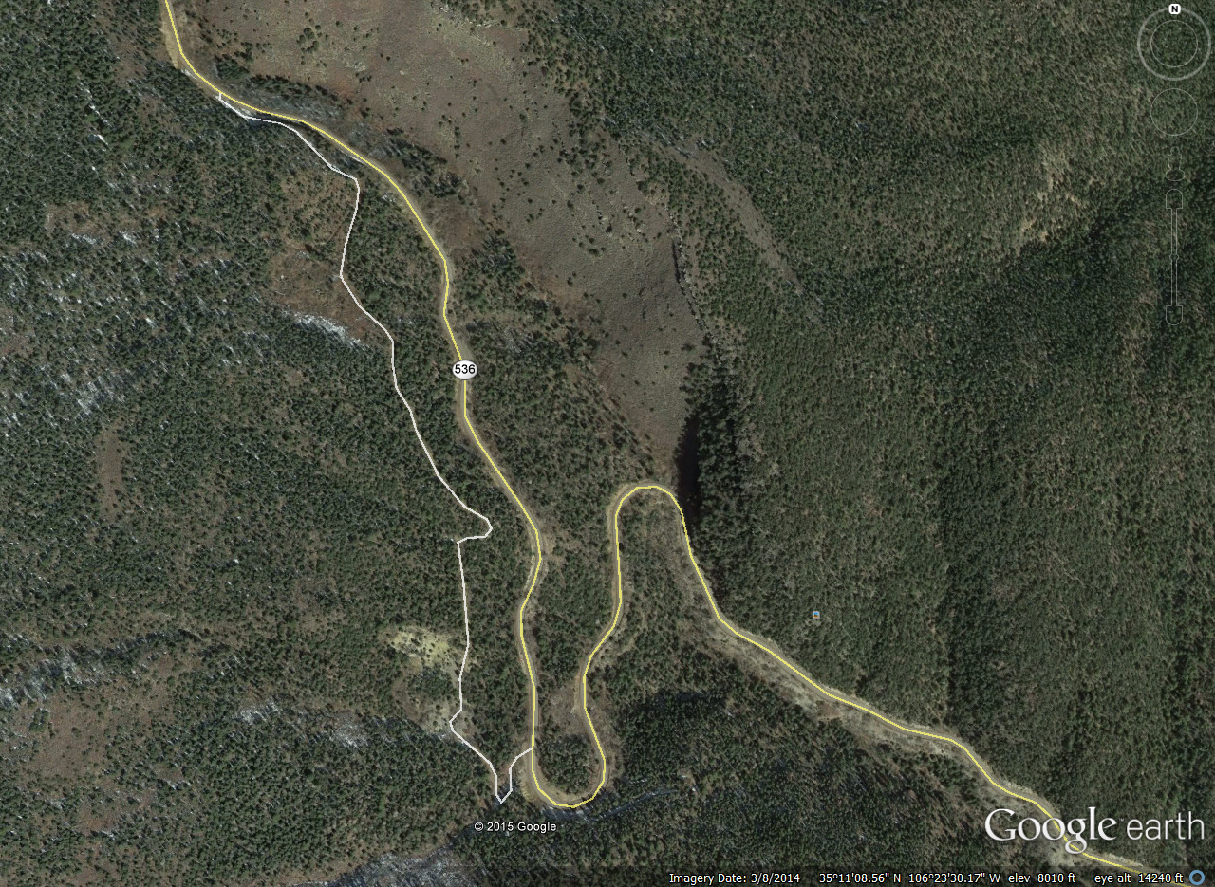If that weren’t enough, the entire polygon is subjected to the traffic noise generated on the road to the Crest, NM 536. The motorcycles that ride up and down this road are particularly noisy and can be heard everywhere on the Oso Corridor and Tree Spring trail. Not exactly a wilderness experience……

Polygon D5-ADJ6 is an even poorer fit for wilderness consideration. Its only apparent qualifications are that it is part of the Cibola National Forest and that it shares a small fraction of its border with the existing Sandia Mountain Wilderness. The western border backs up right to the city. It literally comes right up to streets, backyards, pools, and patios. It is impossible to traverse Trail 365 without hearing dogs barking, children playing, and even dinner conversation coming from backyards! If that were not enough, this polygon has active roads under daily usage, 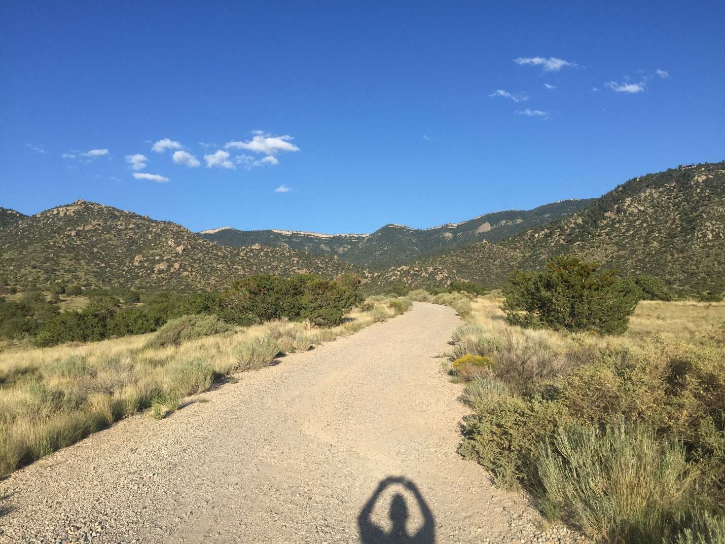

active well water structures, 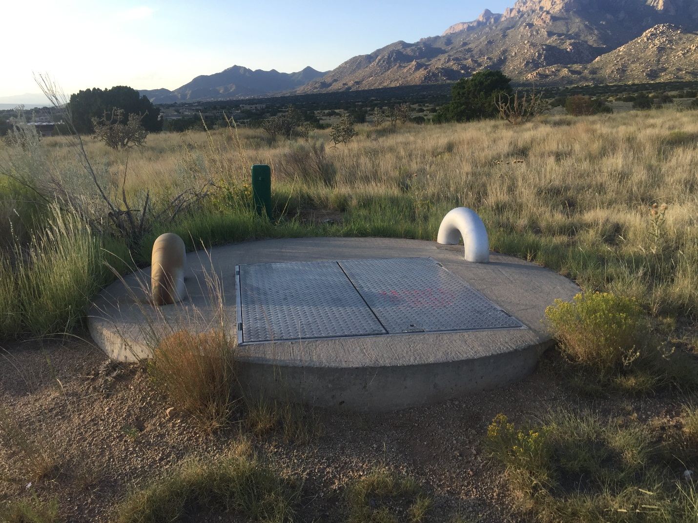

huge man-made linear features for flood control,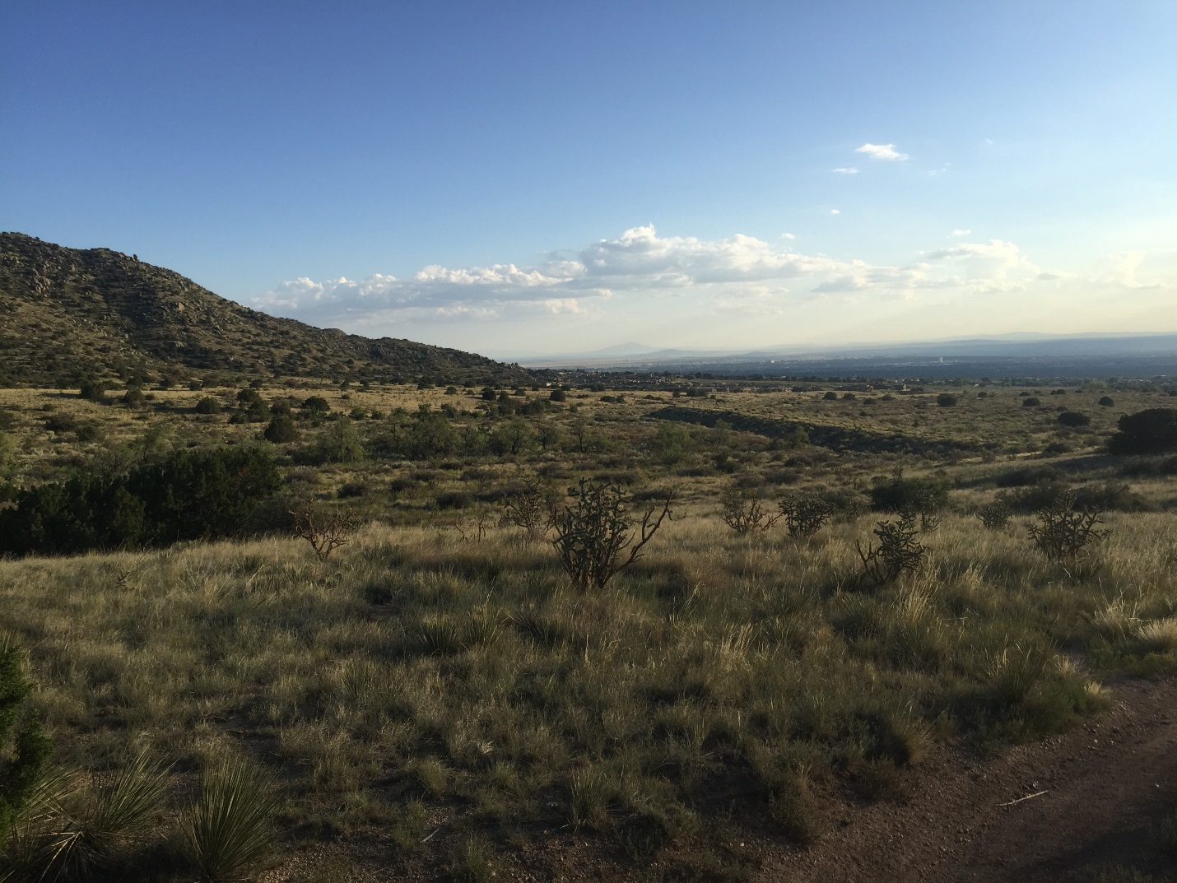and at least one old road that clearly leaves man-made linear features upon the landscape 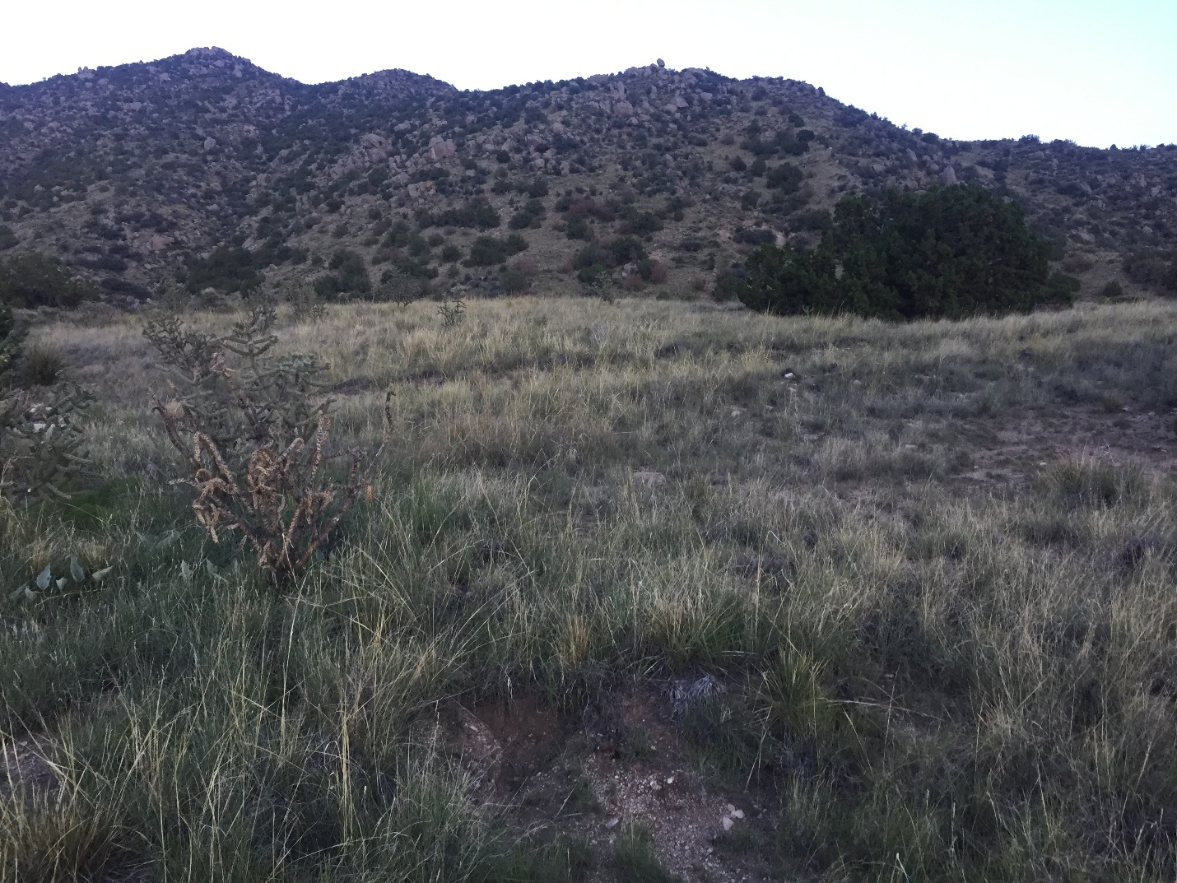

Why am I calling this a road and not user-defined trail? Because it is too linear to be a trail 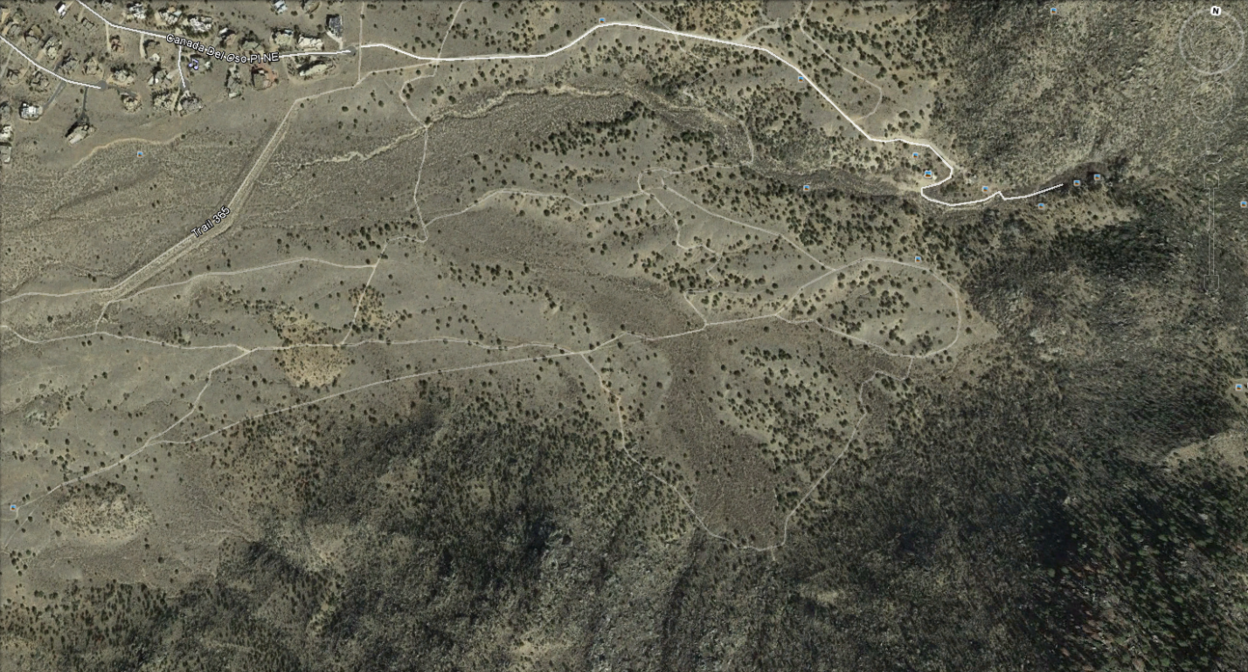

and inspection reveals it to be machine-cut into the hills. The Forest Service knew it was a road when this segment was taken out of service 15+ years ago. Please note the Forest Service signage that is still in place today. 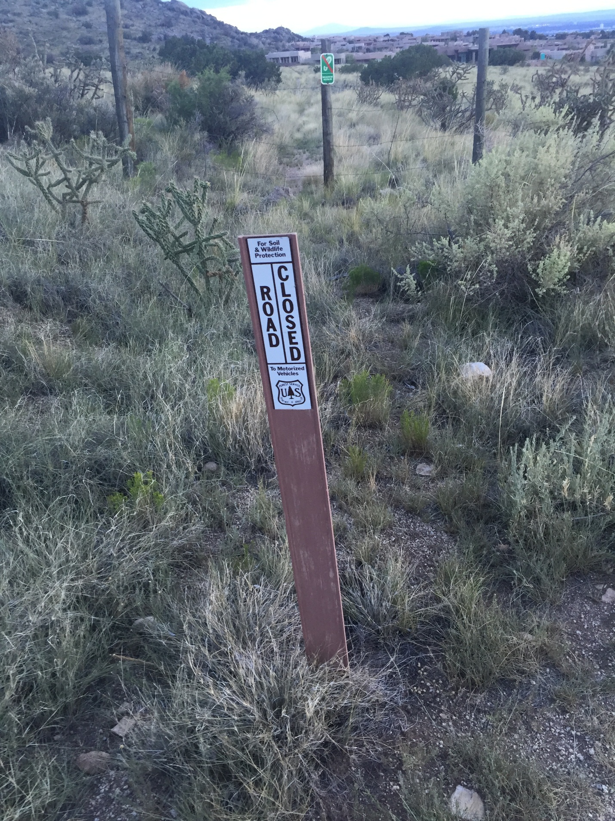

As mentioned above, I am not nearly as familiar with the other polygons that are under consideration for wilderness status in the Sandia Ranger District. However, based on the facts documented here in regard to these two polygons, I find it difficult to believe the Forest Service’s recommendations for the other eight.

My distress with this entire process goes deeper than that, however. I support Wilderness, and recognize its importance in our world. Most reasonable people can understand the need for Wilderness and what must be done to ensure we don’t squander those areas that are left untrammeled. However, this current “inventorying” process by the Forest Service in the Sandia Ranger District is just plain wrong-hearted. Any fool can see that that Polygons D5-ADJ5 and D5-ADJ6 fit neither the technical qualifications nor the intent of Wilderness.

So why did they make it to Phase 2 of the process? What is the Forest Service trying to do by masquerading these polygons as “Lands that May be Suitable for Wilderness”? The lion’s share of the Sandia Ranger District north of I-40 is already Wilderness. Most trail user groups are already locked out of the very cream of the Sandias (the high country) by the existing Wilderness areas. As demonstrated above, these additional 10 polygons in the Phase 2 Inventory are not suitable for Wilderness, will not enhance the huge chunk of wilderness already present. The inclusion of these polygons into the Wilderness would amount to nothing more than a land grab by those who want to lock out all user groups except hikers.

I look forward to being included in the planning process as it moves forward.

Sincerely,

Jim Werkmeister
8701 Washington NE
Albuquerque, NM 87113
(505) 980-1452
jimw@klingerllc.com

