Thank you for the opportunity to comment on the proposal to amend the Siuslaw Forest Plan regarding Integrated Invasive species treatments.

In the **Introduction**, your document says, “Currently the Siuslaw National Forest has no comprehensive strategy on prioritizing and treating invasive species across the Forest.” Within the proposal, I did not see an explanation of prioritization. Please include in the upcoming Draft EIS.

In the section titled **Prevention,** it lays out potential infrastructure, like boot brushes, in places to partially address spread of weeds and seeds on recreationists’ boots. Absent from this section, is prevention of the more obvious, common and much larger daily danger of the spread of weeds by the multitude of Forest sanctioned vehicles, such as logging equipment, contractor’s equipment for projects, herbicide equipment (especially wheeled equipment), road work equipment, etc. In addition, prevention strategies could be developed and included for sanctioned events and regular use of ATV’s and bicycles. Please address how Prevention of the spread of weeds will be addressed by the forest for these every day and potentially much more widespread introduction of new weed populations, than hikers’ boots.

Under **Proposed Action Treatment Descriptions**, each treatment type paragraph ends with an acre number and a statement that infers “no more than” that number of acres in a year would occur. Is a maximum acre the intent, or is that number an estimate perhaps based on previous years treatments? Please clarify. If it is truly a threshold or cap on the number of acres in a year that would be treated with that method, I have the following comments:

All of the **Manual Methods** listed (on Pages 1 and 2), and Insect Biocontrol, Soil Solarization and Shading on Page 2, Mowing and Cutting, Power Raking, and Steaming on Page 3, should not have a cap or threshold above which would not be treated in a year. These methods have limited controversy and disadvantages, and should be used wherever possible, with no cap on number of acres treated with these methods.

I am very skeptical about the use of **livestock** to help control weeds with these things in mind: potential spread of weed seeds from livestock droppings, and spread of weeds on the animals’ fur. And there is no guarantee the livestock will not eat desirable plant species, and favor weeds. Only if there is a comprehensive monitoring program on a small scale livestock weed removal project, do I think this should be included in a Forest Amendment.

The proposal for **Drone application**, fitted with a tank of liquid chemicals will be a ‘difficult sell’ to much of the local public. I have heard groups of locals say they think that drone use, opens a slippery slope toward other aerial applications, which they felt the Siuslaw had promised them they would not engage in. When I learned about the potential for using drones to apply herbicides in some situations, my first thought was how that would increase human safety since the person(s) in charge of weed management would have much lower exposure to chemicals during spray, as they would be operating the spray vehicle remotely. However, I am still extremely concerned about pesticide drift that could occur with spray delivery from 7 to 12 feet in the air. **Unless, it is used in conjunction with** another technology that you did not include—**Electrostatic nozzles/sprayers** for on target spraying, which I will address after the next comments on proposed chemicals, risk assessment, monitoring, and priorities for treatment.

The proposal document available for review, completely lacked any mention of **monitoring treatment effects**, which is integral to Integrated Pest Management (IPM). Please correct this omission with a good discussion of how treatment effects will be monitored and used for adapative management. This should include long-term monitoring of chemical residue, if/when used.

It is important that such a document to amend the Forest Plan, make a strong sincere commitment to **never use Perfluoralkyl and Perfluoralkyl substances**, also known as **PFAS** or, “forever chemicals” which are sometimes added to pesticides to control weeds and pests. PFAS do not break down in the environment and can build up in organs and blood, potentially causing serious health issues. There would never be a situation in which any perceived benefits of PFAS usage, would outweigh the unacceptable long-lasting toxins in the environment.

The resulting document should be transparent and thorough in the description of the short and long-term hazards of each of the pesticides being proposed. Also, if not a NEPA document per se, will there be a process with a **tracking document**, like a “Treatment Plan”, (as Fire has a Burn Plan) to show a reasonably thought out **risk assessment**, with all the options that were available and considered for that situation, and the **rationale** for the choice of treatment method (and if that treatment is chemical, the rationale for the type of pesticide recommended.)? The Forest should also always consider the **non-chemical alternatives first**, in a safety hierarchy that they develop for IPM. Please include a section on how each subsequent treatment under any amendment would be tracked with documentation described within this paragraph.

I do realize that invasive weeds are threatening habitats in multiple ways, and that often our rarest wildlife species are at the highest risk when weeds either overtake native vegetation that are essential for their survival, as is occurring with the Oregon Silverspot butterfly, or vegetation moves into naturally open habitats that are critical for a species, such as is occurring with the Humboldt marten or Snowy Plover. It would be best for the species and their associated ecosystems, to use non-toxic methods whenever possible, but if the “least toxic” herbicide is deemed the best choice, (after vetting and documenting, as discussed in previous paragraph), I encourage you please, to incorporate the **technology of Electrostatic Spraying**, for the increased safety of the pesticide handler or operator, and for the most efficient use of the applied chemical.

Electrostatic spraying is a high-tech technology that uses high-voltage electrostatic technology that charges the droplet particles of the liquid product, which increases adsorption on all surfaces of the target plants. (Electrostatic spray technology is also used for spraying other agricultural products such as fertilizer and growth regulators, and also for spraying disinfectant to cover all surfaces). The following is a comparison of the benefits of using this spray technology (in agriculture) in lieu of compressed air sprayers:

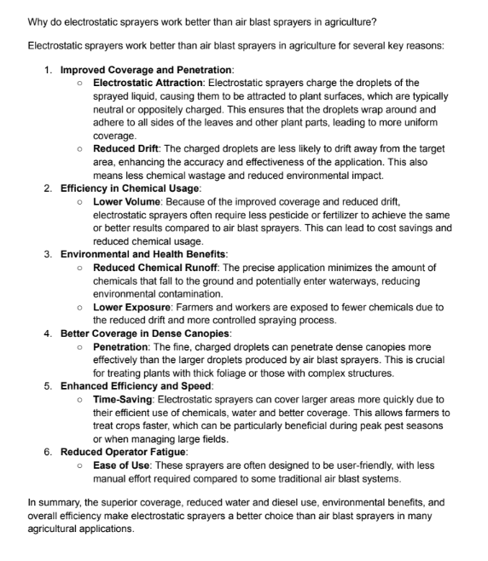

The following is a link to a research paper comparing this electrostatic spray technology for agriculture with currently used sprayers, in China. <https://www.frontiersin.org/journals/ecology-and-evolution/articles/10.3389/fevo.2023.1138180/full#h11>

Electrostatic spray application is already being used on large scale equipment (for orchards, vineyards, etc.) as well as with smaller backpack sprayers, and with other ground based spray equipment. I do not know if this has been used successfully with drone technology, but after speaking with an expert who designs and patents electrostatic sprayers, from Ontarget Spray Systems (Mt. Angel, Oregon) the main hurdle of incorporating this technology with drones is grounding the vehicle. However, this expert thought that theoretically it would work as long as the drone has short flying sessions. This seems likely, since drones probably have a low capacity for carrying a liquid product, and would necessitate frequent landings for refilling its tank.

In summary of this proposed usage of technology, compared with Electrostatic spraying, the traditional direct pesticide spraying method does not distribute the product evenly or does it adhere to the all surfaces of the target resulting in waste and overspray, and potentially poisoning non target species, exposing the applicator to toxins, and causing unnecessary adverse effects to the environmental. If after a risk assessment with careful research and deliberation on site specific situations, a non-toxic alternative is dismissed in favor of chemical application, PLEASE USE electrostatic technology which is proven to be an efficient method, using far less of the chemical due to targeting the plant with little overspray or drift, protecting the human applicator and environment from residue, which would meet the goals of doing the least harm. The side benefit to the agency, is cost savings and increased efficiency. The initial investment of equipment would soon be offset with the decrease in the amount of product required per application. ***Please be warned though***, that not all advertised “Electrostatic equipment”, such as the inexpensive rechargeable nozzles by Ryobi and Victor, are NOT actually using the electrostatic technology. More research needs to be done to see where electrostatic sprayers are locally available for sale or rent. Looking at the timeline for this project, there should be plenty of time to do Electrostatic equipment availability searching! Lastly, there are several YouTube videos showing the electrostatically charged spray being attracted to all parts of a target plant that can illuminate how well this technology works.

As I mentioned earlier, I think that one of the most threatened habitats that should be prioritized for invasive weed removal, is in situations where the non-native vegetation invasion has displaced, prevented or degraded habitat components for **threatened or endangered species**. While reviewing the 2001 Recovery Strategy for the Oregon Silverspot Butterfly,(OSB), I found this assessment on degraded habitat due to non-native grass causing thick mats of thatch that inhibits the growth of needed habitat components for the life-cycle of the threatened butterfly species:

“Both abundance of early blue violets and levels of Oregon silverspot butterfly oviposition activity have been inversely correlated with vegetation height and thatch depth (Singleton 1989, McIver et al. 1991, Pickering et al. 1992). Early blue violets can persist in a suppressed vegetative form or in the seed bank under other vegetation for many years. Removal of shrubs and trees has released dormant early blue violets that subsequently have initiated vigorous growth (Hammond 1986). It is important to note, however, that in the years subsequent to removal of woody overstory, some sites were invaded by perennial, exotic grasses which have suppressed violets. Effective techniques for long-term grass removal are currently unknown. In addition, persistence of violets in the seed bank or in a vegetative form in a perennial, exotic grass-dominated system has never been demonstrated, thus it is unknown if violets would respond vigorously to removal of grass (D. Pickering, The Nature Conservancy, pers. comm. 2001).” (From USFWS, 2001 Recovery Strategy for the Oregon Silverspot Butterfly)

And within the Revised Recovery Plan, USFWS 2001, (the link is included in the next paragraph) there are specific butterfly habitat descriptions and recommendations, such as the following which highlights 4 different subpopulation habitats on the Central Coast District describing habitat conditions, history and issues:

“Rock Creek/ Big Creek sub populations:

“Despite intensive management efforts at Rock Creek-Big Creek since 1980, there has been a net loss of breeding habitat, as measured by early blue violet presence and condition (Hammond 1990a, 1991a, 1993). This is reflected in low numbers of butterflies per unit of habitat (McIver et al. 1991; Pickering 1995; Pickering et al. 1992, 1993).” <https://ecos.fws.gov/docs/recovery_plan/010822.pdf> Pg. 34

“Subsequent study has shown that this situation is due to rapid spread of exotic heath grass (Danthonia decumbens) at this site. Without management, the Oregon silverspot butterfly population at this site would likely have been even more seriously reduced in size and close to extirpation (Hammond 1990a, 1991a).” (Ibid, pg 34)

“The primary management technique has been multiple annual mowing events, a cost effective management technique that has proven to be very effective on control of salal and other woody species. Mowing also temporarily provides a reduction of non-native grass height and thatch accumulation conducive to ovipositing habitat (Hammond 2000), however, mowing does not contribute to 35 non-native grass eradication and may actually increase grass density at the expense of early blue violets and nectar sources in the long-term. It is imperative that long-term solutions to non-native grass eradication and control are found and implemented to ensure that important Oregon silverspot butterfly habitat components of violets and nectar sources are maintained and enhanced.” (Ibid, Pgs 34-35)

“Marine Terrace habitat

Mowing initiated in 1985 and continued through 2000 has effectively controlled the encroachment of woody brush and trees into the salt-spray meadows. The 1985 treatment was followed up with burning of the dried residual material which resulted in a late season flush of violet growth during the same year. Areas with 10 to 20 years of extensive brush cover exhibited successful violet emergence. The early blue violet’s ability to persist for long periods under dense brushy overstory has been attributed to substantial energy reserves concentrated in its rootstalks (Hammond 1986). However, encroachment of non-native grasses, specifically heath grass and bent grass, has occurred since 1985, suppressing 36 violet growth and threatening the Oregon silverspot butterfly habitat quality (Hammond 2000).

Management solutions which reduce non-native grasses in a manner compatible with enhancing early blue violets and nectar sources should be investigated and implemented. Hammond (2000) recommended intensifying mowing treatments or experimenting with grass-specific herbicides. Intensified mowing treatments as a solution should be viewed with caution in light of research which indicates mowing does not increase violets and may actually preclude some nectar sources from flowering (Pickering et al. 2001, Hays and Johnson 1998).” (Ibid, pgs. 35-36)

“Steep slope habitat

The Oregon Silverspot Butterfly Forest Implementation Plan for the Siuslaw National Forest (Hammond 1989) provided management planning for butterflies through 1996. Prescribed burning was a technique that initially appeared to benefit early blue violets (Hammond 1989, 1993), however, as nonnative grass cover increased this technique produced mixed results and was abandoned. Habitat conditions and threats have continued to shift over time. Progress toward meeting management objectives should be reassessed, results from studies of management techniques at other sites should be considered, and an updated management plan should be developed and implemented.” Ibid, pg. 36)

Bray Point

“A management plan for the site was completed in 1989 (Hammond 1989) and work commenced in 1993 with hand slashing of trees and shrubs. Management to increase the violet population at Bray Point is considered to be imperative to maintain the population (Pickering 2000), however, competition from non-native grasses make it unclear which management technique would be most effective. A comprehensive strategy to reduce non-native grasses and to enhance early blue violets should be developed with consideration given to use of prescribed burning (Pickering 2000).” (Ibid, pg. 37)

The Recovery Plan document goes on to describe recommendations for other Oregon silverspot butterfly habitats on and off the Siuslaw National Forest.

Also, there is a fairly recent publication on the effects on the Oregon silverspot butterfly following experimental exposure to various herbicides, that makes this statement in the Introduction:

“Selective herbicides, such as clopyralid and fluazifop-p-butyl, can reduce invasive plant abundance. However, non-target effects of these herbicides, and of adjuvants applied with these herbicides, on the Oregon silverspot are unknown. (From: Doll, Cassandra F., Effects of Herbicides on Oregon Silverspot Butterfly Populations, May 2021, Master’s Thesis, Washington State University, 77 pages. Accessed August 6th, Google Scholar, online)

The study measured and compared a variety of measurements during each stage of a surrogate, closely related butterfly species, to the Oregon Silverspot, called the Zerene silverspot. And concluded the following:

“Our study provides evidence of limited direct effects of herbicides and adjuvants on the Zerene silverspot, providing a sufficient basis to proceed to field studies to evaluate direct and indirect effects of treatments on the butterfly population. A reasonable next step would be to design field-based protocols to apply these treatments in the field and to monitor effects on Oregon silverspot populations. Only with a field study can we estimate the potential benefits of these management strategies relative to their potential costs. In addition to the Oregon silverspot, 24 out of 26 recovery plans for butterflies currently listed as threatened or endangered in the U.S. recommend invasive plant management (USFWS 2020a), including two other S. zerene 37 subspecies: the Behren’s silverspot and the Myrtle’s silverspot (Hammond and McCorkle 1983, Sims 2017). Among these recovery plans, at least 13 have reported herbicide use, but none of them have used clopyralid, while only two have used fluazifop-p-butyl (LaBar and Schultz 2012, Bennion et al. 2020). Our results cautiously support the use of clopyralid and fluazifop-p-butyl with one of two adjuvants, Agri-Dex® and Nu Film® IR, in Oregon silverspot occupied habitat, yet suggest the need for more thorough evaluations of their costs and benefits in the field, and throughout the butterfly’s life cycle.” (Ibid, pg 37)

Looking at the warnings for at least one of these compounds, suggests perhaps unacceptable hazards to the environment. Especially concerning is the acute long-term hazard to the aquatic environment, since the habitat is located in ocean spray meadows:

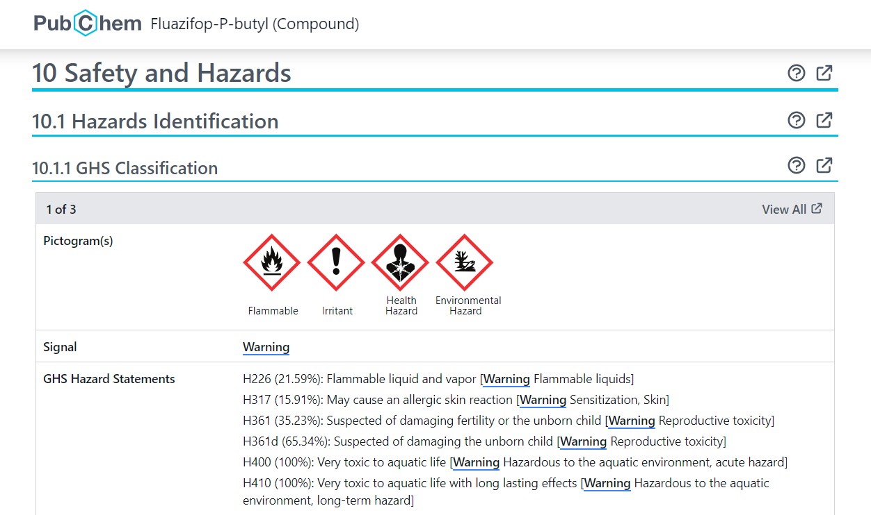

Another part of the OSB strategy explains that whenever the federal government may affect a listed protected species with their actions (including habitat treatments), that consultation with USFWS will be required. Hopefully, this will bring in another opportunity to discuss, research, perhaps do some experimental treatments, in order to recommend the best and least toxic, habitat treatment options on a site-specific basis:

We have responsibilities under the Endangered Species Act for listing, recovery, grants to the States, and consultation with Federal agencies. Section 7(a)(1) of the Endangered Species Act requires that all Federal agencies utilize their authorities in the furtherance of the purposes of the Endangered Species Act, those being the conservation of listed species and their habitats. Section 7(a)(2) of the Endangered Species Act requires Federal agencies to consult with us if their actions may affect listed species or critical habitat. Critical habitat designation affects activities conducted, funded, or authorized by a Federal agency, through section 7(a)(2) of the Endangered Species Act.

Of course, there are other documents, including recovery plans, for other species at risk due to needed vegetation management to make their habitat more conducive to their needs. Again, these and any new scientific information, should be guiding documents in the discussions between USFWS personnel, other species and habitat experts, and FS personnel who are in charge of planning habitat treatments under IPM. In addition to the laundry list of treatment options in the upcoming DEIS for a Forest Plan Amendment, there should be a transparent, well-reasoned and fully described risk assessment for a hierarchy of alternatives with the least harm alternative always being considered as the highest priority, in a **prepared pre-treatment document** of some sort, available to the public, for each site that will be treated under the proposed action.

Thank you again for the opportunity to provide input early in this process, for improving the DEIS for your proposed Forest Plan Amendment.