**Sound Mapping Tools: an ArcGIS toolbox for modeling**

**the propagation of sounds in a wildland setting**

*Version 4.4*

June 22, 2017

**Alexander C. Keyel, Ph.D. 1,* and Sarah E. Reed, Ph.D.1,2**

1 Dept. of Fish, Wildlife, and Conservation Biology, 1474 Campus Delivery, Colorado State University, Fort Collins, CO, 80523-1474, USA

2 Wildlife Conservation Society, Americas Program, 212 South Wallace Avenue, Suite 101, Bozeman, MT, 59715, USA

***\* Contact information:***

Alexander “Sasha” Keyel

Dept. Fish, Wildlife & Conservation Biology

1474 Campus Delivery

Colorado State University

Fort Collins, CO 80523-1474

Email: skeyel@gmail.com

***Suggested citations:***

Keyel, A.C., S.E. Reed, M.F. McKenna, and G. Wittemyer (*in review*). Modeling anthropogenic noise propagation using the Sound Mapping Tools ArcGIS toolbox.

Keyel, A.C., and S.E. Reed. Sound Mapping Tools: an ArcGIS toolbox for modeling the propagation of sounds in a wildland setting. Version 4.4. Colorado State University, Fort Collins, CO.

**Sound Mapping Tools:**

**an ArcGIS toolbox for modeling**

**the propagation of sounds in a wildland setting**

*Version 4.4*

June 22, 2017

**Table of Contents**

1. Abstract …………………. …………..………………………….…………. 3

2. License …………………. …………..………………………….…………. 3

3. Acknowledgements……………………………………………………….. 3

3. Background and Purpose …………..………………………….…………. 4

4. Model Structure ……………………………………………………………. 8

5.Installing Sound Mapping Tools ………………………………………….. 10

6. Model Inputs ……………………………………………………………….. 11

7. Model Outputs ……………………………………………………………… 19

8. Extra Tools ….……………………………………………………………….20

9. Final Notes .....……………………………………………………………… 22

10. References …………………………...…………………………………… 23

**Appendices**

A. Sample Exercise …………………………………………………………... 25

B. Python Tutorial …………..……………………………………..………….. 37

C. Troubleshooting Tips……………………………………………………….42

***Abstract***

Sound Mapping Tools aims to provide a straightforward, accurate, and affordable method for modeling potential terrestrial noise impacts. In this document, we describe the different factors that affect environmental noise propagation and how Sound Mapping Tools incorporates these factors. The Sound Mapping Tools contains three sound propagation models: SPreAD-GIS, based on Harrison et al. 1980, NMSIMGIS based on the NMSim model originally developed by Wyle Laboratories for the National Park Service, and a GIS implementation of ISO 9613-2. The models are intended to predict spatial patterns of sound propagation from various sound sources, such as traffic noise, motorized recreation, and energy development. NMSIMGIS can also be used for aerial sources. Additionally, we intend it to be suitable for research uses (e.g., generating sound level maps). One potentially important application could be for fulfilling the requirement to take engine noise into account when designating roads, trails, and other areas for motorized use (e.g., per the 2005 Forest Service Travel Management Rule).

***License***

Sound Mapping Tools is available under the GNU General Public License 2.0 (GPL 2.0, see gpl-2.0.txt provided with the toolbox).

***Acknowledgements***

Jennifer L. Boggs and Jacob P. Mann assisted in the development of SPreADGIS, and Jessica Sushinski upgraded SPreAD-GIS to ArcGIS 10.x. Bruce Ikelheimer provided the NMSim algorithms (Ikelheimer & Plotkin 2005) in a Python-readable format. The audibility tool was modified from NMSim’s source code written by R. Horonjeff and KJP (assumed to be Keith Plotkin). We thank Damon Joyce, Kurt Fristrup, Megan McKenna, Dan Mennitt, Kathyrn Nuessley, and the National Parks Service Natural Sounds Night Skies Division for valuable feedback on modeling sound propagation and many of the Extra Tools are based on processing steps recommended by K. Nuessly and D Joyce. J. Sushinsky, Courtney Larson, and Jeremy Dertien provided feedback on the tutorials and the User’s Manual. This project was funded by The Wilderness Society, a grant to the Wildlife Conservation Society from the Hewlett Foundation, and by the United States National Park Service.

***Background and Purpose***

Sound propagation is the transmission of acoustic energy through space. Sound waves are introduced into a medium, such as air, by a vibrating object. The vibrating object creating the disturbance could be the vocal chord of a person, the string of a musical instrument, or the rumbling of an engine. In air and water, sound waves propagate as disturbances to the ambient pressure level. A sound is defined as any variation in pressure that is detectable by a human’s (or another species’) ear, whereas the concept of noise is more subjective. Noise is generally defined as sound that is unwanted, causes a disturbance, or disrupts a communication system.

Environmental noise refers the propagation of unwanted or disturbing sounds outdoors. Also known as noise pollution, the most common sources of environmental noise are human transportation systems, especially motor vehicles and aircraft. Increasing levels of environmental noise have been linked to an array of human health and environmental effects (Shannon et al 2015). Prolonged exposure to environmental noise can have physiological and psychological effects on humans, including hearing impairment and loss, interference with communication, sleep disturbance, stress, and declines in job productivity, learning, and social behavior (Berglund & Lindvall 1995). Similarly, environmental noise can affect the physiology, behavior, and distribution of wildlife species (Shannon et al. 2015). While the particular impacts vary by species and habitat, studies have shown that transportation noise can lead to increased stress levels, decreased reproductive success, disruption of communication systems, displacement, flight, and changes in habitat use and foraging behavior (Havlick 2002, Ouren et al. 2007).

In contrast to many other countries, particularly those in the European Union, the U.S. currently has no comprehensive noise control policy, and no single agency is authorized to coordinate noise monitoring or enforce federal regulations. Federal regulation of environmental noise began in 1972, when Congress passed the Noise Control Act, noting that “inadequately controlled noise presents a growing danger to the health and welfare of the Nation’s population.” The Noise Control Act was amended by the Quiet Communities Act of 1978, which established a federal agenda for research and education on noise impacts and promoted the development of state and local programs to monitor and control environmental noise. During this period, the Office of Noise Abatement and Control (ONAC) of the Environmental Protection Agency (EPA) coordinated all federal activities related to environmental noise control. In 1981, the Reagan Administration determined that environmental noise issues were best managed at the state or local level, and the ONAC no longer received funding. Regulation of environmental noise within the federal domain devolved to several agencies, including the Department of Transportation, Department of Labor, and Federal Aviation Administration, each of which created a noise control program of its own. Many states and cities have also adopted noise ordinances, which vary in scope and degree of enforcement.

Most of the early policies addressing environmental noise on federal lands focused on U.S. National Parks. Concern over the adverse effects of increasing numbers of recreational airplane and helicopter flights over Grand Canyon National Park led to passage of the National Parks Overflights Act in 1987. This legislation required the National Park Service (NPS) to study the impacts of aircraft noise on visitors and natural resources. The research studies mandated by the Act, and the Director’s Order on Soundscape Preservation and Noise Management issued in 2000, led to the creation of the NPS Natural Sounds Program, whose mission is to “protect, maintain, or restore acoustical environments throughout the National Park System.” The National Parks Overflights Act also required that the Forest Service assess the impacts of aircraft overflights on National Forest System wilderness areas. The resulting study was limited in scope, but reported few adverse effects of overflights on National Forest wilderness users (Harrison et al. 1992).

More recently, federal land managers have begun to focus on the acoustic footprint of other types of engine noise on public lands – specifically, noise from automobiles and motorized recreational vehicles and energy development. For example, Zion National Park restricted motor vehicle access to Zion Canyon to reduce traffic congestion, improve visitor experiences, and preserve the natural soundscape (Miller 2008). However, little is known about the acoustic impacts of recreational roads and trails on public lands, particularly on National Forest and BLM lands in the western U.S., where motorized recreational activity is widespread.

The nationwide Travel Management Planning process offers an unprecedented opportunity to inventory and plan for the soundscapes of U.S. National Forests. Starting with the first Executive Order issued by the Nixon Administration in 1972, the Forest Service has been required to consider the impacts of noise in its management of motorized recreation. The Order states that off-road vehicle areas and trails should be located to minimize damage to natural resources, harassment of wildlife species, and conflicts with other recreational users, “taking into account noise and other factors” (E.O. 11644). The Travel Management Rule issued in 2005 also requires that decisions to designate roads, trails, and other areas for motorized use take sound into account (36 CFR 212.55(b)). To date, however, very few forest travel analyses have included spatially-explicit maps or models of potential noise impacts from motor vehicle activity.

The initial goal of our project was to identify and demonstrate a straightforward, accurate, and affordable approach for forecasting potential noise propagation from off-road vehicle activity in forested or other natural ecosystems. We first reviewed existing models and software packages available for modeling sound propagation. Based on the results of our review, we decided to adapt the System for the Prediction of Acoustic Detectability (SPreAD; Harrison et al. 1980) to an ArcGIS environment as SPreAD-GIS. We have since added a second model, NMSIMGIS, based on the algorithms of NMSim, a sound propagation model commonly used by the National Park Service. We have also added a GIS implementation of the outdoor noise prediction standard, ISO 9613-2. In this document, we describe the factors that affect environmental noise propagation and explain how to install and use the Sound Mapping Tools toolbox.

*Factors Affecting Environmental Noise Propagation*

In the absence of interference, sound waves propagate geometrically; sound levels decline as the square of the distance from the sound’s source. Several additional factors influence the propagation of environmental noise in forested or wildland settings. Acoustic energy is absorbed by the atmosphere, as a function of elevation, air temperature, and humidity (Harris 1966; ANSI 1995). Additionally, temperature and wind gradients cause sound waves to refract, or bend, changing the spatial pattern of sound propagation (Ingard 1953, Wiener & Keast 1959).

Sound is also absorbed by the ground. The magnitude of attenuation depends on the surface’s porosity or permeability to air (Aylor 1971). Hard, smooth surfaces such as pavement absorb little sound, whereas soft, porous surfaces such as grasses or bare soil can cause sound levels to attenuate substantially. Sound waves are also scattered by vegetation above ground. While empirical data on vegetation loss is limited, the magnitude of attenuation is likely to be a function of the structure, extent, and density of vegetation (Kragh 1981, Fang & Ling 2003).

Terrain features determine the relative importance of ground versus atmospheric effects. Attenuation of noise propagated from hilltops or across valleys primarily depends on geometric spreading and atmospheric absorption (Piercy et al. 1977). On the other hand, a steep hill or ridgeline can act as a sound barrier, creating a ‘shadow zone’ away from the source where sound waves are not directly transmitted (Embleton 1996).

Lastly, the intensity and frequency of environmental noise disturbances vary according to the characteristics of the sound’s source. For example, noise propagated around recreational routes depends on the number and types of vehicles passing by, their engine types (i.e., 2- or 4-stroke), and travel speed (Martin et al. 2005, Dooling & Popper 2007).

The degree to which environmental noises affect humans or wildlife species depends on the ambient sound conditions, as well as an individual’s auditory sensitivity. Ambient sound conditions can vary substantially by time of day, day of the week, and season. For instance, cooling air temperatures between day and night can change the direction of sound waves’ refraction and increase sound levels near the ground; this is one reason that distant sounds are more audible at night. Similarly, ambient conditions are often much quieter in the winter because snow-covered ground absorbs much more sound than do other ground surfaces.

Determining the impact of environmental noise depends on the characteristics of the listener as well as defining a threshold for what constitutes a disturbance. In some environments, simply having a mechanical noise be audible may constitute a sufficient disturbance for humans. In other environments, sounds may only become disturbing if they exceed typical sound levels or occur at unusual times of day. For wildlife species, noise disturbances are typically described in terms of effects that are likely to be biologically detrimental. For example, noise disturbances can cause increased stress levels or other physiological effects in individual animals, mask detection and discrimination of communication signals between animals, or reduce habitat quality for populations (Shannon et al. 2015).

*The Sound Mapping Tools Toolbox*

Sound Mapping Tools is a freely-available ArcGIS toolbox intended to provide researchers and land managers at universities and public agencies an accessible sound propagation model that can be implemented with standard GIS software. Sound Mapping Tools contains three sound propagation models.

First, it includes SPreAD-GIS, which was developed by adapting the System for the Prediction of Acoustic Detectability (SPreAD; Harrison et al. 1980) to an ArcGIS toolbox. SPreAD was developed 30 years ago by the U.S. Forest Service (USFS) and Environmental Protection Agency (EPA) to predict the acoustic impacts of recreational activity in wildland settings. SPreAD was explicitly designed to model how noise propagates in forested and other natural ecosystems. Accordingly, the SPreAD calculation process incorporates the majority of the factors that we hoped to include in our model, including wind and atmospheric effects, ground and vegetation effects, and sound source characteristics. Unlike many commercial applications, which summarize the frequency spectrum into a single summary sound level tuned to the human ear (i.e., an A-weighted sound level), SPreAD’s calculation process tracks the propagation of different frequencies through space. This is especially important for predicting the impacts of noise on wildlife, because animal species vary in their acoustic sensitivity to different frequencies (Dooling & Popper 2007).

We used ArcGIS ModelBuilder and Python scripts to adapt SPreAD to an ArcGIS environment. In December 2008, we released version 1.1 of the SPreAD-GIS model for testing by interested colleagues. We revised the model based on the feedback we received, and we released the public version of the model (version 1.2) in June 2009. We released a new version that incorporated additional tools and substantial revisions (version 2.0) at the end of September 2010. The model was updated to work with ArcGIS 10.3/10.4 in early 2016 and underwent additional testing and revision (version 3.x). New summary features and weighting options have been added in the most recent version (version 4).

Second, Sound Mapping Tools includes the NMSIMGIS model. NMSIMGIS is based on NMSim, which was developed by Wyle Laboratories to validate algorithms used in the NOISEMAP model, and was subsequently adapted for use by NPS (Plotkin 2001). NMSim was identified as the best noise propagation model in an extensive validation study conducted in the Grand Canyon, and is recommended for noise modeling by the Federal Register (Miller et al. 2003, Sunder 2003). At present, NMSIMGIS does not include the Nord2000 model, which incorporates additional weather conditions in NMSim.

Finally, Sound Mapping Tools includes a GIS implementation of ISO 9613-2. ISO 9613-2 was developed to predict sound attenuation outdoors. As an international standard, it was vetted and approved by a technical committee specializing in noise and acoustics.

***Model Structure***

*SPreAD-GIS*: The System for the Prediction of Acoustic Detectability (SPreAD) was originally developed as a system of worksheets and tables, where the user could enter information about the sound source and environment and manually calculate noise propagation from a single point source to a single point receiver (Harrison et al. 1980). Adapting the SPreAD model to ArcGIS, we automated the hand calculation method to predict the propagation of noise in all directions throughout the area of interest. The model can be run for one point or multiple point sound sources[1]. The SPreAD calculation process includes six discrete stages, each of which introduces an additional factor that influences how sound propagates through space (Table 1).

It is important to note that SPreAD-GIS is a static model; the results represent the spatial pattern of potential noise disturbances around the source for a snapshot in time. Ultimately, SPreAD-GIS could be integrated with traffic, recreational visitation, or other dynamic models to forecast the frequency and duration of noise disturbances under different scenarios.

*NMSIMGIS*: Like SPreAD-GIS, NMSIMGIS incorporates spherical spreading loss, atmospheric absorption, and terrain-based effects to arrive at an estimate for a given frequency band. Unlike SPreAD-GIS, it does not model vegetation effects or wind effects. Terrain effects are based on the flow-resistivity and impedance of different ground surfaces, and can include ground-based reflections that increase overall sound levels.

**Table 1.** An example of noise propagation at 400 Hz from a single motorcycle engine operating in a mid-elevation mixed forest on a summer day with an easterly wind. The noise contour interval was 5 dB.

|  |  |  |
| --- | --- | --- |
| *1) Spherical Spreading Loss*  Decline in sound level as a function of distance from the sound’s source. | *2) Atmospheric Absorption Loss*  Decline in sound level due to absorption by the atmosphere. Atmospheric absorption is a function of air temperature, humidity, and elevation. | *3) Foliage and Ground Cover Loss*  Decline in sound level due to absorption by the ground and scattering by vegetation. The rate of foliage and ground cover loss is a function of the predominant land cover and distance from the sound source. |
|  |  |  |
| *4) Downwind and Upwind Loss*  Directional changes in sound level due to wind. Sound levels decline much less rapidly (and may even increase) in downwind areas compared to upwind and crosswind areas. Downwind and upwind areas are defined according to the prevailing wind direction, wind speed, and seasonal conditions. | *5) Terrain Effects*  Determines the areas of the landscape that are primarily influenced by ground effects, barrier effects, or atmospheric effects, and the decline in sound levels due to barrier effects from hills or ridgelines. | *6) Predicted Noise Propagation*  Including predicted noise propagation patterns and excess noise levels— the difference between introduced and background sound levels. The excess noise calculation can be used to identify areas where introduced noise is likely to be audible and/or impact species of concern. |

*ISO 9613-2*: Similarly, ISO 9613-2 incorporates spherical spreading loss, atmospheric absorption, ground effects, and barriers. It assumes downwind propagation, and while a correction for long-term propagation is available, it was not implemented in the current version. The current version identifies barriers as a single highest point above the line between the source and the receiver, and does not account for barrier width (single-diffraction barriers, for details see ISO 9613-2). Reflections, foliage effects, and structures were omitted from the GIS model, again for the reason that accurately representing these factors would require higher-resolution data. Such data sets are not widely available at present.

*Common Elements*: All three models can summarize sound pressure levels over multiple points, multiple frequencies, or both. Sound levels can be weighted across frequency bands, including custom species-specific weightings. Additional tools are in development to allow for a sensitivity analysis based on weather conditions, assessments of audibility, and common sound metrics such as calculation of average sound exposure over a given timeframe (L*eq*).

***Installing Sound Mapping Tools***

Using the Sound Mapping Tools toolbox requires that you have an ArcInfo-level licensed copy of ArcGIS 10.3 or 10.4 (ESRI, Redlands, CA) with the Spatial Analyst extension and Python 2.7 installed on your computer. The appropriate version of Python is typically included with ArcGIS and installed in the C: directory. If you need to install a copy of Python, go to: <http://www.python.org/download/>. Be sure to select a version of Python that is compatible with the current version of ArcGIS and the scripts you will be using.[2]

Copy the *SoundMappingToolsV4_4.zip* file to your computer. Unzip the folder, and place the *smt* folder in a known location on your computer (e.g., directly into your C: drive). Open a blank project in ArcMap. Open ArcToolbox, right-click in the ArcToolbox window, and select *Add toolbox*. Navigate to the toolbox sub-folder (e.g., *C:\smt\toolbox*) and add the *SoundMappingToolsV4_4.tbx* file. When you open the toolbox, you will see that there is a tool for SPreAD-GIS, NMSIMGIS, ISO 9613-2, and an additional set of Extra Tools.

Before starting a new Sound Mapping Tools project, be sure to define a scratch workspace (*Geoprocessing > Environments > Workspace > Scratch Workspace*) with sufficient space to store the intermediate data for the model calculations. Also, keep a clean copy of the entire *Sound Mapping Tools* folder somewhere easily accessible. Many errors in Sound Mapping Tools calculations can be addressed by re-installing the entire *Sound Mapping Tools* directory and re-running your model from the beginning.

***Model Inputs***

Before running a model, you will need to collect and prepare several datasets and parameters that are required inputs for the model (Table 2). ISO 96132 uses the same inputs as NMSIMGIS, consequently see the described inputs for NMSIMGIS.

***Table 2. Example data sources*** Please ensure that all input data sets are in **UTM coordinates** and in the **same coordinate system and have the same cell size**.

| **Model Input** | Example Data source(s) | Notes |
| --- | --- | --- |
| Ambient Sound Conditions | Table 3, field measurements |  |
| Sound Source Locations | * This can be an existing shapefile * a point collected with a GPS unit and uploaded to ArcGIS * digitized using the ArcGIS Editor toolbar | Instructions for digitizing points: see instructions here: http://desktop.arcgis.com/en/arcmap/10.3/manage-data/creating-new-features/creating-point-features-by-clicking-the-map.htm). |
| Model Extent | Draw in ArcGIS | See Fig. 1 for instructions on how to draw this |
| Sound Source Characteristics | Table 3, toolbox/Sources folder, published spectra |  |
| Elevation | National Map: <http://viewer.nationalmap.gov/basic/?basemap=b1&category=ned,nedsrc&title=3DEP%20View> | We recommend the 1-arc second resolution, as this data set is can easily be resampled to a 30 m cell size |
| Land cover data | * National Land Cover Data (2011): <http://www.mrlc.gov/nlcd11_data.php> * GAP national land cover data: <http://gapanalysis.usgs.gov/gaplandcover/> * LANDFIRE: http://www.landfire.gov/ | GAP national land cover data are “the foundation of the most detailed, consistent map of vegetative associations ever available for the United States” |
| Weather Conditions | * NOAA: <https://www.ncdc.noaa.gov/data-access/quick-links#loc-clim> * WeatherUnderground also provides historical data based on the NOAA data. | For example, the [QCLCD ASCII Files](http://www.ncdc.noaa.gov/orders/qclcd/) |
| Receiver offset |  |  |
| Source Characteristics |  |  |

1. *Ambient Sound Conditions (optional)*

You may choose to prepare a dataset that represents the ambient sound conditions for your study area, so that the model may predict locations where noise from the sound source would exceed background levels. You can use *Extra Tools:* *Create ambient sound conditions dataset* to create this dataset based on estimated sound spectra for different land cover types (Table 3), or you may use a custom ambient sound conditions dataset that you develop based on measurements from your study area. Either a single, weighted background ambient can be used (e.g., the Geospatial Sound Model, Mennitt et al. 2014), or ambient sound levels for each 1/3 octave sound frequency band that you will model.

There are two versions of the Geospatial Sound Model (GSM), one that includes anthropogenic background noise and one that excludes this noise. Which background to use will depend on your modeling question. For example, if you want to know impact above natural ambient, you will want to use the GSM without anthropogenic noise. However, if you want to model the impact of a sound source above present conditions, the GSM with both natural and anthropogenic sounds will be more appropriate.

Note that SPreAD-GIS is limited to 1/3 octave bands from 125 – 2000 Hz, while to our knowledge, NMSIMGIS has no frequency band restrictions. If only propagation is of interest and no comparison with the background is desired, ambient sound conditions can be set to NA, and the excess calculations will be skipped.

At a minimum, the extent of the ambient sound conditions dataset should encompass the desired extent for the noise propagation model. If you create a custom ambient sound conditions dataset, it is convenient to place it in the *source_data* folder in an ambient subfolder (if you use the *Create ambient sound conditions dataset* tool to create the dataset, this is the default).

1. *Sound Source Location(s)*

The sound source file is a dataset representing the location(s) from which noise propagates through the environment. It can be a shapefile or feature class representing one or more point source(s).

The attribute table for the sound source locations dataset must include a field with a unique identifier for each point (e.g., *point_id, FID*). The values in this field are used to name the results files for each point. It is convenient to place the sound source location file in the *source_data* folder (but no longer required).

1. *Model Extent*

The model extent is a dataset – usually, a polygon or a raster clipped to the area of interest – that represents the desired spatial extent for the noise propagation model analysis. The model extent can be any size (contingent on sufficient memory), but remember that processing time will increase for larger areas. It is convenient to place the model extent file in the *source_data* folder. Fig. 1 provides instructions for drawing the model extent. The extent must be smaller than any of the input rasters (dem, land cover, ambient), by a cell width or more to avoid extent-related errors.

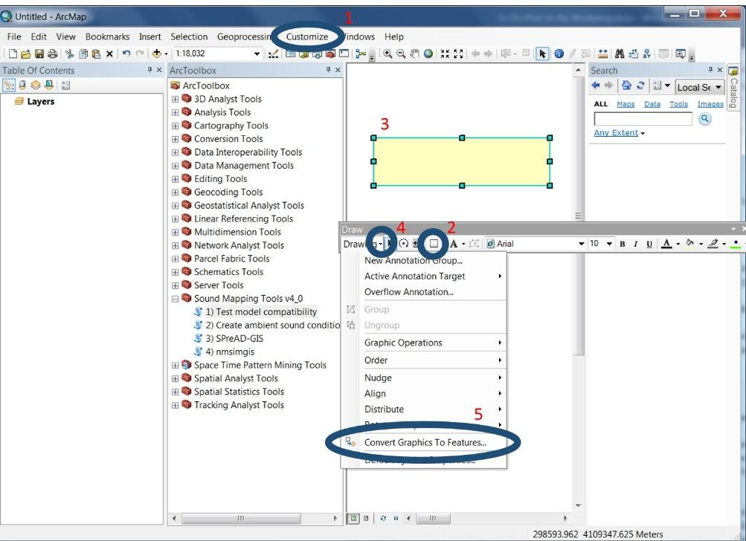

**Table 3.** Background sound spectra. Use the sound levels (dB) in the table corresponding to measured or estimated A-weighted sound levels (dBA); interpolate or extrapolate as needed. Reproduced from Harrison et al. (1980). This has also been adapted to .csv format as Harrison_Background.csv in the source_data folder and can be input directly in the Create Ambient Conditions Tool

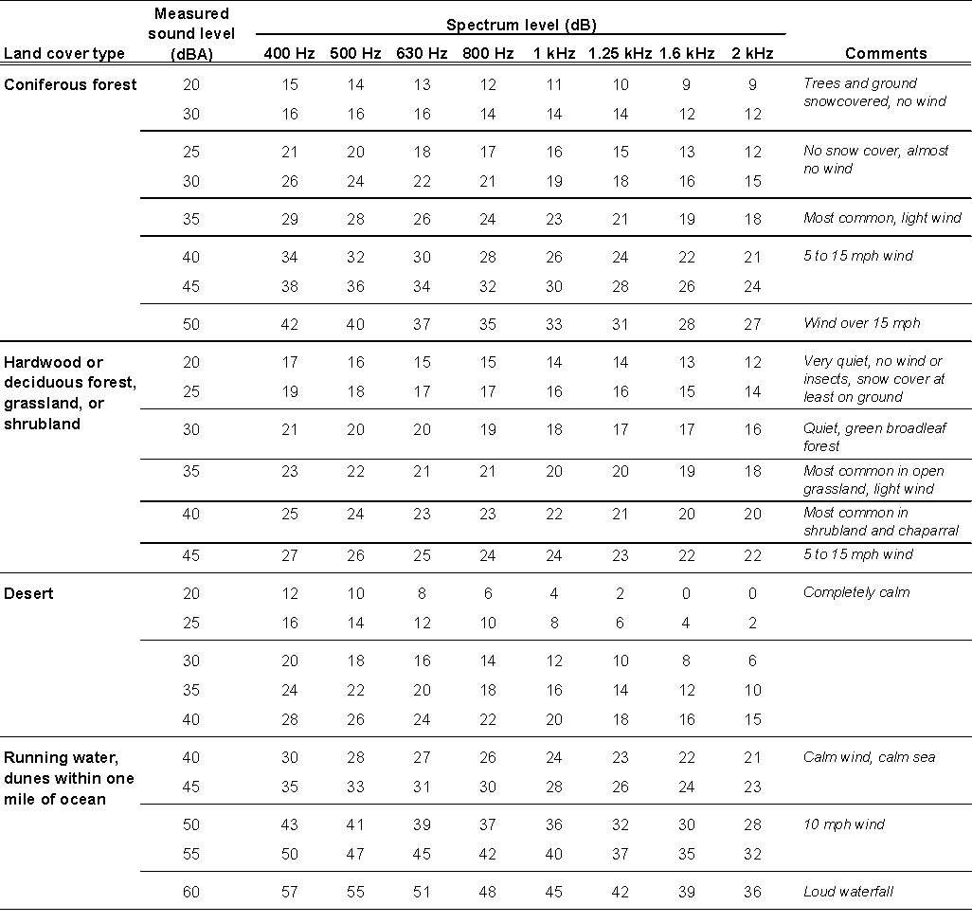

**Table 4.** Sound source spectra at 15.24 m (50 ft). Use the sound levels (dB) in the table if the A-weighted sound level (dBA) of source is known. If level is unknown, use the spectrum indicated by an arrow; interpolate and extrapolate as needed. Reproduced from Harrison et al. (1980).

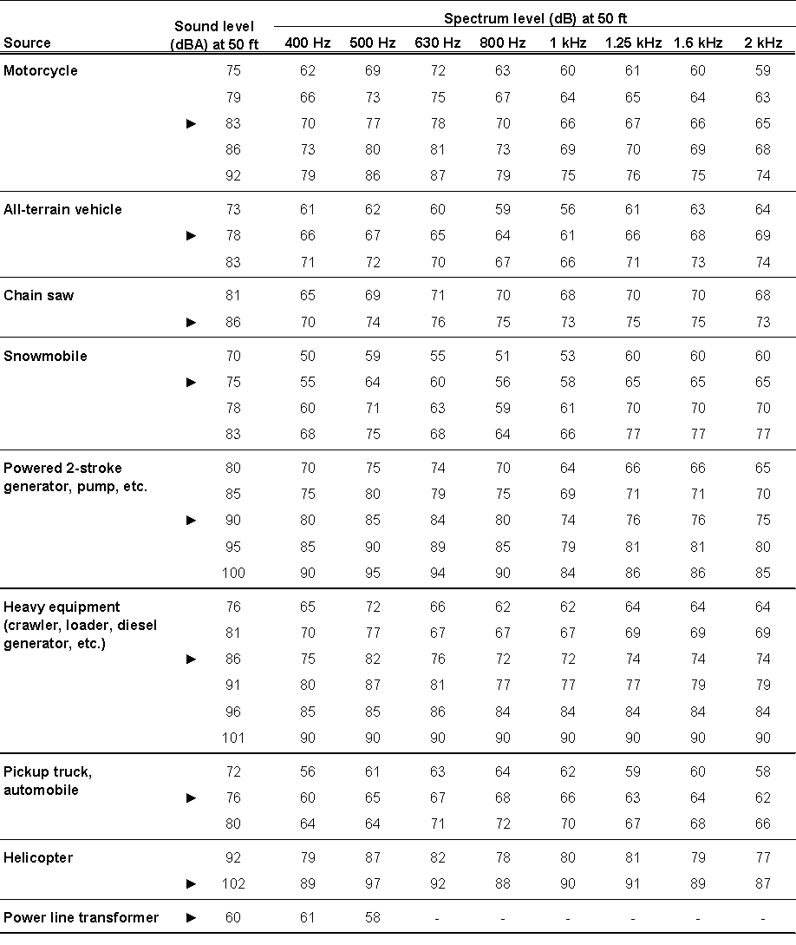

1. *Sound Source Characteristics*

Sound frequency is the one-third octave frequency band for which you wish to run the noise propagation model. Currently, SPreAD-GIS can model noise propagation for thirteen frequency bands ranging from 125 Hz to 2000 Hz, while NMSIMGIS has no known frequency-band restrictions.

Sound level is the measured sound level of the source, or the estimated sound level from Table 4, at the frequency specified above. Detailed noise emissions data are also available for a wide range of engines from vehicle manufacturers or public agencies (e.g., USDOT 1998, Martin et al. 2005).

Measurement distance is the distance at which the sound level of the source engine was measured. If you choose to enter custom source sound level data, you will want to verify the measurement distance, because it varies according to the specific noise emission test methods used.

SMT can include multiple frequencies in the same model run. For SPreAD-GIS, all frequencies with their associated decibel levels and measurement distances should be listed in a .csv table, with the columns Frequency, dB, and Measurement_Distance. For NMSIMGIS, the data must be in the custom .src format. The .csv table used for SPreAD-GIS can be converted to a .src input using the *Convert to SRC* tool in the *Extra Tools* sub-toolbox. Each .src file has one or more associated .avg files (see Figs. 2 & 3 for documentation of the .src and .avg file formats, respectively).

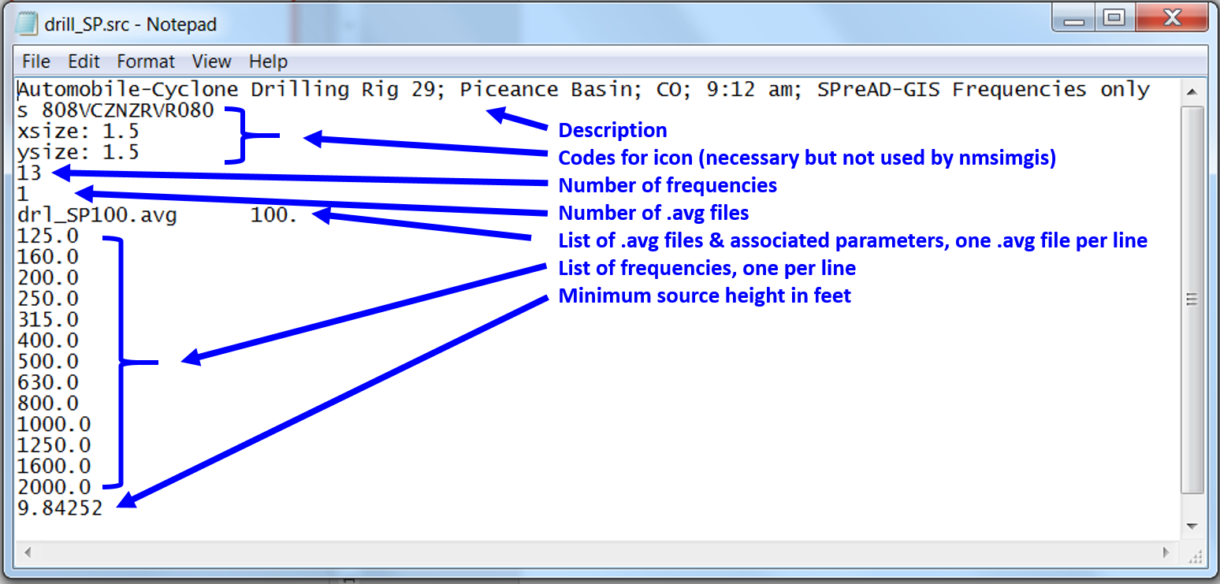

**Fig. 2.** Documentation for the format of a NMSim .src file. Line 1 contains a description of the sound source, Lines 2 – 4 are outdated but must still be present (they relate to the icon drawn in the original NMSim program). Line 5 gives the number of frequencies, while Line 6 indicates the number of .avg files associated with the .src file. The .avg files allow for different behavior depending on conditions (e.g., speed, engine power). Each .avg file has an associated value (e.g., 100). If there is more than one .avg file and the input value (e.g., speed) is intermediate, the sound source level will interpolate based on the two files. The next lines are the individual frequencies to be modeled. The last line is the minimum source height, in feet (note that the input for the Convert to SRC tool in Sound Mapping Tools requires the input in METERS. The tool will convert to feet).

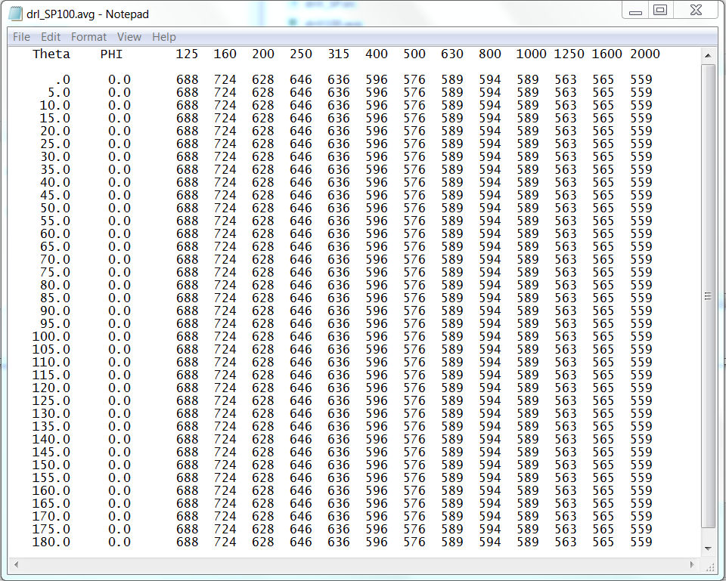

**Fig. 3.**Format for a NMSim .avg file. These files allow sources to be directional (e.g., greater sound levels in front of the source than behind). The theta value gives the angle relative to the source’s heading. PHI relates to the source’s roll angle. For each theta and phi combination, the sound pressure level is given in centibels (cB, dB * 10) for each frequency. Note that this file is space-delimited, so the exact spacing is critically important.

1. *Elevation Dataset*

You will need to prepare a digital elevation model (DEM) for your study area. The extent of the elevation dataset must be the same or larger than the model extent specified above. The elevation values in the ‘VALUE’ field should be in meters. It is convenient to place this file in the *source_data* folder (but not necessary). **IMPORTANT: while the model extent is determined by the model extent input, the final cell size is determined by the elevation data set. It is strongly recommended that all input rasters have the same input cell size.** You can use the Resample (Data Management) tool to adjust the cell sizes of your input layers. We recommend that under Geoprocessing: Environment Settings, you set the “Snap Raster” to the elevation layer before resampling to ensure that all raster layers line up. A cell size of 30 (e.g., from a 1 arc-second digital elevation model) is a nice balance between resolution and computational efficiency. Small cell sizes (e.g., 1 meter) may require many hours for model completion.

1. *Land Cover Dataset:*

You will also need to prepare a land cover dataset for your study area. Convert the file to a raster dataset. For SPreAD-GIS, create a new field and label it ‘SPREADTYPE.’ Reclassify each land cover type into one of the seven SPreAD-GIS land cover categories (Table 5), and list the appropriate code in the ‘SPREADTYPE’ field. For NMSIMGIS, add a field labeled NMSIMTYPE. Reclassify each landcover type into one of the 15 NMSIMGIS land cover categories (Table 6). The extent of the land cover dataset must be the same or larger than the model extent specified above. It is convenient to place the land cover dataset in the *source_data* folder (but not required). If no SPREADTYPE or NMSIMTYPE fields exist, the model will attempt to convert the land cover to the required fields using the values from the National Land Cover Data set (Homer et al. 2015).

**Table 5.** Land cover classifications for SPreAD-GIS. National Land Cover Data can be automatically converted to the SPREADTYPE field.

| Land cover type | SPREADTYPE | NLCD Codes1 |
| --- | --- | --- |
| Barren land | BAR | 31 |
| Coniferous forest | CON | 42, 43 |
| Herbaceous or grassland | HEB | 71 – 74, 81, 82 |
| Hardwood or deciduous forest | HWD | 41 |
| Shrubland | SHB | 51, 52 |
| Urban or developed land | URB | 21 – 24 |
| Water | WAT | 11, ≥90 |

1 These codes can be automatically converted into the corresponding SPREADTYPE

1. *Weather Conditions:*

Collect representative weather conditions for the time of day and season for which you will be running the model scenario(s): air temperature (°C), relative humidity (%), prevailing wind direction (°),wind speed (km h-1) and a general description of the seasonal conditions for which you will be running the model (e.g., *clear, calm summer day*). The seasonal conditions determine the shape of the upwind and downwind areas around the sound source. To avoid errors due to typos, please select this from the drop-down menu. NMSIMGIS only uses temperature and humidity, and does not include other weather conditions at this time.

**Table 6.** Land cover classifications for NMSIMGIS. The NMSIMTYPE codes were based on the National Land Cover Data (NLCD). They can be generated automatically from the NLCD layer. More details on the land cover types can be found here: http://www.mrlc.gov/nlcd11_leg.php

| Land cover type | NMSIMTYPE | NLCD codes1 |
| --- | --- | --- |
| Open water | WATER | 11 |
| Snow-covered landscape | SNOW | 12 |
| Developed, open space | URBAN1 | 21 |
| Developed, low intensity | URBAN2 | 22 |
| Developed, medium intensity | URBAN3 | 23 |
| Developed, high intensity | URBAN4 | 24 |
| Barren land | BARREN | 31 |
| Unconsolidated shoreline | SHORE | 32 |
| Deciduous, evergreen, or mixed forest | FOREST | 41 – 43 |
| Dwarf scrub or shrub/scrub | SHRUB | 51, 52 |
| Grassland/herbaceous landcover | GRASS | 71, 72, 81, 82, 95 |
| Wetlands of any type | WETLAND | ≥90 |
| Lichen-dominated landscape (Alaska) | LICHEN | 73 |
| Moss-dominated landscape (Alaska) | MOSS | 74 |
| NoData classification used in Alaska | AK | 1 |

1The default mapping will translate these codes into the land cover types in the NMSIMTYPE column.

1. *Receiver offset*

The height of the receiver off the ground (e.g., height of a human ear, height of a microphone, height of an animal of interest) in meters must be specified for NMSIMGIS. This allows the model to account for ground-based reflections. With the new approach to barrier calculations, this parameter is now also used by SPreAD-GIS in calculating barrier effects.

1. *Source Characteristics (NMSIMGIS)*

For NMSIMGIS, several source characteristics may be specified: SPEED, HEAD, ROLL, PITCH, ENGINE, and S_OFFSET[3]. SPEED determines the source’s speed (in m s-1), which in some cases may affect noise levels (e.g., for automobiles). HEAD is the source’s heading (degrees, north = 0, east = 90, south = 180, west = 270), and matters for directional source. ROLL determines the roll angle of the source (degrees, right wing down is positive roll) while PITCH determines the degrees above or below horizontal (nose up is positive). For example, an airplane banking to turn would have a roll angle, and if it had its nose up it would have a positive pitch, with its nose down would have negative pitch. ENGINE is an index of engine power (as percent of maximum), and again different engine powers may be associated with different noise levels. Finally, S_OFFSET determines the sources height ABOVE GROUND LEVEL in meters (and not the absolute elevation above sea level!). From the Graphical User Interface, you have an option to allow ArcGIS to fill in default values for any missing fields. If this is set to NO, the model will give an error if any of these fields are missing.

Note that the SPreAD-GIS model does not include a source offset for spherical spreading loss and atmospheric absorption calculations, and therefore is not suitable for high-flying sources such as aircraft, as it will not account for the spherical spreading loss from the vertical direction.

***Model Outputs***

The main output of the Sound Mapping Tools is predicted (weighted or unweighted) sound pressure levels based on the input source(s) for the chosen landscape extent. The model can also produce an estimate of sound above ambient levels, if ambient levels are provided. In addition, the model outputs propagation time, to allow more complicated summaries to be produced.

The predicted sound level by frequency band are also produced, to allow evaluation of frequency-specific propagation or to implement different weighting schemes. All results are in the format of a floating-point geotiff raster dataset and will match the cell size of the input elevation raster (however, all inputs should have the same cell sizes).

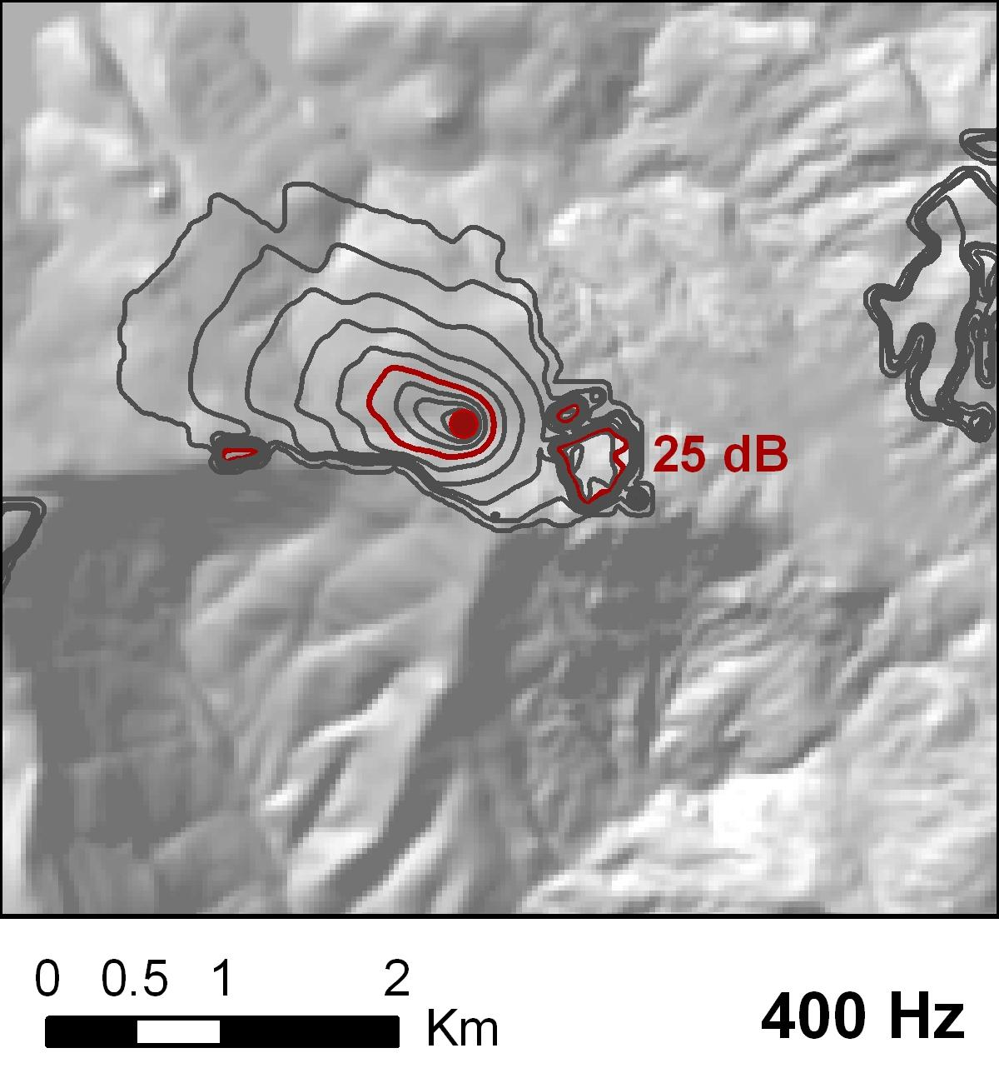

1. *Baseline Noise Propagation*

The predicted pattern of noise propagation around the source, accounting for attenuation due to spherical spreading loss, atmospheric absorption, foliage and ground cover loss, upwind and downwind loss, and terrain effects.

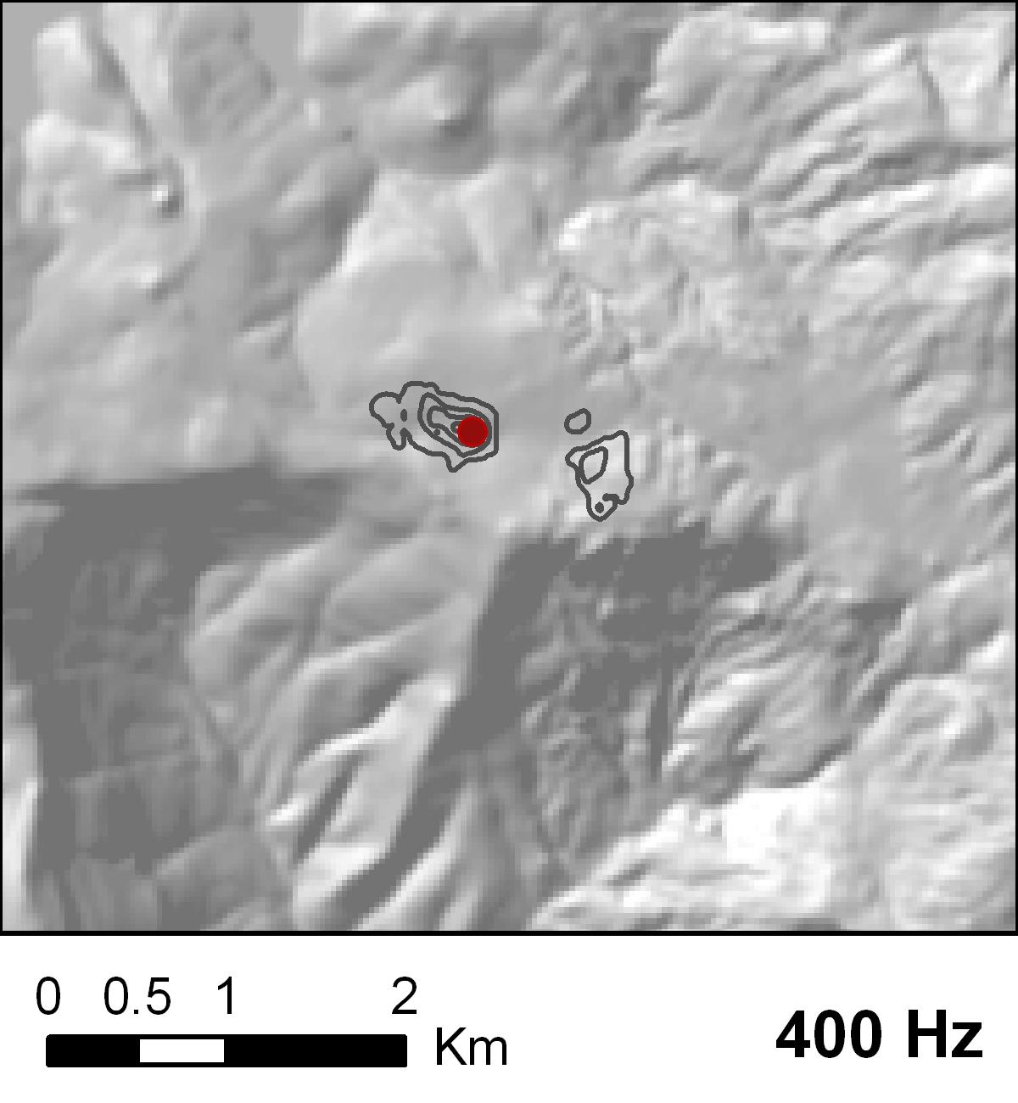

1. *Excess Noise Propagation*

Calculates the difference between introduced noise and background sound levels. The excess noise calculation can be used to identify areas where introduced noise is likely to be audible, or where it may impact species of concern. However, noise can still be audible even when it is below the ambient conditions level.

There are many different ways to display the noise propagation results. For example, the raster datasets could be symbolized to display the decline in sound levels with changes in shade or color. Alternatively, you could use the Surface toolset of the Spatial Analyst extension to create a contour map of sound levels declining away from the source, as we did in the examples shown below:

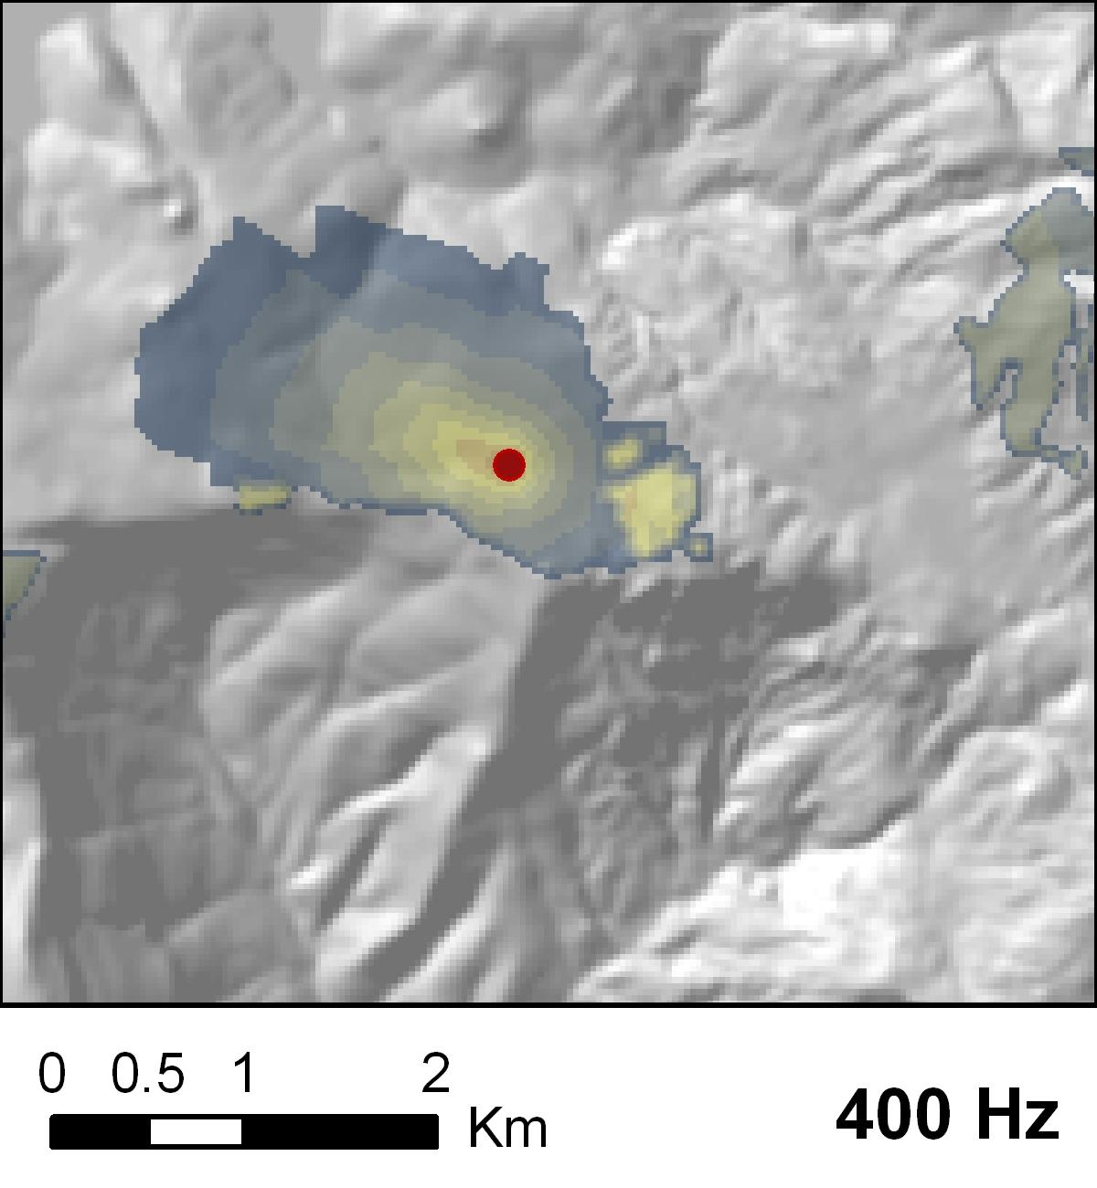

To examine how atmospheric, ground, and terrain effects contributed to the predicted noise propagation patterns in your study area, you may want to inspect data from some of the intermediate steps in the SPreAD-GIS or NMSIMGIS calculation process. Data from the intermediate calculations are retained if the keep_intermediates option is set to “YES” (Toolbox GUI) or 1 (Python) and can be found in the intermediates subfolder.

***Extra Tools***

The toolbox contains some additional tools to help format the inputs expand the suite of outputs and more may be added in the future. At present the following additional tools are included in the toolbox:

1. Add TYPE field
   * This tool adds either the required SPREADTYPE field, the NMSIMTYPE field, or both. It was primarily designed for NLCD 2011, although limited LANDFIRE support exists. This may be useful for adding the SPREADTYPE field for creating ambient conditions. Note that the main model tools will attempt to add these fields if they are missing, assuming an NLCD input data set.
2. Calculate Audibility (d’)
   * Compute audibility (d’, typically d’ > 7 is considered audible) given frequency-band results and background sound levels.
3. Calculate Leq (Batch)
   * This tool is still being tested. The goal is to convert sound pressure levels to a time-averaged (Leq) sound pressure level. This tool can batch process multiple model runs, and convert each to its own time-averaged value.
4. Calculate Leq (Fluctuating)
   * This tool is still being tested. The goal of this tool is to convert several sound pressure levels into a single, time-averaged sound pressure level (Leq).
5. Convert to SRC
   * Convert a SPreAD-GIS source input file (.csv) to a NMSIMGIS .src file. This tool does not support source directivity or variations in source levels.
6. Create ambient sound conditions
   * A tool to create background ambient sound pressure levels based on an input background data table. This tool is described in depth in Appendix A
7. Create custom summary
   * Create a weighted summary sound level from several separate model runs. For example, one could merge results for one model run for cars and one for heavy trucks, and weight the model runs by the number of cars and trucks
8. Examine Effects
   * Produce more detailed analyses of potential noise impacts using either the d’ raster produced by Calculate Audibility or a sound pressure level raster, such as that produced by the standard model outputs.
   * There are three options with this tool: Calculate the area where each sound source is audible, calculate the length of a line where any sound source is audible, and finally calculate the proportion of a focal area above a specified threshold.
9. Test model compatibility
   * The purpose of this tool is to confirm that Sound Mapping Tools is producing the expected outcomes for a given computer/version of ArcGIS/OS. It runs the model for known data, and checks whether known values are obtained. This is critical for catching any bugs or changes that may not raise an error in the tool but none-the-less may corrupt the output. This tool is described in detail in Appendix A.

***Final Notes***

As you begin to prepare data for your first model run, here are a few more things to think about:

1. *Start Small*

The Sound Mapping Tools models have many geoprocessing steps, and depending on the size of your study area and your computer’s processing speed, calculating noise propagation patterns for a single point source could take anywhere from one to several minutes, and it could take minutes to hours for multiple point sources or frequencies. To begin, we suggest making your model extent as small as possible. Early tests of the model have indicated that a meaningful distance for noise propagation around a single point sound source ranges up to 5 km.

1. *Try a Range of Input Values*

The model results will be sensitive to your choices of input values for source characteristics, weather conditions, and ambient sound conditions. We suggest that you run the model multiple times for a range of plausible values for these parameters or use the sensitivity analysis option to obtain maximum and minimum expected propagation for typical weather conditions for your location.

***References***

American National Standards Institute (ANSI). 1995. Method for calculation of the absorption of sound by the atmosphere. Acoustical Society of America, New York, NY.

Aylor, D. 1971. Noise reduction by vegetation and ground. Journal of the Acoustical Society of America 51: 198-205.

Berglund, B. and T. Lindvall (eds.). 1995. Community noise. Archives of the Center for Sensory Research 2: 1-195.

Dooling, R.J. and A.N. Popper. 2007. The effects of highway noise on birds. Environmental BioAcoustics, Rockville, MD.

Embleton, T.F.W. 1996. Tutorial on sound propagation outdoors. Journal of the Acoustical Society of America 100: 31-48.

Fang, C. and D. Ling. 2003. Investigation of the noise reduction provided by tree belts. Landscape and Urban Planning 63: 187-195.

Harris, C.M. 1966. Absorption of sound in air versus humidity and temperature. Journal of the Acoustical Society of America 40: 148-159.

Harrison, R.T., R.N. Clark and G.H. Stankey. 1980. Predicting impact of noise on recreationists. USDA Forest Service, Equipment Technology & Development Center, San Dimas, CA.

Harrison, R., L. Hartmann, and W. Makel. 1992. Report to Congress: Potential impacts of aircraft overflights of National Forest System wildernesses. USDA Forest Service, Equipment Technology & Development Center, San Dimas, CA.

Havlick, D.G. 2002. No Place Distant: Roads and Motorized Recreation on America’s Public Lands. Island Press, Washington, D.C.

Homer, C. G. et al. Completion of the 2011 National Land Cover Database for the conterminous United States-Representing a decade of land cover change information. Photogramm. Eng. Remote Sens. 81: 345 – 354.

Ikelheimer, B., Plotkin, K., 2005. Noise Model Simulation (NMSim) (No. WR 03-09). Wyle Laboratories, Arlington, VA.

Ingard, U. 1953. A review of the influence of meteorological conditions on sound propagation. Journal of the Acoustical Society of America 25: 405-411.

Kragh, J. 1981. Road traffic noise attenuation by belts of trees. Journal of Sound and Vibration 74: 235-241.

Martin, S.A., A. Leung and P. Pallini. 2005. California off-highway vehicle noise study. Wyle Laboratories, Inc., El Segundo, CA.

Mennitt, D., Sherrill, K. & Fristrup, K. (2014). A geospatial model of ambient sound pressure levels in the contiguous United States. The Journal of the Acoustical Society of America, 135, 2746–2764.

Miller, N.P., Anderson, G.S., Horonjeff, R.D., Menge, C.W., Ross, J.C. & Newmark, M. 2003. Aircraft Noise Model Validation Study. Harris Miller Miller & Hanson Inc., Burlington, MA.

Ouren, D.S., C. Haas, C.P. Melcher, S.C. Stewart, P.D. Ponds, N.R. Sexton, L. Burris, T. Fancher and Z.H. Bowen. 2007. Environmental effects of off-highway vehicles on Bureau of Land Management lands: a literature synthesis, annotated bibliographies, extensive bibliographies, and internet resources. U.S. Geological Survey, Open-File Report 2007-1353, Reston, VA. Available at: <http://www.fort.usgs.gov/products/publications/22021/22021.pdf>.

Piercy, J.E., T F.W. Embleton and L.C. Suthrland. 1977. Review of noise propagation in the atmosphere. Journal of the Acoustical Society of America 61: 1403-1418.

Plotkin, K.J. 2001. The role of aircraft noise simulation models. INTERNOSE 2001, pp. 1–6. The Hague, The Netherlands.

Shannon, G., M.F. McKenna, L.M. Angeloni, K.R. Crooks, K.M. Fristrup, E. Brown, K.A. Warner, M.D. Nelson, C. White, J. Briggs, S. McFarland, G. Wittemyer. 2015. A synthesis of two decades of research documenting the effects of noise on wildlife. Biological Reviews: doi 10.1111/brv.12207.

Sunder, M. 2003. Notice of Recommendation From the Aircraft Noise Model Validation Study. Federal Register, pp. 63131–63132. Federal Register.

U.S. Department of Transportation (USDOT). 1998. Federal Highway Administration Traffic Noise Model (FHWA TNM) Technical Manual. John A. Volpe National Transportation Systems Center Acoustics Facility, U.S. Department of Transportation, Cambridge, MA.

Wiener, F.M. and D.N. Keast. 1959. Experimental study of the propagation of sound over ground. Journal of the Acoustical Society of America 31: 724-733.

***Appendix A***

***Sound Mapping Tools Tutorial***

***Pre-requisites***

* SoundMappingTools is compatible with ArcGIS 10.3 and 10.4 running in a Windows environment.
* You must have a valid ArcGIS license with the SpatialAnalyst extension
* You must have basic familiarity with ArcGIS.
* If using a non-US English computer, your decimal setting must be set to use a period (Region and language -> Additional settings -> Decimal symbol - change to period. )

1. ***Goal of the analysis***
   1. In this tutorial, we will look at the potential noise impacts of off-highway vehicles (OHV) on a non-motorized recreation area in Bangs Canyon in western Colorado.
   2. In order to best model the overall sound level, we will model the sound propagation of individual frequency bands (1/3 octave) because sound propagates differently at different frequencies.
   3. These frequency bands will then be summed together, and weighted to human perception of sound, to give an overall assessment of sound levels from the OHV. Finally, we will examine where the sound levels from the OHV exceed the ambient background levels.
2. ***Setting up Sound Mapping Tools:***
   1. First, we will acquire the Sound Mapping Tools ArcGIS toolbox
   2. Go to <http://purl.oclc.org/soundmappingtools>
   3. In the welcome message, click on the link to download SoundMappingTools
   4. Save SoundMappingTools to your computer Follow the link for the registration, and fill out the registration to obtain the password to unlock the toolbox
   5. Unzip the zip file to your desired directory, using the provided password (e.g., into a new folder such as C:\smt\).[4],[5] The new file path must be less than 59 characters, due to limitations of the ESRI GRID raster format.
   6. Open ArcMap
   7. Add the Sound Mapping Tools_v4_4 toolbox:
      * Right click in ArcToolbox and select Add Toolbox…
      * Navigate to C:\smt\toolbox and select Sound Mapping Tools_v4_4.tbx.
   8. Define scratch workspace:
      * Right click in ArcToolbox and select Environments…
      * Expand Workspace
      * Define the Scratch Workspace to be a directory with sufficient space to store intermediate data[6]
   9. On the top ribbon/panel click on Geoprocessing
      * Click Geoprocessing Options
      * uncheck the box next to “Add results of geoprocessing operations to the display” (NOTE: Problematically, this appears not to actually be honored by ArcGIS).
      * Also under the Geoprocessing options, check the box for “Overwrite the outputs for geoprocessing operations” (this may also not be honored by ArcGIS).
3. ***Test that Sound Mapping Tools is producing valid outputs***
   1. Copy the SoundMappingTools_v4_4\testing directory to C:\smt\testing\
   2. Expand *Sound Mapping Tools_v4_4*, then expand the Extra Tools set and double-click on the tool “Test model compatibility”
   3. Fill in the parameters with the appropriate directories (see Fig. 1)
   4. Run the tool. **WARNING**: At present, it takes **~20 min** to complete, as ArcGIS will attempt to add intermediate layers to the map document. Black command prompts may pop up during this process. Please do not close them, they will close on their own when they have finished processing. The validation can also be run from Python outside of ArcMap (open C:\smt\toolbox\scripts\B_Validation.py with a Python editor such as IDLE and run it; see Appendix B for working with Python).
      * If it completes successfully, you should receive a message stating “SoundMappingTools validation completed successfully.”
      * If you receive an error, please report the error to the Sound Mapping Tools Google Group (https://groups.google.com/forum/?hl=en#!forum/soundmappingtools)
        1. Please submit a description of the error to the Sound Mapping Tools Google Group
        2. Please report your version of ArcGIS and Windows
        3. Please keep the intermediate and results files in the testing directory in case they are needed to diagnose the cause of the error.

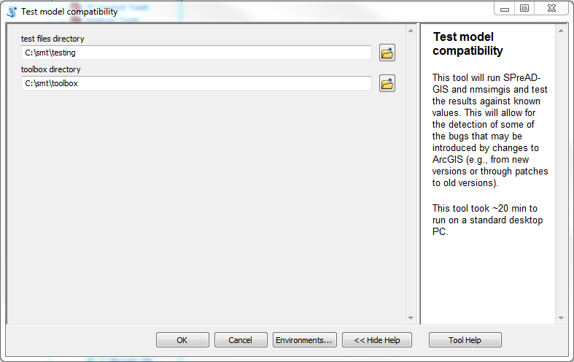

**Fig. A1.** Tool dialog for Tool #1 to check that the software is producing the expected outputs (e.g., that you are working with a supported version of ArcGIS). Note that each parameter is documented in the Help (see red circle), refer to this for more information on each input.

1. ***Examine the input data***
   1. First, add the elevation data set C:\smt\source_data\dem to the map. Visually inspect the terrain.
      * Check the coordinate system for the data layer by right-clicking on it in the Table of Contents, selecting Properties, and looking at the Spatial Reference entry under the Source tab.
      * While data direct from the USGS (http://viewer.nationalmap.gov/basic/) is in GCS_North_American_1983 (NAD83), the data layer must be in the UTM coordinate system. Given its location, Zone 12 is the correct UTM zone to use[7]
      * The sample data has already reprojected and clipped for you. However, you may download data from the National Map (for the tutorial, use: USGS_NED_1_n41w106_ArcGrid). Reproject the data from NAD83 to UTM Zone 12 using the Project tool[8]
      * You can set a hillshade effect to better visualize the terrain by right-clicking on the layer name in the Table of Contents pane, selecting properties and going to the Symbology tab and checking the box for “Use hillshade effect”. In this case, the data is projected into UTM Zone 12.,
   2. Second, add the landcover data set C:\smt\source_data\nlcd to the map.
      * You can see that most of the data is Shrub/Scrub, NLCD code 52.
      * Add a field named “SPREADTYPE” to provide the generalized classification required by the code for the SPreAD-GIS model.[9]
        1. Refer to Table 5 and *Model Inputs* section 6 for more information
      * Now repeat this to add the “NMSIMTYPE” field required for the NMSIMGIS model.
        1. Refer to Table 6 and *Model Inputs* section 6 for more information
      * NOTE: For NLCD data from http://www.mrlc.gov/nlcd2011.php, you can omit the SPREADTYPE/NMSIMTYPE field and Sound Mapping Tools will add the required field based on a standardized reclassification.
      * NOTE: NLCD from other sites may come in a format that does not support attribute tables. You must first use the Copy Raster tool and change the pixel depth to one that supports an attribute table (i.e., not in a floating point format) before adding the field and reclassifying the values.
      * You can view both the terrain and landcover simultaneously by making the landcover layer transparent. Right-click on the layer name in the Table of Contents, select properties, and under the Display tab, set the transparency to 75%.
      * Again, check that the data layer is in the UTM projection (Zone 12), and if not, follow the steps for projecting the data outlined in Step 4a.
   3. Third, add C:\smt\source_data\nonmotorized_trails.shp, a line shapefile containing a non-motorized region. In this region, anthropogenic motor sounds are undesirable.
   4. Fourth, add the sound source shapefile to the map document, C:\smt\source_data\OHV_trail_point.shp.[10] In this tutorial, we are only looking at the impacts of a nearby point on the motorized trail to reduce the computational requirements. Open the attribute table of this point, and inspect the fields, as some of these will be important later. First, note that it has a unique point ID field named “POINT”. You could also use the FID field as the unique point ID field. It has a field labeled S_OFFSET. This is the height of the noise source above ground, in this case, this is estimated as the OHV’s tailpipe, approximated as 0.34 m. We will assume that an OHV on the trail is going 30 mph, so the SPEED field is filled in as 13.4 m/s (meters per second). We will also assume that our OHV is headed east, so the heading field is filled in as 90 degrees.[11] As with the other data layers, check that the shapefile is in a UTM projection (here: Zone 12), and if not, follow the steps for projecting the data outlined in Step 4a.
   5. Fifth, add C:\smt\source_data\Model_Extent.shp to the map document, and again check that it is in the correct projection (UTM Zone 12). This will be our analysis extent, so even though the dem and landcover data are larger than this extent, they will be clipped to the smaller extent to speed the analysis processing time.

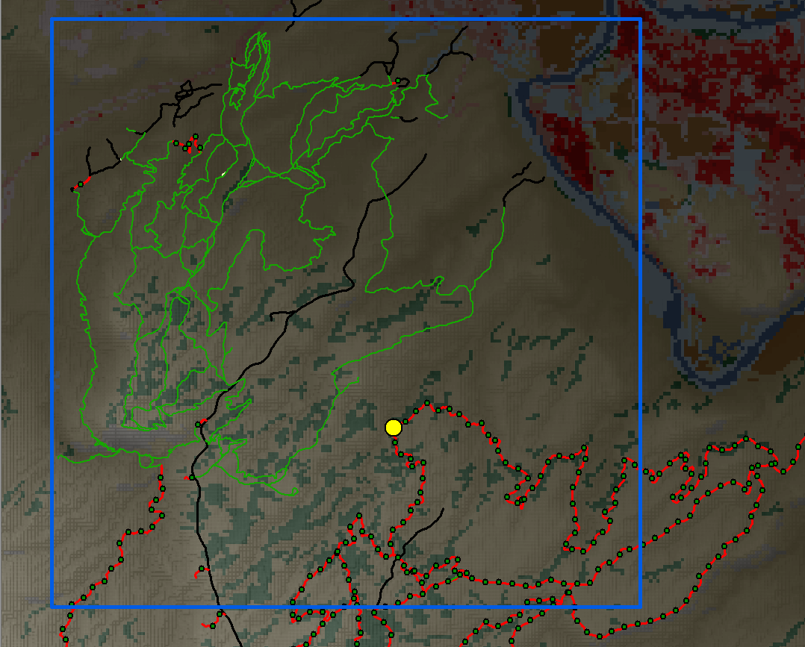

1. ***Create background ambient conditions***
   1. There are two options for using background conditions for comparison purposes. First, you can use an existing overall background layer, such as from the Geospatial Sound Model (GSM), in which case you can skip to step 4 (Link to GSM: https://irma.nps.gov/DataStore/Reference/Profile/2217356)
   2. Second, you can create background ambient raster layers based on a data table describing the ambient conditions for each landcover type. Here, we will create our own background ambient rasters.
   3. Double-click to open the second tool: *2) Create ambient sound conditions dataset.*
   4. In this example, we will use values from Harrison et al. 1980, in the table Harrison_Background.csv. If you have your own values, create a table in a .csv file using Harrison_Background.csv as a template.
   5. Fill in parameters as in Fig. A3:
      * Single Frequency (Hz): LEAVE BLANK
      * Frequency Table: C:\smt\source_data\Frequency_Table.csv
      * Land cover dataset: *C:\smt\source_data\nlcd*
      * Background Table: C:\smt\source_data\Harrison_Background.csv[12]
      * Wind Speed: LEAVE BLANK
      * Snow Cover: LEAVE BLANK
      * Output Path: C:\smt\source_data\ambient
   6. Press *OK* (this took ~30 s to run on my computer)
   7. Open C:\smt\source_data\ambient\ambient00400 in ArcMap. These are the ambient background sound levels at 400 Hz. There is an ambient background for each frequency band, allowing a comparison to be made on a frequency by frequency basis. However, during the model run, these will be aggregated into a single ambient background raster, and this will be used for comparison.

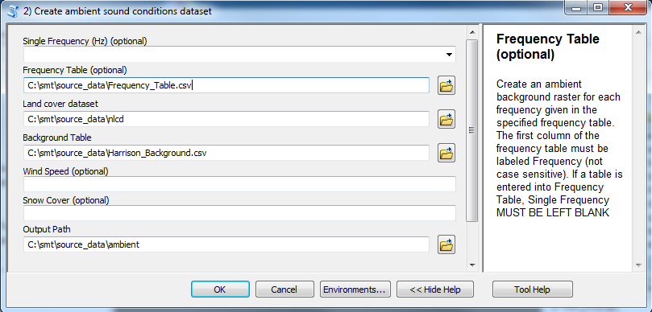



1. ***Run SPreAD-GIS for a single point sound source:***
   1. Next, we will model the sound propagation from the OHV using the SPreAD-GIS model. Double-click to open the third tool: *3) SPreAD-GIS*.
   2. The weather conditions used below are arbitrary, but actual weather conditions for a site of interest in the United States can be found at <https://www.ncdc.noaa.gov/data-access/quick-links#loc-clim>
   3. Fill in parameters as follows (Fig. A4):
      * Toolbox directory: *C:\smt\toolbox*
      * Output directory: *C:\smt*[13]
      * Point File: *C:\smt\source_data\OHV_trail_point.shp*
      * Point ID: *POINT*
      * Model Extent: *C:\smt\source_data\model_extent.shp*
      * Elevation dataset: *C:\smt\source_data\dem*
      * Land cover dataset: *C:\smt\source_data\nlcd*
      * Frequency (Hz): *C:\smt\source_data\ Frequency_Table.csv*
      * Temperature (°C): *28*
      * Humidity (%): *26*
      * Wind Direction (°): *105*
      * Wind Speed (k/hr): *8*
      * Seasonal conditions: *clear, windy summer day*
      * Summarization: *points & frequencies*
      * Ambient Sound Level: *C:\smt\source_data\ambient\ambient00400*[14]
      * Keep Intermediates: *NO*
      * Weighting: *A*
   4. Press *OK* (this took ~14 min on my computer to run for all frequencies)[15]

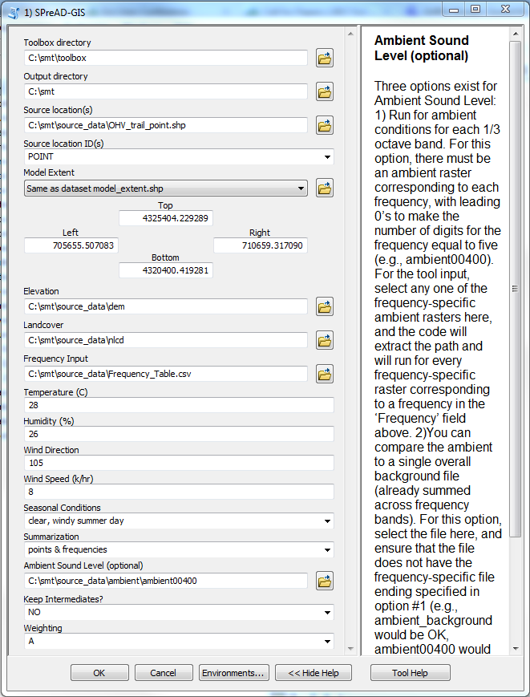



1. ***Viewing model results:***
   1. The C:\smt\spreadgis folder contains your SPreAD-GIS model results
   2. The main output is OHV_trail_point_A.tif. Add this to the ArcMap document. This layer shows the sound propagation, and is an A-weighted[16] sum of all of the 1/3 octave frequency bands examined.
   3. The output background_OHV_trail_point_A.tif is an A-weighted sum of the background 1/3 octave bands, and gives the background levels used for comparison
   4. The output excess_OHV_trail_point_A.tif shows where sound levels exceed background levels, and by how much background levels are exceeded.
   5. Also in the top directory is propagation_time_pt1.tif. This gives the number of seconds the sound takes to reach each cell, and may be of interest for computing maximum sound levels from multiple sources when the exact timing matters.
   6. In the frequency_results folder, you can get the individual frequency band results. In the directory, there are the predicted (pr) levels (ex) for each 1/3 octave band for each point.
   7. The point_summaries directory contains the sum across all points for each 1/3 octave band (in this case they should be exactly the same as the point 1 results, as there was only one point, e.g. pt1_pr00400 should match sumenergy_00400.tif). This directory will not be created if you do not summarize over points (see *Summarization* input documentation for more details)
   8. If you changed keep_intermediates to 1, you will find a temp folder in the main directory and that will contain the intermediate data. This setting will also compute the excess between propagation and background for each 1/3 octave band (assuming background levels are provided). You can find these in the pt1 folder, and the files have the prefix “ex”.
   9. To compare your results to previously executed sample results, open the files in the *SMT4_0_results\2016_09_07_Tutorial_data\spreadgis* folder.
   10. Re-add C:\smt\source_data\nonmotorized_trails.shp to your ArcMap document (if it is not already there). Does an OHV at this location produce sound above background levels for any sections of the non-motorized trails?
   11. For more information on model outputs, please see the *Model Outputs* section of the User’s Manual.
2. ***Run NMSIMGIS/ISO 9613-2 for a single point sound source:***
   1. Next, we will run the NMSIMGIS model. Double-click on the tool labeled 2) NMSIMGIS. These instructions will also work for tool 3) ISO 9613-2.
   2. When you checked the input data, you already checked that the following fields were defined:
      * POINT: a unique identify field for the point
      * SPEED: The source speed, in this case 13.4 m/s (VELOCITY is also an acceptable field name)
      * Other field options are HEAD, ROLL, PITCH, ENGINE, and S_OFFSET. The first four pertain mainly to aircraft, and default to 0 if the fields are absent. S_OFFSET is the height of the source above ground level, and defaults to 1 m. In this example, we have set S_OFFSET to 0.34 and HEAD to 90
   3. Fill in parameters as follows (Fig. A5):
      * Toolbox directory: *C:\smt\toolbox*
      * Output directory: *C:\smt*
      * Point File: *C:\smt\source_data\OHV_trail_point.shp*
      * Point ID: *POINT*
      * Model extent: *C:\smt\source_data\model_extent.shp*
      * Elevation dataset: *C:\smt\source_data\dem*
      * Land cover dataset: *C:\smt\source_data\nlcd*
      * Sound Source Information File: *C:\\smt\\toolbox\\Sources\\HarrisonSources\\ATV2.src*[17]
      * Temperature (°C): *28*
      * Humidity (%): *26*
      * Receiver Offset: *1.22*
      * *Allow Defaults: YES*
      * Summarization: *points & frequencies*
      * ambient sound levels: *C:\smt\source_data\ambient\ambient00400*[18]
      * Keep intermediates: *NO*
      * Weighting: *A*
   4. Press *OK* (~3 min on my computer). A command prompt window may open. This is normal; please just ignore it, it should go away on its own.
   5. You can find your results in C:\smt\NMSIMGIS\. The directory structure is similar to that used for SPreAD-GIS. Add the estimate of final propagation (NMSIMGIS\OHV_trail_point_A.tif) to the map document. Were the results from the two sound propagation models similar? Do the models agree with respect to the impact of the OHV?

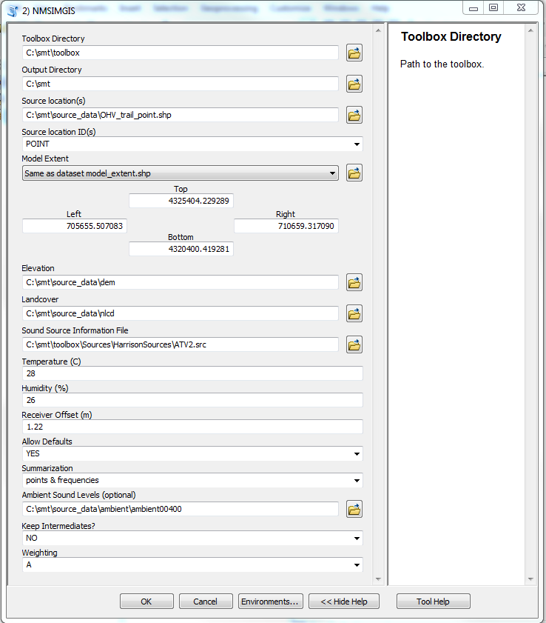



***Appendix B***

***Sound Mapping Tools Python Tutorial***

1. ***Open & run an existing Python Script***
   1. Navigate to C:\smt\source_data\smt_tutorial.py[19] (not smt_tutorial_modified.py, which contains the modifications to the script made in Step 2)
   2. Right-click on smt_tutorial.py and select “Edit with IDLE” (see Fig. B1)[20]
   3. Scroll through the script, and examine each input parameter
   4. Any text beginning with “#” is a comment, and will not be run by the program.
   5. Text to the left of an “=” sign are variables. Variables hold their values and can be used later in the code
   6. Check the following paths
      1. The path on line 32 may work as written, but you may have to change it to a hard-coded path to the toolbox/scripts folder
      2. Line 40 needs to match the directory where your source_data folder is located
      3. Line 46 is the output directory. This is set to write to the same folder that contains your source_data folder. If you do not want that, please enter the path location where you would like your output results to be placed.
   7. When you have familiarized yourself with the script, press F5 to run it
      1. This takes ~2 minutes to run
   8. Congratulations, you have just run SoundMappingTools from Python!
   9. Examine the results, found in your output path (given on Line 46).

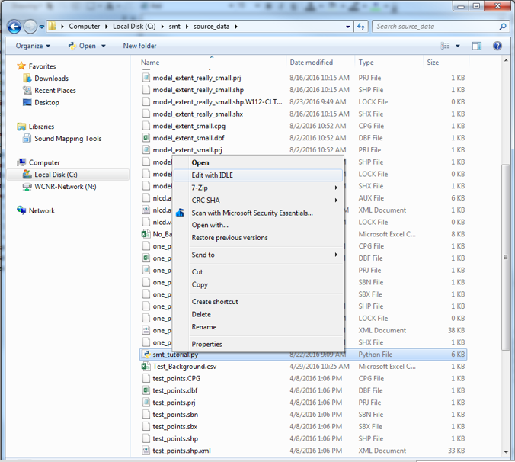



1. ***Modify the script***
   1. For this example, we will assume that the user wants to run only the SPreAD-GIS model, and that they want to run it for three different temperatures. If you are confused about what change to make for any of the steps, you can compare the changes you make below to “smt_tutorial_modified.py” where the changes have all been made.
   2. First, use ’’’ before and after the NMSIMGIS command to disable it (Fig. B2, lines 195 and 204). Now the model will not run NMSIMGIS.
   3. Try re-running the model. Did the model run without error?

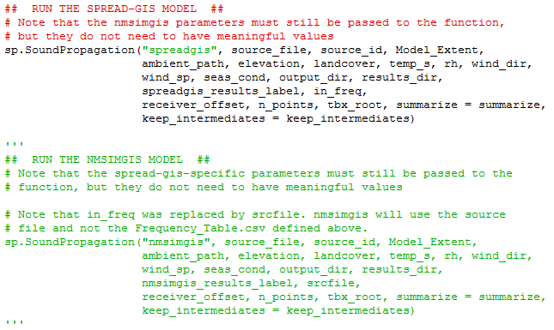



* 1. Second, we create a vector of our desired temperature values (20, 25, 30 C).
     1. Go to line 86 (temp_s = 20). Pressing alt + g will allow you to jump directly to the line. You can find the line number for the cursor by looking at the bottom right.
        1. Put a # before temp_s. This makes it so the program will not run the line because now it is a comment.
     2. Go to line 179 (after the sp.CreateAmbient command but before the sp.SoundPropagation command) and press “enter” twice, then return to line 180. This gives us visual space to add code.
     3. Type:

temp_vec = [20,25,30]

* + - 1. temp_vec is a list. We will tell Python to go through the list and run the model for each value in the list. Hit enter again to start a new line.
    1. Type:

for temp_s in temp_vec:

* + - 1. This creates a for-loop. Python will go through each value in temp_vec, assign it to temp_s, then run the spreadgis model.
  1. At present, Python will overwrite each run with the results of the next run. We do not want that!
     1. Go to line 168 (spreadgis_results_label = "python_test_spreadgis") and change it to a comment with a #. This disables the previous results label.

Next, go to line 182 (after the “for temp_s in temp_vec:” command)

* + 1. and press enter. Make sure the cursor is indented 4 spaces (or press tab). Then add: spreadgis_results_label = “temp_%s” % temp_s
       1. The %s uses string formatting. The %s in the label will be replaced with the value of the variable temp_s. This allows us to create a unique label for each temperature, and will prevent our results from being overwritten.
    2. The frequency-specific results in the spreadgis folder will still be overwritten, however. To prevent that, you would need to change the output_dir variable to be different between the model runs.
  1. Last, indent lines 185 – 193, the ones containing the sp.SoundPropagation command. Do this by highlighting them and pressing the “tab” key.
     1. By indenting those lines, it places them inside the for loop.
  2. Now hit F5 and run the modified script (See Fig. B3 for the command). This took my computer ~20 minutes.
  3. Add the results (temp_20_A.tif, temp_25_A.tif, temp_30_A.tif) to the ArcMap document, and compare the difference in propagation between the three temperatures.
     1. In this case, the differences in sound propagation between the three temperatures were small (generally < 1 dB).
     2. The modified script is available as smt_tutorial_final.py
     3. The above example is pretty simplistic, but you can run substantially more complicated analyses using the concepts outlined here.
  4. For more information, use Google, or consult a book on Python, such as early editions of Mark Lutz’s Learning Python or the first 5 chapters of Deitel’s Python: How to Program.
     1. Note that ArcGIS 10.x uses Python 2 NOT Python 3.

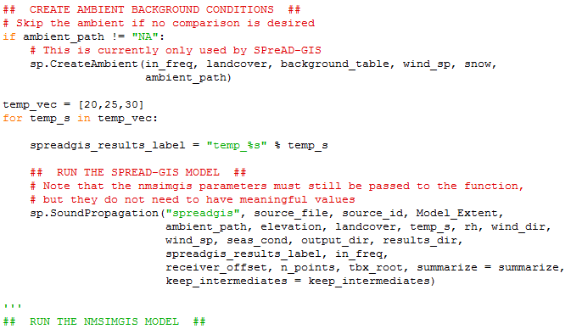

***Appendix C***

**Troubleshooting tips**

***General Troubleshooting***

1. The model has been tested with ArcGIS 10.3 and ArcGIS 10.4. The model is NOT compatible with ArcGIS Pro. Please run Tool #1 Test model compatibility prior to using the tool on data, as this will check that the code is running as expected on known data, as ArcGIS version updates have been known to introduce bugs into the tool.
2. See Readme.txt in the toolbox folder for the most up-to-date information about known issues and model updates.
3. The model, and ArcGIS in general, is sensitive to having input or output data files open in either ArcMap or Windows. Before running the model, be sure to close all open data files and windows, including Windows Explorer, and remove any data layers used in the model from active ArcMap data frames.
4. When you encounter an error in a model calculation, first take a close look at your software installation and input data. Are you running the correct versions of ArcGIS and Python? Are all of your input datasets in the same projection and do the raster datasets have the same cell size? Have you included all of the required fields? For example, have you re-classified your land cover dataset to include the ‘SPREADTYPE’ field? Did you include a unique point identifier field? Once you are confident that your input data is correct, try re-opening ArcMap and running the model a second time—sometimes minor errors in intermediate data calculations are overwritten and the model will work fine.
5. If these suggestions don’t work, or anytime you are in doubt about how to proceed, re-install a clean copy of the entire Sound Mapping Tools folder and input data sets and re-run your model from the beginning. There is a good chance that any errors you encounter are a function of a missing data file or folder, or a data file that cannot be overwritten. Do not attempt to move or edit any intermediate data files manually; the directory structure is very sensitive to additions and deletions. Instead, re-install the entire smt folder (e.g., in your C: drive).

***SPECIFIC ISSUES***

1. Schema locks: ArcGIS will lock some files, and these locks are not always removed at the appropriate time. This can cause the tool to crash, when a later step needs to modify a locked file (e.g. to delete it because it is no longer needed).
   1. Examples of this error include:
      1. WindowsError: [Error 183] Cannot create a file when that file already exists:
      2. WindowsError: [Error 32] The process cannot access the file because it is being used by another process:
   2. Possible solutions:
      1. Close the Python console or ArcMap and then reopen it and try again
      2. Check whether a file is open in ArcMap. If so, remove it from the map document and check that the identify tool window is closed
      3. Check whether the file or directory is open in Windows Explorer. Sometimes this can place locks on a folder, and may lead to errors
      4. Try manually deleting the directory where the locked file was and re-running the model (obviously, do not delete any original data that you do not have backed up!)
      5. Try re-booting your computer
      6. Try re-running the model in a new, clean directory
2. Memory problems: Some of these computations are memory intensive. When the computer runs out of memory, you may get an explicit memory error. If you are getting strange results, check the memory usage by the computer and consider running the program without other memory intensive programs simultaneously (e.g., Pandora Radio, iTunes). If the error is in NMSIMGIS when run from the ArcGIS toolbox interface, try running the model from Python instead. When run in ArcMap, there is a bug in the code (mosaic raster won’t work for more than 2 rasters), and the current workaround (only process the landscape in two pieces) can be memory intensive for landscapes with many cells.
3. Many of the inputs use comma separated files as does at least one internal process in NMSIMGIS. These comma-separated files are hard-coded to use the US system, where the separator is a comma ‘,’ and not the European system, where the separator may be a semi-colon instead ‘;’. Please report this to the SoundMappingTools Google Group if this is a limiting issue for you.
4. Missing output error:
   1. Occasionally NMSIMGIS will produce an empty layer for the propagation time output (the range in the legend will be e-38 to e38). This error is intermittent, and the exact cause has not yet been identified, but is likely due to a problem with re-setting the extent environment following the NMSIMGIS analysis.
5. Directory related errors:
   1. It appears that if you set the model output directory to be a letter directory (e.g., C:\ or D:\) SPreAD-GIS will not run properly. I do not understand the cause of these errors, but to avoid them, simply place your results in a folder (e.g., smt). Note that the error message is completely non-intuitive and is unrelated to the simplest way to fix the error. Example of this error:
      1. Example 2

I lost the traceback. The error occurred during the Barrier propagation step, and said that it could not copy a barrier file name over another file of the exact same name (except one file path had all double-backslashes, and the other had forward slashes except for after D:. Note that overwrite was on.

* 1. Path names differing: There have been reports that having the toolbox_dir and output_dir folders be different, the model may crash with a non-intuitive error message. Similarly, I’ve had reports of the model crashing when the current workspace is not the same as the scratch workspace. I have not been able to replicate either of these errors, so if you get either of these errors, please send me the full traceback, and the paths used for toolbox_dir, output_dir, current workspace, and scratch workspace. Theoretically, none of these paths should need to be the same, so

1. Comma vs. period for decimal point
   1. On some other language operating systems (e.g., French), the default decimal separator is a comma and not a period. This may cause the toolbox to crash, with a non-intuitive error message. You can check and if necessary change your decimal settings in your computer settings:
   2. 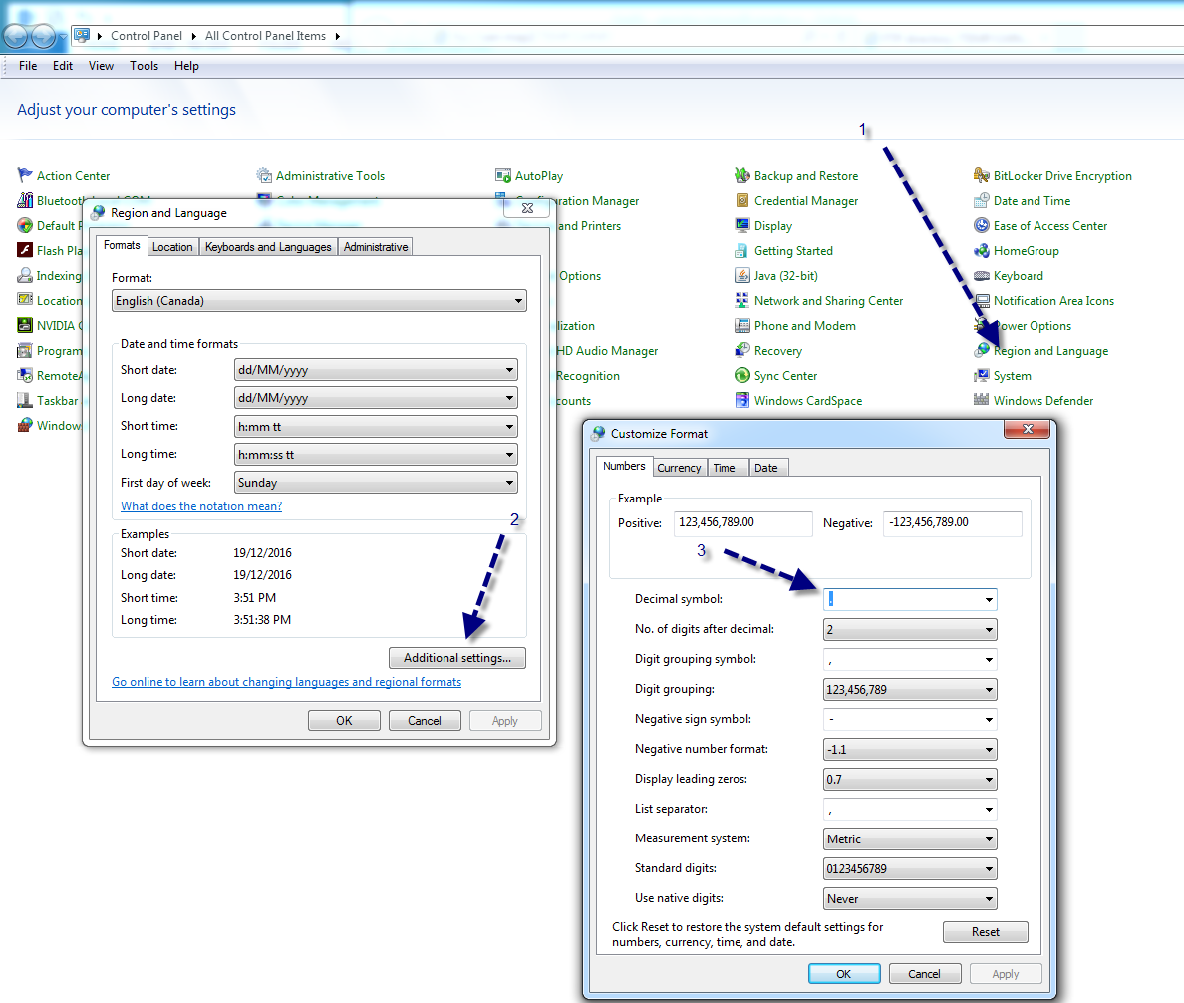
   3. Thanks to Charles-René Bernier for figuring this out & providing the graphic
2. Unable to save in output format FGDBR
   1. I got this error after I had canceled a SPreAD-GIS run in ArcMap and it crashed ArcGIS (no error message). The next time I tried to run SPreAD-GIS, and every time afterwards, I got the below error
   2. This error occurred due to a corruption of my scratch workspace ‘C:\Users\skeyel\Documents\ArcGIS\Default.gdb’. I deleted the entire scratch workspace (I had nothing important in that folder), and after that, the code ran without the error. Note that deleting the scratch workspace while you have an open ArcMap document may cause ArcMap to crash.

Traceback (most recent call last):

File "C:\smt\toolbox\scripts\C_spreadgis.py", line 166, in <module>

weighting = weighting, truncate = truncate, landcover_type = "nlcd")

File "C:\smt\toolbox\scripts\soundprophlpr.py", line 231, in SoundPropagation

point_fill, freq_fill, my_times, my_time_labels, point_counter)

File "C:\smt\toolbox\scripts\spreadgishlpr.py", line 54, in spreadgis

tbx_root, my_times, my_time_labels, point_counter)

File "C:\smt\toolbox\scripts\spreadgishlpr.py", line 191, in NoisePropagationOnePoint

wind = windloss(wind_dir, wind_sp, seas_cond, eucdist_ft, eucdir, freq_s, intermediates_dir, CellSize, RasterExtent, sound_src, dem_ft)

File "C:\smt\toolbox\scripts\spreadgishlpr.py", line 743, in windloss

con_result.save(conresult_file)

RuntimeError: ERROR 010240: Could not save raster dataset to C:\Users\skeyel\Documents\ArcGIS\Default.gdb\minus_ras with output format FGDBR.

Failed to execute (spreadgis).

Failed at Wed Sep 14 16:27:11 2016 (Elapsed Time: 32.56 seconds)

1. The Fortran Error of Death
   1. We don’t fully understand the cause(s) of this error.
   2. One cause appears to be not using \\ in the NMSim source file path names when running the code directly from the ArcGIS toolbox.
   3. When this error occurs, you must close it by closing the red X in the upper right-hand corner (clicking OK does nothing). It will also close ArcMap.
   4. 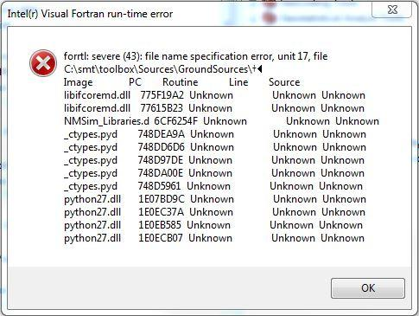
2. arcgisscripting.ExecuteError: ERROR 010067: Error in executing grid expression. Neighbor size exceeds grid sizeFailed to execute (FocalStatistics).
   1. This error occurred in a very narrow landscape. The problem is one of the tools requires a 9 x 9 cell array, and my landscape was only 3 cells wide, causing the tool to crash. Solution is to increase the size of the landscape.
3. ImportError: No module named soundprophlpr
   1. This error may occur if you are using Python directly
   2. You need to use:

import sys

sys.path.append("****/toolbox/scripts/")

where **** is the path to the toolbox/scripts folder (and not literally ****!). This tells Python where to find the Sound Mapping Tools python scripts.

1. Focal Area assessment: It appears that small focal areas may cause the Zonal Statistics step to fail.
2. Key error: 255. This may mean that the Model Extent is larger than the landcover extent, and ArcGIS is unhelpfully supplying NoData (255) for locations outside of the extent. This can be solved by ensuring that all of the land cover fields are adequately described by the SPREADTYPE field and the Model Extent is within the landcover extent (Note: even if you create the landcover extent using the screen display, the screen display may still have a greater extent). Check the extent carefully to ensure that it fits within the raster inputs by at least two cell widths, and if not, create a new extent that fits completely within the raster inputs.
3. ‘AttributeError: Object: Cannot clear environment <extent>’, encountered when running the “Test model compatibility” tool. This is a misleading error message, and appears to relate more to a lack of memory than a problem with the extent. Possible solutions include: freeing up memory on your computer (e.g. by closing other programs), increasing the memory available on your computer, or using another computer with more memory. Fewer memory errors occur when running the tool (toolbox/scripts/B_validation.py) from Python.

1. Starting in Version 2.0 of the model, SPreAD-GIS no longer calculates noise propagation for line and polygon sound sources because these calculations caused too many errors in the terrain effects module. Instead, noise propagation around a linear (e.g., road) or an area source (e.g., parking lot) can be simulated by modeling each engine noise source and then summing their combined effect.
2. SPreAD-GIS v. 4.4 was developed using Python 2.7.11.
3. These fields are not case sensitive, and some synonyms will be accepted by the code: SPEED: vel, velocity; HEAD: heading, course; ENGINE: engpow, engine_power; S_OFFSET: source_offset, soffset, msl, msl_m
4. Note that you may install the folder in any directory you wish (but path names with special characters and/or spaces should be avoided!). Here, we use C:/smt/ for convenience and simplicity. If you do chose to use another location, please adjust all of the paths below as appropriate to reflect the chosen directory.
5. Note: Path names can use either forward slashes or a backslashes in the toolbox inputs.
6. The ESRI default for this and the current workspace may work just fine
7. You can find a map of UTM zones here: <https://en.wikipedia.org/wiki/Universal_Transverse_Mercator_coordinate_system#/media/File:Utm-zones.jpg> (last accessed 2016-09-03). If your region of interest spans more than one UTM zone, either break the analysis into pieces or select the UTM zone that contains the majority of the region of interest.
8. DO NOT USE the Define_projection tool, as this does not project the data, it just tells ArcMap what the current projection is. If you change this, you will be telling ArcMap the wrong projection, it will display your data incorrectly!
9. To add a field, open the attribute table in ArcGIS, click on the Table Options icon in the upper left corner and select “Add Field”. If this is grayed-out, check that you are not in an edit session as you cannot add field while actively editing shapefiles.
10. If you wanted to create your own point files, you can create a new point shapefile using ArcCatelog. Then use Customize: Toolbars: Editor to get the Editor toolbar. Start an edit session with the new point shapefile as the target. In the Create Features Pane select your new layer. The “Create Point” option on the editing toolbar should now be activated, you can now click on the map to add points to the map.
11. Note that in this example, neither speed nor heading matter, as our source file does not differentiate speeds nor source directivity, but some source files may require this information.
12. These correspond to background values given in Harrison et al. 1980. If you have field measurements, feel free to create a new table containing your own measured values.
13. Do not pick a single letter directory (C:\, D:\) as this appears to cause very unstable behavior and will generally crash SPreAD-GIS.
14. Three options exist for Ambient Sound Level: 1) Run for ambient conditions for each 1/3 octave band. For this option, there must be an ambient raster corresponding to each frequency, with leading 0’s to make the number of digits for the frequency equal to five (e.g., ambient00400). For the tool input, select any one of the frequency-specific ambient rasters here, and the code will extract the path and will run for every frequency-specific raster corresponding to a frequency in the ‘Frequency’ field above. 2)You can compare the ambient to a single overall background file (already summed across frequency bands). For this option, select the file here, and ensure that the file does not have the frequency-specific file ending specified in option #1 (e.g., ambient_background would be OK, ambient00400 would not, as the code would run Option #1 instead). 3) If no comparison with the background is desired, leave the optional field blank, and no background comparison will be made.
15. To shorten the run time for testing purposes, you may delete some of the frequencies from Frequency_Table.csv. This will affect the interpretation of the summed and weighted results however.
16. A-weighting was selected. If another weighting was selected, that weighting would be used here.
17. double-backslashes are recommended for the Sound Source Information File, to avoid the Fortran Error (see Appendix C Troubleshooting for more information).
18. Select any one of the background rasters here, and the code will extract the path and will run for all of the background layers. Alternatively, if comparison to a single background file is desired, place this file here, and ensure that the last digits of the file DO NOT match a frequency in the analysis. Alternatively, you may enter “NA” here, and no background comparison will be made.
19. As in Appendix A, if your source_data folder is located somewhere else, please use that path here instead.
20. IDLE is an IDE, or an Integrated Development Environment. Basically, that means a fancy text editor. You can write code inside the text editor, then run it in a console or shell. If you do a lot of Python script editing, you are strongly encouraged to use a different IDE. I prefer Spyder, due to its similarities to RStudio, and it is available through the Anaconda Python installation: <https://www.continuum.io/downloads>. This tutorial does not cover the steps required to get Anaconda to communicate with ArcGIS.