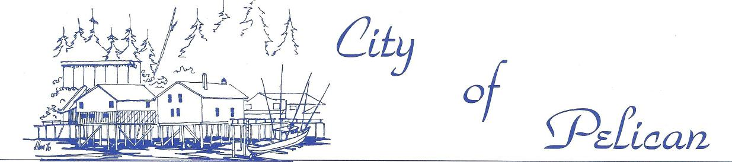

EQUAL OPPORTUNITY EMPLOYER

11-18-19

David Schmid

Regional Forester   
USFS Alaska Region

Dear Mr. Schmid,

The City of Pelican would like to formally request a public meeting and subsistence hearing on the Alaska Roadless Rule Process from the Forest Service during the comment period on the Alaska Roadless Rule Draft Environmental Impact Statement, which ends on December 17th. Pelican has been left out of this rulemaking process and was not visited during the scoping period. The City of Pelican is working hard to draft a resolution stating our position on the Roadless Rule process, although we are at a timely disadvantage as the Forest Service did not reach out and contact Pelican regarding a public meeting. We believe that the Forest Service is being negligent by excluding Pelican from the public information meetings and subsistence hearings, as our community members depend on intact roadless areas in Southeast Alaska for our subsistence harvesting, economic livelihoods, and way of life.

Pelican is concerned with the selection of a full exemption from the 2001 Roadless Rule as the preferred alternative in the Alaska Roadless Rulemaking process. The foundation of the

economy in Pelican is dependent upon commercial fishing, which is heavily supported by the intact watersheds still left on the Tongass. These watersheds and intact roadless areas also help mitigate and contribute towards local adaptation efforts towards climate change, which is also affecting the viability of the fish stocks that we depend on. Pelican residents deserve to hear from the Forest Service about how the proposed exemption from the Roadless Rule could affect the areas that we depend on for our economic livelihood and subsistence harvest.

Pelican is located on Chichagof Island, separated from the West Chichagof-Yakobi Island

Wilderness area by Lisianski inlet and bordered by LUD II management areas on the eastern side. We therefore suspect that you may deny our request by stating that a full exemption would not affect Pelican. We would like to put to rest any such ill-advised determination before it takes place. The commercial fishermen of Pelican depend on fish stocks that are supported by watersheds throughout the Tongass. When fish habitat is degraded in one area of the Tongass,

1

OFFICE OF THE MAYOR - PUBLIC WORKS DEPARTMENT - PELICAN HEALTH CLINIC - PELICAN VOLUNTEER FIRE DEPARTMENT

|  |  |  |
| --- | --- | --- |
|  | *of* | *Pelican,* |
|  |  |

EQUAL OPPORTUNITY EMPLOYER

such as Prince of Wales, the effects are felt throughout the entire fishing fleet in Southeast Alaska. Our fishermen are nomadic and go wherever the fish are biting. Therefore, even if the LUD II and wilderness areas around Pelican retain their protections, the loss of roadless protections on Eastern Chichagof Island and the rest of the Tongass will have impacts for the economic livelihoods of our fishermen and guides. Furthermore, our burgeoning tourism industry would be harmed by a full exemption as conflict on the Tongass between developers, fishermen, environmentalists, and loggers would drive away tourism. Finally, and most importantly, our local food security would be impacted by a full exemption in several ways. Increased timber harvest resulting from a full exemption would negatively impact deer populations, which means more hunters vying for less of the resource. Pelican residents use the entire Chichagof island territory for subsistence harvesting and areas outside of the LUD II management zones and the Wilderness area would have subsistence resources impacted by a full exemption.

We request a public meeting from the Forest Service so that our citizens have a chance to formulate an educated opinion on the Alaska Roadless Rulemaking process, and submit their subsistence concerns for the record. We look forward to scheduling this meeting at your earliest convenience, but we stress that it must occur while the comment period is still open (i.e. before December 17th) or the Forest Service may be liable for violation of the National Environmental Policy Act by deliberately excluding the voices of this rural Southeast Alaska community from the rulemaking process. We look forward to your prompt response.

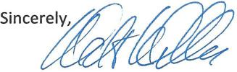

Walt Weller

City of Pelican Mayor   
Pelican, Ak. 99832

2

OFFICE OF THE MAYOR - PUBLIC WORKS DEPARTMENT - PELICAN HEALTH CLINIC - PELICAN VOLUNTEER FIRE DEPARTMENT