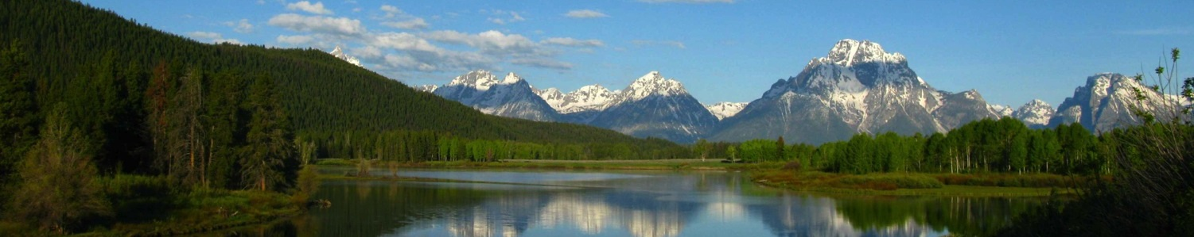 August 7, 2023

***Our Mission: To promote, recommend and advocate for programs and projects within the Custer-Gallatin National Forest that will provide for the public health, safety and general welfare of our communities under the sustainable multiple-use management concept to meet the diverse needs of our communities through a transparent, collaborative and mutually supportive process within a diverse and committed stakeholder group.***

**Membership**

**County Commissions**

***Carbon Co.  
Madison Co.  
 Park Co.  
Gallatin Co.   
Stillwater Co.   
Big Horn Co.   
Sweet Grass Co.***

***Powder River Co.  
 Rosebud Co.***

**Industry Representation**

***Skiing -  
 Red Lodge Mountain***

***Minerals/Mining –   
Stillwater Mining Corp.***

***Multiple Use –   
Citizens for Balanced Use***

***Recreational & Economic Dev. -   
Big Sky Chamber***

***Agriculture/Ranching -   
OPEN***

***Timber -  
Sun Mtn. Lumber Co.***

***Motorized Recreation -   
Montana Trail Vehicle Riders Assoc.***

***Quiet Recreation -   
Winter Wildlands Alliance  
SW Mont. Mtn.. Biking Advocates***

***Fishing and Hunting -   
Montana Back Country Hunters & Anglers***

***Outfitters -   
Montana Outfitters   
 & Guides Assn.***

***Montana University Extension***

**Conservation NGOs**

***Greater Yellowstone Coalition  
  
  
The Wilderness Society***

***Society for Range Management,  
Northern Great Plains Section***

***Trout Unlimited***

***Ttout Unlimited***

**Custer Gallatin Working Group**

Big Horn, Carbon, Gallatin, Madison, Park, Powder River, Rosebud, Sweet Grass & Stillwater Counties

**Stillwater Mining Company, East Boulder Mine Amendment 004 Expansion EIS #61385**

The Custer Gallatin Working Group (CGWG) appreciates your consideration of our comments on the subject project. Established in July 2014, the CGWG is a collaborative that works to develop agreement around priority areas and approaches for project work on the Custer Gallatin National Forest. The CGWG represents a wide range of stakeholder interests including County Commissioners, representatives of Conservation NGO’s, the Skiing industry, Agriculture and Ranching, Quiet and Motorized Recreation, Hunters, Anglers, Outfitters, Mining Recreation, Economic Development and the Timber Industry. Our purpose is to “Restore* or maintain the landscapes of a nine county** area of southern Montana that contains the Custer Gallatin National Forest to desired conditions that will sustain the productive interrelationships of the physical, economic, ecological and social environments of the region.”

The CGWG accepted the East Boulder Mine Amendment 004 as a project that we felt should be reviewed and evaluated by our collaborative. We formed a committee with the responsibility of becoming informed of the project’s needs, social, economic and environmental impacts. The committee has toured the existing facility and was provided with an overview of the project’s needs and location of the area of expansion. Several members of the committee attended the public meeting in Big Timber on July 12th. There were three questions asked at the public meeting. Two of those questions were concerned about impacts to traffic. Those were satisfactorily answered. The other question was regarding the mitigation of potential impacts to the waste storage sites with a 1000-year storm event. The response given was that the scope of that type of event would not only impact the mine, but also the entire drainage area, and that no prediction would be accurate. The East Boulder Mine has been on the landscape since 2002. Much of the impact on the landscape already exists. Although the expansion of the mine tailings and waste rock storage area will have an additional visual and environmental impact to the area, the expansion is necessary to the physical, economic, ecological and social environments of the community, as well as the Nation.

The CGWG members, except for three abstentions, support the preferred alternative for the Stillwater Mining Company, East Boulder Mine Amendment 004 Expansion EIS #61385. The three abstentions are Colin Cooney representing Trout Unlimited and Randy Weimer representing Sibanye-Stillwater, and Barb Cestero with the Wilderness Society. Trout Unlimited supports the concept of the project but is in negotiations with Sibanye-Stillwater to establish a “tailings pond monitoring committee with TU having a seat on the committee. Randy Weimer abstains for conflict-of-interest reasons. Barb Cestero abstains from any CGWG votes while on sabbatical.

We feel that Montana DEQ and the Forest Service have met their obligations to ensure that the project meets or exceeds the MEPA and NEPA requirements.

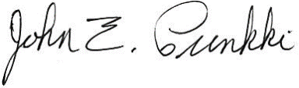  
Sincerely,

John E. Prinkki, Chair  
Custer Gallatin Working Group  
[jeprinkki@gmail.com](mailto:jeprinkki@gmail.com)  
406-425-1516