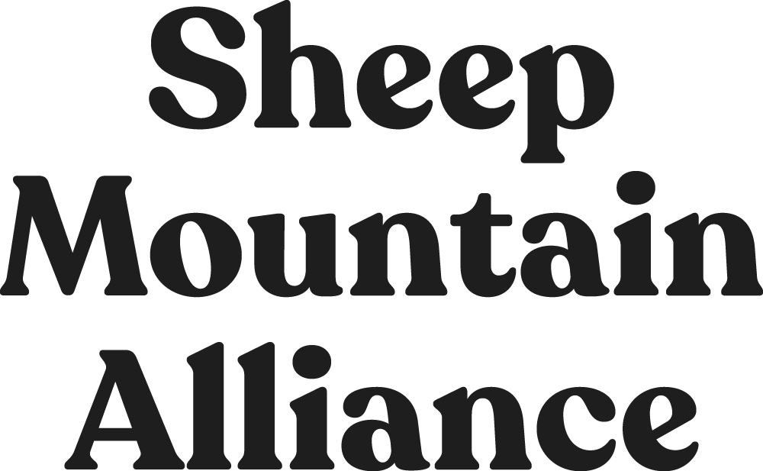

**PO Box 389, Telluride, CO 81435 • 970-728-3729 •** [**www.sheepmountainalliance.org**](http://www.sheepmountainalliance.org)

March 25, 2020

Dolores Ranger District, San Juan National Forest

Derek Padilla, District Ranger

Tom Rice, Recreation Program Manager

29211 Highway 184 Dolores, CO 81323

Submitted via online comment form

Re: Comment on Rico Trails Project (#56748) Draft Environmental Assessment

To District Ranger Derek Padilla and Recreation Staff Officer Tom Rice:

Sheep Mountain Alliance (SMA) respectfully submits these comments on behalf of our more than 800 members and supporters to the US Forest Service with respect to the agency’s draft Environmental assessment for the Rico Area Trails Project.

Sheep Mountain Alliance is a 31-year-old nonprofit dedicated to conservation of the Telluride area and Southwest Colorado. Our members regularly use the Rico Area for work, recreation, and to support their health and livelihoods.

While we understand the desire for increased trail connectivity on the Rico Area, we believe that this project is ill-conceived and premature. A thorough EIS is critical to a project of this type, which will have long term and significant impacts on ecosystems, wildlife, the landscape at large, and the human communities adjacent to propose trails.

SMA has read and reviewed the comment letter submitted on March 25, 2020 by Wild Earth Guardian’s attorney Marla Fox concerning the Rico Trails Project - February 2020 Draft Environmental Assessment (EA). SMA supports, adopts, and incorporates the comments in Ms. Fox’s letter and the information cited in her references and attachments

Thankyou for your consideration of this letter.

Sincerely,

Karen Tuddenham

Executive Director

Sheep Mountain Alliance