**Ecological Reforestation: A Basic Guide for Achieving Resilience**

Malcolm North and Marc Meyer, US Forest Service

## **Background**

With increases in wildfire size and severity, the scale of postfire restoration and reforestation are presenting significant challenges to current forest agencies work force, budgets, and traditional practices. Recent science publications such as PSW-GTR-270**1** and 278**2**, and literature reviews**3-5** have proposed holistic approaches to western forest landscape restoration which informs reforestation, beneficial fire use, and how to develop and prioritize management actions across large landscape scales. Complementary to these new approaches, here we suggest strategic changes in reforestation practices that can improve seedling survival and growth, and restore resilient forest structural conditions in an era of changing climate conditions and disturbance regimes**6**.

## **Planting for Resilience: Variable spacing, lower density, and early fire use**

Traditional gridded planting of conifer seedlings comes from an agronomic approach designed to maximize tree stocking to provide for sustained timber yield, boost initial growth rates, and rapidly shade competing shrubs**7**. It has no analog in natural ecosystems and depends heavily on future thinning treatments. Under current USFS regional guidance (i.e., recommended range of 200-300 trees per acre in drier pine to mesic mixed conifer), the dense, uniform structure of young stands (< 60 years old) wastes limited seed and nursery capacity while lacking resistance to fire and drought**8**. More resilient reforestation practices are needed, based on best available science, that build on natural forest adaptation traits to these stresses using three key changes:

1. Adopt a planting spatial pattern based on **I**ndividual trees, **C**lumps of trees, and **O**penings (ICO) that improves forest resistance to severe fire**9-11**. Species composition and spacing between and within clumps would vary in response to slope position, microsite moisture, and likely fire behavior**12-14**.
2. Lower initial planting densities that are roughly 1.2-1.5 times the densities of mature forest with restored fire regimes (i.e., mostly 60 to 160 seedlings per acre[1]). Low established seedling numbers after five years would not trigger subsequent interplanting unless numbers dropped below mature stand densities (Table 1).
3. The use of early beneficial[2] fire and targeted shrub control to build young forest resilience.

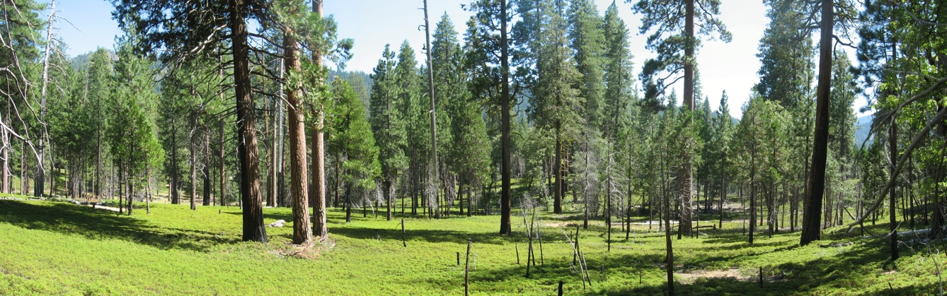

ICO pattern produced by a restored fire regime in Yosemite NP.

**Planting Patterns Considering Topographic and Microsite Variation**

In studies of mature ICO patterns, local site conditions influencing soil moisture (i.e., concave shape, more northerly aspect, gentler slope, deeper, less porous soils) and fire intensity (i.e., slope steepness, more southwesterly aspect) affect forest composition and spatial patterns at larger topographic to smaller microsite scales**15,16**. In general, wetter, flatter slope positions (valley bottoms) can support larger tree clumps including some fire-intolerant and moisture-sensitive species (i.e., fir and cedar). Steeper, drier topographies (upper slopes and ridge-tops) will burn with greater intensity and frequency, and should favor pines and more individual stems and small tree clumps**12,15-19**. Differences in these site factors occur with slope position, providing a range of mature stand densities and spatial patterns used to guide reforestation patterns**1,2**.

At finer spatial scales, variation among microsites that influence soil moisture, solar exposure, and fire intensity can influence the growth and survival of tree seedlings and saplings. For instance, pockets of deeper soil could improve growing conditions for conifers**19** and understory vegetation could provide critical shading for developing seedlings in harsh environments, such as in high-severity patches**14,20**.

When planting for these desired mature forest conditions, we suggest following the percentage of trees occurring as individuals and in each of the two clump sizes (Table 1), but planting at densities and distance between seedlings that account for about 20-50% seedling mortality. Site conditions and future stand treatments, such as the use of prescribed fire, should influence mortality estimates**21,22**. Within wind-dispersal distance of live mature trees (generally about 200 ft), natural regeneration may be sufficient to meet desired densities and spatial arrangements of conifer seedlings, although planting may help supplement low densities of heavy-seeded pines.

*Table 1. Desired pine/mixed-conifer forest structure class percentages and canopy cover by landscape position within frequent-fire forest landscapes of California. Percentages rounded to the nearest 5% and are based on published estimates in forest landscapes with reestablished, active fire regimes****12,13,17****.*

|  |  |  |  |
| --- | --- | --- | --- |
| **Forest Structure Class\*** | **Valley bottom** | **Mid-slope** | **Ridgetop** |
| Individual trees | 10% | 15% | 20% |
| Small clusters (2-4 trees) | 15% | 25% | 30% |
| Medium to large clusters (> 5 trees) | 75% | 60% | 50% |
| Open canopy gaps (>800 ft2)** | 20% | 30% | 40% |
| Canopy cover**^** | 45% | 40% | 30% |
| Density (trees/ac)**^^** | 90-115 | 80-100 | 50-85 |

* Stems within all cluster sizes had a consistent density that averaged to 12 feet apart. Mature stands averaged 12 clusters/acre.

** Minimum gap size that is > to canopy area of a large overstory tree (i.e., radius 16 ft.).

**^** Open gaps plus canopy cover is <100% because small openings, interstitial space between tree crowns, is 30-35%.

**^^** Density ranges vary between lower values for yellow pine to higher values for mesic, mixed conifer.

Jeffrey pine plantation that experienced differential mortality among microsites from drought and fire, resulting in an ICO pattern. Inyo NF.

**Shrub Control and Prescribed Fire**

Although shrubs provide numerous ecosystem services[3], they can be strong competitors with tree seedlings for sunlight and scarce soil moisture[4]. Many species that are common in Mediterranean climates can rapidly resprout from below-ground root crowns and maintain persistent seed banks that germinate following fire. In many high-severity burn areas, planting should occur as soon as possible after the burn, preferably before dense shrub growth overtops the height of tree seedling planting stock (generally within 3-6 years). Reforestation may require early, aggressive shrub control and avoidance measures. Resilient reforestation practices may consider using three site preparation and maintenance approaches for limiting shrub competition and reducing fuels:

1. **Beneficial fire for shrub control and fuels reduction** – Prescribed fire, cultural burning, and wildfires (with beneficial fire effects) can be applied or used before initial planting and after saplings (especially pines) are about 13 to 20 years old to reduce shrub cover, fuels, and build greater seedling fire tolerance**25,26**. Dry or old shrubs can be a fuel accelerant, but young, vigorous shrubs in burn scars can act as a heat sink because of their rapid uptake of soil moisture and relatively high foliar moisture content**27**. Prescribed burns implemented shortly after rain can use shrubs to buffer adjacent tree seedling clumps from heat-related injury while still consuming surface fuels. Beneficial fire can also be effective at promoting heterogeneity in young, dense stands established with homogenous grid spacing**28**.
2. **Targeted mechanical or chemical shrub control** – Grubbing or spot herbiciding of above-ground shrubs at the planting site can be very effective if tree seedlings are planted in clusters rather than as individuals. The larger shrub reduced area, especially where shrubs exceed >50% cover, can help the cluster of tree seedlings ‘lock’ the site, shading out resprouting and encroaching shrubs that would overwhelm a single seedling**23**. This should be considered in how far apart seedlings within a clump are planted. Within clump spacing should be close enough so that growing seedlings will develop interlocking crowns and shade out shrubs before they overtop tree seedlings.
3. **Post-fire shrub avoidance** – Targeted planting of seedlings in portions of a severely-burned forest stand that contains low to moderate levels of post-fire shrub cover (generally <60%) and suitable microsite conditions (e.g., higher soil water availability and site productivity), can facilitate tree establishment and growth[5]. These plantings would reduce competition between shrubs and developing seedlings, as well as minimize the time and energy devoted to shrub control. Select sites of high shrub cover (>60%) may be targeted for reforestation in areas of higher soil productivity**29** and other resource considerations (e.g., areas important for forest habitat connectivity). Forests that were reburned at high severity (i.e., repeated stand-replacing severity over short intervals purposefully or due to successive wildfires) may result in reduced post-fire shrub cover, snags, and surface fuels in places, which can be especially suitable for targeted reforestation efforts**30**.

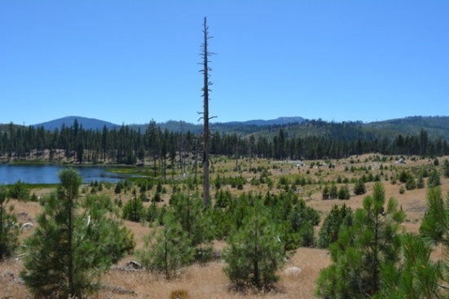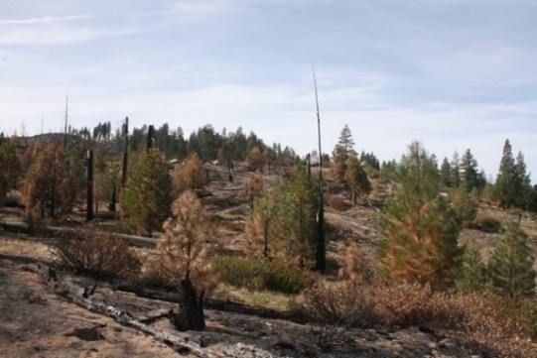

Cluster planting on the Moonlight fire: Left: 10 years after planting; Right: After a plantation was burned by the 2022 Dixie fire. (Photos by Ryan Thompkins, UCANR).

**Implementation**

Planting an ICO pattern that varies with topography (Table 1) and microsite condition may initially be more challenging than standard gridded reforestation, but it affords a more robust and adaptive spatial pattern. Each planter will plant seedlings slightly differently depending on how they ‘read’ the terrain, but the pattern’s resulting heterogeneity, congruent with water availability and likely fire behavior, should support higher survival and growth**21**. Having crews dedicated to adaptive planting and early prescribed fire use would build needed complementary skills. Depending on existing conditions (i.e., generally avoiding areas of hardwoods, fuel piles, shallow soils, existing natural regeneration, etc.), planting contracts can be developed to specify an established range of spacing distances and seedling densities.

For Example: Microsite cluster planting with 2-4 stems/cluster and 20 ft between clusters:

Total of **97 stems/acre** can be planted (range: 82-109 stems)

Variations: At 15-ft cluster spacing: total of **115 stems/acre** (range: 97-130 stems/acre)

At 15-ft cluster spacing and increasing to 5 stems/cluster: total of **162 stems/acre**

Lower density of stems (i.e., wider cluster spacing or fewer stems per cluster) can be planted on ridgetops compared to mid-slopes and valley bottoms (Table 1).

Lower density of stems can be achieved by planting 10 to 20% of grid points (contingent on landscape position) with individual stems rather than clusters (Table 1)[6].

**References**

**1)** Meyer, M. 2021. PSW-GTR-270 **2)** Long, J. 2023. PSW-GTR-278 **3)** Stevens, J. 2021. FEM 502: 119678 **4)** Larson, A. 2022. FEM 504: 119680 **5)** Churchill, D. 2022. FEM 504: 119796 **6)** North, M.. 2019. FEM 432:209 **7)** Rubilar, R. 2018. Cur. For. Rep. 4:23 **8)** Zald, H. 2018. Eco. Apps 28:1068 **9)** Koontz, M. 2020. Ecol, Letters 23:483 **10)** Ziegler, J. 2021. Eco. & Evol. 11:820 **11)** Ritter, S. 2023. Fire 6:321 **12)** Ng, J. 2020. FEM 472:118220 **13)** Lydersen, J. 2012. Ecosystems 15:1134 **14)** Marshall, L. 2023. Fire Ecol. 19:26 **15)** North, M. 2009. PSW-GTR-220 **16)** Kane, V. 2015. FEM 338:1 **17)** Fry, D. 2014. PLOS ONE DOI:10.1371/journal.pone.0088985 **18)** Lydersen, J. 2013. FEM 304:370 **19)** Meyer, M. 2007. Plant & Soil 294:113 **20)** Marsh, C. 2023. FEM 537:120971 **21)** Marsh, C. 2022. FEM 525:120524 **22)** Zald, H. 2008. FEM 256:168 **23)** Fertel, H. 2022. FEM 519:120270 **24)** Gomez-Aparicio, L. 2005. J. Veg. Sci. 16:191 **25)** York, R. 2021. Can. J. For.Res. 51:781 **26)** Bellows, R. 2016. FEM 376:193 **27)** Royce, E. 2001. Am. J. Botany 88:911 **28)** Knapp, E. 2006. Int. J. Wild. Fire 15:37 **29)** Odland, M. 2021. FEM 495:119361 **30)** Stevens-Rumann. 2016. Eco. Apps. 26:1842 FEM: Forest Ecology and Management

1. Planting densities will depend on factors that influence seedling and sapling mortality, namely fire frequency and intensity, soil moisture holding capacity, evaporative water demand, and developing shrub cover. For example, harsh sites with low seedling survivorship may require higher densities or acceptance of longer establishment periods for trees to achieve desired stand conditions.
2. Beneficial fire includes intentional prescribed and cultural burning, and wildfires managed under a multiple objective strategy (including resource objectives).
3. Native shrubs can provide watershed and soil stabilization, nitrogen fixation, wildlife habitat, invasive plant suppression, biodiversity, and shading for conifer seedlings in hot and dry environments.
4. Most competitive effects of shrubs to tree seedlings are evident in a few shrub species (e.g., mountain whitethorn) that attain high post-fire cover (mostly ≥50%). However, there is evidence that lower to moderate shrub cover has negligible or even positive effects on tree seedling growth and survivorship in frequent-fire forests**23**,**24**.
5. Avoiding areas of low shrub cover due to shallow soils and other site conditions that support sparse vegetation.
6. Natural mortality within seedling clusters may also produce some individual stems in developing stands. Higher planting densities could be achieved by decreasing intercluster spacing, planting higher numbers per cluster, or planting higher seedling densities in clusters adjacent to avoidance areas (e.g., fuel piles, hardwood patches).