**MEMORANDUM State of Alaska**

Department of Fish and Game

Division of Commercial Fisheries

TO: file DATE: December 15, 2016

PHONE NO: 465-4228

FROM: Kyle Hebert SUBJECT: Hawk Inlet Intertidal Clam Investigation

Dive Fisheries Research Supervisor

Region I

In 2014, during the environmental impact statement development for Hecla Greens Creek Mining Company’s proposed tailings disposal facility expansion, Mr. William Brent raised a concern about low clam abundance in Piledriver Cove, Hawk Inlet, where he resides. Hecla’s Greens Creek Mine facilities are located in Hawk Inlet, within six kms north of Piledriver Cove. I discussed the concern with Kate Kanouse (ADF&G Habitat Division) and Will Collingwood (ADEC Division of Water), and agreed to perform a casual investigation of clams present in Piledriver Cove if time and staff allowed.

Purpose

The purpose of this investigation was to qualitatively characterize the intertidal clam community in Piledriver Cove and conduct a similar investigation nearby at the mouth of Greens Creek, also in Hawk Inlet.

Methods

On May 6, 2016, ADF&G Division of Commercial Fisheries staff conducted a one-day investigation near the mouth of Hawk Inlet in Piledriver Cove, and at the Greens Creek delta approximately 1.5 kms north of Piledriver Cove, to evaluate presence of intertidal clams (Figure 1). The investigation was conducted by department divers stationed aboard ADF&G’s R/V Kestrel, while in between herring spawn deposition dive surveys.

Although we did not design a survey that is capable of producing data for use in rigorous statistical analysis, the investigation involved a series of transects with the intent to provide a systematic mechanism to count clams and characterize clam distribution within the study sites. We completed nine transects during the investigation, five transects in the northern half of Piledriver Cove, and four transects in the delta south of Green’s Creek (Table 1). All transects were located in the intertidal zone at the marine terminus of a stream. Substrate types were similar at both study sites and dominated by mud, sand, and gravel.

Transects were generally oriented in an east-west direction and conducted at -3.0 tidal stage. Due to the low tide stage, diving was not necessary to thoroughly examine intertidal clam habitat. Subtidal habitat was not explored. Transects were completed by laying a 0.1 m2 plastic sampling frame spaced equidistant within each transect, and recording the estimated elevation (mean lower low water), the number of clams by species, and substrate type. After positioning a frame, a shovel or rake was used to excavate the substrate to a depth of at least 30 cm. The sampling frame was spaced within each transect either 10, 20 or 30 m apart, depending on the frequency of clams observed along neighboring transects. For example, toward the mouth (i.e. northern side) of Piledriver Cove, the first transects were conducted with 10-m intervals between frames where clam habitat appeared most suitable. Consequently, for transects at the head of the bay where clam habitat was less optimal, the frame spacing interval was increased to reduce the survey time in areas expected to yield fewer clams.

Results and Discussion

Several types of clams and cockles were observed during the investigation: butter clams *Saximdomus giganteus,* venus clams *Humilaria kennerleyi* and *Compsomyax subdiaphana*, Pacific littleneck (or “steamer”) clams P*rotothaca staminea*, pink neck clams *Mactromeris polynyma*, and cockles *Clinocardium nuttalli*. We found few clams (Table 2) and the density of combined clam/cockle species in Piledriver Cove was approximately 1.55 /m2 (Table 3). The approximate density of individual clam types ranged from 0.04/m2 (pink neck clams) to 3.99/m2 (butter/venus clams). The term “approximated” is used rather than “estimated”, because the lack of a proper survey design limits the degree to which conclusions can be made about accuracy or variation of the results.

No clams were observed at the Greens Creek delta study site. As there are no prior data available, it is unknown if clams ever resided there. Although the substrate appeared to be consistent with hard shell clam habitat, it generally consisted of less mud and more gravel than substrate at the Piledriver Cove study site. It is possible that despite the close proximity of the two sites and the apparent similarities of substrate, the difference in clam abundance is due to other physical or environmental factors that were not measured–such as salinity concentration, which governs clam/cockle habitat suitability.

Table 1.–Coordinates (Datum WGS1984) for transect locations at study sites near the entrance to Hawk Inlet, Admiralty Island, Southeast Alaska.



Table 2.–Total counts of clams observed along transects surveyed near the entrance of Hawk Inlet, Admiralty Island, Southeast Alaska.



Table 3.–Mean density of clams (per m2) within and among transects surveyed near the entrance of Hawk Inlet, Admiralty Island, Southeast Alaska.



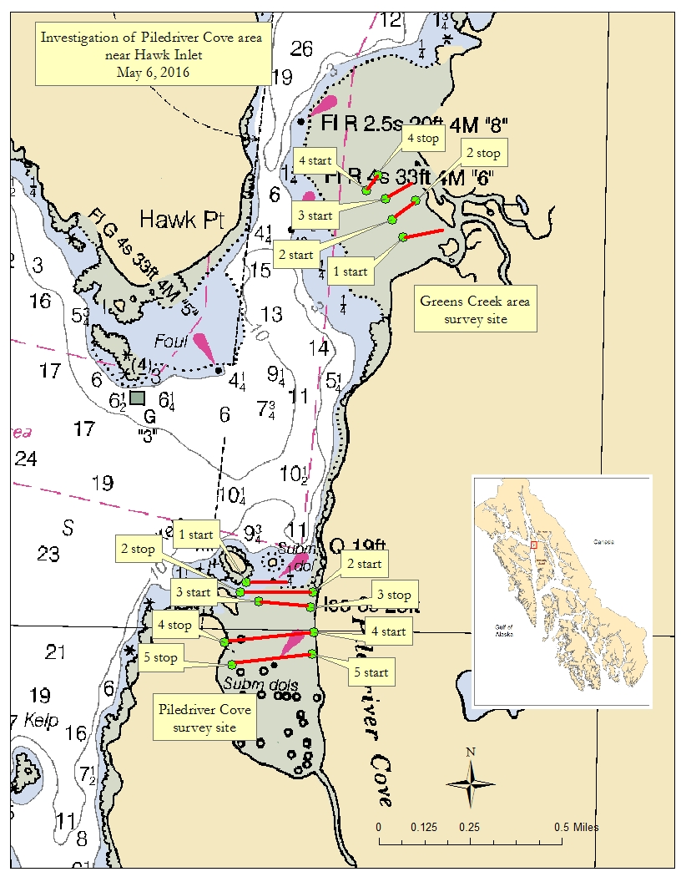

Figure 1.–Map of study sites with transect locations near the entrance of Hawk Inlet, Admiralty Island, Southeast Alaska.

CC:

Kate Kanouse, ADF&G Habitat, Douglas

Will Collingwood, ADEC Water, Juneau

Kyle Moselle, ADNR OPMP, Juneau

Matthew Reece, USFS, Juneau