16 January 2019

TO:   Nikki Swanson, Sweet Home District Ranger

VIA: <https://cara.ecosystem-management.org/Public//CommentInput?Project=53520>

**Subject: Calapooia (draft) Environmental Assessment — comments**

Dear Forest Service:

Please accept the following comments from Oregon Wild concerning the Calapooia (draft) Environmental Assessment , <https://www.fs.usda.gov/project/?project=53520>. Oregon Wild represents 20,000 members and supporters who share our mission to protect and restore Oregon’s wildlands, wildlife, and water as an enduring legacy. Our goal is to protect areas that remain intact while striving to restore areas that have been degraded. This can be accomplished by moving over-represented ecosystem elements (such as logged and roaded areas) toward characteristics that are currently under-represented (such as roadless areas and complex old forest).

The proposed action alternative involves:

* 1132 acres of treatment in the Upper Calapooia Watershed
  + 706 acres of commercial thinning in stands 40-60 years old (283 acres in riparian reserves).
  + 50-70 tpa retained
  + 109 acres of gap creation
  + 28 acres of dominant tree release
  + 289 acres of untreated skips
  + 381 acres of ground-based logging
  + 12 mmbf
* Land allocations: riparian reserves, AMA, CHU
* 51 miles of road reconstruction
* 1 mile of new temporary road construction
* 2 miles of non-system road use and decommissioning
* 5 miles road decommissioning
* 843 acres of weed treatment
* 3 acres fall and leave
* Minimum 50 foot no-cut buffer along streams
* Establishment of a day-use area in the Calapooia River Corridor

Oregon Wild appreciates the focus on this project on thinning stands under 80 years old. We also appreciate road decommissioning, minimizing road construction, weed treatments, fall and leave in riparian reserves, and unthinned skips which will partially mitigate the effects of commercial wood removal.

As noted in our scoping comments, our main concerns remain –

* Making treatments spatially variable, including clumps of trees that are typical in old growth forests;
* Providing generous no cut buffers on streams, recognizing that commercial logging will cause a significant long-lasting reduction in wood recruitment and even small trees can provide pool-forming wood in small streams;
* Gaps should mimic natural disturbance by retaining some structure in the form of live and dead trees;
* Retain all legacy trees and snags.
* Focus thinning on Douglas fir. Retain underrepresented conifers (cedar, hemlock, pine, yew, etc) and hardwoods (maple, alder, etc); Post harvest fuel reduction efforts should be designed to avoid eliminating these elements of diversity.
* Focus treatments on places that are accessible form existing roads, so as to avoid the adverse effects of new road construction, and to move toward the HRV for watershed integrity and road density.

This project is located in an AMA but the EA does not explain how this project integrates diverse AMA objectives. We think this project may in fact do so, and the FS is missing an opportunity to highlight that fact.

We object to log hauling during the wet season and during wet weather. This activity poses too great a risk to aquatic resources. The FS places too much faith in mitigation and BMPs that are not always fully implemented or fully effective. The EA should more fully disclose the risks associated with this activity.

We urge the FS to provide a map to help display cumulative effects. The list of projects in Appendix C is somewhat helpful but it could be better. For instance, this map shows cumulative clearcutting in a spatial way:

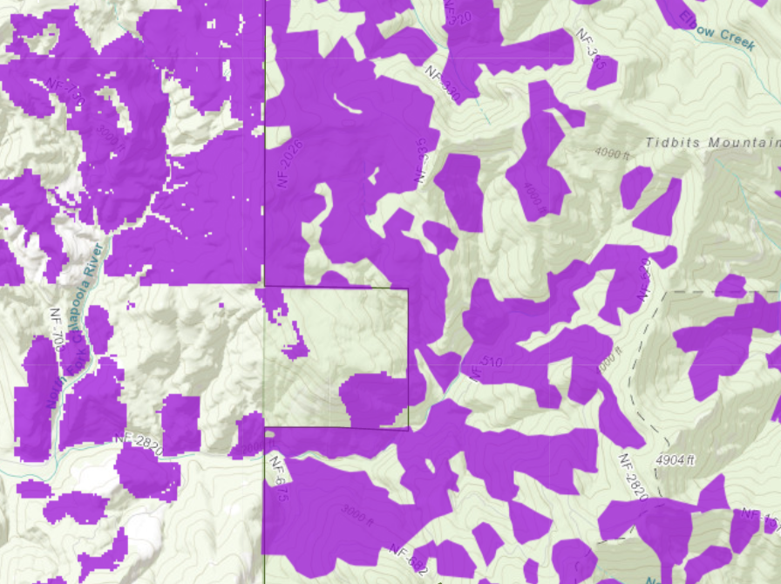

<https://logging.oregonhowl.org/> This map also shows recent clearcuts (since ~2000) on adjacent private timberlands. This is relevant to cumulative impacts on wildlife habitat and watershed values.

We are pleased to see the analysis of depleted summer streamflow caused by cumulative effects of plantations across the landscape (including both public and private lands). This analysis should be done at appropriate watershed scales (rather than the arbitrary scale of the project area). **“**Long‐term paired‐basin studies extending over six decades revealed that the conversion of mature and old‐growth conifer forests to plantations of native Douglas‐fir produced persistent summer streamflow deficits of 50% relative to reference basins, in plantations aged 25 to 45 years. This result challenges the widespread assumption of rapid ‘hydrologic recovery’ following forest disturbance …”

Perry, T. D., and Jones, J. A. (2016) Summer streamflow deficits from regenerating Douglas-fir forest in the Pacific Northwest, USA. Ecohydrology, doi: [10.1002/eco.1790](http://dx.doi.org/10.1002/eco.1790). <http://onlinelibrary.wiley.com/doi/10.1002/eco.1790/full>. The EA should also explain the connection between the aggregate recovery percentage (ARP) analysis and the low-flow analysis which might seem contradictory to the casual reader.

Appendix A “Compliance with Laws & Regulations” should address compliance with the LRMP (as amended) because that is required by the National Forest Management Act.

The Owl Thin Project occurred recently in the northern part of this area. We hope that none of those units overlap with this thinning proposal. Repeated commercial thinning can have significant cumulative adverse effects on soil, snag recruitment, carbon storage, etc.

Appendix D makes various unit-specific recommendations to minimize soil impacts. Does the EA say whether these recommendations will be followed?

The EA could do a better job of justifying each road segment with site-specific analysis of impacts and alternatives. For instance, the proposed road at the intersection of section 7, 8, 17, 18 (accessing units 4, 5, and 11) is rather long.

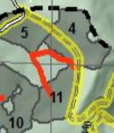

Can this proposed road segment be shortened or avoided by dropping some of the acres of treatment and reallocating those acres to the skips? For instance, maybe the east half of unit 11 could be thinned from the existing road, and the west half dropped, avoiding a significant portion of that road construction.

We urge the FS to adopt some mechanism to ensure that untreated skips are retained in an untreated (or non-commercially treated condition) long enough to ensure they serve their intended purposes, such as recruitment of dead wood which can take a long time, maybe even indefinite.

The scale, location, and juxtaposition of skips should be carefully planned (just like commercial treatments). For instance, skips should be embedded within treated stands so that relatively dense patches of tree boles within stands can provide some mid-canopy occlusion for flying squirrels.

The EA says:

Wiens (2012) has recommended retaining conifer forests older than 120 years of age as a method to reduce interspecific competition between the owl species. Where barred owls occur, he has found that spotted owl survival greatly declines as the percent of forests >120 years of age in the general home range drops below 35%.

The EA should disclose whether the project area is above the 35% threshold, and if so, disclose the exacerbating adverse impacts of logging stands less than 120 years old, e.g. reducing cover for prey species, reducing dead wood habitat, etc.

We are very dissatisfied with the FS’ boilerplate NEPA analysis regarding carbon and climate. It makes several highly misleading statements about forest carbon and climate change. The analysis inappropriately mischaracterizes the role of individual logging projects in the cumulative problem of global GHG emissions. The analysis misstates the effects of logging related carbon emissions that are not related to “deforestation.” The analysis grossly misstates the climate effects of logging intended to reduce disturbance. The analysis misleadingly implies that logging benefits the climate by increasing forest productivity.

We hope underburning is accomplished as a mosaic rather than a wall-to-wall blacked ground that sets back understory diversity and simplifies stand structure.

We support converting more of the commercial thinning in riparian reserves to fall and leave treatments to help mitigate the adverse effects of wood removal in land allocations where abundant wood is desired.

The EA says:

The minor reduction in wood recruitment would occur at a very slow rate due to the naturally slow rate of the dominant wood recruitment processes (bank erosion and tree mortality) of streams in the project area. The beneficial impacts of thinning to accelerate tree growth, riparian forest structure and shrub diversity would be very minor at all scales due to the relatively small area treated and slow rates of tree growth.

This could be improved by disclosing that: (i) wood recruitment is often pulsed (e.g., during wind and ice storms and floods) rather than continuous; (ii) every tree that is removed from riparian reserves represents a loss of wood recruitment to the stream and/or riparian uplands; (iii) the trees that will be removed would keep growing on site and provide increasing ecological value over time if retained; (iv) the “very minor” beneficial effects attributed to thinning would still occur under no action, just a bit more delayed. We are not opposed some careful thinning in young stands in the outer half of riparian reserves, but we think the benefits are over-stated and the trade-offs are under-stated.

Each substantive issue discussed in these comments should be (i) incorporated into the purpose and need for the project, (ii) incorporated into a NEPA alternative, (iii) carefully analyzed as part of the effects analysis, and (iv) considered for mitigation.

Note: If any of these web links in this document are dead, they may be resurrected using the Wayback Machine at Archive.org. <http://wayback.archive.org/web/>

Sincerely,

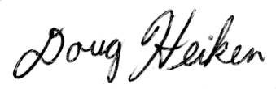

Doug Heiken

[dh@oregonwild.org](mailto:dh@oregonwild.org)