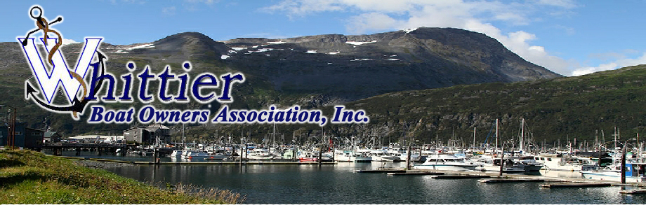

For 30 years, the Whittier Boat Owners Association (WBOA) has represented the wide interests of Prince William Sound (PWS) boaters, both commercial and recreational, that have countless decades of experience in PWS. In addition to boating throughout the Sound, WBOA members among other activities fish, hunt, hike, berry pick, photograph, whale and bird watch, and introduce countless visitors from throughout world to the wonders of PWS. Many WBOA members’ livelihoods are dependent upon the pristine wilderness qualities of PWS.

The WBOA strongly opposes the proposed 2016 Chugach National Forest revised land management plan primarily for the reason that the revised plan proposes eliminating Knight Island, College Fiord and the area around Columbia Glacier from the Wilderness Study Area (WSA), and, consequently, from the extra layer of protection guaranteed by that management designation. Instead of eliminating areas from the WSA, WBOA members universally support, at bare minimum, preserving the Wilderness Study Area classification for the PWS areas currently so designated. Additionally, we recommend that the WSA classification, and the extra protection established by that classification, be extended to Montague Island. Montague Island is the largest uninhabited island in the United States. It is the most remote island in PWS and, in many ways, the PWS area most deserving of wilderness classification.

PWS is under assault from increased recreational use, commercial activities and onshore development. At the same time, it has become better known and more widely loved and cherished. There is minimal public support for reducing WSA protection in PWS. This is not the time to reduce management protections, but instead, increase them. The Chugach National Forest is a national treasure and all of it must be strongly protected for future generations.

The WBOA specifically recommends that:

1) Montague Island be added to the original 1.9 million acre Wilderness Study Area (WSA) of western Prince William Sound and all of it should be recommended to Congress for designation as Wilderness; the WSA should continue to be managed as Wilderness until it is congressionally designated;

2) The eastern Chugach - including the Copper River/Bering River/Martin Lake & River/Katalla River and watersheds - area should be protected as critical salmon and wildlife habitat and continue to allow existing use for fishers and subsistence harvesters;

3) The Chugach Forest should be withdrawn from mineral and forestry activity; and additional protective conservation acquisition areas should be identified;

4) And the [Exxon Valdez Oil Spill (EVOS) Restoration mandate](http://r20.rs6.net/tn.jsp?f=001mhzM_h9IiXqOKxGRuzpFDnAOpU98tjnpcqQinxbLrbQSssdkG5m-7xEdIhU8SLigi9E5p-0AlESqTM461uKYct2AbBh9_IAdkF3KScwbNzZG-V32YcVtGiWPMejP147h3THVt96nkpiwoa4xETz0wh-0vyMDulEUCS_JZmDAcITUkFYDeXRfcqjCz1YtKHmlDGrc99qmepUmWAS0WDRMbwPIk0Yw_IGyUHUlGKiYhhevY5ZmtkeiY2AJpKTZGXyIJdKXwDv8D-c=&c=ScmQ-YrN_04x5wH5Zfaz3garxYStEiCZ4V1wCVbUIDaGGUYKiEG8DQ==&ch=EGUtYsMDRhAUAfIu3m49uAOXZ4myA-4ORTaBC3Ixo2xiFY5-rR4Rww==) for the region must be upheld.

**The Proposed Forest Plan Revision, as written, is unacceptable and must be re-written to preserve the region more completely and managed primarily for the protection and conservation of fish and wildlife habitat as ANILCA intended.**