Liz Byrd visit off Blodgett Rd

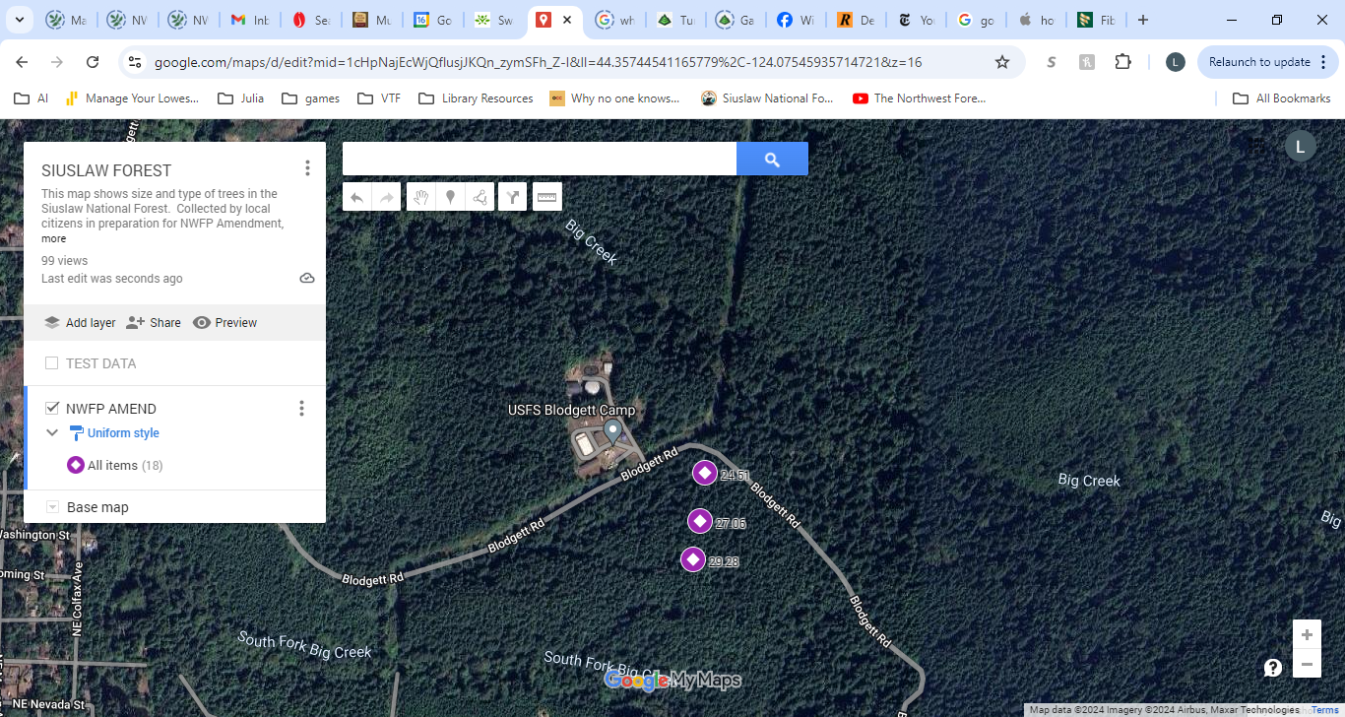

Willow visit off NF 51

