

October 6, 2020

Dear Mr. Goshen:

# Re: San Antonio Exploration Drilling #58629

On behalf of the over 5000 employees directly and indirectly impacted by the mining industry here in Southern Arizona supports and thanks you for your efforts with respect to this project. These processes are time consuming and the attention to detail benefits all concerned.

The Southern Arizona Business Coalition (SABC), formed in 2012 stands in support of the San Antonio proposed exploration drilling program that is identified on the Coronado National Forest’s Website under Schedule of Proposed Actions. Below are several but not all points that can be made in support of this effort by Arizona Standard.

*“Since 1950 the world’s population has grown from 2.5 billion to over 7.7 billion and the need of copper has grown over 9 times the amount needed in 1950”, Dr. Brad Ross, Director of the Lowell Institute of Mining, University of Arizona.* Where the US was an exporter of copper we are now a net importer. We must allow for responsible development of new mining projects here and make the US self-reliant on much need critical and other mineral resources that protect our national independence.

1. Mining provides economic opportunities, community support and much needed taxes for the Santa Cruz County region and is a part of the cultural heritage of the area.
2. No impacts to local water supply and water quality and is constructed to have minimum disturbance.
3. Continues access for recreation.
4. Ongoing reclamation.

As the above points will be stressed by other proponents, we’d like to address something that isn’t address very often and that is the medical importance that copper and other critical minerals. Both Bill and I are of the senior community now and our medical needs have increase and fortunately for our generation technology and future generations technology has contributed to life saving medical opportunities.

Below is part of piece penned by Mary Poulton, PhD., UA Lowell Institute for Mineral Resources, Professor Emerita.

Mining plays a crucial role in protecting us from germs and to effectively deliver medicine.

Copper and its alloys (brasses, bronzes, cupronickel, copper-nickel-zinc, and others) are natural antimicrobial materials. The U.S. Environmental Protection Agency recognized copper as the afirst effective metallic antimicrobial agent in 2008 (Vincent et al., 2017). But the role of copper as a disinfectant has been long known. The use of copper to disinfect wounds and drinking water was described in one of the oldest known books, an ancient Egyptian scroll dating to 2600 B.C. (Grass et al., 2011). It was observed that copper workers were immune to the cholera outbreaks in Paris in 1832. In fact, copper was a widely used antimicrobial agent until the advent of antibiotics in 1932. Copper is essential in most living organisms and have been found in 30 types of proteins (Grass et al., 2011).

There are 274 different copper alloys that have been certified as antimicrobial materials that have public health benefits (https://en.wikipedia.org/wiki/Antimicrobial_properties_of_copper). Studies have shown that the MRSA virus is killed in as little as 45 minutes on contact with copper surfaces (Grass et al., 2011). Over 99.9% of E. coli microbes are killed after just 1–2 hours on copper. On stainless steel surfaces, the microbes can survive for weeks. Copper has been shown effective in killing strains of the norovirus, influenza A virus, HIV-1, and the hepatitis C virus (Vincent et al., 2017).

Protective face masks impregnated with copper oxide have been shown to be protective against human and avian influenza A virus, unlike other face masks (Vincent et al., 2017).

The Copper Development Association ([www.copper.org](http://www.copper.org)) cites recent studies that show the SARS-CoV-2 virus which causes the disease COVID-19 is viable for 2 to 3 days on plastic and stainless steel surfaces but is killed within 4 hours on copper surfaces (Doremalen et al., 2020).

Copper and its alloys (brasses, bronzes, cupronickel, copper-nickel-zinc, and others) are natural antimicrobial materials. The U.S. Environmental Protection Agency recognized copper as the first effective metallic antimicrobial agent in 2008 (Vincent et al., 2017). But the role of copper as a disinfectant has been long known. The use of copper to disinfect wounds and drinking water was described in one of the oldest known books, an ancient Egyptian scroll dating to 2600 B.C. (Grass et al., 2011). It was observed that copper workers were immune to the cholera outbreaks in Paris in 1832. In fact, copper was a widely used antimicrobial agent until the advent of antibiotics in 1932. Copper is essential in most living organisms and have been found in 30 types of proteins (Grass et al., 2011).

There are 274 different copper alloys that have been certified as antimicrobial materials that have public health benefits (https://en.wikipedia.org/wiki/Antimicrobial_properties_of_copper). Studies have shown that the MRSA virus is killed in as little as 45 minutes on contact with copper surfaces (Grass et al., 2011). Over 99.9% of E. coli microbes are killed after just 1–2 hours on copper. On stainless steel surfaces, the microbes can survive for weeks. Copper has been shown effective in killing strains of the norovirus, influenza A virus, HIV-1, and the hepatitis C virus (Vincent et al., 2017).

Protective face masks impregnated with copper oxide have been shown to be protective against human and avian influenza A virus, unlike other face masks (Vincent et al., 2017).

The Copper Development Association ([www.copper.org](http://www.copper.org)) cites recent studies that show the SARS-CoV-2 virus which causes the disease COVID-19 is viable for 2 to 3 days on plastic and stainless steel surfaces but is killed within 4 hours on copper surfaces (Doremalen et al., 2020).

Today more than ever we need all our critical minerals, including copper for the advancement of technology and medicine to contribute to a healthy environment.

Thank you for your professional approach in address this very important process. And again SABC is strongly supportive of the proposed San Antonio Exploration Drilling Project.

Sincerely,

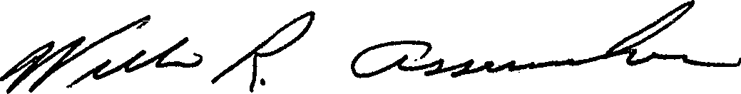 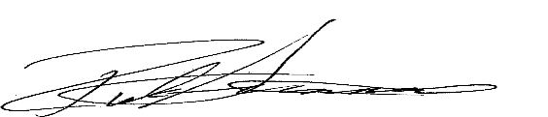

Bill Assenmacher, Co–Founder SABC Rick Grinnell, Co-Founder, SABC

For further information please contact:

Rick Grinnell, Southern Arizona Business Coalition

P.O. Box 26945

Tucson, AZ. 85726

520.247.3268 (c)

rick@soazbc.com

[www.soazbc.com](http://www.soazbc.com)