Dear District Rangers Edwards and Mercer, Buena Vista, March 17, 2023

The following comments on the Proposed Action – *Dispersed Camping Management on the Leadville and Salida Ranger Districts* – are provided by the Friends of Fourmile chapter of the Greater Arkansas River Nature Association GARNA.

Most of our comments refer to the proposal as it would affect the Fourmile Travel Management Area within Chaffee County, although we will make a few general observations about the proposed actions on other areas of Forest lands in Chaffee and Lake Counties.

**Description of our Chapter**

The *Friends of Fourmile* volunteer chapter was created and came under sponsorship of the non-profit cooperating association GARNA following development of the joint BLM/FS Fourmile Travel Management Plan begun in late 1999 and approved in 2002. Founding members of FoF were participants in preparing the citizen’s alternative in the Plan’s NEPA process. Even though we are a small group now numbering about 14, we have been consistently active since 2003 in providing patrolling, visitor contacts, annual Memorial Day surveys (each year since 2009), creation and revision of maps, brochures and etiquette panels, trash cleanup, and construction of buck and rail and other campsite containment structures. We have been participants in the *Recreation in Balance* Taskforc*e* and active in both the RIMS and Collector App survey programs and are actively collaborating with the Rec Adopter program. In our 20 years of effort, we have contributed over 20,100 volunteer hours, divided between lands managed by the BLM and the USFS within the 100,000ac Fourmile Travel Management Area.

We have a perspective on the Fourmile TMA that spans more than two decades of on-the-ground observations of changing visitor uses, increases in visitation numbers, resource impacts and occasional user conflicts. We believe we can provide informed comment on the Proposed Action in Fourmile in general as well as on specific areas and camping sites. Our comments below reflect both these interests.

**General comments**

Our first observation is in reference to the NEPA process. We would appreciate clarification on where this Proposal lies within the process; the NOPA indicates that an environmental assessment is being prepared yet the Proposal seems to have selected a preferred alternative before the EA has been made available for review. Although the Proposal as outlined in NOPA is generally very acceptable to our Chapter, we will reserve final opinions until the EA is available and impacts of this preferred alternative and other alternatives addressed is available

With that proviso, we agree with the Proposal’s overall approach addressing the challenge of accommodating increasing demand for Vehicle Based Dispersed Camping (VBDC) while providing adequate resource protection and maintaining the quality of the visitor experience. We see the principles of adaptive management as outlined, and the listed triggers to take corrective action, as being reasonable and workable, although they will entail considerable effort and continued engagement to effectively implement. The emphasis on identifying areas suited to designated dispersed camping, with some areas being left for dispersed camping, we see as appropriate as a starting condition (not, however, inside Fourmile, see below). We understand with adaptive management there may be future conditions where additional designated dispersed areas may need to be created. Addition of partially or fully developed campgrounds to accommodate visitors not able to find designated sites is a logical and necessary future option.

However, adaptive management should not be interpreted as a mechanism to continuously add camping opportunities – whether in designated, dispersed or developed campgrounds – in response to demand without recognizing there are finite visitor capacity limits. We urge you to be sensitive to the cumulative impacts of increasing camping opportunities on the two Districts as a whole and in Fourmile especially. We disagree with the conventional wisdom that increased demand is inevitable and that public lands managers are obligated to inevitably accommodate these demands. There are limits beyond which impacts on resources and the visitor experience should not be acceptable.

We emphasize there is need for collaboration with the BLM and its own camping management plan. The NOPA indicates there has been collaboration with the BLM prior to this Proposal’s development, and we urge this collaboration continue during the implementation phase of both plans. This is true particularly in the jointly managed Fourmile TMA but also important in many other areas where Forest lands are adjacent to BLM lands. A Record of Decision on the BLM camping management plan has already been issued and in principle their plan can begin being implemented as of the middle of March 2023. Because there is potential for unintended consequences on Forest lands if the BLM begins implementing designated dispersed camping in adjacent lands, we urge the two agencies collaborate on appropriate timelines for implementation.

Finally, as we observe for the Fourmile TMA (below), the transition envisioned in both the Forest Service and BLM VBDC approaches is going to require a thoughtfully planned communications strategy in several phases. We imagine a first step informing the visiting public that changes are coming, and a subsequent phase that guides users to designated sites, dispersed areas, developed campgrounds and overflow areas and outlines appropriate behavior in each. The third and perhaps final phase would confirm that regulations will be enforced and establish consequences for non-compliance.

**Comments related to the Proposal’s effects on the Fourmile TMA**

Our interpretation of the VB Designated Campsites map as it relates to the Fourmile TMA is that all FS system routes within the TMA will, at least ultimately, be subject to designated dispersed camping; no traditional dispersed camping will be allowed. We strongly agree with this approach, which is consistent with recommendations we made in the scoping phase. Our argument is that in an area already experiencing such intensive use, leaving some areas open to traditional dispersed camping would lead to the very same kind of uncontrolled addition of new sites and existing site expansions that the camping management plan is attempting to curtail.

We are concerned that if the transition to designated dispersed in the TMA takes a considerable length of time (for example more than 2 or 3 seasons) then the extra pressure on dispersed-allowed areas (meaning system routes not yet with formal designated sites) will lead to numerous unacceptable new traditional dispersed or expanded sites which would later have to be eliminated and rehabilitated. We therefore urge that you make that transition as smoothly and rapidly as possible. We recognize this will require considerable financial and staff resources and hope that you will make an effective case to upper management (and/or other funding sources) that a lengthy transition will result in unacceptable and even irreversible resource damage.

With respect to making the transition we offer assistance from our volunteer chapter in ways you feel appropriate, from helping assess conditions (the Proposal’s Table 2), triggers (Table 3), or the various management actions in the Adaptive Management Toolbox (Table 4.) Although your own staff will have principal responsibility in these tasks, we believe we can provide context and detail. Our 20 years of monitoring visitor use and detailed knowledge of the hundreds of existing dispersed sites in Fourmile can be of value as you make decisions on which of these sites (or new ones) should become designated dispersed sites, with subsequent facilities and containments. We also help in the longer term when routine monitoring of designated sites will be necessary, in collaboration with your staff and other volunteer resources (e.g., the Rec Adopter program).

An important issue which we did not see in the Proposal has to do with spur roads to existing dispersed campsites. Dozens of those spurs are non-system routes not appearing on the Salida District MVUM. Since many existing dispersed sites served by those non-MVUM spurs are likely candidates for eventual designation, we urge that during the designation process you ensure these spur roads become legitimate access ways even though they may not be recognized on the MVUM or in the recently prepared San Isabel NF-wide Travel Management documents.

In addition to the proposed Fourmile plans, we strongly support the Proposal’s recommendation to establish designated dispersed camping throughout the Browns Creek Raspberry Gulch area, with a developed campground nearby. Our Friends Chapter provided advice on the successful development and early operations of the Friends group Browns Creek Alliance. We urge the Forest Service to continue its ongoing cooperative relationship with this Alliance and other similar groups that may develop and involve them in implementation of eventual plans within their areas of focus.

Again, in reference to areas outside of Fourmile in both Chaffee and Lake Counties, we note from the VB map there would be designated dispersed camping along various routes known to already be receiving intense VBDC pressure (confirmed by the Heat Map). We concur with this approach and advise (as in the Fourmile situation) that you try to implement designated dispersed camping along the full extent of these system routes as rapidly as possible.

We also note on the VB map that some system roads would remain open to traditional dispersed camping in parts of Chaffee and Lake County. We advise, as the Proposal indicates, that these routes continue to be routinely monitored. We acknowledge – as evidenced on the Heat Map – that dispersed camping pressure currently is low in these areas, but Adaptive Management should be employed if establishment of designated camping elsewhere shifts camping use to these lesser-used traditional dispersed areas, and unacceptable resource damage begins to occur.

Returning to comments on the Fourmile TMA, we note the Proposal does not directly address walk-in camping near system routes. In our Chapter’s experience we have observed frequent VBDC use where a vehicle is parked legally along a system route and visitors walk a short distance off the route, carrying their camping equipment. Typically, they build a rock firepit which they do not dismantle, and frequently cut dead (and live) branches to use as firewood. In some cases, this situation leads eventually to vehicles developing a spur road to the site, thus creating a new traditional dispersed site with resulting resource impacts. Given that the Proposal indicates NO traditional dispersed camping off system roads would be permitted within the Fourmile TMA it seems walk-in camping of this type should not be permitted. We recommend that the future Proposal/Plan clarify this issue. A related situation is where campers in an existing site walk around or through an opening in a containment fence and establish an additional dispersed site beyond the containment boundary, adding a rock firepit. This type of walk-in should be addressed (and prohibited) for designated sites but clarified for traditional dispersed camping areas outside Fourmile.

We note the Proposal does not directly address the issue of backpacking (within Fourmile or elsewhere). We grant this is not strictly vehicle-based camping and thus may be beyond the scope of this Proposal. However, it seems appropriate the Proposal at least takes note of it. For example, in Fourmile would it be permitted to park a vehicle legally alongside a system route or at a trailhead and hike a considerable distance from the system route, overnight camp, build – and leave – a firepit, and create a latrine? What about the use of fire pans and a requirement to carry out human waste? If this Proposal cannot include such decisions, at least be clear that it is beyond the scope and that it may or will eventually be separately addressed.

Is overflow camping addressed in the Proposal? If not, we recommend that it be considered. We anticipate that as extensive areas (e.g., all system routes in Fourmile) become subject to designated dispersed camping, in heavy use periods like Memorial Day there will be demand for sites that exceeds the number of designated sites and sites in the proposed developed campground at 375C. Overflow management requires cooperation with the BLM and municipal or private interests.

The Adaptive Management Toolbox (Table 4.) is a welcome list of specific actions. We see them all as applicable within the Fourmile TMA; our Chapter has been involved in many of these actions, under supervision of agency contacts, prior to the development of camping management plans by either agency. We look forward to these actions being undertaken by agency staff during plan implementation and anticipate offering our assistance.

The “Add Education” tool is one which we take particular notice of, given that for the past 15+ years our Chapter has played a major role in education of Fourmile visitors. We have installed over 40 kiosks containing TMA maps, local area maps, and visitor etiquette panels which we prepared under agency guidance (and funding) as well as producing and distributing over 200,000 copies of the Fourmile brochure and map. Our tasks included managing brochure and kiosk panel inventories and stocking dozens of brochure boxes on kiosks and supplying brochures to local businesses and other outlets. In anticipation of designated dispersed camping and additional developed campgrounds, we foresee the need for substantial revision of existing mapping and messaging. We also foresee the need for wide scale and close-up mapping indicating site locations and numbering, plus regulations associated with designated dispersed camping. We look forward to discussing with Forest Service and BLM what continued roles our Chapter might play in this category.

In reviewing some of the site-specific mapping made available in public meetings we noted an error in the map portraying the potential for a developed campground on 375C in north Fourmile. We have reported this error to the document’s Canon City preparers but for the record, below are those specific comments in the form of our email to Beth Davis.

As noted in the email, the Friends of Fourmile agrees this is an appropriate location to eventually provide developed campground facilities, perhaps beginning with a no-fee, no host approach but with a permanent restroom, designated sites, metal fire rings and picnic tables.

**From:** Alan Robinson <[robinsonalanh@gmail.com](mailto:robinsonalanh@gmail.com)>   
**Sent:** Sunday, February 26, 2023 8:57 PM  
**To:** Davis, Beth - FS, CO <[mary.davis@usda.gov](mailto:mary.davis@usda.gov)>  
**Cc:** Edwards, Perry - FS, CO <[James.Edwards1@usda.gov](mailto:James.Edwards1@usda.gov)>; Mellick, Lisa - FS, CO <[lisa.mellick@usda.gov](mailto:lisa.mellick@usda.gov)>  
**Subject:** Re: [External Email]Question on FS camping Management materials

Dear Beth,                                 February 26, 2023

Thank you for the quick action in posting those wall maps on the web. [deleted text].

[Deleted text] several of us interested in the potential for a campground in Fourmile in the area of FR375C noticed a problem in that wall map. Here is the map:

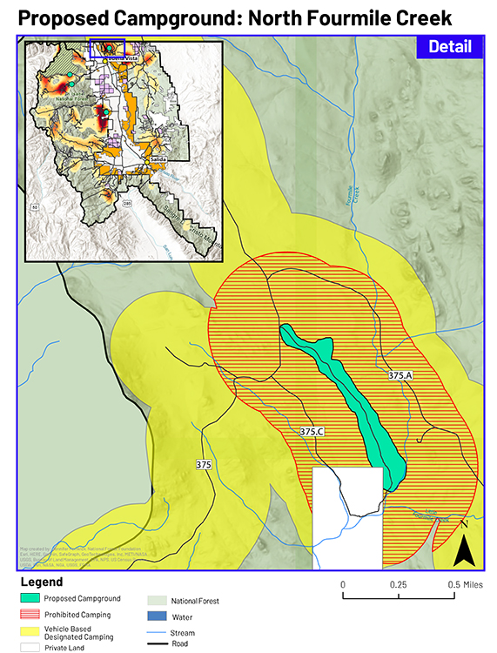

[Deleted text] There is an error in the NVUM in which the number 375C is attached to a non-system road that was closed about the time the 2002 Fourmile TMP was completed. It used to end in a sandy wash that was being abused by hill climbing vehicles; FS and FoF closed that off about 2005 as per a decision in the TMP.  There is a system road just to the east (not on the MVUM) that has long been signed and accepted as 375C. You properly indicate that road as where a potential campground may be developed. I realize that changing the NVUM is not likely an option but perhaps on your wall map you could shift the FR375C marker over to the correct FR and erase the closed non-system route. People who know Fourmile well may otherwise be confused. FoF is the group responsible for creating and printing the Fourmile TMA map, and we made sure it accurately reflected the MVUM; so unfortunately, the Fourmile map also has the slightly incorrect location of 375C.

Also, the white rectangle indicating private land is not current. There is no longer any private land down there.

Just for your information the Friends of Fourmile is familiar with camping situations on (the correct) 375C. Here’s what we did near its junction with 375 with FS supervision in 2018:

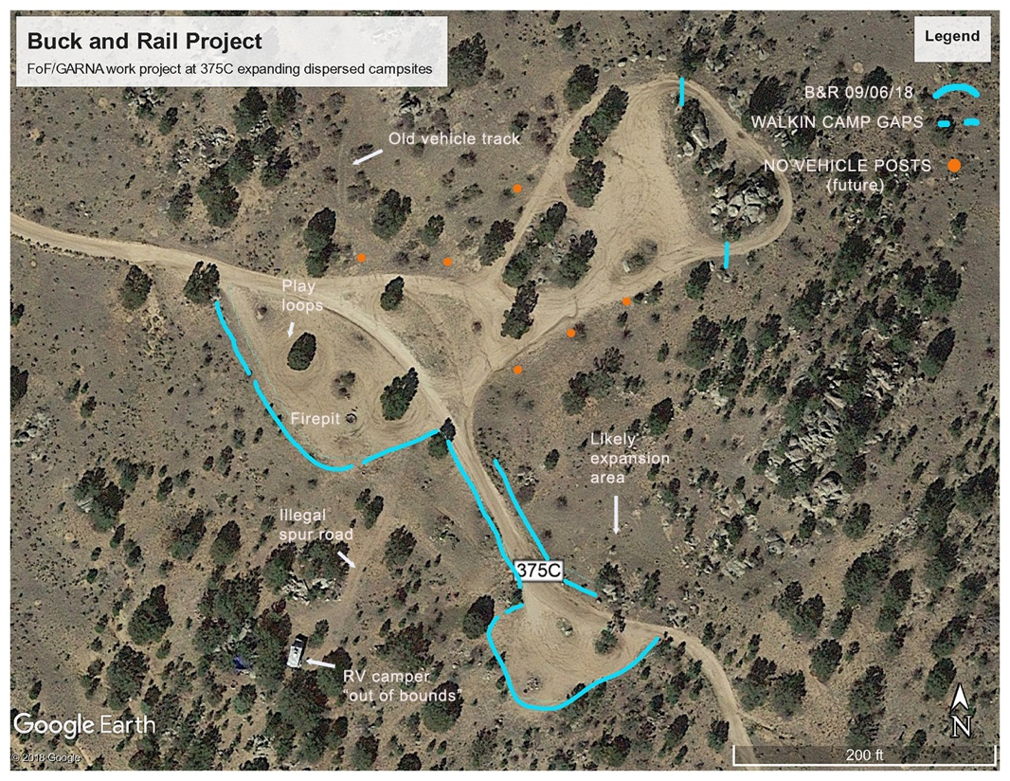

When we started monitoring this area after 2003 there was only one relatively small, dispersed site in the upper right corner. Starting about 2015 with a huge Memorial Day influx of RVs, everything over on the left of the road suddenly appeared and began expanding in following years. In one of the largest of several dozen FoF B&R projects we put in 150 yards of fencing as indicated on the image. Since then, the area boundaries have been fairly well respected.

We’ve also been monitoring the 6-8 sites farther south on 375C down to its dead end at a historical site named the Sailor Homestead (a day use area now, since overnight camping was causing damage near the creek). As we will be commenting later, the FoF agrees the upper part of 375C is a reasonable location for a modestly sized campground. However, the turquoise envelope on your map extends too far south – as shown it would drop steeply down (4WD) and would be inappropriately close to Fourmile Creek.

[Deleted text]

Alan Robinson

Agency Contact  
Friends of Fourmile Chapter of GARNA  
Tel  (719) 395-3396 Cell (719) 221-1259

e-mail: [robinsonalanh@gmail.com](mailto:robinson@chaffee.net)

<http://www.garna.org/friends-of-fourmile.htm>



End of Comments

Submitted by

Alan Robinson

Agency Contact  
Friends of Fourmile Chapter of GARNA  
Tel  (719) 395-3396 Cell (719) 221-1259

e-mail: [robinsonalanh@gmail.com](mailto:robinson@chaffee.net)

<http://www.garna.org/friends-of-fourmile.htm>

