Current accelerated and egregious logging projects of mature and true old-growth forests, such as the Blue and Gold Logging Project in Washington State, the Upper Cheat River Project in West Virginia, the Wrangell Island Project in Alaska, the South Fork Project in California, the Southside Project in North Carolina, --and the list goes on!-- underscore that the US Forest Service (USFS) has not worked in good faith to comply with Executive Order #14072 and has not worked towards the protection or strengthening of our mature and old-growth forests. **This is why we must impose a logging moratorium on all National Forests.**

The purpose of EO14072 is to restore and conserve our Nation’s Forests, including mature and old-growth forests by:

1. Fostering long-term United States forest health through climate-smart reforestation for the benefit of Americans today and for generations to come;
2. Defining, identifying, and completing an inventory of old-growth and mature forests on Federal lands, accounting for regional and ecological variations and make such inventory publicly available; and
3. Analyzing the threats to mature and old-growth forests on Federal lands, including from wildfires and climate change; and develop policies, with robust opportunity for public comment, to institutionalize climate-smart management and conservation strategies that address threats to mature and old-growth forests on Federal lands.

Instead of complying, the Draft Environmental Impact Statement (“DEIS”), provided by the USFS, does the opposite.

1. The proposed DEIS permits “proactive stewardship” for old-growth forests and states that this so-called “proactive stewardship” would help forests become resilient and adaptable to current stressors and future environments. This will not work and goes against widely accepted science regarding best management practices around CO2 sequestration and biodiversity needs. The best management approach to strengthen mature and old-growth forest ecosystems is proforestation *(See Moomaw, Masino, and Faison, 2019 “Intact Forests in the United States: Proforestation Mitigates Climate Change and Serves the Greatest Good”)*. Regarding carbon sequestration, the science again is very clear that no management is the best approach *(See Nunery and Keeton, 2010, “Forest carbon storage in the northeastern United States: Net effects of harvesting frequency, post-harvest retention, and wood products” and graphic below.)* In order to let our old-growth and mature forests become more resilient, we must let them follow their natural dynamic. The USFS, per their statements, also erroneously assumes that the quickly evolving climatic changes are predictable, which they are not.

In the name of “forest health” and “wildfire prevention,” the USFS is preemptively destroying our forest ecosystems through aggressive thinning and logging. These management practices have degraded -- and are continuing to degrade-- the little that is left of old-growth. The DEIS proposes continuing down the same path taken by the USFS to date and promises different outcomes from what we can see. “Proactive stewardship,” “climate-smart forest management,” and “maintaining forest health” are all approached with the same tool: logging (and potentially some “prescribed” burning) despite clear scientific evidence that no management is the best way to maintain and improve forest ecosystems resilience. In addition the DEIS does not propose any pathway on how to recruit future old-growth despite this being an essential part of EO14072. The approach proposed in the DEIS would keep our forest ecosystems unnaturally young, halting them from reaching their maximum ecosystem services potential: from carbon sequestration, to providing healthy waters, air, soils, and habitat for biodiversity. In short, destroying forest ecosystems through thinning and logging does not help the forests, the climate emergency, or biodiversity.

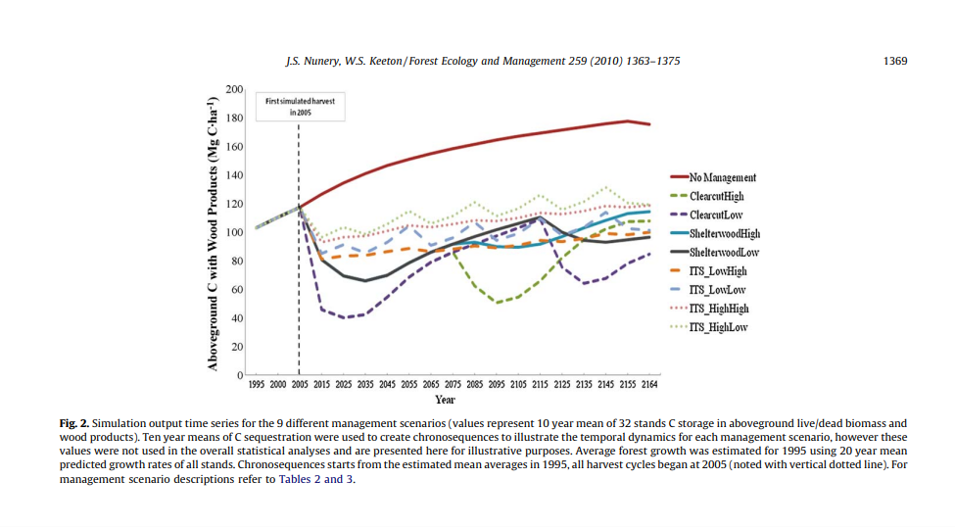

2. The DEIS does not obey the EO14072 in its request to clearly define, map, delineate, or respect ecological variations. It does not suggest or mention any input from local forest groups or experts on the ground who are eager and willing to help save our forest ecosystems. It does not distinguish between economic standards and ecological standards, nor does it specify when to use which one, leaving all management options –including logging- open. In fact, the DEIS proposes the same forest management practices for eastern forests as for purported western forest needs, emphasizing wildfire prevention --even though this is hardly an issue in the East. What is worse, eastern forests are proposed to be managed to reduce mesophication when this is a positive development as it increases moisture, carbon capture, and naturally reduces fire hazards. Our diversity of forests requires a forest-by-forest approach and there must be a pathway for mature forests to become old-growth through proforestation. The USFS must respect the natural and continuous dynamic evolution of forest ecosystems which are adapting to our changing climate as best they can instead of attempting to freeze a forest’s natural dynamic to match some random point in its evolution selected by the USFS. The USFS also needs to refrain from continuing to manage forests to remain in a specific stage of forest succession and let forests complete their own natural dynamic.

3. The DEIS does not accurately reflect the threats to our forests:

a. The biggest threat to our forests consists of those who want to profit from timber and woody biomass for energy– namely the USFS and industry. It is unfortunate that the USFS is being pushed to meet growing timber targets extracting from the very same forests it is supposed to protect. The USFS even goes as far as suggesting that woody biomass pellet factories could fund additional management. Until such day that the USFS is removed from the timber trade, it will not protect our forests. In its Threats Assessment, published by the Agency in June of 2024, the USFS itself acknowledges that logging prior to 1990 had harmful impacts and credits public pressure as a major factor in the reduction of rampant logging for commercial profit. However, the USFS has not changed its ways and now we have now have much increased pressures of severe climate and biodiversity crises.

b. Forests are adapted to wildfires and need to be protected from thinning and fire management implemented by the USFS which has mostly increased the size and speed of wildfire-propagation. Logging, under the euphemisms of “thinning to reduce potential fires” or “to halt disease” or “reduce fuel loads” because a forest, per the USFS, is “overstocked” belies modern science and IPCC recommendations which demand proforestation (see above). Thinning destroys important micro-climates and all the life in it, and removes shady, cool, and moist forest floors which slow down or resist fire. It opens a forest up to winds that carry the flames faster and farther. It also removes the oldest trees which can withstand a wildfire and which would help regenerate forests. The mere practice of thinning often releases more CO2 than a wildfire when all lifecycle emissions are counted. Meanwhile, prescribed burns do not reduce the fuel loads for more than a 2-3 years but harm the ecosystem and release CO2 each time applied. In short, the USFS wildfire management approach is a failure. Wildfire management funds should be dedicated to hardening communities, not to preemptively destroying forests in backcountry. *(See Hanson, 2021, “Debunking Wildfire Myths to Save Our Forests and Our Climate.”)*

Instead of continuing to do business as usual as the USFS suggests as its preferred option, it must obey EO14072 and change current management practices in order to strengthen our forests. The USFS should also look towards Executive Order #14008 which asks for permanent legal protections on 30% of all waters and lands in the U.S. by 2030. Within the 30%, we must prioritize forest protections since 80% of all terrestrial life lives in forests and forests are the only true and effective terrestrial method of carbon sequestration. This is our lifeboat!

We must institute a logging moratorium immediately to protect our mature and old-growth forests and then set permanent and legal protections on all 145 million acres of National Forests to reach our 30 x 30 goals.