Dear Ms. Jewett:
Thank you for the opportunity to comment on the Foothills Landscape Project Draft Environmental Assessment (“Draft EA”).
The process that has led to this Draft EA has been styled as a collaboration by the agency. I have participated in it from the beginning, attending many meetings and submitting written comments. This process has not been a collaboration. The agency had a plan in mind when the process began 4 years ago and has not deviated in any significant way from this plan. This can easily be determined by reading the comments submitted as the plan was released. Nearly all the comments opposed the project. How can this be called a collaboration when only the agency’s views were considered? At several meetings there were nearly as many agency employees present as public participants. After 4 years and hundreds of thousands of dollars of employee time the agency thought so little of the collaborative nature of the process that the Draft EA, consisting of many hundreds of pages of text, tables, charts and specialist reports was released over the Christmas holidays with only a 30 day comment period. Your staff has worked long and hard on this project but unfortunately has been given an impossible task and poor direction.
There are many problems with this project. First and foremost is the fact that this project violates NEPA by denying the public the right to make informed comment on when and where timber cutting, herbicide use, burning and road building will occur. All the public will know is that somewhere at some undetermined time 80,000 acres of mechanized timber harvest, 75,000 acres of herbicide application, 50,000 acres of burning and miles of road building will occur.
This is more timber cutting than has occurred on all the Region 8 Forests in the last 10 years. If timber cutting were to continue at the same pace as it has in the past on this Forest it will take 40 years to complete.
The Agency spent little time in the scoping proposal discussing the effects of climate change and carbon storage other to state that temperatures will rise and precipitation amounts will remain the same and then state that
“Carbon sequestration is not a direct purpose of the Foothills Landscape project. There is likely to be benefits to carbon sequestration as a result of the project and those will be explored further during the effects analysis…”
Unfortunately the Draft EA has little more to say about the subjects.
In fact the general consensus concerning precipitation is that while the total amount of precipitation may remain the same, rain events will occur in violent downpours as witnessed in Louisiana and Texas in the last few years. This Forest has witnessed such events in the deluges experienced in December of 2015 that swept away parts of several roads on the Conasauga District which took years to repair.
The lesson to be learned from this is the less ground disturbance the better. The project however proposes timber harvesting over tens of thousands of acres. Timber harvesting requires temporary roads, skid trails, log landings and heavy truck traffic. All of this ground disturbance leaves areas vulnerable to landslides and erosion in major rain events. As the exact areas to be harvested are not identified it is difficult to comment precisely as to the extent of this danger. After upwards of 25” of rain in December of 2015 barely 35” of rain fell in all of 2016. Downpours of up to 3” per hour have become common as the climate warms.
The Draft EA on page 44 states “Carbon sequestration is not a direct purpose of the Foothills Landscape, though benefits from carbon sequestration as a result of the project are likely.” In fact as timber is harvested Carbon storage will decrease .Tops, laps and branches left on the forest floor decompose and the regenerating forest does not sequester the same amount of carbon as the mature, growing trees removed. Masticating the debris left over from timber harvest will only hasten decomposition and increase the rate of carbon release. This deficit will last for decades. Timber harvesting with bulldozers, skidders, masticators and truck traffic adds more carbon to the atmosphere as all these machines consume large amounts of diesel fuel.
In addition to the effects of timber harvest the plan to regularly burn tens of thousands of acres perpetually will upon burning release vast amounts of carbon into the atmosphere that otherwise would have been released slowly over decades while adding fertility, structure and tilth to the forest soil.
As CO2 rates in the atmosphere continue to increase to critical levels the failure of the EA to adequately analyze the effects of this huge project on carbon storage is another indication that a more thorough study should be done in the form of an EIS.
Despite all of this and the undeniable evidence of climate change this project proposes to give the public one chance to comment on a variety of treatments that most likely will be implemented in a vastly different climate.
Extensive use of unnamed herbicides are planned to be used for decades ahead but the public is expected to make informed comments based on no information? Over the years many commonly used pesticides have been found to have terrible side effects and their use has been curtailed .Who can predict what herbicides commonly used today will upon investigation over time be discovered to have serious environmental problems. Restricting the public’s right to comment once for decades to come is a violation of the letter and spirit of NEPA. The agency should notice that many of the comments received have criticized planned herbicide use. Not much collaboration on this issue.
The project proposes to repair this forest’s failing road system to facilitate timber harvest. Currently the forest has only a fraction of the money necessary to maintain the existing road system let alone funds to repair and rebuild and expand. Where will this money come from? Why will the future be any different than the past? This forest has spent considerable time and money on two studies of their road system in the last 15 years .The Roads Analysis Policy ( RAP) [compiled by a private contractor at a cost of $70,000] and the Transportation Analysis Policy (TAP) done in house. Despite RAP and TAP little has been done on the ground to repair the roads and halt the environmental degradation (which the EA correctly identifies as the major source of stream siltation).The projected increase in timber harvest and the heavy truck traffic required to effect this harvest will put additional stress on the road system for decades to come. How can the public be expected to comment intelligently now on activities that may or may not occur for decades ahead that depend on uncertain funding.
The preferred alternative selected in the draft foothills EA proposes to expand the existing 275 acres of wildlife openings in the foothills area by 14oo acres. The wildlife openings (food plots) that exist on the CONF both on the foothills and elsewhere are for the most part nonproductive and provide very little if any benefit to wildlife. The agency did not acquire fertile farm land when the CONF was established but rather steep and rocky forest land ill-suited for cultivation. What areas had been farmed had been abandoned as a result of their unsuitability prior to Forest Service acquisition. 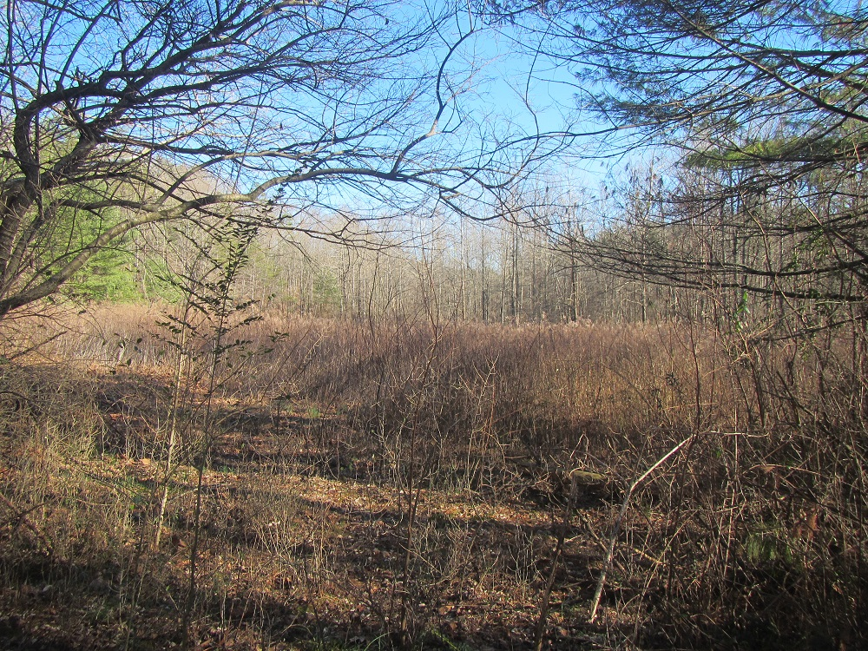
Overgrown and untended FS food plot on Cochran Creek in the foothills. Actually one of the few on reasonably fertile land but due to lack of resources and remote location nonproductive.
The Agency acknowledged problems with the food plots on Agency land, mostly managed by the GA DNR, in 2000 when they proposed to poison the existing vegetation and start over in an attempt to create a more nutritious clover mix rather than the fescue cover that existed. 20 years later the food plots if tended at all remain predominately low value fescue. A major problem with food plots is that when cleared initially the clearing was done with bulldozers and most of the topsoil was bladed off with the stumps. This can be seen when looking at the mounds of soil on the perimeter of the openings. Autumn Olive planted in some openings has proved to be an invasive problem. Neither the Agency nor the DNR has the manpower to properly maintain the many small scattered food plots. Given this record of failure it makes no biologic or economic sense to expand the size or number of the openings.
The reason given for the cutting, burning and poisoning of tens of thousands of acres here on the CONF is to make the forest healthy and resilient. The agency should look north 100 miles to the Great Smokies National Park. Managed by the Park Service for not much longer than the CONF the forest there is resilient and healthy with little or no management activity. Tourists flock from all over the world to visit. Forests have been managing themselves for thousands of years in this area. The agency wants to restore the forest to what? Back to an era of grazing and burning that led to an expansion of Yellow Pine species beyond their natural boundaries? Scarifying areas mechanically to duplicate the actions of the hooves of sheep, cattle and hogs (introduced after the European conquest) that roamed these mountains prior to FS acquisition. Despite the current administration’s mandate to increase timber production the agency should recognize that the vast majority of ‘collaborators’want this to be a recreational forest. Vegetative management projects should be kept small and results analyzed and the public informed and given a chance to comment before embarking on new projects. Just the opposite from the proposed project.
One final comment is that there is absolutely no economic analysis in the draft EA . How will all these activities be paid for? I think this raises a legitimate concern that the selection of trees to be harvested will be based on their economic value rather than on some idea of restoration.

David Govus
Ellijay GA 200110

