Forest Visit Documentation Form
Siuslaw National Forest
09/15/2024
Forest Visit ID Name __Site 12 (off Wassen Rd.)________________________
(Use any name you wish. Followed Forest Service road No.)
Multiple stops on the same road, ID Name followed by 1, 2, 3, etc.)
GPS DM or DMs location: Latitude _43° 42’54.8” N ______________________________
Longitude _123° 51’18.2” W_________________________
(I-Phone compass provides Lat Long location or use the recommended App.)
Latitude typically starts with 44⁰ and ends with a N for north.
Longitude typically starts with 123⁰ and ends with W for west.
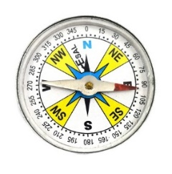
Compass Direction from Road (Check One)
N ___ NE ____ E ____ SE _ X _ S ____ SW ____ W ____ NW ____

Road Number from Siuslaw Road Map: off Wassen Rd.
Measured Tree Circumference (inches): 107” = Diameter: 34”

*Largest tree: 232” = Diameter: 74” (there were numerous trees of this size at site)

(Circumference x 3.141 = diameter)
Estimated diameter of Typical Dominant (tallest) Trees (inches): 34”
Place an X next to tree species present. Doug fir: X Hemlock: Cedar: X
Sitka Spruce: Alder: X Big Leaf Maple: X
Is a shade tolerant understory of Hemlock or Cedar present? Yes: No:
Describe understory:

Plants Identified
Huckleberry: Salmonberry: X Thimbleberry: Blackberry:
Elderberry: Vine Maple: Dogwood: Cascara:
Salal: Ferns: X Moss: X Lichen: X Fungi:

Notes on other plants present:

Animals observed:
Chipmunks heard squeaking.

Birds Present:
Scrub Jays heard.
Notes:

___________________________________________________________________________________
Keeping Track of Your Forest Photos
Option 1: Before you take your forest photos, write down the forest visit name on the form and take a photo of the name. Then take the forest photos. Note that the photos after the forest visit name belong to that name.
Option 2: Take a screen shot while your GPS app is on before your forest and tree photos (I-Phone).

Optional (All information in the form will be viewable by the public)
Your Name:
City: State:
Insert Stand Photo (Optional)
ID/Name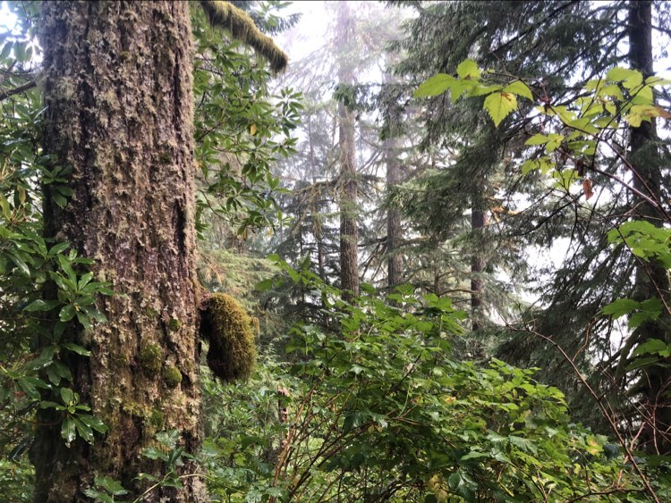

Insert Photo of the typical tree that was measured (Optional)
ID/Name: Typical tree (measured)
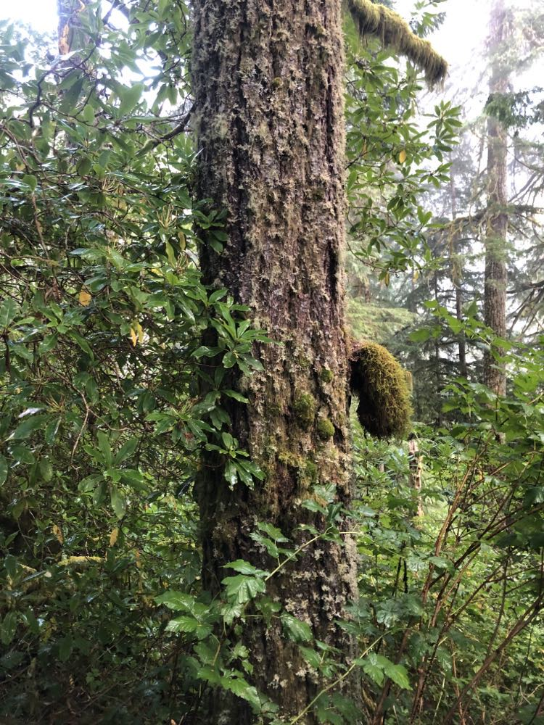

ID/Name: *Largest tree measured (there were numerous trees of this size at site)
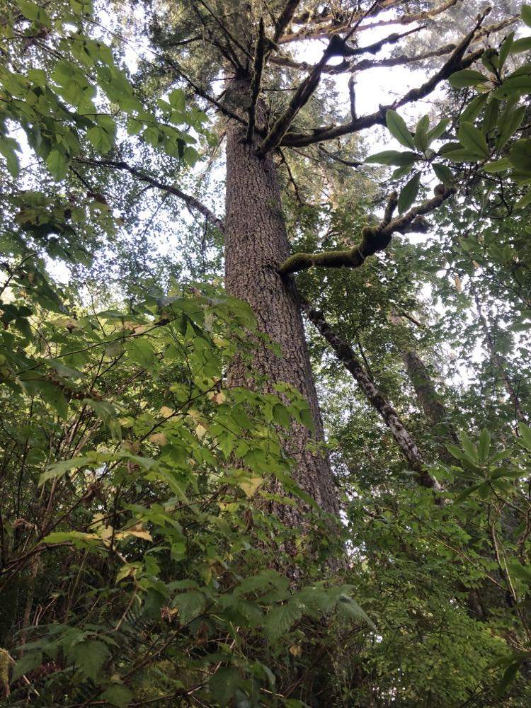
Save the document as a pdf file for uploading to the Forest Service comment portal.
Wait for guidance from the CRA for writing your text comments placed into the comment portal.

