June 3, 2019

**Comments on Custer Gallatin Forest Plan Revision DEIS**

Dear Reviewing Official:

We have traveled extensively across the Custer Gallatin National Forest (CGNF) for more than a decade, with a particular emphasis on exploring Wilderness Study Areas, Recommended Wilderness, and inventoried roadless areas that lack formal protections of any kind.

The Custer Gallatin National Forest harbors an incredible diversity of species, many of which exist in few other places in the US and are often taken for granted by residents of Montana and Wyoming. The CGNF and surrounding landscapes are still undeveloped and wild enough to support grizzly bears, wolves, wolverines, and other wide-ranging mammals that require large, intact home ranges. Pressures from [new and expanding forms of recreation](https://mountainjournal.org/scientists-say-mountain-biking-negatively-impacts-bears), especially mechanized and motorized vehicles like mountain bikes, ATVs, dirt bikes, snowmobiles, and new snow bikes, threaten to disturb denning animals, surprise animals in formerly remote areas, and otherwise shrink and fragment sensitive habitat.

To be clear, what makes this region of Montana unique are not the recreation opportunities (which can be found on many other National Forests across the country), but rather the wealth of species and wild landscapes that are unique to the Northern Rockies. All of this can be lost without management direction (including strong standards and guidelines) that preserves or enhances wilderness character.

Following are brief comments on specific regions of the Forest. In general, I support Alternative D to maximize the extent of Recommended Wilderness on the CGNF. Montana’s fish and wildlife require the space and security of large RWAs to survive and thrive into a warmer future. I also believe that is essential for the CGNF to follow the Kootenai NF, Beaverhead-Deerlodge NF, and others that prohibit “non-conforming uses” in Wildrernes areas. Only by proactively maintaining wilderness character will these areas retain their suitability for designation by Congress someday in the future.

**Chalk Buttes**

The Chalk Buttes are a unique landscape that deserves Recommended Wilderness status for its unique qualities. In few other places in SE Montana can you find such solitude, so little human development, and a wild and untrammeled landscape that has largely been left to its own devices. In the Chalk Buttes, you are more likely to find a dinosaur bone than another recreating human. The Chalk Buttes deserve to be managed without developed trails. This area is appropriate for dispersed recreation on foot and horse. Such landscapes are rare and extremely valuable across the National Forest System, nationally.

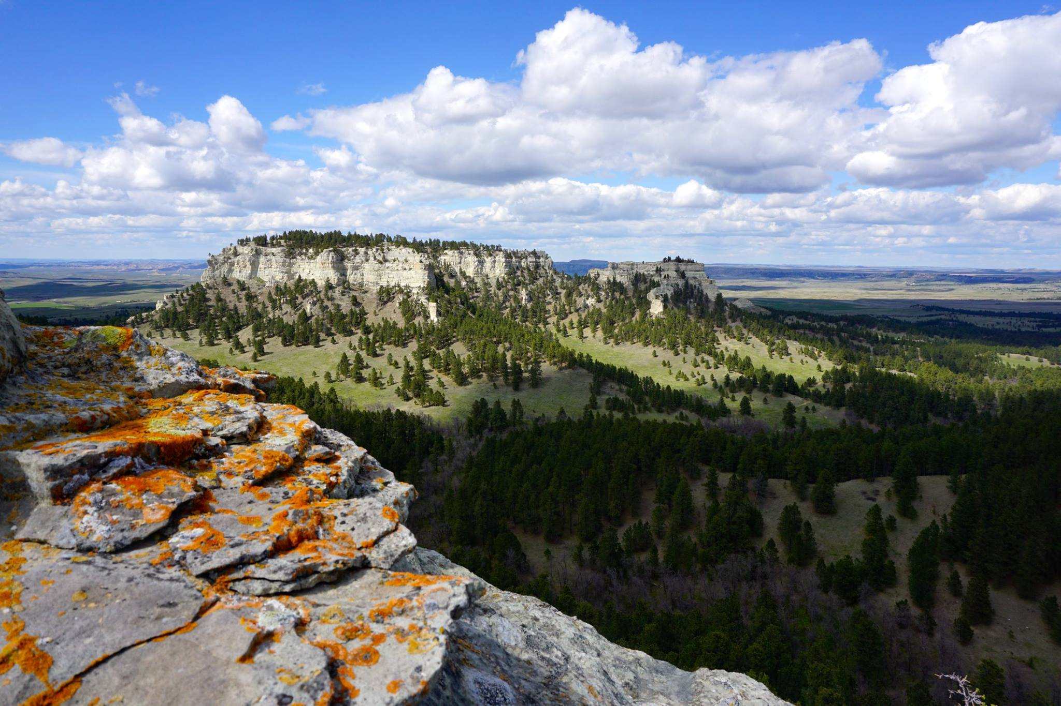

The trail-less and wild Chalk Buttes

**Earthquake/Lionhead**

Standing atop the Idaho-Montana border in the Lionhead IRA at sunset, a herd of mountain goats moved across the open plateau several hundred yards away. This landscape is situated at a critical crossroads for Yellowstone NP’s wildlife. If species are to migrate to surrounding landscapes, including someday to Central Idaho wildlands (Frank Church-Selway Bitterrroot), they will pass through the Lionhead IRA, into the Centennials, and beyond. This area is one of only two that has been managed as a Recommended Wilderness under the current Forest Plan, but yet it has also been opened to mountain bikes and other uses that are incompatible with Wilderness designation. Going forward, if the area is to retain RWA status, non-conforming uses must be removed to give the area the best chance possible to retain its wilderness character and suitability for designation by Congress by removing social conflict between recreational user groups.

**Gallatins**

All of the Hyalite-Porcupine-Buffalohorn WSA deserves to be in Recommended Wilderness status. This is the largest remaining unprotected mountain range radiating out of Yellowstone NP, with all of the same wildlife found within the Park, except an even higher concentration of grizzly bears. While eating dinner one night on the Gallatin crest, my wife and I gazed down on a grizzly munching on her own dinner in a meadow only a few hundreds of yards away. These are the types of experiences you can expect in the Gallatins. I believe the entirety of the HPB-WSA should be protected as an RWA to preserve sensitive wildlife habitat. High-intensity recreation should be kept to the northern end of the Gallatin Range, outside of the WSA, as well as other high-use areas like the Bridgers and Bangtail.

**Pryors**

An altogether unique landscape, the Pryors rise out of Montana’s only true desert, in the rain shadow of the Beartooths. Because of their unique climate, the Pryors support many plant and animal species and communities that are uncommon or rare elsewhere at the same latitude. The Pryors have some of the oldest and healthiest Whitebark Pines we’ve seen anywhere in the Northern Rockies. Bear Canyon has been identified as an Important Bird Area by Montana Audubon. Because of the Pryor’s open terrain and fragile desert soils, they are easily abused by ORV recreation. One pass of an ATV or dirt bike can destroy what little vegetation might be on the surface. The Pryor’s unique ecology demands the highest protection possible as Recommended Wilderness.

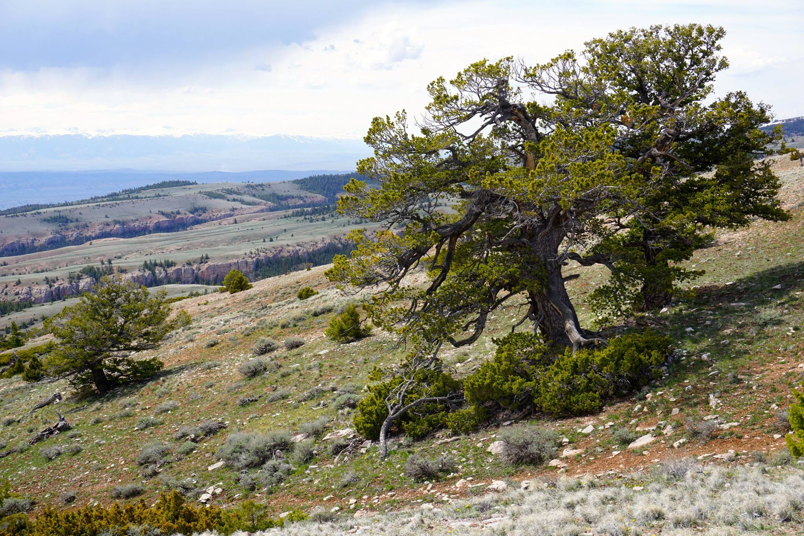

Ancient and immense Whitebark Pines on the slopes of Red Pryor Mtn. in the Bear Canyon Recommended Wilderness Area (Alt D)

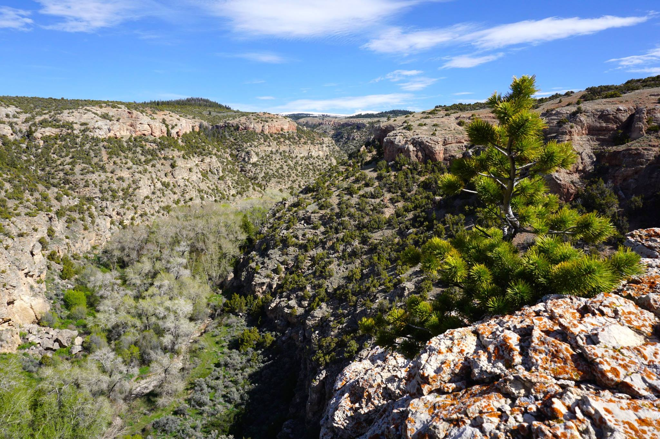

Big, wild, and roadless Bear Canyon in the Bear Canyon Recommended Wilderness (Alt D)

**Crazy Mountains**

Despite their status as one of Montana’s highest ranges, with an extraordinary wealth of wildlife, and scenery on par with any range in the Northern Rockies, the Crazy Mountains somehow remain relatively unknown. Between this anonymity, the incredibly rugged terrain, and the fact that there are many trail-less basins, means that the Crazies are *wilder* than many comparably sized roadless areas in Montana *despite* the fact that there is significant checkerboard that needs to be dealt with in the long term. Fortunately, nearly all of the private parcels remain undeveloped and indistinguishable from public lands that surround them. But it will require proactive efforts on the part of the CGNF to ensure that this continues to be the case. The full roadless area of the Crazies should be protected in RWA status. The boundaries of Alternative D are too small.

What’s more, I hope that the CGNF will give special consideration to the Crow Tribe, which has been unfairly left out of past decision-making as it relates to their historical territory, including the Crazy and Pryor Mountains.

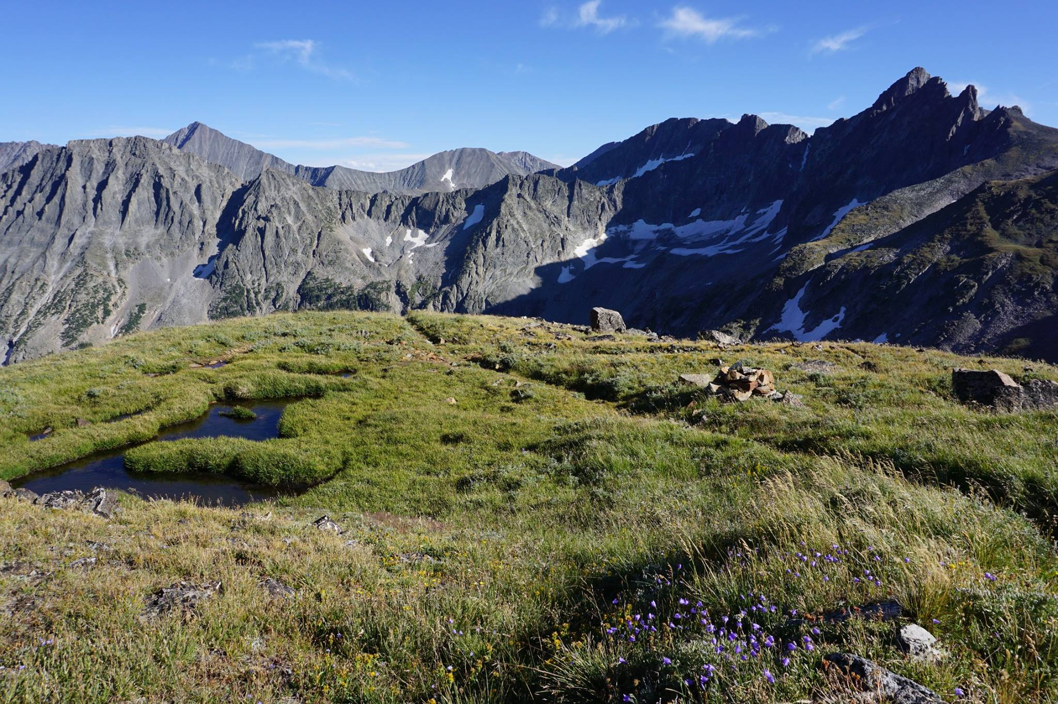

The wild and majestic Crazy Mountains in the Crazy Mountains Recommended Wilderness (Alt D)

Thanks for your careful consideration of these comments.

Best regards,

Zack

Zack Porter

17 N. Park Dr.  
Montpelier, VT 05602