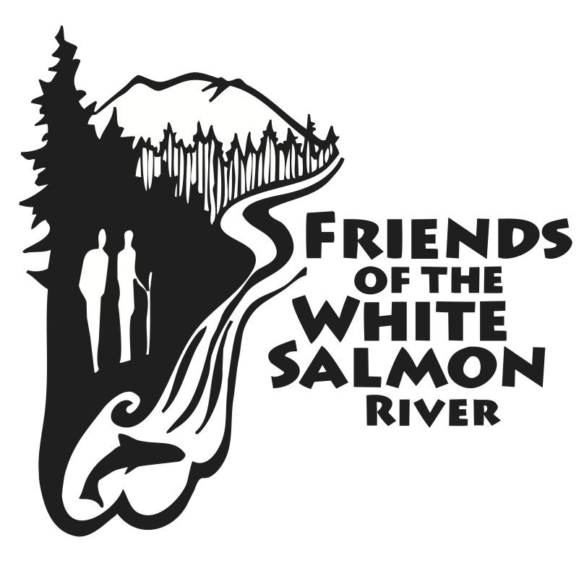

Friends of the White Salmon River

Post Office Box 802

White Salmon, Washington 98672

(509) 637-5749

[http://www.friendsofthewhitesalmon.org/](http://www.friendsofthewhitesalmon.org)

October 31, 2024

Erin Black

District Ranger

Mt. Adams Ranger Station

2455 Highway 141

Trout Lake, Washington 98650

*Via website:* [*https://cara.fs2c.usda.gov/Public//CommentInput?Project=63961*](https://cara.fs2c.usda.gov/Public//CommentInput?Project=63961)

RE: Comments on Little White Salmon Forest Resiliency and Fire Risk Mitigation Environmental Assessment

Dear Ms. Black:

We appreciate the opportunity to comment on the Little White Salmon Forest Resiliency and Fire Risk Mitigation Project. The mission of Friends of the White Salmon River (FWSR) is to protect biodiversity, build resilience, and strengthen ecological functions of watersheds of Klickitat and Skamania counties. Friends of the White Salmon River has led local advocacy efforts since 1976.

The document reflects hard work by USFS staff and management, and we appreciate that effort very much. We also appreciate the work you have done to involve the public in this process. For lack of capacity, we have not been active participants in this process of study and discussion. It seems to me, looking in from the outside, that the groups and interests who have been most intensely involved are those who have an economic interest in timber harvest, which includes the Washington State Department of Natural Resources.

The EA list of agencies consulted does not include the Washington Department of Fish and Wildlife, which is unfortunate, since they have statutory responsibility to preserve and protect Washington fish and wildlife, resources owned by and managed for the benefit of the public.

The EA is highly technical, both in substance and in the planning framework, some of it somewhat outside our area of expertise. Nevertheless, we think this is an important proposal, so we will offer our comments. We hope they will be useful.

We agree there is a need for this proposal, and we think that valuable knowledge may be gained through implementation of the project. We generally agree with the Purpose and Need statements, particularly the need to build resiliency to climate-change-related stressors. We are doubtful, however, that even well-informed agencies and scientists have sufficient knowledge and wisdom to manage forests for resilience to climate change, so we are not supportive of an approach as invasive and intense as this one.

We do not see in the EA a consideration of the effects of regrowth during and after the period of this Project. Forests are living systems, and Great Spirit willing, they will continue to grow. How long will it take for canopies to close in again, for example? We support the effort to help forests heal from past human actions that we now perceive to have been harmful, such as plantations. However, since we recognize some past errors, understandable as they may be, we need to bring a spirit of humility and caution to present actions, and we need to include the forest as an active partner, not a passive collection of sticks to be managed.

Philosophy aside, we do have some specific comments.

We strongly support the removal of 2,351 acres of old growth from the Project. Those stands are irreplaceable. Thank you for taking this action.

If there is a reference in the EA to the Lost Creek ancient forest near Willard, we did not see it. We would like to see specific mention that this old growth is excluded from treatment.

**Desired condition for riparian habitat**

The desired condition for riparian areas and in-stream aquatic habitat should include a goal for salmon habitat, even if that habitat is downstream of the project area. The Little White Salmon is a major sub-basin and is known in the past to offer important habitat for anadromous fish. The CRITFC sub-basin plan for the Little White[1] includes emphasis on upstream health. The Project addresses sediment and water temperature. It should at minimum include a desired condition to deliver water of sufficient quantity and quality downstream to support salmon and steelhead, and probably lamprey.

We would also like to see a goal of no net loss of shoreline functions, which is a requirement for shoreline planning under Washington State law. We understand that the Project is under a federal planning framework, but this is an important goal because it recognizes various riparian functions.

**The importance of monitoring**

The Project is a grand experiment conducted in an environment where important conditions cannot be controlled or even predicted. The EA, page 38-39, describes anticipated changes in temperature by the end of the 21st century for the Gifford Pinchot National Forest. It goes on to say, “Precipitation patterns are also expected to change, but the direction and magnitude of precipitation changes are less certain than those for temperature.”

Everything about this Project will be affected by on-going climate change, which is unpredictable by nature. Therefore, we think that careful on-going monitoring will be essential. We know that monitoring is hard to fund and, in this case, hard to design. It is essential, nevertheless, for the Project to be able to adapt to new information or changing conditions.

**Carbon stewardship**

Science on carbon storage and forests is far from settled, especially as regards newly planted or younger trees. This section is, unavoidably, full of “estimates” and “likely” as it makes its way to the conclusion that the Project would not have significant effects in terms of removal and emissions of forest carbon. We do not necessarily disagree with the conclusion, since it does seem likely that the proposed thinning will have less impact than more intensive harvest activity. It is just that the analysis that leads to a conclusion of no significant effect depends on carbon storage in timber, while the analysis that leads to a conclusion that no action would have significant negative effect relies primarily on road conditions.

On page 47, the EA provides an estimate that in the Gifford Pinchot National Forest, 32.7 percent of total carbon stocks is stored in the soil. On page 48, it says that “below ground carbon stocks would not be impacted by the proposed action.” It would be helpful to have a little more information on this point. It seems soil disturbance results from road building and timber harvest.

**Hydrology, riparian function, and riparian reserves**

Riparian reserves and riparian buffers come up in several places in the EA. A description of the purpose of riparian reserves is described on pages 18-19, and it is quite broad and admirable. However, also on page 19, is the statement that “riparian reserves occur in many of the stands being evaluated for thinning, both in the matrix and the LSR allocations.” Further, on page 26, it says “a portion of Riparian Reserves would be thinned.” It goes on to say that the thinning would leave 30% or 40% canopy,

We understand that there may be strong reasons to thin in some specific places in Riparian Reserves outside the no-cut buffers. If thinning is unavoidable, the 30% - 40% canopy cover is too low.

The no-cut buffers proposed on page 26 are not adequate and we think do not actually reflect the requirements of the Aquatic Conservation Strategy, which appears to be focused on function, not a set distance. We would suggest following the guidelines from the Washington State Department of Fish and Wildlife, which recommend no vegetative disturbance within the buffer. [2]

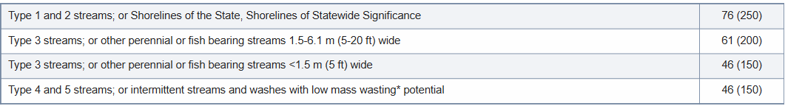

We expect the Gifford Pinchot National Forest to be able to offer substantial and effective riparian protection. This is public land, and the interests of profit from harvest must be balanced by the interests of species who live on the land. In the evaluation of impacts on fisheries, page 59, and in a few other places in the EA, we find statements to the effect that there may be “short-term effects to individual resident” fishes and other species. Those individuals also have an interest in what you do, since their lives are affected. We understand that human activities sometimes have unavoidable impacts on individuals of other species, but in this Project on public land, there is an opportunity to minimize impacts on riparian buffers and all the species that depend on them.

**Amendments to the Forest Plan**

We do not support the proposed amendments to the Forest Plan, especially for the area around the Monte Cristo RNA. We are familiar with the special values of the Washington State DNR Natural Area Preserve adjacent. These values are way beyond visual and scenic. An amendment to allow more habitat disturbance in this area is not a good thing. We also support the comments submitted by the Cascade Forest Conservancy on the more technical problems with amendments to the Forest Plan, including the comments about scheduled timber harvest.

**Complex mature forest**

We support Cascade Forest Conservancy in requesting that the 549 acres of remaining complex mature forests be dropped from the harvest plans, for the reasons given in their comments. We think that a forest over 80 years old is well into the process of diversification and self-thinning, and as part of the experiment of this Project, we should include an experiment of leaving forests that are well on their way to maturity to figure the next years, and response to climate change, for themselves.

**Wildlife and plants**

The EA does not adequately address effects on Western Gray Squirrel, whose habitat requirements are described on page 62. This species has recently been uplisted to endangered by Washington and is in danger of extirpation.

The EA also does not recognize State of Washington designations of endangered species present in the Project area, particularly Cascade Red Fox and Fisher. We would like to see additional consideration of their habitat needs. Marbled Murrelet and Oregon Spotted Frog are also designated endangered by the State.

Regarding plants, the State of Washington’s list of endangered plants[3] is much more extensive than the federal list, according to this chart from the Washington State Department of Natural Resources. We request that state endangered plant species present in the Project area be included in Table 12.

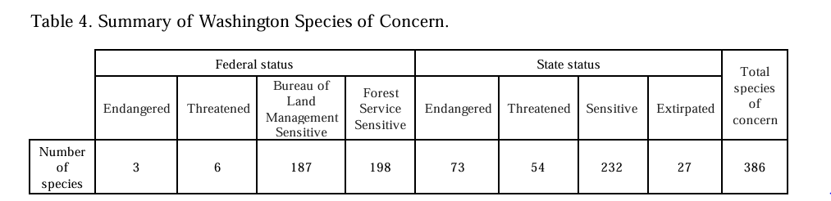

On page 60 of the EA, we find the statement that consultation with USFW will be completed prior to finalization of the EA. We suggest that the results of that consultation be made available to the public for comment.

**Cascade Forest Conservancy comments that we support**

We support comments from Cascade Forest Conservancy on the following points (in addition to ones noted above):

Diameter limits for matrix stands.

Reconsideration of the canopy targets in the area of concentrated treatments within the watershed's eastern part, due to the intensity of harvest and thinning in that area. The EA treats the Project as a whole, but impacts are going to be more severe in this area of concentration.

Potential Control Line treatments

Fire Risk Analysis. Including prescribed fire implementation.

Protect all Douglas-firs trees with a 30” diameter or more in matrix stands; and

Provide a no-cut buffer of 1.5 to 2 drip lines on all trees with a 40” diameter or more to protect their root systems from the negative impacts of heavy machinery.

**Road decommissioning**

We strongly support the road decommissioning and closures proposed for the Project, for the reasons given in the EA. The hydrologic reconnection at South Prairie is particularly important given the unique nature of that spot and the benefits to habitat and water quality that will be derived from road decommissioning. **We note that many of the climate change resiliency benefits result from these actions****. Changing these actions would necessarily affect the EA analysis of building climate change resiliency.**

In summary, we support a cautious approach to this Project. The Project is a bold step to restore diversity and complexity in the forest environment and to address generally recognized problems. It is also a step into somewhat unknown territory.

Very truly yours,

  
Patricia L. Arnold

Executive Director

Friends of the White Salmon River

[pat.arnold@friendsofthewhitesalmon.org](mailto:pat.arnold@friendsofthewhitesalmon.org)

1. 2014 update can be found at https://plan.critfc.org/vol2/subbasin-plans/little-white-salmon-river/#:~:text=The%20Little%20White%20Salmon%20River,salmon%20population%20of%20unknown%20abundance.
2. https://wdfw.wa.gov/publications/00029
3. 2024 Washington Vascular Plant Species of Conservation Concern, from Natural Heritage Report 2024-07 Washington State Department of Natural Resources.